UNITED STATES
SECURITIES AND EXCHANGE COMMISSION
WASHINGTON, D.C. 20549
FORM 10-Q

(Mark One)
☒ |  |  | QUARTERLY REPORT PURSUANT TO SECTION 13 OR 15(d) OF THE SECURITIES EXCHANGE ACT OF 1934
For the quarterly period ended June 30, 2025
OR
☐ |  |  | TRANSITION REPORT PURSUANT TO SECTION 13 OR 15(d) OF THE SECURITIES EXCHANGE ACT OF 1934
For the transition period from ___________ to ___________
Commission file number 001-42693

Chime Financial, Inc.
(Exact name of registrant as specified in its charter)
Delaware |  |  |  |  |  | 46-0925388
(State or other jurisdiction of  incorporation or organization) |  |  |  |  |  | (I.R.S. Employer  Identification No.)
101 California Street, Suite 500  San Francisco, CA |  |  |  |  |  | 94111
(Address of Principal Executive Offices) |  |  |  |  |  | (Zip Code)
(844) 244-6363
Registrant’s telephone number, including area code
Securities registered pursuant to Section 12(b) of the Act:
Title of each class |  |  |  |  |  | Trading Symbol(s) |  |  |  |  |  | Name of each exchange on which registered
Class A common stock, $0.0001 par value per share |  |  |  |  |  | CHYM |  |  |  |  |  | The Nasdaq Stock Market LLC
Indicate by check mark whether the registrant (1) has filed all reports required to be filed by Section 13 or 15(d) of the Securities Exchange Act of 1934 during the preceding 12 months (or for such shorter period that the registrant was required to file such reports), and (2) has been subject to such filing requirements for the past 90 days. Yes ☐ No ☒
Indicate by check mark whether the registrant has submitted electronically every Interactive Data File required to be submitted pursuant to Rule 405 of Regulation S-T (§232.405 of this chapter) during the preceding 12 months (or for such shorter period that the registrant was required to submit such files). Yes ☒ No ☐
Indicate by check mark whether the registrant is a large accelerated filer, an accelerated filer, a non-accelerated filer, a smaller reporting company, or an emerging growth company. See definitions of “large accelerated filer,” “accelerated filer,” “smaller reporting company,” and “emerging growth company” in Rule 12b-2 of the Exchange Act.
Large accelerated filer |  |  |  |  |  | ☐ |  |  |  |  |  | Accelerated filer |  |  |  |  |  | ☐
Non-accelerated filer |  |  |  |  |  | ☒ |  |  |  |  |  | Smaller reporting company |  |  |  |  |  | ☐
 |  |  |  |  |  |  |  |  |  |  |  | Emerging growth company |  |  |  |  |  | ☐
If an emerging growth company, indicate by check mark if the registrant has elected not to use the extended transition period for complying with any new or revised financial accounting standards provided pursuant to Section 13(a) of the Exchange Act. ☐
Indicate by check mark whether the registrant is a shell company (as defined in Rule 12b-2 of the Exchange Act). Yes ☐ No ☒
As of August 6, 2025, the numbers of shares of the issuer’s Class A and Class B common stock outstanding were 339,528,738 and 32,182,289 and no shares of Class C common stock were outstanding.

TABLE OF CONTENTS
Part 1- Financial Statements |  |  | 4
Item 1. Financial Statements (unaudited) |  |  | 4
Condensed Consolidated Balance Sheets |  |  | 4
Condensed Consolidated Statements of Operations |  |  | 5
Condensed Consolidated Statements of Comprehensive Income (Loss) |  |  | 6
Condensed Consolidated Statements of Redeemable Convertible Preferred Stock and Stockholders’ Equity (Deficit) |  |  | 7
Condensed Consolidated Statements of Cash Flows |  |  | 9
Notes to Unaudited Condensed Consolidated Financial Statements |  |  | 11
Note 1 - Organization and Description of Business |  |  | 11
Note 2 - Basis of Presentation and Summary of Significant Accounting Policies |  |  | 11
Note 3 - Revenue |  |  | 14
Note 4 - Fair Value Measurement |  |  | 15
Note 5 - Marketable Securities |  |  | 16
Note 6 - Loans Held For Investment, Net |  |  | 17
Note 7 - Credit Obligations |  |  | 18
Note 8 - Property, Equipment, and Software, Net |  |  | 19
Note 9 - Significant Balance Sheet Components |  |  | 20
Note 10 - Indebtedness |  |  | 20
Note 11 - Redeemable Convertible Preferred Stock, Common Stock, and Stockholders’ Equity (Deficit) |  |  | 21
Note 12 - Stock-Based Compensation |  |  | 23
Note 13 - Net Income (Loss) Per Share |  |  | 27
Note 14 - Related Party Transactions |  |  | 29
Note 15 - Income Taxes |  |  | 29
Note 16 - Commitments and Contingencies |  |  | 30
Note 17 - Subsequent Events |  |  | 31
Item 2. Management’s Discussion and Analysis of Financial Condition and Results of Operations. |  |  | 32
Item 3. Quantitative and Qualitative Disclosures About Market Risk. |  |  | 47
Item 4. Controls and Procedures. |  |  | 48
Part II - Other Information |  |  | 49
Item 1. Legal Proceedings. |  |  | 49
Item 1A. Risk Factors |  |  | 49
Item 2. Unregistered Sales of Equity Securities and Use of Proceeds |  |  | 100
Item 3. Defaults Upon Senior Securities |  |  | 101
Item 4. Mine Safety Disclosures |  |  | 101
Item 5. Other Information |  |  | 101
Item 6. Exhibits |  |  | 101
Signatures |  |  | 104

1

SPECIAL NOTE REGARDING FORWARD-LOOKING STATEMENTS
This Quarterly Report on Form 10-Q (this “Quarterly Report”) contains forward-looking statements within the meaning of the federal securities laws, which statements involve substantial risks and uncertainties. Forward-looking statements generally relate to future events or our future financial or operating performance. In some cases, you can identify forward-looking statements because they contain words such as “may,” “will,” “shall,” “should,” “expect,” “plan,” “anticipate,” “could,” “intend,” “target,” “project,” “contemplate,” “believe,” “estimate,” “predict,” “potential” “goal,” “objective,” “seek,” or “continue,” or the negative of any of these words or other similar terms or expressions that concern our expectations, strategy, plans or intentions. This Quarterly Report includes, among others, forward-looking statements regarding our:
•our future financial performance, including our expectations regarding our revenue, cost of revenue and operating expenses, and our ability to achieve and maintain future profitability;
•our ability to successfully execute our business and growth strategy;
•our ability to attract and retain Active Members and maintain and increase their engagement with our platform and their Purchase Volume, as well as our ARPAM;
•the sufficiency of our cash, cash equivalents, and investments and amounts available under our credit facility to meet our working capital and liquidity needs;
•the demand for our platform;
•the future performance of, and our expectations regarding, certain of our products;
•our ability to develop new products and bring them to market in a timely manner and make enhancements to current products;
•our ability to compete with existing and new competitors in existing and new markets;
•our expectations regarding our compliance with and the effects of existing and developing laws and regulations, including with respect to financial services and privacy and data protection;
•our expectations related to the development, investment in, and integration of AI and ML technologies, including generative AI, into our products and operations;
•our ability to manage risk associated with our business;
•our expectations regarding new and evolving markets;
•our ability to maintain and protect our brand;
•our ability to maintain the security and availability of our platform;
•our expectations and management of future growth;
•our expectations concerning our bank partners and other third-party service providers;
•our ability to maintain, protect, and enhance our intellectual property; and
•the increased expenses associated with being a public company.
We caution you that the foregoing list may not contain all of the forward-looking statements made in this Quarterly Report.
2

We have based the forward-looking statements contained in this Quarterly Report primarily on our current expectations, estimates, forecasts, and projections about future events and trends that we believe may affect our business, financial condition, results of operations, and prospects. The outcome of the events described in these forward-looking statements is subject to risks, uncertainties, and other factors, including those described in the section titled “Risk Factors” and elsewhere in this Quarterly Report. Moreover, we operate in a very competitive and rapidly changing environment. New risks and uncertainties emerge from time to time and it is not possible for us to predict all risks and uncertainties that could have an impact on the forward-looking statements contained in this Quarterly Report. Although we believe that we have a reasonable basis for each forward-looking statement contained in this Quarterly Report, we cannot assure you that the future results, events, and circumstances reflected in the forward-looking statements will be achieved or occur at all, and actual future results, events, and circumstances could differ materially from those described in the forward-looking statements. Accordingly, you should not place undue reliance upon forward-looking statements as predictions of future events.
Neither we nor any other person assumes responsibility for the accuracy and completeness of any of these forward-looking statements. Moreover, the forward-looking statements made in this Quarterly Report relate only to our expectations as of the date on which the statements are made. We undertake no obligation to update any forward-looking statements made in this Quarterly Report to reflect events or circumstances after the date of this Quarterly Report or to reflect new information or the occurrence of unanticipated events, except as required by law.
In addition, statements that “we believe” and similar statements reflect our beliefs and opinions on the relevant subject. These statements are based upon information available to us as of the date of this Quarterly Report, and while we believe such information forms a reasonable basis for such statements, such information may be limited or incomplete, and our statements should not be read to indicate that we have conducted an exhaustive inquiry into, or review of, all potentially available relevant information. These statements are inherently uncertain and investors are cautioned not to unduly rely upon these statements.

3

PART I. - FINANCIAL INFORMATION
ITEM 1. Financial Statements
CHIME FINANCIAL, INC.
CONDENSED CONSOLIDATED BALANCE SHEETS
(In thousands, except share and per share amounts)
(unaudited)

 |  |  | June 30,  2025 |  |  |  |  |  | December 31,  2024
Assets
Current assets:
Cash and cash equivalents |  |  | $ | 868,284 |  |  |  |  | $ | 337,697
Restricted cash |  |  | 13,515 |  |  |  |  |  | 12,303
Marketable securities |  |  | 225,063 |  |  |  |  |  | 368,889
Product collateral |  |  | 212,983 |  |  |  |  |  | 181,723
Accounts receivable, net |  |  | 229,594 |  |  |  |  |  | 216,161
Loans held for investment, net |  |  | 114,120 |  |  |  |  |  | 99,799
Prepaid expenses and other current assets |  |  | 72,520 |  |  |  |  |  | 70,464
Total current assets |  |  | 1,736,079 |  |  |  |  |  | 1,287,036
Property, equipment and software, net |  |  | 89,101 |  |  |  |  |  | 92,700
Operating lease right of use assets, net |  |  | 45,575 |  |  |  |  |  | 49,332
Other assets |  |  | 31,719 |  |  |  |  |  | 31,969
Total assets |  |  | $ | 1,902,474 |  |  |  |  | $ | 1,461,037
Liabilities, redeemable convertible preferred stock, and stockholders❜ equity (deficit)
Current liabilities:
Accounts payable |  |  | $ | 51,800 |  |  |  |  | $ | 35,846
Accrued and other current liabilities |  |  | 168,919 |  |  |  |  |  | 224,594
Product obligation |  |  | 138,979 |  |  |  |  |  | 114,377
Total current liabilities |  |  | 359,698 |  |  |  |  |  | 374,817
Operating lease liabilities, net of current portion |  |  | 74,765 |  |  |  |  |  | 80,590
Other non-current liabilities |  |  | 39,913 |  |  |  |  |  | 46,109
Total liabilities |  |  | 474,376 |  |  |  |  |  | 501,516
Commitments and contingencies (Note 16)
Redeemable convertible preferred stock, $0.0001 par value: No shares authorized, issued, and outstanding as of June 30, 2025. 258,613,394 shares authorized and 258,464,156 shares issued and outstanding with a liquidation preference of $2,894,515 as of December 31, 2024. |  |  | — |  |  |  |  |  | 2,890,121
Stockholders’ equity (deficit):
Preferred stock, $0.0001 par value: 100,000,000 shares authorized, no shares issued and outstanding as of June 30, 2025. No shares authorized, issued, and outstanding as of as of December 31, 2024. |  |  | — |  |  |  |  |  | —
Common stock, $0.0001 par value: No shares authorized, issued, and outstanding as of June 30, 2025. 416,094,141 shares authorized, 66,950,736 shares issued and outstanding as of December 31, 2024. |  |  | — |  |  |  |  |  | 2
Class A common stock, $0.0001 par value: 5,000,000,000 shares authorized, 338,594,524 shares issued and outstanding as of June 30, 2025. No shares authorized, issued and outstanding as of December 31, 2024. |  |  | 28 |  |  |  |  |  | —
Class B common stock, $0.0001 par value: 65,000,000 shares authorized, 32,182,289 shares issued and outstanding as of June 30, 2025. No shares authorized, issued and outstanding as of December 31, 2024. |  |  | 3 |  |  |  |  |  | —
Class C common stock, $0.0001 par value: 500,000,000 shares authorized, no shares issued and outstanding as of June 30, 2025. No shares authorized, issued and outstanding as of December 31, 2024 |  |  | — |  |  |  |  |  | —
Additional paid-in capital |  |  | 4,702,788 |  |  |  |  |  | 433,363
Accumulated other comprehensive income (loss) |  |  | (116) |  |  |  |  |  | 203
Accumulated deficit |  |  | (3,274,605) |  |  |  |  |  | (2,364,168)
Total stockholders’ equity (deficit) |  |  | 1,428,098 |  |  |  |  |  | (1,930,600)
Total liabilities, redeemable convertible preferred stock, and stockholders’ equity (deficit) |  |  | $ | 1,902,474 |  |  |  |  | $ | 1,461,037
The accompanying notes are an integral part of these condensed consolidated financial statements.

4

CHIME FINANCIAL, INC.
CONDENSED CONSOLIDATED STATEMENTS OF OPERATIONS
(In thousands, except share and per share amounts)
(unaudited)

 |  |  | Three Months Ended  June 30, |  |  |  |  |  |  |  |  |  |  |  | Six Months Ended  June 30,
 |  |  | 2025 |  |  |  |  |  | 2024 |  |  |  |  |  | 2025 |  |  |  |  |  | 2024
Revenue |  |  | $ | 528,149 |  |  |  |  | $ | 384,214 |  |  |  |  | $ | 1,046,893 |  |  |  |  | $ | 776,186
Cost of revenue |  |  | 67,120 |  |  |  |  |  | 50,504 |  |  |  |  |  | 127,538 |  |  |  |  |  | 97,951
Gross profit |  |  | 461,029 |  |  |  |  |  | 333,710 |  |  |  |  |  | 919,355 |  |  |  |  |  | 678,235
Operating expenses:
Transaction and risk losses |  |  | 98,247 |  |  |  |  |  | 35,000 |  |  |  |  |  | 207,392 |  |  |  |  |  | 71,038
Member support and operations |  |  | 203,097 |  |  |  |  |  | 69,821 |  |  |  |  |  | 281,706 |  |  |  |  |  | 137,889
Sales and marketing |  |  | 185,006 |  |  |  |  |  | 118,021 |  |  |  |  |  | 317,579 |  |  |  |  |  | 235,068
Technology and development |  |  | 621,754 |  |  |  |  |  | 75,371 |  |  |  |  |  | 699,636 |  |  |  |  |  | 150,301
General and administrative |  |  | 279,667 |  |  |  |  |  | 41,638 |  |  |  |  |  | 326,840 |  |  |  |  |  | 80,890
Depreciation and amortization |  |  | 3,896 |  |  |  |  |  | 3,300 |  |  |  |  |  | 7,703 |  |  |  |  |  | 7,458
Total operating expenses |  |  | 1,391,667 |  |  |  |  |  | 343,151 |  |  |  |  |  | 1,840,856 |  |  |  |  |  | 682,644
Loss from operations |  |  | (930,638) |  |  |  |  |  | (9,441) |  |  |  |  |  | (921,501) |  |  |  |  |  | (4,409)
Other income, net |  |  | 6,215 |  |  |  |  |  | 9,904 |  |  |  |  |  | 11,569 |  |  |  |  |  | 20,413
Income (loss) before income taxes |  |  | (924,423) |  |  |  |  |  | 463 |  |  |  |  |  | (909,932) |  |  |  |  |  | 16,004
Provision (benefit) for income taxes |  |  | (1,047) |  |  |  |  |  | 78 |  |  |  |  |  | 505 |  |  |  |  |  | (284)
Net income (loss) |  |  | $ | (923,376) |  |  |  |  | $ | 385 |  |  |  |  | $ | (910,437) |  |  |  |  | $ | 16,288
Undistributed earnings attributable to preferred stockholders |  |  | — |  |  |  |  |  | (385) |  |  |  |  |  | — |  |  |  |  |  | (16,288)
Net income (loss) attributable to common stockholders |  |  | $ | (923,376) |  |  |  |  | $ | — |  |  |  |  | $ | (910,437) |  |  |  |  | $ | —
Net income (loss) per share attributable to common stockholders, basic and diluted |  |  | $ | (7.29) |  |  |  |  | $ | — |  |  |  |  | $ | (9.44) |  |  |  |  | $ | —
Weighted average number of shares outstanding used to compute net income (loss) per share attributable to common stockholders, basic and diluted |  |  | 126,620,499 |  |  |  |  |  | 64,677,568 |  |  |  |  |  | 96,412,477 |  |  |  |  |  | 64,558,990
The accompanying notes are an integral part of these condensed consolidated financial statements.

5

CHIME FINANCIAL, INC.
CONDENSED CONSOLIDATED STATEMENTS OF COMPREHENSIVE INCOME (LOSS)
(In thousands)
(unaudited)

 |  |  | Three Months Ended  June 30, |  |  |  |  |  |  |  |  |  |  |  | Six Months Ended  June 30,
 |  |  | 2025 |  |  |  |  |  | 2024 |  |  |  |  |  | 2025 |  |  |  |  |  | 2024
Net income (loss) |  |  | $ | (923,376) |  |  |  |  | $ | 385 |  |  |  |  | $ | (910,437) |  |  |  |  | $ | 16,288
Other comprehensive income (loss):
Net unrealized loss on marketable securities, net of tax |  |  | (752) |  |  |  |  |  | (300) |  |  |  |  |  | (670) |  |  |  |  |  | (1,478)
Foreign currency translation adjustments |  |  | 342 |  |  |  |  |  | (82) |  |  |  |  |  | 351 |  |  |  |  |  | (228)
Total comprehensive income (loss) |  |  | $ | (923,786) |  |  |  |  | $ | 3 |  |  |  |  | $ | (910,756) |  |  |  |  | $ | 14,582
The accompanying notes are an integral part of these condensed consolidated financial statements.

6

CHIME FINANCIAL, INC.
CONDENSED CONSOLIDATED STATEMENTS OF REDEEMABLE CONVERTIBLE PREFERRED STOCK AND STOCKHOLDERS’ EQUITY (DEFICIT)
(In thousands, except share amounts)
(unaudited)

 |  |  | Redeemable Convertible  Preferred Stock |  |  |  |  |  |  |  |  |  |  |  |  |  |  | Common Stock(1) |  |  |  |  |  |  |  |  |  |  |  | Additional  Paid-in Capital |  |  |  |  |  | Accumulated Deficit |  |  |  |  |  | Accumulated  Other Comprehensive Income (Loss) |  |  |  |  |  | Total  Stockholders’ Equity (Deficit)
 |  |  | Shares |  |  |  |  |  | Amount |  |  |  |  |  |  |  |  | Shares |  |  |  |  |  | Amount
Balance as of December 31, 2024 |  |  | 258,464,156 |  |  |  |  |  | $ | 2,890,121 |  |  |  |  |  |  |  | 66,950,736 |  |  |  |  |  | $ | 2 |  |  |  |  | $ | 433,363 |  |  |  |  | $ | (2,364,168) |  |  |  |  | $ | 203 |  |  |  |  | $ | (1,930,600)
Net income |  |  | — |  |  |  |  |  | — |  |  |  |  |  |  |  |  | — |  |  |  |  |  | — |  |  |  |  |  | — |  |  |  |  |  | 12,939 |  |  |  |  |  | — |  |  |  |  |  | 12,939
Issuance of common stock upon exercise of stock options |  |  | — |  |  |  |  |  | — |  |  |  |  |  |  |  |  | 636,796 |  |  |  |  |  | — |  |  |  |  |  | 717 |  |  |  |  |  | — |  |  |  |  |  | — |  |  |  |  |  | 717
Stock-based compensation |  |  | — |  |  |  |  |  | — |  |  |  |  |  |  |  |  | — |  |  |  |  |  | — |  |  |  |  |  | 8,749 |  |  |  |  |  | — |  |  |  |  |  | — |  |  |  |  |  | 8,749
Change in accumulated other comprehensive income, net of tax |  |  | — |  |  |  |  |  | — |  |  |  |  |  |  |  |  | — |  |  |  |  |  | — |  |  |  |  |  | — |  |  |  |  |  | — |  |  |  |  |  | 91 |  |  |  |  |  | 91
Balance as of March 31, 2025 |  |  | 258,464,156 |  |  |  |  |  | $ | 2,890,121 |  |  |  |  |  |  |  | 67,587,532 |  |  |  |  |  | $ | 2 |  |  |  |  | $ | 442,829 |  |  |  |  | $ | (2,351,229) |  |  |  |  | $ | 294 |  |  |  |  | $ | (1,908,104)
Net loss |  |  | — |  |  |  |  |  | — |  |  |  |  |  |  |  |  | — |  |  |  |  |  | — |  |  |  |  |  | — |  |  |  |  |  | (923,376) |  |  |  |  |  | — |  |  |  |  |  | (923,376)
Issuance of common stock in connection with initial public offering, net of issuance costs |  |  | — |  |  |  |  |  | — |  |  |  |  |  |  |  |  | 30,700,765 |  |  |  |  |  | 3 |  |  |  |  |  | 770,585 |  |  |  |  |  | — |  |  |  |  |  | — |  |  |  |  |  | 770,588
Conversion of redeemable convertible preferred stock to common stock in connection with initial public offering |  |  | (258,464,156) |  |  |  |  |  | (2,890,121) |  |  |  |  |  |  |  |  | 258,667,796 |  |  |  |  |  | 26 |  |  |  |  |  | 2,890,095 |  |  |  |  |  | — |  |  |  |  |  | — |  |  |  |  |  | 2,890,121
Issuance of common stock upon settlement of restricted stock units, net of shares withheld |  |  | — |  |  |  |  |  | — |  |  |  |  |  |  |  |  | 13,403,583 |  |  |  |  |  | — |  |  |  |  |  | (322,619) |  |  |  |  |  | — |  |  |  |  |  | — |  |  |  |  |  | (322,619)
Issuance of common stock upon exercise of stock options |  |  | — |  |  |  |  |  | — |  |  |  |  |  |  |  |  | 96,118 |  |  |  |  |  | — |  |  |  |  |  | 410 |  |  |  |  |  | — |  |  |  |  |  | — |  |  |  |  |  | 410
Stock-based charitable contribution |  |  | — |  |  |  |  |  | — |  |  |  |  |  |  |  |  | 321,019 |  |  |  |  |  | — |  |  |  |  |  | 11,168 |  |  |  |  |  | — |  |  |  |  |  | — |  |  |  |  |  | 11,168
Stock-based compensation |  |  | — |  |  |  |  |  | — |  |  |  |  |  |  |  |  | — |  |  |  |  |  | — |  |  |  |  |  | 910,320 |  |  |  |  |  | — |  |  |  |  |  | — |  |  |  |  |  | 910,320
Change in accumulated other comprehensive income (loss), net of tax |  |  | — |  |  |  |  |  | — |  |  |  |  |  |  |  |  | — |  |  |  |  |  | — |  |  |  |  |  | — |  |  |  |  |  | — |  |  |  |  |  | (410) |  |  |  |  |  | (410)
Balance as of June 30, 2025 |  |  | — |  |  |  |  |  | $ | — |  |  |  |  |  |  |  | 370,776,813 |  |  |  |  |  | $ | 31 |  |  |  |  | $ | 4,702,788 |  |  |  |  | $ | (3,274,605) |  |  |  |  | $ | (116) |  |  |  |  | $ | 1,428,098
__________________
(1)The share amounts listed above combine common stock, Class A common stock and Class B common stock. In connection with the completion of our initial public offering, all previously outstanding shares of common stock were reclassified into Class A common stock and Class B common stock. Refer to Note 2 for more information.
The accompanying notes are an integral part of these condensed consolidated financial statements.

7

CHIME FINANCIAL, INC.
CONDENSED CONSOLIDATED STATEMENTS OF REDEEMABLE CONVERTIBLE PREFERRED STOCK AND STOCKHOLDERS’ EQUITY (DEFICIT)
(In thousands, except share amounts)
(unaudited)
 |  |  | Redeemable Convertible  Preferred Stock |  |  |  |  |  |  |  |  |  |  |  |  |  |  | Common Stock |  |  |  |  |  |  |  |  |  |  |  | Additional  Paid-in Capital |  |  |  |  |  | Accumulated Deficit |  |  |  |  |  | Accumulated  Other Comprehensive Income (Loss) |  |  |  |  |  | Total  Stockholders’ Equity (Deficit)
 |  |  | Shares |  |  |  |  |  | Amount |  |  |  |  |  |  |  |  | Shares |  |  |  |  |  | Amount
Balance as of December 31, 2023 |  |  | 258,464,156 |  |  |  |  |  | $ | 2,890,121 |  |  |  |  |  |  |  | 64,394,985 |  |  |  |  |  | $ | 2 |  |  |  |  | $ | 384,489 |  |  |  |  | $ | (2,338,824) |  |  |  |  | $ | 720 |  |  |  |  | $ | (1,953,613)
Net income |  |  | — |  |  |  |  |  | — |  |  |  |  |  |  |  |  | — |  |  |  |  |  | — |  |  |  |  |  | — |  |  |  |  |  | 15,903 |  |  |  |  |  | — |  |  |  |  |  | 15,903
Issuance of common stock upon exercise of stock options |  |  | — |  |  |  |  |  | — |  |  |  |  |  |  |  |  | 196,039 |  |  |  |  |  | — |  |  |  |  |  | 208 |  |  |  |  |  | — |  |  |  |  |  | — |  |  |  |  |  | 208
Repurchases of common stock |  |  | — |  |  |  |  |  | — |  |  |  |  |  |  |  |  | (1,490) |  |  |  |  |  | — |  |  |  |  |  | (27) |  |  |  |  |  | — |  |  |  |  |  | — |  |  |  |  |  | (27)
Stock-based compensation |  |  | — |  |  |  |  |  | — |  |  |  |  |  |  |  |  | — |  |  |  |  |  | — |  |  |  |  |  | 5,173 |  |  |  |  |  | — |  |  |  |  |  | — |  |  |  |  |  | 5,173
Change in accumulated other comprehensive loss, net of tax |  |  | — |  |  |  |  |  | — |  |  |  |  |  |  |  |  | — |  |  |  |  |  | — |  |  |  |  |  | — |  |  |  |  |  | — |  |  |  |  |  | (1,324) |  |  |  |  |  | (1,324)
Balance as of March 31, 2024 |  |  | 258,464,156 |  |  |  |  |  | $ | 2,890,121 |  |  |  |  |  |  |  | 64,589,534 |  |  |  |  |  | $ | 2 |  |  |  |  | $ | 389,843 |  |  |  |  | $ | (2,322,921) |  |  |  |  | $ | (604) |  |  |  |  | $ | (1,933,680)
Net income |  |  | — |  |  |  |  |  | — |  |  |  |  |  |  |  |  | — |  |  |  |  |  | — |  |  |  |  |  | — |  |  |  |  |  | 385 |  |  |  |  |  | — |  |  |  |  |  | 385
Issuance of common stock upon exercise of stock options |  |  | — |  |  |  |  |  | — |  |  |  |  |  |  |  |  | 341,686 |  |  |  |  |  | — |  |  |  |  |  | 392 |  |  |  |  |  | — |  |  |  |  |  | — |  |  |  |  |  | 392
Repurchases of common stock |  |  | — |  |  |  |  |  | — |  |  |  |  |  |  |  |  | (26,500) |  |  |  |  |  | — |  |  |  |  |  | (510) |  |  |  |  |  | — |  |  |  |  |  | — |  |  |  |  |  | (510)
Stock-based compensation |  |  | — |  |  |  |  |  | — |  |  |  |  |  |  |  |  | — |  |  |  |  |  | — |  |  |  |  |  | 6,366 |  |  |  |  |  | — |  |  |  |  |  | — |  |  |  |  |  | 6,366
Issuance of common stock and restricted common stock in connection with business acquisition |  |  | — |  |  |  |  |  | — |  |  |  |  |  |  |  |  | 1,645,775 |  |  |  |  |  | — |  |  |  |  |  | 18,506 |  |  |  |  |  | — |  |  |  |  |  | — |  |  |  |  |  | 18,506
Change in accumulated other comprehensive loss, net of tax |  |  | — |  |  |  |  |  | — |  |  |  |  |  |  |  |  | — |  |  |  |  |  | — |  |  |  |  |  | — |  |  |  |  |  | — |  |  |  |  |  | (382) |  |  |  |  |  | (382)
Balance as of June 30, 2024 |  |  | 258,464,156 |  |  |  |  |  | $ | 2,890,121 |  |  |  |  |  |  |  | 66,550,495 |  |  |  |  |  | $ | 2 |  |  |  |  | $ | 414,597 |  |  |  |  | $ | (2,322,536) |  |  |  |  | $ | (986) |  |  |  |  | $ | (1,908,923)
The accompanying notes are an integral part of these condensed consolidated financial statements.

8

CHIME FINANCIAL, INC.
CONDENSED CONSOLIDATED STATEMENTS OF CASH FLOWS
(In thousands)
(unaudited)
Six Months Ended
June 30,
 |  |  |  |  |  |  | 2025 |  |  |  |  |  | 2024
Operating activities:
Net income (loss) |  |  |  |  |  |  | $ | (910,437) |  |  |  |  | $ | 16,288
Adjustments to reconcile net income (loss) to net cash provided by operating activities:
Depreciation and amortization |  |  |  |  |  |  | 14,669 |  |  |  |  |  | 11,351
Non-cash lease expense |  |  |  |  |  |  | 3,058 |  |  |  |  |  | 2,615
Stock-based compensation |  |  |  |  |  |  | 918,843 |  |  |  |  |  | 11,594
Stock-based charitable contribution |  |  |  |  |  |  | 11,168 |  |  |  |  |  | —
Provision for transaction dispute losses |  |  |  |  |  |  | 31,045 |  |  |  |  |  | 24,125
Change in fair value of product obligation |  |  |  |  |  |  | 43,579 |  |  |  |  |  | 31,015
Provision for credit losses |  |  |  |  |  |  | 44,096 |  |  |  |  |  | 1,868
Impairment related to real estate assets and internal-use software |  |  |  |  |  |  | — |  |  |  |  |  | 211
Amortization of premium on marketable securities |  |  |  |  |  |  | (2,365) |  |  |  |  |  | (7,884)
Other |  |  |  |  |  |  | 208 |  |  |  |  |  | 73
Changes in operating assets and liabilities:
Product collateral |  |  |  |  |  |  | (31,260) |  |  |  |  |  | (24,980)
Accounts receivable, net |  |  |  |  |  |  | (14,342) |  |  |  |  |  | 8,026
Prepaid expenses and other assets |  |  |  |  |  |  | (1,432) |  |  |  |  |  | (1,170)
Accounts payable |  |  |  |  |  |  | 15,954 |  |  |  |  |  | 836
Accrued and other liabilities |  |  |  |  |  |  | (93,291) |  |  |  |  |  | 30,510
Operating lease liabilities |  |  |  |  |  |  | (7,773) |  |  |  |  |  | (5,306)
Settlements of the product obligation |  |  |  |  |  |  | (18,977) |  |  |  |  |  | (28,335)
Cash flows provided by operating activities |  |  |  |  |  |  | 2,743 |  |  |  |  |  | 70,837
Investing activities:
Purchase of marketable securities |  |  |  |  |  |  | (234,050) |  |  |  |  |  | (289,452)
Proceeds from sales of marketable securities |  |  |  |  |  |  | 256,514 |  |  |  |  |  | 16,985
Proceeds from maturities of marketable securities |  |  |  |  |  |  | 123,200 |  |  |  |  |  | 306,875
Purchases of loans held for investment |  |  |  |  |  |  | (2,368,152) |  |  |  |  |  | (54,732)
Repayments of loans held for investment |  |  |  |  |  |  | 2,311,634 |  |  |  |  |  | 30,618
Purchase of property, equipment and software |  |  |  |  |  |  | (3,631) |  |  |  |  |  | (134)
Capitalization of internal-use software |  |  |  |  |  |  | (6,389) |  |  |  |  |  | (4,298)
Acquisition of business, net of cash acquired |  |  |  |  |  |  | — |  |  |  |  |  | (11,036)
Cash flows provided by (used in) investing activities |  |  |  |  |  |  | 79,126 |  |  |  |  |  | (5,174)
Financing activities:
Payment of debt issuance costs related to the credit facility |  |  |  |  |  |  | (1,134) |  |  |  |  |  | —
Proceeds from the issuance of common stock upon initial public offering, net of underwriting discounts and offering costs paid |  |  |  |  |  |  | 772,556 |  |  |  |  |  | —
Taxes paid related to net share settlement of restricted stock units |  |  |  |  |  |  | (322,619) |  |  |  |  |  | —
Proceeds from exercise of stock options |  |  |  |  |  |  | 1,127 |  |  |  |  |  | 600
Repurchases of common stock |  |  |  |  |  |  | — |  |  |  |  |  | (593)
Cash flows provided by financing activities |  |  |  |  |  |  | 449,930 |  |  |  |  |  | 7
Net increase in cash and cash equivalents and restricted cash |  |  |  |  |  |  | 531,799 |  |  |  |  |  | 65,670
Cash, cash equivalents, and restricted cash, beginning of period |  |  |  |  |  |  | 350,000 |  |  |  |  |  | 239,745
Cash, cash equivalents, and restricted cash, end of period |  |  |  |  |  |  | $ | 881,799 |  |  |  |  | $ | 305,415
Cash and cash equivalents, end of the period |  |  |  |  |  |  | $ | 868,284 |  |  |  |  | $ | 295,415
Restricted cash, end of the period |  |  |  |  |  |  | 13,515 |  |  |  |  |  | 10,000
Cash, cash equivalents, and restricted cash, end of the period |  |  |  |  |  |  | $ | 881,799 |  |  |  |  | $ | 305,415
9

CHIME FINANCIAL, INC.
CONDENSED CONSOLIDATED STATEMENTS OF CASH FLOWS
(In thousands)
(unaudited)
Six Months Ended
June 30,
 |  |  |  |  |  |  | 2025 |  |  |  |  |  | 2024
Supplementary cash flow disclosure:
Cash paid for interest |  |  |  |  |  |  | $ | 140 |  |  |  |  | $ | 233
Cash paid for income taxes |  |  |  |  |  |  | 1,071 |  |  |  |  |  | 161
Supplemental disclosures of noncash investing and financing activities:
Deferred offering costs not yet paid |  |  |  |  |  |  | 1,968 |  |  |  |  |  | —
Reclassification of deferred offering costs to additional paid-in capital upon initial public offering |  |  |  |  |  |  | 14,815 |  |  |  |  |  | —
Conversion of redeemable convertible preferred stock to common stock in connection with initial public offering |  |  |  |  |  |  | 2,890,121 |  |  |  |  |  | —
Purchases of property, equipment and software in accounts payable |  |  |  |  |  |  | 294 |  |  |  |  |  | —
Cash consideration, accrued but not yet paid, related to acquisition of business |  |  |  |  |  |  | — |  |  |  |  |  | 2,300
The accompanying notes are an integral part of these condensed consolidated financial statements.

10

CHIME FINANCIAL, INC.
NOTES TO CONDENSED CONSOLIDATED FINANCIAL STATEMENTS
(In thousands, except share and per share amounts, ratios, or as noted)

NOTE 1 – ORGANIZATION AND DESCRIPTION OF BUSINESS
Chime Financial, Inc. (“Chime” or the “Company”) is a financial technology company with a mission to unite everyday people to unlock their financial progress. Through its proprietary technology platform, Chime offers a suite of products that address members’ critical financial needs. The Company partners closely with multiple third-party bank partners to offer a broad suite of products across spending, liquidity, credit building, savings, and community.
The Company was incorporated in the state of Delaware in 2012 and is headquartered in San Francisco, California with offices in Chicago, Illinois, and New York, New York.

NOTE 2 – BASIS OF PRESENTATION AND SUMMARY OF SIGNIFICANT ACCOUNTING POLICIES
Initial Public Offering
On June 13, 2025, the Company closed its initial public offering (“IPO”) of 36,800,000 shares of Class A common stock, including 6,099,235 shares sold by selling stockholders and 4,800,000 shares sold by the Company pursuant to the exercise of the option granted to the underwriters, at a public offering price of $27.00 per share. The total net proceeds the Company received in the IPO were approximately $770.6 million after deducting underwriting discounts and commissions of $43.5 million and offering expenses of $14.8 million.
In connection with the closing of the IPO, all shares of the Company’s outstanding redeemable convertible preferred stock automatically converted into a total of 258,667,796 shares of the Company’s common stock and all previously outstanding shares of the Company’s common stock, along with the 258,667,796 shares of common stock mentioned above, were automatically reclassified into an equivalent number of shares of the Company’s Class A common stock. Additionally, a total of 32,182,289 shares of Class A common stock held by Christopher Britt, the Company’s Chief Executive Officer and Chair, and Ryan King, a member of the Company’s Board of Directors (the “Co-Founders”) and their related entities were exchanged for an equivalent number of shares of Class B common stock pursuant to the terms of certain exchange agreements.
In connection with the IPO, the Company filed its Amended and Restated Certificate of Incorporation (the “Charter”), which authorizes a total of 5.0 billion shares of Class A common stock, 65.0 million shares of Class B common stock, 500.0 million shares of Class C common stock, and 100.0 million shares of preferred stock.
Basis of Presentation and Principles of Consolidation
The accompanying unaudited condensed consolidated financial statements have been prepared in accordance with generally accepted accounting principles in the United States of America (“GAAP”) and the applicable rules and regulations of the Securities and Exchange Commission (“SEC”) for interim reporting. Certain information and note disclosures included in the Company’s annual financial statements prepared in accordance with GAAP have been condensed or omitted pursuant to such rules and regulations. These unaudited condensed consolidated financial statements should be read in conjunction with the audited annual consolidated financial statements for the year ended December 31, 2024 included in the Company’s final prospectus for its IPO dated June 11, 2025 and filed with the SEC pursuant to Rule 424(b)(4) under the Securities Act of 1934 on June 12, 2025 (the “Final Prospectus”). As of June 30, 2025, there have been no material changes in the Company’s significant accounting policies from those that were disclosed in its audited annual consolidated financial statements for the year ended December 31, 2024. In the opinion of management, these unaudited condensed consolidated financial statements reflect all adjustments, including those of a normal and recurring nature, which are necessary for a fair presentation of the results for the interim period presented. The results of operations for interim periods are not necessarily indicative of results for the full year. The unaudited condensed consolidated financial statements include the accounts of the Company’s wholly-owned subsidiaries. All intercompany balances and transactions have been eliminated. The reporting currency of the Company is the U.S. Dollar.
11

CHIME FINANCIAL, INC.
NOTES TO CONDENSED CONSOLIDATED FINANCIAL STATEMENTS
(In thousands, except share and per share amounts, ratios, or as noted)
Segment Reporting
The Company operates as a single operating segment and therefore, one reportable segment. The Company’s Chief Operating Decision Maker (“CODM”) is its chief executive officer, who reviews financial information presented on a consolidated basis for purposes of making operating decisions, allocating resources and evaluating the Company’s financial performance. The CODM assesses performance for the single segment and decides how to allocate resources based on net income or loss as reported on the condensed consolidated statements of operations as consolidated net income (loss). Revenue from external customers and significant segment expenses are presented in the Company's condensed consolidated statements of operations. The measure of segment assets is reported on the balance sheet as total consolidated assets. Substantially all long-lived assets are located in the United States, and all revenue is generated in the United States.
Use of Estimates
The preparation of these condensed consolidated financial statements requires management to make estimates and assumptions relating to reported amounts of assets, liabilities, revenues, and expenses. Significant estimates and assumptions include but are not limited to accrued transaction dispute losses, fair value of the product obligation, the allowance for expected credit losses, valuation of income taxes, the capitalization and estimated useful life of internal-use software, the fair value and useful lives of assets acquired and liabilities assumed through business combinations, and the fair value of equity awards and stock-based compensation. These estimates are inherently subject to judgment. Actual results could differ from these estimates, and such differences may be material to the condensed consolidated financial statements.
Stock-Based Compensation
RSUs
The Company primarily grants service-based restricted stock units (“RSUs”) which vest upon the satisfaction of both a service condition and a liquidity condition. The service condition for these awards is generally satisfied over four years while the liquidity condition is satisfied upon the occurrence of a change in control of the Company or the consummation of an initial public offering of the Company’s equity securities, as defined in the applicable RSU agreements.
The Company measures RSUs based on the fair value of the underlying common stock on the date of grant. Up until the IPO, the Company had not recognized any stock-based compensation expense related to RSUs as the liquidity condition had not been satisfied. Upon consummation of the IPO, the Company recorded cumulative stock-based compensation expense using the accelerated attribution method for those RSUs for which the service condition had been satisfied prior to the occurrence of the liquidity event. The Company will record the remaining unrecognized stock-based compensation expense over the remainder of the requisite service period. For RSUs granted after the IPO, the Company will record stock-based compensation on a straight-line basis over the requisite service period.
PSUs
Performance-based PSUs
The Company granted restricted stock units with a service condition, a liquidity condition, and other operational performance-based vesting conditions. The awards are measured at fair value of the underlying common stock on the date of grant. Upon consummation of the IPO, the Company recorded cumulative stock-based compensation expense using the accelerated attribution method for those awards that are expected to vest based on the probability of achieving the performance criteria. The Company will record the remaining unrecognized expense over the remainder of the expected achievement period for the performance conditions of the awards.
12

CHIME FINANCIAL, INC.
NOTES TO CONDENSED CONSOLIDATED FINANCIAL STATEMENTS
(In thousands, except share and per share amounts, ratios, or as noted)
Market-based PSUs
In addition, the Company granted restricted stock units with a service condition, a liquidity condition, and a stock price hurdle market-based vesting condition. The awards are measured at fair value on the date of grant using a Monte Carlo valuation model which incorporates various assumptions including expected stock price volatility, expected term, risk-free interest rates, expected date of a qualifying event, and expected Company valuation amounts. The Company records stock-based compensation expense for such awards using the accelerated attribution method over the requisite service period. The Company determines the requisite service period by comparing the derived service period to achieve the market-based vesting condition and the explicit time-based service period, using the longer of the two service periods as the requisite service period.
Accounts Receivable, Net
Accounts receivable, net consisted of the following as of the following dates:
 |  |  | June 30, 2025 |  |  |  |  |  | December 31, 2024
Receivables due from bank partners(1) |  |  | $ | 95,088 |  |  |  |  | $ | 97,994
Network incentive receivable |  |  | 123,620 |  |  |  |  |  | 111,097
Other receivables |  |  | 10,886 |  |  |  |  |  | 7,070
Accounts receivable, net |  |  | $ | 229,594 |  |  |  |  | $ | 216,161
_________________
(1)Receivables due from bank partners are net of bank partner and network costs. As of June 30, 2025 and December 31, 2024, $56.8 million and $42.8 million of gross receivables due from bank partners were pledged as collateral.
Concentrations of Credit Risk
Financial instruments that potentially expose the Company to concentration of credit risk consist of cash and cash equivalents, product collateral, marketable securities, and accounts receivable. The Company’s cash equivalents are invested in interest-bearing money market funds that invest in a portfolio of short-term U.S. government obligations, which include U.S. Treasuries and other securities issued or guaranteed by the U.S. government. The Company does not hold or issue financial instruments for trading purposes. Cash on deposit with financial institutions may, at times, exceed federally insured limits. Management believes that these financial institutions are financially sound and, accordingly, minimal credit risk exists.
As of June 30, 2025 and December 31, 2024, the Company had 100% of its product collateral with two bank partners based on contractual agreements with each bank partner.
As of June 30, 2025 and December 31, 2024, there were no concentrations of investments in securities of the same issuer, except for U.S. government securities, which amounted to $209.9 million and $352.6 million, or 93% and 96%, of the investments in marketable securities. All debt securities within the Company’s portfolio are investment-grade securities.
As of June 30, 2025, the Company had receivables outstanding from two bank partners, that represent 41% of receivables collectively (24% and 17% for each respective bank partner), and one card network partner that represented 52% of receivables. As of December 31, 2024, the Company had receivables outstanding from two bank partners, that represent 45% of receivables collectively (25% and 20% for each respective bank partner), and one card network partner that represented 50% of receivables.
13

CHIME FINANCIAL, INC.
NOTES TO CONDENSED CONSOLIDATED FINANCIAL STATEMENTS
(In thousands, except share and per share amounts, ratios, or as noted)
Recently Issued Accounting Pronouncements Not Yet Adopted
In December 2023, FASB issued ASU 2023-09, Income Taxes (Topic 740): Improvements to Tax Disclosures. This ASU expands disclosures in an entity’s income tax rate reconciliation table and regarding cash taxes paid. The update will be effective on a prospective basis for annual periods beginning after December 15, 2024. Upon adoption of this ASU, the Company expects to include certain additional disclosures in the effective income tax rate reconciliation in the notes to the consolidated financial statements.
In November 2024, the FASB issued ASU 2024-03, Income Statement - Reporting Comprehensive Income - Expense Disaggregation Disclosures (Topic 220): Disaggregation of Income Statement Expenses, which requires disclosure of additional information about specific expense categories underlying certain income statement expense line items. Additionally, in January 2025, the FASB issued ASU 2025-01 to clarify the effective date of ASU 2024-03. This ASU is effective for annual periods beginning after December 15, 2026 and requires either prospective or retrospective application. The Company is currently evaluating the impact of the ASU on its disclosures.

NOTE 3 – REVENUE
Disaggregation of revenue
The Company’s products and services are offered only to members within the United States. The following table provides information about the Company’s disaggregated revenue streams:
 |  |  | Three Months Ended  June 30, |  |  |  |  |  |  |  |  |  |  |  | Six Months Ended  June 30,
 |  |  | 2025 |  |  |  |  |  | 2024 |  |  |  |  |  | 2025 |  |  |  |  |  | 2024
Payments revenue |  |  | $ | 366,101 |  |  |  |  | $ | 307,963 |  |  |  |  | $ | 741,413 |  |  |  |  | $ | 625,275
Platform-related revenue (1)(2) |  |  | 162,048 |  |  |  |  |  | 76,251 |  |  |  |  |  | 305,480 |  |  |  |  |  | 150,911
Total revenue |  |  | $ | 528,149 |  |  |  |  | $ | 384,214 |  |  |  |  | $ | 1,046,893 |  |  |  |  | $ | 776,186
__________________
(1)In the three and six months ended June 30, 2025, platform-related revenue included $86.0 million and $157.7 million that was not derived from contracts with customers. In the three and six months ended June 30, 2024, platform-related revenue included $14.4 million and $27.4 million that was not derived from contracts with customers.
(2)In the three and six months ended June 30, 2025, platform-related revenue included $77.7 million and $142.0 million related to MyPay receivables, which was comprised of $48.2 million and $87.1 million related to off-balance sheet MyPay receivables and $29.5 million and $54.9 million related to on-balance sheet MyPay receivables. In the three and six months ended June 30, 2024, platform-related revenue included $8.6 million and $16.2 million related to MyPay receivables, which was comprised of $6.5 million and $14.1 million related to off-balance sheet MyPay receivables and $2.1 million and $2.1 million related to on-balance sheet MyPay receivables.
Deferred revenue
The Company records deferred revenue for member-paid tips received prior to the expiration of the contractual refundable period. The deferred revenue balances were as follows:
Balance as of December 31, 2024 |  |  |  |  |  |  |  |  |  | $ | 4,064
Balance as of June 30, 2025 |  |  |  |  |  |  |  |  |  | 4,468
Increase in deferred revenue during the period |  |  |  |  |  |  |  |  |  | $ | 404
The Company recognized materially all revenue from amounts included in the opening deferred revenue balances for the six months ended June 30, 2025. Changes in deferred revenue during the period are driven by the increase in the amount of tips paid by members for using SpotMe.

14

CHIME FINANCIAL, INC.
NOTES TO CONDENSED CONSOLIDATED FINANCIAL STATEMENTS
(In thousands, except share and per share amounts, ratios, or as noted)
NOTE 4 – FAIR VALUE MEASUREMENT
The Company’s financial instruments consist primarily of cash equivalents, marketable securities, accounts receivable, prepaid and other current assets, accounts payable, accrued and other current liabilities, and the product obligation. Accounts receivable, prepaid and other current assets, accounts payable, and accrued and other current liabilities are stated at their carrying value, which approximates fair value due to the short time to the expected receipt or payment date. Cash equivalents, marketable securities, and the product obligation are carried at fair value.
The following table summarizes the assets and liabilities measured at fair value on a recurring basis by level within the fair value hierarchy:
 |  |  | June 30, 2025
 |  |  | Level 1 |  |  |  |  |  | Level 2 |  |  |  |  |  | Level 3
Assets
Cash equivalents:
Money market funds |  |  | $ | 758,566 |  |  |  |  | $ | — |  |  |  |  | $ | —
U.S. government securities |  |  | 39,720 |  |  |  |  |  | — |  |  |  |  |  | —
Marketable securities:
U.S. government securities |  |  | 209,905 |  |  |  |  |  | — |  |  |  |  |  | —
U.S. agency securities |  |  | — |  |  |  |  |  | 15,158 |  |  |  |  |  | —
Total assets |  |  | $ | 1,008,191 |  |  |  |  | $ | 15,158 |  |  |  |  | $ | —
Liabilities
Product obligation |  |  | $ | — |  |  |  |  | $ | — |  |  |  |  | $ | 138,979
Total liabilities |  |  | $ | — |  |  |  |  | $ | — |  |  |  |  | $ | 138,979
 |  |  | December 31, 2024
 |  |  | Level 1 |  |  |  |  |  | Level 2 |  |  |  |  |  | Level 3
Assets
Cash equivalents:
Money market funds |  |  | $ | 268,002 |  |  |  |  | $ | — |  |  |  |  | $ | —
Marketable securities:
U.S. government securities |  |  | 352,627 |  |  |  |  |  | — |  |  |  |  |  | —
U.S. agency securities |  |  | — |  |  |  |  |  | 16,262 |  |  |  |  |  | —
Total assets |  |  | $ | 620,629 |  |  |  |  | $ | 16,262 |  |  |  |  | $ | —
Liabilities
Product obligation |  |  | $ | — |  |  |  |  | $ | — |  |  |  |  | $ | 114,377
Total liabilities |  |  | $ | — |  |  |  |  | $ | — |  |  |  |  | $ | 114,377
The Company classifies money market funds, U.S. government securities, and U.S. agency securities within Level 1 or Level 2 of the fair value hierarchy as the Company determined the fair value of these instruments using quoted market prices or alternative pricing sources and models utilizing market observable inputs.
15

CHIME FINANCIAL, INC.
NOTES TO CONDENSED CONSOLIDATED FINANCIAL STATEMENTS
(In thousands, except share and per share amounts, ratios, or as noted)
The Company accounts for the product obligation as a derivative. The Company’s product obligation is measured at fair value on a recurring basis using unobservable inputs at each reporting period and are classified within Level 3. The fair value is derived using the discounted cash flow method. The key estimates and assumptions impacting the fair value include the Company’s expectation that the historical cash flows are indicative of future cash flows; that historical losses realized on the product obligation are indicative of future losses, adjusted, where applicable, for seasonality and new information about future expectations; and the expected recovery rate.
The following table presents quantitative information about the significant unobservable inputs for the product obligation measured at fair value on a recurring basis, weighted by the total unrecovered balance:
June 30, 2025
Significant Unobservable Inputs |  |  |  |  |  | Range |  |  |  |  |  | Weighted Average Rate
Discount rate |  |  |  |  |  | 3.96%-4.99% |  |  |  |  |  | 3.97 |  | %
Expected loss rate |  |  |  |  |  | 0.00% -100% |  |  |  |  |  | 8.03 |  | %
December 31, 2024
Significant Unobservable Inputs |  |  |  |  |  | Range |  |  |  |  |  | Weighted Average Rate
Discount rate |  |  |  |  |  | 4.16%-5.16% |  |  |  |  |  | 4.17 |  | %
Expected loss rate |  |  |  |  |  | 0.27% -100% |  |  |  |  |  | 9.46 |  | %
Refer to Note 7 - Credit Obligations for more information on the product obligation.
The Company did not have any transfers between Level 1, Level 2, and Level 3 assets or liabilities during the periods presented.

NOTE 5 – MARKETABLE SECURITIES
The following tables summarize the amortized cost, gross unrealized gains and losses, and fair value of the Company’s available for sale (“AFS”) securities aggregated by investment category:
 |  |  | June 30, 2025
 |  |  | Cost or Amortized Cost |  |  |  |  |  | Unrealized Gains |  |  |  |  |  | Unrealized Losses |  |  |  |  |  | Total Estimated Fair Value
Marketable securities:
U.S. government securities |  |  | $ | 209,812 |  |  |  |  | $ | 108 |  |  |  |  | $ | (15) |  |  |  |  | $ | 209,905
U.S. agency securities |  |  | 15,151 |  |  |  |  |  | 9 |  |  |  |  |  | (2) |  |  |  |  |  | 15,158
Total marketable securities |  |  | $ | 224,963 |  |  |  |  | $ | 117 |  |  |  |  | $ | (17) |  |  |  |  | $ | 225,063
 |  |  | December 31, 2024
 |  |  | Cost or Amortized Cost |  |  |  |  |  | Unrealized Gains |  |  |  |  |  | Unrealized Losses |  |  |  |  |  | Total Estimated Fair Value
Marketable securities:
U.S. government securities |  |  | $ | 351,930 |  |  |  |  | $ | 707 |  |  |  |  | $ | (10) |  |  |  |  | $ | 352,627
U.S. agency securities |  |  | 16,189 |  |  |  |  |  | 73 |  |  |  |  |  | — |  |  |  |  |  | 16,262
Total marketable securities |  |  | $ | 368,119 |  |  |  |  | $ | 780 |  |  |  |  | $ | (10) |  |  |  |  | $ | 368,889
As of June 30, 2025 and December 31, 2024, the Company had 14 and 4 marketable securities positions in an unrealized loss position. The unrealized losses above were as a consequence of interest rate changes. The Company does not intend to sell nor anticipate that it will be required to sell these securities before recovery of the amortized cost basis. Unrealized losses on available-for-sale debt securities were determined not to be related to credit related losses, therefore, no allowance for credit losses was recorded. There were no material realized gains or losses from marketable securities that were reclassified out of accumulated other comprehensive income for the three and six months ended June 30, 2025 and 2024.
16

CHIME FINANCIAL, INC.
NOTES TO CONDENSED CONSOLIDATED FINANCIAL STATEMENTS
(In thousands, except share and per share amounts, ratios, or as noted)
The gross unrealized losses and fair values for those investments that were in an unrealized loss position as of June 30, 2025 and December 31, 2024, aggregated by investment category and the length of time that individual securities have been in a continuous loss position are as follows:
 |  |  | June 30, 2025
 |  |  | Less than 12 months |  |  |  |  |  |  |  |  |  |  |  | Greater than 12 months |  |  |  |  |  |  |  |  |  |  |  | Total
 |  |  | Fair Value |  |  |  |  |  | Gross Unrealized Losses |  |  |  |  |  | Fair Value |  |  |  |  |  | Gross Unrealized Losses |  |  |  |  |  | Fair Value |  |  |  |  |  | Gross Unrealized Losses
Marketable securities:
U.S. government securities |  |  | $ | 122,822 |  |  |  |  | $ | (15) |  |  |  |  | $ | — |  |  |  |  | $ | — |  |  |  |  | $ | 122,822 |  |  |  |  | $ | (15)
U.S. agency securities |  |  | 5,011 |  |  |  |  |  | (2) |  |  |  |  |  |  |  |  |  |  |  |  |  |  |  |  |  | 5,011 |  |  |  |  |  | (2)
Total |  |  | $ | 127,833 |  |  |  |  | $ | (17) |  |  |  |  | $ | — |  |  |  |  | $ | — |  |  |  |  | $ | 127,833 |  |  |  |  | $ | (17)
 |  |  | December 31, 2024
 |  |  | Less than 12 months |  |  |  |  |  |  |  |  |  |  |  | Greater than 12 months |  |  |  |  |  |  |  |  |  |  |  | Total
 |  |  | Fair Value |  |  |  |  |  | Gross Unrealized Losses |  |  |  |  |  | Fair Value |  |  |  |  |  | Gross Unrealized Losses |  |  |  |  |  | Fair Value |  |  |  |  |  | Gross Unrealized Losses
Marketable securities:
U.S. government securities |  |  | $ | 19,951 |  |  |  |  | $ | (10) |  |  |  |  | $ | — |  |  |  |  | $ | — |  |  |  |  | $ | 19,951 |  |  |  |  | $ | (10)
Total |  |  | $ | 19,951 |  |  |  |  | $ | (10) |  |  |  |  | $ | — |  |  |  |  | $ | — |  |  |  |  | $ | 19,951 |  |  |  |  | $ | (10)
The following table summarizes the Company’s marketable securities by contractual maturity:
 |  |  | As of June 30, 2025
 |  |  | Amortized Cost |  |  |  |  |  | Fair Value
Within one year |  |  | $ | 210,751 |  |  |  |  | $ | 210,851
After one year to five years |  |  | 14,212 |  |  |  |  |  | 14,212
Total |  |  | $ | 224,963 |  |  |  |  | $ | 225,063

NOTE 6 - LOANS HELD FOR INVESTMENT, NET
Loans held for investment, net consisted of the following:
 |  |  | June 30,  2025 |  |  |  |  |  | December 31,  2024
Loans held for investment |  |  | $ | 186,024 |  |  |  |  | $ | 130,448
Less: allowance for expected credit losses |  |  | (71,904) |  |  |  |  |  | (30,649)
Total loans held for investment, net |  |  | $ | 114,120 |  |  |  |  | $ | 99,799
17

CHIME FINANCIAL, INC.
NOTES TO CONDENSED CONSOLIDATED FINANCIAL STATEMENTS
(In thousands, except share and per share amounts, ratios, or as noted)
Credit Quality Information
The Company analyzes its loans held for investment based on the aging of unpaid principal. This is the credit quality indicator management uses to evaluate the allowance for expected credit losses on loans held for investment. Below is a summary of the loans held for investment by vintage:
Days from origination |  |  | June 30, 2025 |  |  |  |  |  | December 31, 2024
1 - 30 |  |  | $ | 109,847 |  |  |  |  | $ | 98,452
31 - 60 |  |  | 11,011 |  |  |  |  |  | 10,451
61 - 90 |  |  | 9,255 |  |  |  |  |  | 7,697
91 - 120 |  |  | 8,516 |  |  |  |  |  | 5,705
Greater than 120 |  |  | 47,395 |  |  |  |  |  | 8,143
Total |  |  | $ | 186,024 |  |  |  |  | $ | 130,448

NOTE 7 - CREDIT OBLIGATIONS
The Company has credit obligations related to both on- and off-balance sheet receivables from members. Credit obligations related to MyPay loans held for investment on the Company’s balance sheets are recorded as an allowance for expected credit losses. Future expected cash flows, including credit obligations related to MyPay receivables retained by the bank partners, SpotMe, and other instances where a member’s account is overdrawn are recorded as a product obligation on the condensed consolidated balance sheets.
MyPay receivables on the Company’s balance sheet have the risks and characteristics similar to the off-balance sheet balances retained by the bank partners and similar risk characteristics were applied consistently for the products during underwriting. Accordingly, the credit exposure is expected to be similar for these obligations.
Allowance for Expected Credit Losses
The allowance for expected credit losses on loans held for investment reflects the Company’s estimate of uncollectible balances resulting from credit losses and is based on the determination of the amount of lifetime expected credit losses inherent in the loans held for investment as of the reporting date. The Company measures the allowance for expected credit losses based on a discounted cash flow method, where future cash flows estimated using the roll rate method are discounted. Historical data is categorized into pools with similar risk characteristics, and roll rates are calculated based on the vintage loans held for investment origination, defined as by month. This results in an expected loss rate for each vintage. The Company considers whether the current conditions and reasonable and supportable forecasts about future conditions indicate that expected loss rates derived based on historical experience merit adjustment. In assessing such adjustments, the Company evaluates factors such as unemployment rates, short-term economic trends, and cash collections subsequent to the balance sheet date. The expected loss rate is then applied to the outstanding principal balance of each vintage at the end of the period, resulting in the recognition of the expected loss at period-end. The allowance for expected credit loss is recorded against loans held for investment, along with a corresponding charge recorded within transaction and risk losses in the consolidated statement of operations. In general, loans held for investment are charged-off after 365 days of non-payment. At each reporting period, the Company adjusts the allowance for changes in the estimate of lifetime expected credit losses and reverses the allowance upon either payment of the loans held for investment or upon charge-off.
18

CHIME FINANCIAL, INC.
NOTES TO CONDENSED CONSOLIDATED FINANCIAL STATEMENTS
(In thousands, except share and per share amounts, ratios, or as noted)
Below is a summary of the changes in allowance for expected credit losses on MyPay loans held for investment:
Six Months Ended
June 30,
Balance, beginning of the period |  |  | $ | 30,649
Provision for expected credit losses |  |  | 42,197
Amounts written off |  |  | (942)
Recoveries collected |  |  | —
Balance, end of the period |  |  | $ | 71,904
Product Obligation
The following table presents a reconciliation of the Company’s product obligation:
 |  |  |  | Three Months Ended  June 30, |  |  |  |  |  |  |  | Six Months Ended  June 30,
 |  |  |  |  |  | 2025 |  |  |  |  |  | 2024 |  |  |  |  |  | 2025 |  |  |  |  |  | 2024
Balance, beginning of the period |  |  |  |  |  | $ | 124,672 |  |  |  |  | $ | 88,077 |  |  |  |  | $ | 114,377 |  |  |  |  | $ | 88,600
Change in fair value of product obligation(1) |  |  |  |  |  | 14,828 |  |  |  |  |  | 16,423 |  |  |  |  |  | 43,579 |  |  |  |  |  | 31,015
Settlements |  |  |  |  |  | (521) |  |  |  |  |  | (13,220) |  |  |  |  |  | (18,977) |  |  |  |  |  | (28,335)
Balance, end of the period |  |  |  |  |  | $ | 138,979 |  |  |  |  | $ | 91,280 |  |  |  |  | $ | 138,979 |  |  |  |  | $ | 91,280
__________________
(1)In the three and six months ended June 30, 2025, $24.4 million and $56.6 million was recorded as transaction and risk losses for SpotMe and other member negative balances, $34.1 million and $69.5 million was recorded as transaction and risk losses for off-balance sheet MyPay receivables, and $48.2 million and $87.1 million of the change in fair value of the product obligation was recorded as revenue related to off-balance sheet MyPay receivables on the condensed consolidated statements of operations. In the three and six months ended June 30, 2024, $19.4 million and $38.5 million was recorded as transaction and risk losses for SpotMe and other member negative balances, $3.5 million and $6.6 million was recorded as transaction and risk losses for off-balance sheet MyPay receivables, and $6.5 million and $14.1 million of the change in fair value of the product obligation was recorded as revenue related to off-balance sheet MyPay receivables on the condensed consolidated statements of operations.
The Company’s maximum exposure to losses under its product obligation was $626.1 million and $454.3 million as of June 30, 2025 and December 31, 2024, which represent the total possible undiscounted amounts the Company could be required to pay, assuming no recoveries.

NOTE 8 – PROPERTY, EQUIPMENT, AND SOFTWARE, NET
As of June 30, 2025 and December 31, 2024, property, equipment, and software, net consisted of the following:
 |  |  | June 30,  2025 |  |  |  |  |  | December 31,  2024
Computer equipment and purchased software |  |  | $ | 4,290 |  |  |  |  | $ | 3,734
Furniture and fixtures |  |  | 10,234 |  |  |  |  |  | 9,177
Leasehold improvements |  |  | 63,754 |  |  |  |  |  | 61,736
Capitalized internal-use software |  |  | 70,181 |  |  |  |  |  | 63,565
Total property, equipment, and software |  |  | $ | 148,459 |  |  |  |  | $ | 138,212
Less: accumulated depreciation and amortization |  |  | (59,358) |  |  |  |  |  | (45,512)
Property, equipment, and software, net |  |  | $ | 89,101 |  |  |  |  | $ | 92,700
Depreciation and amortization expense on property, equipment, and software was $7.4 million and $14.6 million for the three and six months ended June 30, 2025, and $6.1 million and $11.3 million for the three and six months ended June 30, 2024.

19

CHIME FINANCIAL, INC.
NOTES TO CONDENSED CONSOLIDATED FINANCIAL STATEMENTS
(In thousands, except share and per share amounts, ratios, or as noted)
NOTE 9 – SIGNIFICANT BALANCE SHEET COMPONENTS
Other Assets
Other assets consisted of the following:
 |  |  | June 30,  2025 |  |  |  |  |  | December 31,  2024
Goodwill |  |  | $ | 27,492 |  |  |  |  | $ | 27,492
Other assets |  |  | 4,227 |  |  |  |  |  | 4,477
Total other assets |  |  | $ | 31,719 |  |  |  |  | $ | 31,969
Accrued and Other Current Liabilities
Accrued and other current liabilities consisted of the following:
 |  |  | June 30,  2025 |  |  |  |  |  | December 31,  2024
Accrued expenses |  |  | $ | 82,011 |  |  |  |  | $ | 100,486
Accrued bonus |  |  | 31,268 |  |  |  |  |  | 53,344
Current portion of lease liability |  |  | 13,099 |  |  |  |  |  | 15,746
Accrued transaction dispute losses(i) |  |  | 9,919 |  |  |  |  |  | 7,759
Network incentive obligation |  |  | 17,397 |  |  |  |  |  | 27,147
Other current liabilities |  |  | 15,225 |  |  |  |  |  | 20,112
Total accrued and other current liabilities |  |  | $ | 168,919 |  |  |  |  | $ | 224,594
_________________
(1)The reconciliation of the beginning and ending accrued transaction dispute losses is as follows:
 |  |  |  |  | Three Months Ended  June 30, |  |  |  |  |  |  |  | Six Months Ended  June 30,
 |  |  |  |  |  |  | 2025 |  |  |  |  |  | 2024 |  |  |  |  |  | 2025 |  |  |  |  |  | 2024
Accrued transaction dispute losses, beginning of the period |  |  |  |  |  |  | $ | 12,408 |  |  |  |  | $ | 6,913 |  |  |  |  | $ | 7,759 |  |  |  |  | $ | 4,385
Provision for transaction dispute losses |  |  |  |  |  |  | 13,074 |  |  |  |  |  | 10,492 |  |  |  |  |  | 31,045 |  |  |  |  |  | 24,125
Realized losses |  |  |  |  |  |  | (15,563) |  |  |  |  |  | (10,940) |  |  |  |  |  | (28,885) |  |  |  |  |  | (22,045)
Accrued transaction dispute losses, end of the period |  |  |  |  |  |  | $ | 9,919 |  |  |  |  | $ | 6,465 |  |  |  |  | $ | 9,919 |  |  |  |  | $ | 6,465
Other Non-Current Liabilities
Other non-current liabilities consisted of the following:
 |  |  | June 30,  2025 |  |  |  |  |  | December 31,  2024
Network incentive obligation, net of current portion |  |  | $ | 37,566 |  |  |  |  | $ | 43,826
Other non-current liabilities |  |  | 2,347 |  |  |  |  |  | 2,283
Total other non-current liabilities |  |  | $ | 39,913 |  |  |  |  | $ | 46,109

NOTE 10 – INDEBTEDNESS
Revolving Credit Facilities
As of December 31, 2024, the Company was party to a credit agreement with certain lenders, which provided for a $125.0 million senior secured credit facility maturing on June 5, 2028 (the “prior facility”). As of December 31, 2024, the Company had letters of credit outstanding under the prior facility in a face amount of $20.1 million, which resulted in remaining borrowing capacity under the prior facility of $104.9 million, and no revolving loans had been drawn under the prior facility.
20

CHIME FINANCIAL, INC.
NOTES TO CONDENSED CONSOLIDATED FINANCIAL STATEMENTS
(In thousands, except share and per share amounts, ratios, or as noted)
On March 31, 2025, the Company terminated the prior facility and entered into a credit agreement with Morgan Stanley Senior Funding, Inc., as the administrative agent, the collateral agent, a letter of credit issuer and a lender, First-Citizens Bank & Trust Company, as a letter of credit issuer and a lender, and Goldman Sachs Lending Partners LLC, JPMorgan Chase Bank, N.A., Barclays Bank PLC, MUFG Bank Ltd., Texas Capital Bank, and Deutsche Bank AG New York Branch, as lenders, which provides for a $475.0 million senior secured revolving credit facility maturing on March 31, 2030 (the “credit facility”), or such later date as may be extended in accordance with the terms of the credit facility. As of June 30, 2025, the Company had letters of credit outstanding thereunder in a face amount of $31.4 million. As of June 30, 2025, no funds have been drawn under the credit facility.
Loans under the credit facility initially bear interest at the Company’s option of (i) an annual rate based on the forward-looking term rate based on the Secured Overnight Financing Rate (“Term SOFR”), based on an interest period of one, three, or six months, plus an applicable margin of 1.50% or (ii) a base rate (the “base rate”) equal to the highest of (A) the prime rate, (B) the effective federal funds rate, plus 0.50%, and (C) Term SOFR for a one-month interest period plus 1.00%, in each case plus 0.50%. From and after the date financial statements are delivered under the credit facility for the fiscal quarter ending June 30, 2025, the applicable margin for (a) Term SOFR loans shall be either 1.50% or 1.25% and (b) base rate loans shall be either 0.50% or 0.25%, in each case, depending on the Company’s Consolidated Total Debt to Consolidated EBITDA Ratio (as defined in the credit agreement for the credit facility). The Term SOFR rate is at all times subject to a floor of 0%. The Company is obligated to pay other customary fees for a credit facility of this size and type, including letter of credit fees, an upfront fee, and an unused commitment fee.
The Company’s obligations under the credit facility are required to be guaranteed by certain of its subsidiaries. Such obligations, including the guaranties, are secured by substantially all of the Company’s assets and those of the subsidiary guarantors. The credit facility includes customary affirmative and negative covenants, including, among others, restrictions on debt, liens, investments, fundamental changes, dividends, distributions, repurchases and/or redemptions of equity interests, and transactions with affiliates. In addition, the credit facility requires the Company to satisfy a minimum liquidity covenant. The Company was in compliance with all covenants as of June 30, 2025.

NOTE 11 – REDEEMABLE CONVERTIBLE PREFERRED STOCK, COMMON STOCK, AND STOCKHOLDERS’ EQUITY (DEFICIT)
Common Stock
As of December 31, 2024, the Company’s amended and restated certificate of incorporation authorized the Company to issue 416,094,141 shares of $0.0001 par value common stock, of which 66,950,736 shares were issued and outstanding. The holder of each share of common stock had the right to one vote for each such share.
In connection with the completion of the IPO on June 13, 2025, the Company filed its Charter, which authorizes three classes of $0.0001 par common stock: 5.0 billion shares of Class A common stock, 65.0 million shares of Class B common stock and 500.0 million shares of Class C common stock. As of June 30, 2025, the Company had 338,594,524 shares of Class A common stock, 32,182,289 shares of Class B common stock, and no shares of Class C common stock issued and outstanding.
The rights of the holders of Class A common stock, Class B common stock, and Class C common stock are identical, except with respect to voting and conversion. Each share of Class A common stock is entitled to one vote per share. Each share of Class B common stock is entitled to 20 votes per share and is convertible at any time into one share of Class A common stock. Shares of Class C common stock have zero voting rights, except as otherwise required by law. Common stockholders are entitled to dividends when and if declared by the board of directors. There were no dividends declared or paid to common stockholders during the three and six months ended June 30, 2025 and 2024.
21

CHIME FINANCIAL, INC.
NOTES TO CONDENSED CONSOLIDATED FINANCIAL STATEMENTS
(In thousands, except share and per share amounts, ratios, or as noted)
Redeemable Convertible Preferred Stock
Immediately prior to the completion of the Company’s IPO, all of the Company’s then-outstanding shares of redeemable convertible preferred stock were automatically converted into 258,667,796 shares of common stock and, in connection with the IPO, all shares of voting common stock underlying the redeemable convertible preferred stock were reclassified into an equivalent number of shares of Class A common stock. The holders of the Company’s redeemable convertible preferred stock had certain voting, dividend, and redemption rights, as well as liquidation preferences and conversion privileges, in respect of the redeemable convertible preferred stock. All of such rights, preferences, and privileges associated with the redeemable convertible preferred stock were terminated at the time of the Company’s IPO in conjunction with the conversion mentioned above.
The following table summarizes redeemable convertible preferred stock as of December 31, 2024 and immediately prior to the conversion into common stock upon completion of the IPO:
Class |  |  |  |  |  | Shares Authorized |  |  |  |  |  | Shares Issued and Outstanding |  |  |  |  |  | Per Share Liquidation Preference |  |  |  |  |  | Aggregate Liquidation Preference |  |  |  |  |  | Per Share Dividend Per Annum |  |  |  |  |  | Carrying Value, Net of Issuance Costs
Series Seed |  |  |  |  |  | 8,447,522 |  |  |  |  |  | 8,447,522 |  |  |  |  |  | $ | 0.172000 |  |  |  |  | $ | 1,453 |  |  |  |  | $ | 0.01032 |  |  |  |  | $ | 1,437
Series A |  |  |  |  |  | 22,879,812 |  |  |  |  |  | 22,879,812 |  |  |  |  |  | 0.272000 |  |  |  |  |  | 6,223 |  |  |  |  |  | 0.01632 |  |  |  |  |  | 6,109
Series A-2 |  |  |  |  |  | 18,051,770 |  |  |  |  |  | 18,051,770 |  |  |  |  |  | 0.259180 |  |  |  |  |  | 4,679 |  |  |  |  |  | 0.01555 |  |  |  |  |  | 4,604
Series B |  |  |  |  |  | 28,863,992 |  |  |  |  |  | 28,863,992 |  |  |  |  |  | 0.470340 |  |  |  |  |  | 13,576 |  |  |  |  |  | 0.02822 |  |  |  |  |  | 12,615
Series C |  |  |  |  |  | 31,700,221 |  |  |  |  |  | 31,700,221 |  |  |  |  |  | 2.125790 |  |  |  |  |  | 67,388 |  |  |  |  |  | 0.17006 |  |  |  |  |  | 67,266
Series C-1 |  |  |  |  |  | 770,230 |  |  |  |  |  | 770,230 |  |  |  |  |  | 2.125790 |  |  |  |  |  | 1,637 |  |  |  |  |  | 0.17006 |  |  |  |  |  | 36
Series D |  |  |  |  |  | 76,687,100 |  |  |  |  |  | 76,687,100 |  |  |  |  |  | 5.224700 |  |  |  |  |  | 400,667 |  |  |  |  |  | 0.41798 |  |  |  |  |  | 400,420
Series E |  |  |  |  |  | 40,551,970 |  |  |  |  |  | 40,551,970 |  |  |  |  |  | 17.261800 |  |  |  |  |  | 700,000 |  |  |  |  |  | 1.38090 |  |  |  |  |  | 699,674
Series F |  |  |  |  |  | 14,662,469 |  |  |  |  |  | 14,513,241 |  |  |  |  |  | 40.920800 |  |  |  |  |  | 593,893 |  |  |  |  |  | 3.27370 |  |  |  |  |  | 593,608
Series G |  |  |  |  |  | 15,998,308 |  |  |  |  |  | 15,998,298 |  |  |  |  |  | 69.069800 |  |  |  |  |  | 1,104,999 |  |  |  |  |  | 5.52560 |  |  |  |  |  | 1,104,352
Total |  |  |  |  |  | 258,613,394 |  |  |  |  |  | 258,464,156 |  |  |  |  |  |  |  |  |  |  |  | $ | 2,894,515 |  |  |  |  |  |  |  |  |  |  | $ | 2,890,121
Preferred Stock
In connection with the Company’s IPO, the Charter became effective which authorized the issuance of 100.0 million shares of preferred stock with a par value of $0.0001 per share with rights and preferences, including voting rights, designated from time to time by the Company’s board of directors.
Common Stock Warrants
The Company has issued warrants to purchase its common stock to non-employee service providers and others in connection with debt financings, credit facilities, and promissory notes. The Company recorded the warrants within stockholders’ equity.
As of June 30, 2025 and December 31, 2024, there were 787,840 warrants outstanding and exercisable with a weighted average exercise price of $0.10. The weighted average remaining life as of June 30, 2025 and December 31, 2024 was 1.54 years and 2.03 years. There was no warrant activity in the six months ended June 30, 2025.

22

CHIME FINANCIAL, INC.
NOTES TO CONDENSED CONSOLIDATED FINANCIAL STATEMENTS
(In thousands, except share and per share amounts, ratios, or as noted)
NOTE 12 – STOCK-BASED COMPENSATION
Equity Incentive Plans
The 2012 Stock Option and Grant Plan, as amended (the “2012 Plan”) was adopted, approved, and became effective in August 2012. Under the 2012 Plan, the Company was authorized to grant incentive stock options (“ISOs”), non-qualified stock options (“NSOs”), restricted stock awards (“RSAs”), unrestricted stock awards, RSUs, and PSUs. In connection with the IPO, the 2012 Plan was terminated effective immediately prior to the effectiveness of the 2025 Equity Incentive Plan (the “2025 Plan”). Under the 2025 Plan, the Company is authorized to grant ISOs, within the meaning of Section 422 of the Code, to employees and any parent and subsidiary corporations’ employees, as well as NSOs, RSAs, RSUs, PSUs, stock appreciation rights, and performance awards to employees, directors, and consultants, and the Company’s parent and subsidiary corporations’ employees and consultants.
Under the 2025 Plan, the Company initially reserved 46,500,000 shares of Class A common stock. In addition, the shares reserved for issuance under the 2025 Plan also includes any shares subject to stock options, restricted stock units, or similar awards granted under the 2012 Plan that, on or after the effective date of the IPO, expire or otherwise terminate without having been exercised in full, are tendered to or withheld by us for payment of an exercise price or for satisfying tax withholding obligations, or are forfeited to or repurchased by us due to failure to vest (provided that the maximum number of shares that may be added to the 2025 Plan pursuant to this sentence is 91,000,000 shares). The number of shares available for issuance under the 2025 Plan also includes an annual increase on the first day of each fiscal year beginning with the Company’s 2026 fiscal year, equal to the lesser of: (1) 46,500,000 shares of common stock, (2) five percent (5%) of the total number of shares of all classes of the Company’s outstanding common stock as of the last day of the immediately preceding fiscal year, or (3) such other amount as the Company’s board of directors may determine no later than the last day of the immediately preceding fiscal year.
As of June 30, 2025, there were 58,565,109 shares of Class A common stock reserved for future issuance under the 2025 Equity Incentive Plan.
Stock Options
The Company awards stock options with service-based vesting conditions to employees, generally vesting over a four-year period and contingent upon continued employment on each vesting date (“service-based stock options”). In 2024, the Company also granted stock options with performance-based vesting conditions to certain executives.
Stock options are granted with an exercise price of at least 100% of the fair market value of the Company’s stock at the date of grant and are exercisable when vested. In the event that an employee owns greater than 10% of the total combined voting power of all classes of stock of the Company, the exercise price must not be less than 110% of the fair market value of the Company’s stock at the date of grant.
23

CHIME FINANCIAL, INC.
NOTES TO CONDENSED CONSOLIDATED FINANCIAL STATEMENTS
(In thousands, except share and per share amounts, ratios, or as noted)
Service-based stock options
A summary of the Company’s service-based stock option activity for the year ended June 30, 2025 is as follows:
 |  |  | Outstanding Stock Options |  |  |  |  |  | Weighted average exercise price ($) |  |  |  |  |  | Weighted-average remaining contractual life (years) |  |  |  |  |  | Aggregate intrinsic value
Balance as of December 31, 2024 |  |  | 31,463,015 |  |  |  |  |  | $ | 6.87 |  |  |  |  | 5.42 |  |  |  |  |  | $ | 567,641
Granted |  |  | 2,466,800 |  |  |  |  |  | 27.90
Exercised |  |  | (732,914) |  |  |  |  |  | 1.46
Forfeited/Cancelled |  |  | (46,647) |  |  |  |  |  | 13.89
Balance as of June 30, 2025 |  |  | 33,150,254 |  |  |  |  |  | $ | 8.54 |  |  |  |  | 5.32 |  |  |  |  |  | $ | 860,840
Vested and expected to vest as of June 30, 2025 |  |  | 33,150,254 |  |  |  |  |  | $ | 8.54 |  |  |  |  | 5.32 |  |  |  |  |  | $ | 860,840
Exercisable as of June 30, 2025 |  |  | 26,165,118 |  |  |  |  |  | $ | 5.39 |  |  |  |  | 4.38 |  |  |  |  |  | $ | 761,943
Aggregate intrinsic value represents the difference between the Company’s estimated fair value of its common stock and the exercise price of outstanding options with an exercise price below such estimated fair value. Aggregate intrinsic value for stock options exercised for the six months ended June 30, 2025 was $19.2 million.
Performance stock options
In March 2024, the Company granted 1,200,000 stock options to certain executives, subject to both a service-based vesting condition and a performance-based vesting condition, each of which must be satisfied in order for an option share to vest. The service-based vesting schedule is satisfied in 48 equal monthly installments over four years following the vesting commencement date. The performance conditions relate to the achievement of specified revenue and other financial metric targets for the 2024 fiscal year as compared to 2023. In the first quarter of 2025, it was determined that the performance conditions were met for 400,000 shares pursuant to such awards and the remaining 800,000 shares pursuant to such awards were cancelled.
The following table summarizes the performance stock option activity for the six months ended June 30, 2025:
 |  |  | Outstanding Stock Options |  |  |  |  |  | Weighted average exercise price ($) |  |  |  |  |  | Weighted-average remaining contractual life (years) |  |  |  |  |  | Aggregate intrinsic value
Balance as of December 31, 2024 |  |  | 1,200,000 |  |  |  |  |  | $ | 17.35 |  |  |  |  | 9.24 |  |  |  |  |  | $ | 9,071
Granted |  |  | — |  |  |  |  |  | —
Exercised |  |  | — |  |  |  |  |  | —
Forfeited/Cancelled |  |  | (800,000) |  |  |  |  |  | 17.35
Balance as of June 30, 2025 |  |  | 400,000 |  |  |  |  |  | $ | 17.35 |  |  |  |  | 8.74 |  |  |  |  |  | $ | 6,864
Vested and expected to vest as of June 30, 2025 |  |  | 400,000 |  |  |  |  |  | $ | 17.35 |  |  |  |  | 8.74 |  |  |  |  |  | $ | 6,864
Exercisable as of June 30, 2025 |  |  | 133,332 |  |  |  |  |  | $ | 17.35 |  |  |  |  | 8.74 |  |  |  |  |  | $ | 2,288
24

CHIME FINANCIAL, INC.
NOTES TO CONDENSED CONSOLIDATED FINANCIAL STATEMENTS
(In thousands, except share and per share amounts, ratios, or as noted)
RSAs
Service-Based RSAs
A summary of the Company’s service-based RSA activity for six months ended June 30, 2025 is as follows:
 |  |  | Number of Shares of Restricted Stock |  |  |  |  |  | Weighted-average grant date fair value per share
Balance as of December 31, 2024 |  |  | 799,822 |  |  |  |  |  | $ | 23.25
Granted |  |  | — |  |  |  |  |  | —
Vested |  |  | (133,299) |  |  |  |  |  | 23.25
Forfeited/Cancelled |  |  | — |  |  |  |  |  | —
Balance as of June 30, 2025 |  |  | 666,523 |  |  |  |  |  | $ | 23.25
The total value of shares vested in the six months ended June 30, 2025 was $4.2 million. No service-based RSAs vested in the six months ended June 30, 2024.
Performance-Based RSAs
As of June 30, 2025 and December 31, 2024, the Company had 509,186 performance-based RSAs outstanding at a weighted average grant date fair value of $23.25. There were no shares granted, vested, or forfeited in the in the six months ended June 30, 2025.
RSUs
A summary of the Company’s service-based RSUs activity is as follows:
 |  |  | Number of Restricted Stock Units |  |  |  |  |  | Weighted-average grant date fair value per share
Unvested as of December 31, 2024 |  |  | 39,328,435 |  |  |  |  |  | $ | 24.18
Granted |  |  | 10,639,574 |  |  |  |  |  | 28.06
Vested |  |  | (121,747) |  |  |  |  |  | 26.74
Vested and settled (1) |  |  | (25,352,450) |  |  |  |  |  | 26.20
Forfeited/Cancelled |  |  | (1,361,532) |  |  |  |  |  | 22.18
Unvested as of June 30, 2025 |  |  | 23,132,280 |  |  |  |  |  | $ | 23.86
__________________
(1)Includes 11,948,867 shares of common stock underlying RSUs that were withheld to cover taxes on the settlement of vested RSUs during the six months ended June 30, 2025.

The total value of service-based RSUs vested in the six months ended June 30, 2025 was $688.5 million
25

CHIME FINANCIAL, INC.
NOTES TO CONDENSED CONSOLIDATED FINANCIAL STATEMENTS
(In thousands, except share and per share amounts, ratios, or as noted)
PSUs
Performance-based PSUs
A summary of the Company’s performance-based PSU activity for six months ended June 30, 2025 is as follows:
 |  |  | Number of Shares of Restricted Stock |  |  |  |  |  | Weighted-average grant date fair value per share
Balance as of December 31, 2024 |  |  | 1,929,943 |  |  |  |  |  | $ | 23.25
Granted |  |  | 4,800,000 |  |  |  |  |  | 28.10
Vested |  |  | — |  |  |  |  |  | —
Forfeited/Cancelled |  |  | — |  |  |  |  |  | —
Balance as of June 30, 2025 |  |  | 6,729,943 |  |  |  |  |  | $ | 26.71
In June 2024 in connection with the acquisition of Salt Labs, Inc., certain employees were granted 1,929,943 PSUs which vest based upon the achievement of designated operational metrics, continued employment, and upon the occurrence of a liquidity event. The liquidity-based vesting condition was satisfied upon completion of the Company’s IPO.
In April 2025, the Co-Founders were granted 4,800,000 PSUs which vest based upon the achievement of growth and profit performance-based metrics, continued employment, and upon the occurrence of a liquidity event. The liquidity-based vesting condition was satisfied upon completion of the Company’s IPO.
Market-based PSUs
Additionally, in April 2025 the Co-Founders were granted 1,600,000 PSU awards which vest based upon the achievement of stock price hurdle market-based metrics, continued employment, and upon the occurrence of a liquidity event. The liquidity-based vesting condition was satisfied upon completion of the Company’s IPO. The fair value of these PSUs with a market condition was determined using a Monte Carlo valuation model that incorporated multiple stock price paths and probabilities that the Company stock price hurdles are met, with the following weighted-average assumptions:
Expected volatility |  |  | 63.70 |  | %
Risk-free interest rate |  |  | 3.92 |  | %
Expected dividend yield |  |  | —
The weighted-average grant date fair value per share of the awards was $23.96.
All 1,600,000 market-based PSUs were outstanding as of June 30, 2025, as none have vested or been cancelled.
2025 Employee Stock Purchase Plan
The Company’s board of directors adopted, and the Company's stockholders approved, the 2025 Employee Stock Purchase Plan (the “ESPP”), which became effective immediately prior to the effectiveness of the registration statement on Form S-1 related to the IPO. A total of 9,300,000 shares of Class A common stock were initially reserved for sale under the ESPP. The number of shares of Class A common stock reserved for sale will automatically increase on the first day of each fiscal year beginning with the 2026 fiscal year, equal to the lesser of: (1) 9,300,000 shares, (2) one percent (1%) of the total number of shares of all classes of the Company’s common stock outstanding as of the last day of the immediately preceding fiscal year, or (3) such other amount as the board of directors may determine no later than the last day of the immediately preceding fiscal year.
26

CHIME FINANCIAL, INC.
NOTES TO CONDENSED CONSOLIDATED FINANCIAL STATEMENTS
(In thousands, except share and per share amounts, ratios, or as noted)
Subject to any limitations contained therein, the ESPP allows eligible employees to contribute (in the form of payroll deductions or otherwise to the extent permitted by the administrator) an amount established by the administrator, but not exceeding 15% of their eligible compensation, from time to time in its discretion to purchase common stock at a discounted price per share.
As of June 30, 2025, there had been no offering period or purchase period under the ESPP, and no such period will begin unless and until determined by the Company’s board of directors as the administrator of the ESPP. As of June 30, 2025, there remained 9,300,000 shares reserved for sale under the ESPP.
Stock-Based Compensation Expense
The following table summarizes the total stock-based compensation expense for the six months ended June 30, 2024 and 2025:
 |  |  |  |  | Three Months Ended  June 30, |  |  |  |  |  |  |  |  |  | Six Months Ended  June 30,
 |  |  |  |  |  | 2025 |  |  |  |  |  | 2024 |  |  |  |  |  | 2025 |  |  |  |  |  | 2024
Member support and operations |  |  |  |  |  | $ | 119,517 |  |  |  |  | $ | 1,010 |  |  |  |  | $ | 120,641 |  |  |  |  | $ | 2,073
Sales and marketing |  |  |  |  |  | 42,406 |  |  |  |  |  | 275 |  |  |  |  |  | 42,889 |  |  |  |  |  | 500
Technology and development |  |  |  |  |  | 530,249 |  |  |  |  |  | 2,689 |  |  |  |  |  | 533,952 |  |  |  |  |  | 4,256
General and administrative |  |  |  |  |  | 217,975 |  |  |  |  |  | 2,445 |  |  |  |  |  | 221,361 |  |  |  |  |  | 4,765
Total |  |  |  |  |  | $ | 910,147 |  |  |  |  | $ | 6,419 |  |  |  |  | $ | 918,843 |  |  |  |  | $ | 11,594
Included in the table above, the Company recorded stock-based compensation of $885.8 million related to service-based RSUs, $10.6 million related to performance-based PSUs, and $4.2 million related to market-based PSUs in the three and six months ended June 30, 2025 as the liquidity condition for these awards was satisfied in connection with the Company’s IPO.
During the three and six months ended June 30, 2025, the Company capitalized $0.2 million and $0.2 million each period of stock-based compensation expense related to capitalized internal-use software. During the three and six months ended June 30, 2024, the Company capitalized nil each period of stock-based compensation expense related to capitalized internal-use software.
As of June 30, 2025, there was $564.3 million of unrecognized stock based compensation expected to be recognized over a weighted average period of 2.43 years.

NOTE 13 – NET INCOME (LOSS) PER SHARE
The Company presents net income (loss) per share attributable to common stockholders in conformity with the two-class method required for participating securities, and considered redeemable convertible preferred stock which was outstanding prior to the Company’s IPO to be participating securities. The two-class method requires earnings available to common stockholders for the period to be allocated between common stock and participating securities based upon their respective rights to receive dividends as if all earnings for the period had been distributed.
In connection with the IPO, the Company amended its certificate of incorporation and created multiple classes of common stock (see Note 2). Class A, Class B, and Class C common stock share proportionately, on a per share basis, in the Company’s net income (losses) and participate equally in the dividends on common stock, if declared. The Company allocates net income (losses) attributable to common stock between each class of common stock on a one-to-one basis when computing net income (loss) per share. As a result, basic and diluted net income (loss) per share or each class of common stock are equivalent.
27

CHIME FINANCIAL, INC.
NOTES TO CONDENSED CONSOLIDATED FINANCIAL STATEMENTS
(In thousands, except share and per share amounts, ratios, or as noted)
The Company calculates basic net income (loss) per share attributable to common stockholders by dividing net income (loss) attributable to common stockholders by the weighted-average number of shares of common stock outstanding during the period. Diluted net income (loss) per share attributable to common stockholders gives effect to all potential shares of common stock, including common stock issuable upon conversion of redeemable convertible preferred stock, stock options, RSUs, and common stock warrants to the extent these are dilutive. Basic and diluted net income (loss) per share is the same for all periods presented because the effects of potentially dilutive items were anti-dilutive.
The Company calculated basic and diluted net income (loss) per share attributable to common stockholders as follows (in thousands, except per share amounts):
 |  |  |  |  | Three Months Ended  June 30, |  |  |  |  |  |  |  | Six Months Ended  June 30,
 |  |  |  |  |  |  | 2025 |  |  |  |  |  | 2024 |  |  |  |  |  | 2025 |  |  |  |  |  | 2024
Numerator:
Net income (loss) |  |  |  |  |  |  | $ | (923,376) |  |  |  |  | $ | 385 |  |  |  |  | $ | (910,437) |  |  |  |  | $ | 16,288
Less: Undistributed earnings attributable to redeemable convertible preferred stockholders |  |  |  |  |  |  | — |  |  |  |  |  | (385) |  |  |  |  |  | — |  |  |  |  |  | (16,288)
Net income (loss) attributable to common stockholders, basic and diluted |  |  |  |  |  |  | $ | (923,376) |  |  |  |  | $ | — |  |  |  |  | $ | (910,437) |  |  |  |  | $ | —
Denominator:
Weighted-average number of common shares outstanding used to compute net income (loss) per share attributable to common stockholders, basic and diluted |  |  |  |  |  |  | 126,620,499 |  |  |  |  |  | 64,677,568 |  |  |  |  |  | 96,412,477 |  |  |  |  |  | 64,558,990
Net income (loss) per share, basic and diluted |  |  |  |  |  |  | $ | (7.29) |  |  |  |  | $ | — |  |  |  |  | $ | (9.44) |  |  |  |  | $ | —
The following outstanding shares of potentially dilutive securities were excluded from the computation of diluted net income (loss) per share because including them would have had an anti-dilutive effect, or issuance of such shares is contingent upon the satisfaction of certain conditions which were not satisfied at the end of the respective periods:
 |  |  | Three Months Ended  June 30, |  |  |  |  |  |  |  |  |  |  |  | Six Months Ended  June 30,
 |  |  | 2025 |  |  |  |  |  | 2024 |  |  |  |  |  | 2025 |  |  |  |  |  | 2024
Redeemable convertible preferred stock on an as-converted basis |  |  | — |  |  |  |  |  | 258,667,796 |  |  |  |  |  | — |  |  |  |  |  | 258,667,796
Outstanding options to purchase common stock |  |  | 33,550,254 |  |  |  |  |  | 32,748,497 |  |  |  |  |  | 33,550,254 |  |  |  |  |  | 32,748,497
Unvested service-based RSUs |  |  | 23,132,280 |  |  |  |  |  | 36,625,556 |  |  |  |  |  | 23,132,280 |  |  |  |  |  | 36,625,556
Unvested performance-based PSUs |  |  | 6,729,943 |  |  |  |  |  | 1,929,943 |  |  |  |  |  | 6,729,943 |  |  |  |  |  | 1,929,943
Unvested market-based PSUs |  |  | 1,600,000 |  |  |  |  |  | — |  |  |  |  |  | 1,600,000 |  |  |  |  |  | —
Unvested restricted stock awards |  |  | 1,175,709 |  |  |  |  |  | 1,442,297 |  |  |  |  |  | 1,175,709 |  |  |  |  |  | 1,442,297
Warrants to purchase common stock |  |  | 787,840 |  |  |  |  |  | 787,840 |  |  |  |  |  | 787,840 |  |  |  |  |  | 787,840
Total anti-dilutive securities |  |  | 66,976,026 |  |  |  |  |  | 332,201,929 |  |  |  |  |  | 66,976,026 |  |  |  |  |  | 332,201,929

28

CHIME FINANCIAL, INC.
NOTES TO CONDENSED CONSOLIDATED FINANCIAL STATEMENTS
(In thousands, except share and per share amounts, ratios, or as noted)
NOTE 14 – RELATED PARTY TRANSACTIONS
As of December 31, 2024, a member of the Company's board of directors was an executive officer of Dallas Basketball Limited (“the Dallas Mavericks”). The Company is party to a multi-year sponsorship agreement with the Dallas Mavericks. During the three and six months ended June 30, 2024 the Company paid $0.4 million and $6.4 million in sponsorship fees as part of the agreement. There were no balances outstanding or due as of December 31, 2024. The board member ceased serving as an executive officer of the Dallas Mavericks in 2025.
In 2022, the Company established the Chime Scholars Foundation (the “Foundation”), which is a non-controlled nonprofit organization formed for the purpose of distributing charitable donations to recipients generally located in the communities the Company serves. In furtherance of this initiative, the Company entered into an agreement to gift 3,210,192 shares of the Company’s Class A common stock to the Foundation in ten annual installments commencing upon the Company’s IPO. The first annual installment of 321,019 shares of Class A common stock were transferred to the Foundation in June 2025. During the three and six months ended June 30, 2025, the Company recognized $11.2 million of stock-based charitable contribution for the fair value of donated shares, based on the closing stock price on the day of donation, within general and administrative expenses in the condensed consolidated statement of operations. Cash donations are recognized as expenses when paid to the Foundation. During the three and six months ended June 30, 2025, cash donations were nil and $0.7 million. During the three and six months ended June 30, 2024, cash donations were $1.2 million.

NOTE 15 – INCOME TAXES
 |  |  |  |  |  | Three Months Ended  June 30, |  |  |  |  |  |  |  |  |  |  |  | Six Months Ended  June 30,
 |  |  |  |  |  | 2025 |  |  |  |  |  | 2024 |  |  |  |  |  | 2025 |  |  |  |  |  | 2024
Income before income taxes |  |  |  |  |  | $ | (924,423) |  |  |  |  | $ | 463 |  |  |  |  | $ | (909,932) |  |  |  |  | $ | 16,004
Provision (benefit) for income taxes |  |  |  |  |  | (1,047) |  |  |  |  |  | 78 |  |  |  |  |  | 505 |  |  |  |  |  | (284)
Effective tax rate |  |  |  |  |  | 0.1 |  | % |  |  |  | 16.8 |  | % |  |  |  | (0.1) |  | % |  |  |  | (1.8) |  | %
The Company’s tax provision for interim periods is determined using an estimated annual effective tax rate (“ETR”), adjusted for discrete items arising in the period. In each quarter, the Company updates its estimated annual ETR and make a year-to-date calculation of the provision.
The Company’s ETR was 0.1% and (0.1)% for the three and six months ended June 30, 2025. The primary difference between the ETR and the federal statutory tax rate for each period was due to the non-deductible executive compensation, the excess tax benefits from stock-based compensation and valuation allowance on the Company’s deferred tax assets. Tax expense for the six months ended June 30, 2025 was primarily due to certain state taxes. The Company’s ETR was 16.8% and (1.8)% for the three and six months ended June 30, 2024. The primary difference between the ETR and the federal statutory tax rate for each period is due to the valuation allowance on the Company’s deferred tax assets. The tax expense consisted of current federal and state taxes.
Management reviews all available positive and negative evidence in assessing the realizability of deferred tax assets. As of June 30, 2025, the Company maintained a full valuation allowance against the net deferred tax assets in applicable jurisdictions.
On July 4, 2025, H.R. 1 the One Big Beautiful Bill Act was signed into law in the U.S., which contains a broad range of tax reform provisions affecting businesses. As the legislation was signed into law after the close of the second quarter, the impacts are not included in the Company’s operating results for the six months ended June 30, 2025. Management is currently evaluating the impact of the tax law changes on the Company’s financial statements.

29

CHIME FINANCIAL, INC.
NOTES TO CONDENSED CONSOLIDATED FINANCIAL STATEMENTS
(In thousands, except share and per share amounts, ratios, or as noted)
NOTE 16 – COMMITMENTS AND CONTINGENCIES
Lease Commitments
The Company leases certain property under operating leases that expire at various dates. The most significant of these operating leases is the corporate headquarters in San Francisco, California. For the three and six months ended June 30, 2025, rent expense for all operating leases was $2.7 million and $5.5 million. For the three and six months ended June 30, 2024, rent expense for all operating leases was $2.7 million and $5.3 million.
In April 2025, the Company entered into a lease for office space at 122 Fifth Avenue, New York, New York with a commencement date based on delivery of the premises in agreed-upon condition. The lease has a term of 11 years, 2 months from the commencement date. Base rent payments are approximately $7.5 million annually for the first six years and $8.2 million annually for the remainder of the term, subject to a rent abatement period of fourteen months beginning on the commencement date. As of June 30, 2025, the lease had not yet commenced.
The Company’s operating lease costs are as follows:
 |  |  |  |  | Three Months Ended  June 30, |  |  |  |  |  |  |  | Six Months Ended  June 30,
 |  |  |  |  |  |  | 2025 |  |  |  |  |  | 2024 |  |  |  |  |  | 2025 |  |  |  |  |  | 2024
Fixed operating lease costs |  |  |  |  |  |  | $ | 2,622 |  |  |  |  | $ | 2,503 |  |  |  |  | $ | 5,271 |  |  |  |  | $ | 5,015
Variable operating lease costs |  |  |  |  |  |  | 1,940 |  |  |  |  |  | 1,749 |  |  |  |  |  | 3,676 |  |  |  |  |  | 3,703
Short-term lease cost |  |  |  |  |  |  | 73 |  |  |  |  |  | 180 |  |  |  |  |  | 216 |  |  |  |  |  | 313
Sublease income |  |  |  |  |  |  | (225) |  |  |  |  |  | (219) |  |  |  |  |  | (449) |  |  |  |  |  | (436)
Total lease cost |  |  |  |  |  |  | $ | 4,410 |  |  |  |  | $ | 4,213 |  |  |  |  | $ | 8,714 |  |  |  |  | $ | 8,595
Variable operating lease costs are primarily related to payments made to the Company’s landlords for common area maintenance, property taxes, insurance, and other operating expenses.
The Company’s lease agreements do not contain any residual value guarantees or material restrictive covenants.
The weighted average remaining operating lease term and the weighted average discount rate used in the calculation of the Company’s lease assets and lease liabilities were as follows:
 |  |  | June 30, 2025
Weighted average remaining operating lease term (in years) |  |  | 6.9
Weighted average discount rate |  |  | 4.95 |  | %
Cash flows related to leases were as follows:
 |  |  |  |  | Three Months Ended  June 30, |  |  |  |  |  |  |  | Six Months Ended  June 30,
 |  |  |  |  |  |  | 2025 |  |  |  |  |  | 2024 |  |  |  |  |  | 2025 |  |  |  |  |  | 2024
Operating cash flows:
Payments for operating lease liabilities |  |  |  |  |  |  | $ | 4,934 |  |  |  |  | $ | 4,526 |  |  |  |  | $ | 9,810 |  |  |  |  | $ | 8,486
30

CHIME FINANCIAL, INC.
NOTES TO CONDENSED CONSOLIDATED FINANCIAL STATEMENTS
(In thousands, except share and per share amounts, ratios, or as noted)
Future minimum lease payments under non-cancelable operating leases (with initial lease terms in excess of one year) as of June 30, 2025 were as follows:
Remainder of 2025 |  |  | $ | 9,956
2026 |  |  | 15,741
2027 |  |  | 21,005
2028 |  |  | 20,545
2029 |  |  | 21,563
2030 |  |  | 20,710
Thereafter |  |  | 73,063
Total lease payments |  |  | $ | 182,583
Less: imputed interest |  |  | 41,481
Less: leases executed but not yet commenced |  |  | 53,238
Total operating lease liabilities |  |  | $ | 87,864
Contingencies
In the ordinary course of business, the Company may be subject to various legal proceedings, including, from time to time, actions which are asserted to be maintainable as class action suits, and is at times subjected to government and regulatory proceedings, investigations and inquiries. The Company reviews these matters on an ongoing basis to determine whether it is probable and estimable that a loss has occurred and uses that information when making accrual and disclosure decisions. If the potential loss is considered probable and the amount can be reasonably estimated, the Company accrues a liability for the estimated loss. Loss contingencies that are reasonably possible of occurrence, if any, are subject to disclosure.

NOTE 17 – SUBSEQUENT EVENTS
During the second quarter of 2025, the Company entered into a new lease agreement for office space in New York City as described in Note 16. The lease commenced on August 1, 2025 and the Company recorded a right-of-use asset of $42.1 million and corresponding lease liability of $53.2 million on its consolidated balance sheet.

31

ITEM 2. MANAGEMENT’S DISCUSSION AND ANALYSIS OF FINANCIAL CONDITION AND RESULTS OF OPERATIONS
This section presents management’s perspective on our financial condition and results of operations. The following discussion and analysis is intended to highlight and supplement data and information presented elsewhere in this Quarterly Report on Form 10-Q, and should be read in conjunction with our interim unaudited condensed consolidated financial statements and notes elsewhere in this Quarterly Report on Form 10-Q and our audited consolidated financial statements and the related notes and the discussion under the heading "Management's Discussion and Analysis of Financial Condition and Results of Operations" for the year ended December 31, 2024 included in the final prospectus dated June 11, 2025 and filed with the SEC pursuant to Rule 424(b)(4) on June 12, 2025 (the “Final Prospectus”). This discussion contains forward-looking statements that involve risks and uncertainties. Factors that could cause or contribute to such differences include those identified below and those discussed elsewhere, particularly in the sections titled “Risk Factors” and “Special Note Regarding Forward-Looking Statements.” Financial data as of and for the three and six months ended June 30, 2025 and 2024 has been derived from our unaudited condensed consolidated financial statements appearing at the beginning of this Quarterly Report on Form 10-Q. Our historical results are not necessarily indicative of the results that may be expected for any period in the future. Chime is a technology company, not a bank. Banking services are provided by The Bancorp Bank, N.A. or Stride Bank, N.A.; Members FDIC. We are not a Member of the FDIC, and FDIC-insured accounts are provided by our bank partners.

Overview
We created Chime to help everyday people make progress in their financial lives. For too long, millions of Americans, including the 75% of the adult population that earn up to $100,000 annually, have struggled with bank relationships that are not always aligned with their best interests. So we set out to create a new approach. We are an asset-light technology company that has pioneered a business model that succeeds when we earn and maintain our members’ trust. Through our direct relationships with FDIC-insured bank partners, we deliver products that address the most critical financial needs of everyday people across spending, saving, accessing liquidity, and building credit, all while avoiding punitive fees.
Through our broad suite of products, we have built trusted relationships with 8.7 million Active Members as of June 30, 2025. The majority of our Active Members rely on Chime to serve as their primary financial relationship, which we believe are the most valuable relationships in consumer financial services. As our members’ central financial hub, Chime becomes the platform through which members consistently deposit their paychecks and conduct their everyday spend, creating durable and long-lasting relationships with high engagement and exceptional member satisfaction.
Our proprietary technology platform and our digital-first approach give us both a radical cost-to-serve advantage and greater innovation velocity compared to traditional banks. We believe these advantages will improve over the long term as we continue to scale. This structural advantage is complemented with a payments-based business model that is aligned with our members: we primarily generate revenue when members spend using a Chime-branded debit or credit card, based on fees paid via the card networks, rather than fees paid to us by our members.
Importantly, our members typically use Chime-branded debit and credit cards for non-discretionary expenses, such as food, groceries, gas, and utilities, which makes our payments revenue more resilient to changes in economic conditions. Recurring paycheck deposits through our platform also provide a first-in-line repayment position for Chime-branded liquidity products. This enables us to offer our members access to valuable, short-term credit and liquidity products at scale when our members need it most, while maintaining low loss rates.
We are bold in our ambition to build a generational consumer brand that empowers everyday Americans to make progress in their financial journeys.

32

Recent Developments
On June 13, 2025, we closed our IPO of 36,800,000 shares of Class A common stock at a public offering price of $27.00. 30,700,765 shares of Class A common stock were sold by us, including 4,800,000 shares pursuant to the exercise of the option granted to the underwriters to purchase additional shares, and 6,099,235 shares of Class A common stock were sold by selling stockholders. We received net proceeds from the IPO of $770.6 million after deducting underwriting discounts and offering costs. In connection with the IPO, 32,182,289 shares of our Class A common stock owned by Christopher Britt, our co-founder, Chief Executive Officer and Chair, and Ryan King, our co-founder and a member of our board of directors (our “Co-Founders”) and their related entities were exchanged for an equivalent number of shares of Class B common stock.
In the second quarter of 2025, we recognized a total of $928.1 million in stock-based compensation expense and related payroll taxes, of which $885.8 million was stock-based compensation expense associated with RSUs, including $10.6 million related to performance-based and $4.2 million related to market-based PSUs, as a result of the satisfaction of the liquidity-based vesting condition upon the effective date of the Registration Statement on Form S-1 filed in connection with our IPO. To meet the related tax withholding requirements for RSUs settled, we withheld 11,948,867 of the 25,352,450 shares of Class A common stock issuable to holders of vested RSUs. Based on the IPO price of $27.00 per share, the tax withholding obligation was $322.6 million, which was paid within the quarter.

Key Metrics and Non-GAAP Financial Measures
We review several operating and financial metrics, including the key metrics set forth below, to help us evaluate our business and growth trends, establish budgets, evaluate the effectiveness of our investments, and assess operational efficiencies. Our definitions for such key metrics may differ from the definitions used by other companies and therefore comparability may be limited. In addition, other companies may not publish these or similar metrics or may use other financial measures to evaluate their performance, all of which could reduce the usefulness of our key metrics as comparative measures.
Key Metrics
 |  |  | Three Months Ended  June 30, |  |  |  |  |  |  |  |  |  |  |  | Six Months Ended  June 30,
(in millions) |  |  | 2025 |  |  |  |  |  | 2024 |  |  |  |  |  | 2025 |  |  |  |  |  | 2024
Purchase Volume |  |  | $ | 32,430 |  |  |  |  | $ | 27,582 |  |  |  |  | $ | 66,970 |  |  |  |  | $ | 56,748
Purchase Volume
We define Purchase Volume as the total dollar value of member purchase transactions using Chime-branded debit or credit cards during a given period, net of any adjustments or refunds. Purchase Volume is a key driver of payments revenue, because the interchange fees upon which our payments revenue is based are generally determined as a percentage of the underlying transaction value plus a fixed amount per transaction based upon rates set by the card networks. Purchase Volume is also a key indicator of aggregate member engagement. Purchase Volume does not include other types of transaction volumes such as deposits, ATM withdrawals, SpotMe and MyPay advances, sending or receiving funds with Pay Anyone, and ACH or direct debit transfers. Purchase Volume exhibits seasonality, most prominently in the first quarter of each year due to increased spending following our members’ receipt of tax refunds.
33

Three Months Ended
June 30,
(in millions, except for Average Revenue per Active Member) |  |  | 2025 |  |  |  |  |  | 2024
Active Members |  |  | 8.7 |  |  |  |  |  | 7.1
Average Revenue per Active Member (ARPAM) |  |  | $ | 245 |  |  |  |  | $ | 218
Active Members
We define an Active Member as a member who has initiated a money movement transaction on our platform in the last calendar month of the applicable period. Member-initiated money movement transactions include, but are not limited to, purchases with Chime-branded debit or credit cards, funding a member account, withdrawing funds from an ATM, sending or receiving funds with Pay Anyone, or taking a MyPay advance. Active Members are a key indicator of the scale of our engaged member base. The number of Active Members exhibits modest seasonality, with a slight increase typically occurring in the first quarter of a year, when our members often receive tax refunds through their Chime account, which has resulted in increased money movement transactions, including a larger number of members re-engaging with us on an Active basis.
Average Revenue per Active Member (“ARPAM”)
We define Average Revenue per Active Member (“ARPAM”) as revenue generated in the calendar quarter multiplied by four and divided by the average of the number of Active Members at the end of the prior quarter and the end of the current quarter. ARPAM is a key indicator of our ability to monetize member engagement, as it captures both the impact of payments revenue from Purchase Volume as well as the monetization of products that contribute to platform-related revenue. Since ARPAM historically has largely been driven by Purchase Volume, the seasonality exhibited by Purchase Volume, which occurs most prominently in the first quarter of each year due to increased spending following our members’ receipt of tax refunds, has resulted in quarterly fluctuation of ARPAM.
Non-GAAP Financial Measures
To supplement our consolidated financial statements prepared and presented in accordance with GAAP, we use certain non-GAAP financial measures, as described below, to facilitate analysis of our financial trends and for internal planning and forecasting purposes.
We use transaction profit, transaction margin, adjusted EBITDA, and adjusted EBITDA margin in conjunction with GAAP measures to evaluate our operating performance, formulate business plans, prepare budgets and forecasts, and make strategic decisions, including those relating to operating expenses and the allocation of internal resources. We believe that our non-GAAP financial measures provide useful information to investors, analysts and others about our business and financial performance, enhance their overall understanding of our performance and can assist in providing a more consistent and comparable overview of our financial performance across periods. Our definitions may differ from the definitions used by other companies and therefore comparability may be limited. In addition, other companies may not publish these or similar metrics. Further, these metrics have certain limitations in that they do not include the impact of certain expenses that are reflected on our consolidated statements of operations. Thus, our non-GAAP financial measures should be considered in addition to, not as substitutes for, or in isolation from, measures prepared in accordance with GAAP.
We encourage investors and others to review our business, results of operations, and financial information in their entirety, not to rely on any single financial measure, and to view our non-GAAP financial measures in conjunction with their respective most directly comparable financial measure calculated in accordance with GAAP.
34

Transaction Profit and Transaction Margin
We define transaction profit as gross profit less transaction and risk losses. We define transaction margin as transaction profit divided by revenue. We believe that transaction profit and transaction margin are key measures of the incremental profit generated by member transactions.
The following table presents a reconciliation of gross profit to transaction profit:
 |  |  | Three Months Ended  June 30, |  |  |  |  |  |  |  |  |  |  |  | Six Months Ended  June 30,
(in thousands, except percentages) |  |  | 2025 |  |  |  |  |  | 2024 |  |  |  |  |  | 2025 |  |  |  |  |  | 2024
Gross profit |  |  | $ | 461,029 |  |  |  |  | $ | 333,710 |  |  |  |  | $ | 919,355 |  |  |  |  | $ | 678,235
Gross margin |  |  | 87 |  | % |  |  |  | 87 |  | % |  |  |  | 88 |  | % |  |  |  | 87 |  | %
Adjusted for: Transaction and risk losses |  |  | 98,247 |  |  |  |  |  | 35,000 |  |  |  |  |  | 207,392 |  |  |  |  |  | 71,038
Transaction profit |  |  | $ | 362,782 |  |  |  |  | $ | 298,710 |  |  |  |  | $ | 711,963 |  |  |  |  | $ | 607,197
Transaction margin |  |  | 69 |  | % |  |  |  | 78 |  | % |  |  |  | 68 |  | % |  |  |  | 78 |  | %
Adjusted EBITDA and Adjusted EBITDA Margin
We define adjusted EBITDA as net income (loss), adjusted for (i) depreciation and amortization expense, (ii) other income (expense), net, (iii) provision (benefit) for income taxes, (iv) stock-based compensation expense including related payroll tax, and (v) certain expenses that do not reflect our core operations and may vary significantly from period to period, including restructuring charges, impairment charges, stock-based charitable expense, and certain legal and regulatory charges, as applicable. We define adjusted EBITDA margin as adjusted EBITDA divided by revenue. We believe that adjusted EBITDA and adjusted EBITDA margin are key measures of our operating performance, and management uses these measures to formulate business plans, prepare budgets and forecasts, and make strategic decisions, including those relating to operating expenses and the allocation of internal resources. We have increased our adjusted EBITDA margin as a result of Active Member and Purchase Volume growth, realized operating leverage through increased scale, and from efficiently managing our operating costs.
The following table presents a reconciliation of net income (loss) to adjusted EBITDA for each of the periods indicated:
 |  |  |  |  |  | Three Months Ended  June 30, |  |  |  |  |  |  |  |  |  |  |  | Six Months Ended  June 30,
(in thousands, except percentages) |  |  |  |  |  | 2025 |  |  |  |  |  | 2024 |  |  |  |  |  | 2025 |  |  |  |  |  | 2024
Net income (loss) |  |  |  |  |  | $ | (923,376) |  |  |  |  | $ | 385 |  |  |  |  | $ | (910,437) |  |  |  |  | $ | 16,288
Net margin |  |  |  |  |  | (175) |  | % |  |  |  | — |  | % |  |  |  | (87) |  | % |  |  |  | 2 |  | %
Adjusted for:
Depreciation and amortization expense |  |  |  |  |  | 7,411 |  |  |  |  |  | 6,117 |  |  |  |  |  | 14,669 |  |  |  |  |  | 11,351
Other (income) expense, net(1) |  |  |  |  |  | (6,215) |  |  |  |  |  | (9,904) |  |  |  |  |  | (11,569) |  |  |  |  |  | (20,413)
Provision (benefit) for income taxes |  |  |  |  |  | (1,047) |  |  |  |  |  | 78 |  |  |  |  |  | 505 |  |  |  |  |  | (284)
Stock-based compensation expense and related payroll tax |  |  |  |  |  | 928,062 |  |  |  |  |  | 6,419 |  |  |  |  |  | 936,758 |  |  |  |  |  | 11,594
Stock-based charitable contribution expense |  |  |  |  |  | 11,168 |  |  |  |  |  | — |  |  |  |  |  | 11,168 |  |  |  |  |  | —
Adjusted EBITDA |  |  |  |  |  | $ | 16,003 |  |  |  |  | $ | 3,095 |  |  |  |  | $ | 41,094 |  |  |  |  | $ | 18,536
Adjusted EBITDA margin |  |  |  |  |  | 3 |  | % |  |  |  | 1 |  | % |  |  |  | 4 |  | % |  |  |  | 2 |  | %
__________________
(1)Relates primarily to interest income, which consists of interest and dividends earned on our cash and cash equivalents and marketable securities.

35

Components of our Results of Operations
Revenue
Payments Revenue
We recognize payments revenue based on interchange fees generated from purchase transactions made by members using their Chime-branded debit and credit cards. Our bank partners, as issuing banks, collect the interchange fees from these transactions, and pass amounts onto us based on these fees. Our payments revenue reflects the gross amount of the interchange fees. Interchange fees are generally determined as a percentage of the underlying transaction value plus a fixed amount per transaction based upon rates set by the card networks.
To deliver payment services to members, we contract with our bank partners to provide Chime members with access to deposit products and services such as full-featured, FDIC-insured checking accounts, debit cards, and secured credit cards.
Platform-Related Revenue
We earn platform-related revenue from other products offered to our members that provide additional convenience, financial management tools, and access to liquidity. These products include access to ATMs, MyPay, high yield savings, third-party partnerships, SpotMe, and cash deposits.
We offer our members access to over 45,000 fee-free ATMs. Each time members withdraw money at certain ATMs that are not in our network of fee-free ATMs, we charge them a fixed ATM fee in accordance with the terms and conditions in the member agreements. As we maintain control of the integrated transaction processing services before delivery to our members, we record revenue on a gross basis.
We offer our members access to MyPay, which enables members to receive money in advance of payday up to a predetermined limit for free within 24 hours, or instantly for a flat fee. We recognize the instant transfer fee net of fees paid to bank partners that are related to the product as revenue. We record on-balance sheet MyPay receivables as loans held for investment, net on the consolidated balance sheets and accrue instant transfer fee revenue for these loans using the effective interest rate method. For the off-balance sheet MyPay receivables that are retained by either of the bank partners, we recognize revenue based on the instant transfer fee, net of fees paid to bank partners, at an amount that approximates fair value.
We offer our members access to high yield savings accounts with no minimum deposit requirements. Member savings account balances are held in interest bearing deposit accounts offered through our bank partners. Under the terms of our applicable contractual agreements with each bank partner, member deposits are either placed in the community deposit sweep program or held by our bank partners. The earned interest is passed to us which we recognize as revenue, net of the interest paid to our members. Under the terms of our applicable contractual agreements, the interest rate paid to members by Bancorp is determined by us and the interest rate paid to members by Stride is determined by agreement between us and Stride.
We also generate revenue from third-party partnership agreements through products where we receive payment from partners that offer products and services to members on the Chime app, such as Experian Boost, which provides an opportunity for members to raise their FICO scores by paying eligible bills through Chime, and our Offers Marketplace, where members can receive discounts on life, renters, pet, and car insurance, utilities, wireless plans, and other third-party products.
We offer our members access to SpotMe, a fee-free overdraft protection product that allows enrolled members to overdraw their account up to a predetermined limit free of charge. Members may tip Chime, at their discretion, for the use of the feature once the overdraft is repaid and may rescind the tip during the specified refundable period as defined in the member agreement. We defer the recognition of revenue until the expiration of the refundable period.
36

Members can deposit cash into their accounts for free at certain retail locations or for a fee at other retail locations. Through contracts with third party cash deposit networks, we earn revenue upon each qualifying cash deposit outside our free network at a rate that varies depending on the cash deposit network and retailer. We do not have the primary responsibility for fulfilling members’ cash deposit requests and we recognize revenue net of fees paid to our third-party cash deposit networks upon settlement of the cash deposit in the members’ accounts.
Cost of Revenue
Cost of revenue consists primarily of transaction processing and bank partner costs, and card and ATM network expenses, net of incentives.
Transaction Processing and Bank Partner Costs
Transaction processing and bank partner costs include expenses incurred related to our third-party processor, which processes transactions and provides a ledger for member accounts. These third-party processor costs are generally equal to a fixed amount per transaction coupled with a large-volume discount factor. Transaction processing and bank partner costs also include hosting and software costs, including the amortization of internal-use software, related to ChimeCore, our proprietary payment processor and ledger that launched in 2024, and the internal-use software supporting the MyPay product and others. Our third-party processor, which processed transactions and provided a ledger for member accounts prior to the launch of ChimeCore, continues to do so for member accounts not yet migrated to ChimeCore. Additionally, transaction processing and bank partner costs include payments to bank partners, including fees paid for serving as our card issuing bank and for card network sponsorship. These expenses are predominantly based on a specified percentage of the Purchase Volume at each respective bank partner, which percentage generally decreases with scale.
Card and ATM Network Expenses, Net of Incentives
We pay card and ATM networks for providing the worldwide networks through which card payment and ATM transactions are authorized, processed, and settled. These fees are generally based on the Purchase Volume and the total number of transactions in the period, and vary by network and transaction type. As part of our overall agreements with card networks, we also have marketing and incentive arrangements that provide us with certain incentives on a periodic basis, including quarterly and annual incentives based on transaction volumes in the period, contract signing bonus, and other marketing incentives. We record these incentives as a reduction to the cost of revenue as they are earned.
Our cost of revenue will be impacted by our growth as well as our ability to drive efficiencies in transaction processing and bank partner costs, including through our transition of transaction processing to ChimeCore, as well as card and ATM costs, net of incentives. In absolute dollars, we expect that cost of revenue will fluctuate from period to period in the near term and increase in the long term. As a percentage of revenue, we expect cost of revenue will fluctuate from period to period in the near term and decline in the long term as we scale.
Gross Profit
Gross profit consists of our total revenue minus total cost of revenue.
Operating Expenses
Transaction and Risk Losses
Transaction and risk losses primarily consist of losses relating to liquidity products both on- and off-balance sheet, overdrawn member accounts, and transaction dispute losses.
37

Losses relating to our off-balance sheet receivables that are retained by bank partners and relate to MyPay and SpotMe, as well as other instances where a member’s account is overdrawn, are estimated at each period end and recognized on our consolidated balance sheets as our product obligation. This obligation is measured at fair value, using a discounted cash flow model to calculate the present value of future cash flows, estimated for the discount rate and expected loss rates based on current period data and historical trends. Changes in fair value of the product obligation related to credit exposure are recorded as transaction and risk losses for the period.
Our credit obligations relating to MyPay receivables we purchase, which are reflected on our balance sheet as loans held for investment, are recorded as a provision for credit losses within transaction and risk losses.
Transaction dispute losses result from member-initiated disputes with merchants or due to processing fraudulent transactions. We estimate the provision for transaction dispute losses each period based on current period data points and historical trends related to loss rates.
Our transaction and risk losses will be impacted by the expansion of existing liquidity products and the introduction of new liquidity products offered through our platform. Following the launch of MyPay in 2024, our transaction and risk losses have increased. In absolute dollars, we expect that transaction and risk losses will fluctuate from period to period in the near term and increase in the long term compared to the second quarter of 2025. As a percentage of revenue, we expect that transaction and risk losses will fluctuate from period to period in the near term and in the long term compared to the second quarter of 2025.
Member Support and Operations
Member support and operations expenses include the costs of the third-party vendors we use for certain member support and loss prevention services, the costs of physical debit and credit card issuance, software to help manage member interactions, and member onboarding and account verification expenses. Member support and operations also includes personnel-related expenses including salaries, employee benefit costs, and stock-based compensation for employees engaged in member support, risk, and operations functions, and allocated overhead.
In absolute dollars, we expect that member support and operations expenses will fluctuate from period to period in the near term and increase in the long term as we continue to grow our Active Member base. As a percentage of revenue, we expect that member support and operations expenses will fluctuate from period to period in the near term and decrease in the long term as we scale and continue to drive operational efficiencies, including through the use of AI and automation.
Sales and Marketing
Sales and marketing expenses consist primarily of general marketing and promotional activities, including advertising costs associated with the production and communication of advertisements in various media outlets, referral bonuses given to members who refer another member to Chime with certain qualifying conditions, and other marketing incentives. Sales and marketing expenses also include personnel-related expenses including salaries, employee benefit costs, and stock-based compensation for employees engaged in sales and marketing functions and allocated overhead.
In absolute dollars, we expect that sales and marketing expenses will generally increase from period to period in the near term and increase in the long term as we continue to invest in member acquisition. As a percentage of revenue, we expect that sales and marketing expenses will fluctuate from period to period in the near term and decrease in the long term as we scale and continue to drive operational efficiencies, including through the use of AI and automation.
Technology and Development
Technology and development expenses primarily consist of personnel-related expenses including salaries, employee benefit costs, and stock-based compensation for employees engaged in the engineering, product management, data, and design functions and allocated overhead, as well as certain costs for cloud infrastructure, and other costs to support and improve our platform.
38

In absolute dollars, we expect that technology and development expenses will generally increase from period to period in the near term and increase in the long term as we continue to make investments in product innovation. As a percentage of revenue, we expect that technology and development expenses will fluctuate from period to period in the near term and decrease in the long term as we scale and continue to drive operational efficiencies, including through the use of AI and automation.
General and Administrative
General and administrative expenses primarily consist of personnel-related expenses, including salaries, employee benefit costs, and stock-based compensation for employees engaged in the security, legal, compliance, human resources and finance functions, and allocated overhead. General and administrative also includes professional services fees, business software, and legal and regulatory settlements.
We expect to incur additional general and administrative expenses as a result of operating as a public company, including expenses related to compliance with the rules and regulations of the SEC and the Nasdaq listing standards, additional corporate and director and officer insurance expenses, greater investor relations expenses and increased legal, audit and consulting fees. We also expect to increase the size of our general and administrative function to support our increased compliance requirements and the growth of our business. In absolute dollars, we expect that general and administrative expenses will generally increase from period to period in the near term and increase in the long term. As a percentage of revenue, we expect that general and administrative expenses will fluctuate from period to period in the near term and decrease in the long term as we scale.
Depreciation and Amortization
Depreciation and amortization expenses primarily consist of amortization of our capitalized software and depreciation on our property and equipment.
Other Income, Net
Other income, net primarily includes interest income, which consists of interest and dividends earned on our cash and cash equivalents and marketable securities.
Provision (Benefit) for Income Taxes
The provision (benefit) for income taxes consists primarily of income taxes in certain federal, state, local, and foreign jurisdictions in which we conduct business. Our effective tax rate will vary depending on the relative proportion of foreign to domestic income, use of tax credits, changes in the valuation of our deferred tax assets and liabilities, and changes in tax laws.

39

Results of Operations
The following table summarizes our unaudited condensed consolidated statements of operations data for each of the periods indicated:
 |  |  |  |  |  | Three Months Ended  June 30, |  |  |  |  |  |  |  |  |  |  |  | Six Months Ended  June 30,
(in thousands, except share and per share amounts) |  |  |  |  |  | 2025 |  |  |  |  |  | 2024 |  |  |  |  |  | 2025 |  |  |  |  |  | 2024
Revenue |  |  |  |  |  | $ | 528,149 |  |  |  |  | $ | 384,214 |  |  |  |  | $ | 1,046,893 |  |  |  |  | $ | 776,186
Cost of revenue(1) |  |  |  |  |  | 67,120 |  |  |  |  |  | 50,504 |  |  |  |  |  | 127,538 |  |  |  |  |  | 97,951
Gross profit |  |  |  |  |  | 461,029 |  |  |  |  |  | 333,710 |  |  |  |  |  | 919,355 |  |  |  |  |  | 678,235
Operating expenses:
Transaction and risk losses |  |  |  |  |  | 98,247 |  |  |  |  |  | 35,000 |  |  |  |  |  | 207,392 |  |  |  |  |  | 71,038
Member support and operations(2) |  |  |  |  |  | 203,097 |  |  |  |  |  | 69,821 |  |  |  |  |  | 281,706 |  |  |  |  |  | 137,889
Sales and marketing(2) |  |  |  |  |  | 185,006 |  |  |  |  |  | 118,021 |  |  |  |  |  | 317,579 |  |  |  |  |  | 235,068
Technology and development(2) |  |  |  |  |  | 621,754 |  |  |  |  |  | 75,371 |  |  |  |  |  | 699,636 |  |  |  |  |  | 150,301
General and administrative(2) |  |  |  |  |  | 279,667 |  |  |  |  |  | 41,638 |  |  |  |  |  | 326,840 |  |  |  |  |  | 80,890
Depreciation and amortization(1) |  |  |  |  |  | 3,896 |  |  |  |  |  | 3,300 |  |  |  |  |  | 7,703 |  |  |  |  |  | 7,458
Total operating expenses |  |  |  |  |  | 1,391,667 |  |  |  |  |  | 343,151 |  |  |  |  |  | 1,840,856 |  |  |  |  |  | 682,644
Income (loss) from operations |  |  |  |  |  | (930,638) |  |  |  |  |  | (9,441) |  |  |  |  |  | (921,501) |  |  |  |  |  | (4,409)
Other income, net |  |  |  |  |  | 6,215 |  |  |  |  |  | 9,904 |  |  |  |  |  | 11,569 |  |  |  |  |  | 20,413
Income (loss) before income taxes |  |  |  |  |  | (924,423) |  |  |  |  |  | 463 |  |  |  |  |  | (909,932) |  |  |  |  |  | 16,004
Provision (benefit) for income taxes |  |  |  |  |  | (1,047) |  |  |  |  |  | 78 |  |  |  |  |  | 505 |  |  |  |  |  | (284)
Net income (loss) |  |  |  |  |  | $ | (923,376) |  |  |  |  | $ | 385 |  |  |  |  | $ | (910,437) |  |  |  |  | $ | 16,288
Undistributed earnings attributable to preferred stockholders |  |  |  |  |  | — |  |  |  |  |  | (385) |  |  |  |  |  | — |  |  |  |  |  | (16,288)
Net income (loss) attributable to common stockholders |  |  |  |  |  | $ | (923,376) |  |  |  |  | $ | — |  |  |  |  | $ | (910,437) |  |  |  |  | $ | —
Net income (loss) per share attributable to common stockholders, basic and diluted |  |  |  |  |  | $ | (7.29) |  |  |  |  | $ | — |  |  |  |  | $ | (9.44) |  |  |  |  | $ | —
Weighted average number of shares outstanding used to compute net income (loss) per share attributable to common stockholders, basic and diluted |  |  |  |  |  | 126,620,499 |  |  |  |  |  | 64,677,568 |  |  |  |  |  | 96,412,477 |  |  |  |  |  | 64,558,990
__________________
(1)Total depreciation and amortization includes amounts as follows:
 |  |  | Three Months Ended  June 30, |  |  |  |  |  |  |  |  |  |  |  | Six Months Ended  June 30,
(in thousands) |  |  | 2025 |  |  |  |  |  | 2024 |  |  |  |  |  | 2025 |  |  |  |  |  | 2024
Depreciation and amortization recorded in cost of revenue |  |  | $ | 3,515 |  |  |  |  | $ | 2,817 |  |  |  |  | $ | 6,966 |  |  |  |  | $ | 3,893
Depreciation and amortization recorded as operating expense |  |  | 3,896 |  |  |  |  |  | 3,300 |  |  |  |  |  | 7,703 |  |  |  |  |  | 7,458
Total depreciation and amortization |  |  | $ | 7,411 |  |  |  |  | $ | 6,117 |  |  |  |  | $ | 14,669 |  |  |  |  | $ | 11,351
40

(2)Amounts include stock-based compensation as follows:
 |  |  | Three Months Ended  June 30, |  |  |  |  |  |  |  |  |  |  |  | Six Months Ended  June 30,
(in thousands) |  |  | 2025 |  |  |  |  |  | 2024 |  |  |  |  |  | 2025 |  |  |  |  |  | 2024
Member support and operations |  |  | $ | 119,517 |  |  |  |  | $ | 1,010 |  |  |  |  | $ | 120,641 |  |  |  |  | $ | 2,073
Sales and marketing |  |  | 42,406 |  |  |  |  |  | 275 |  |  |  |  |  | 42,889 |  |  |  |  |  | 500
Technology and development |  |  | 530,249 |  |  |  |  |  | 2,689 |  |  |  |  |  | 533,952 |  |  |  |  |  | 4,256
General and administrative |  |  | 217,975 |  |  |  |  |  | 2,445 |  |  |  |  |  | 221,361 |  |  |  |  |  | 4,765
Total stock-based compensation expense |  |  | $ | 910,147 |  |  |  |  | $ | 6,419 |  |  |  |  | $ | 918,843 |  |  |  |  | $ | 11,594
Comparison of the three and six months ended June 30, 2025 and June 30, 2024
Revenue
 |  |  | Three Months Ended  June 30, |  |  |  |  |  |  |  |  |  |  |  | Change |  |  |  |  |  | Change |  |  |  |  |  | Six Months Ended  June 30, |  |  |  |  |  |  |  |  |  |  |  | Change |  |  |  |  |  | Change
(in thousands, except percentages) |  |  | 2025 |  |  |  |  |  | 2024 |  |  |  |  |  | ($) |  |  |  |  |  | % |  |  |  |  |  | 2025 |  |  |  |  |  | 2024 |  |  |  |  |  | ($) |  |  |  |  |  | %
Payments revenue |  |  | $ | 366,101 |  |  |  |  | $ | 307,963 |  |  |  |  | $ | 58,138 |  |  |  |  | 19 |  | % |  |  |  | $ | 741,413 |  |  |  |  | $ | 625,275 |  |  |  |  | $ | 116,138 |  |  |  |  | 19 |  | %
Platform-related revenue |  |  | 162,048 |  |  |  |  |  | 76,251 |  |  |  |  |  | 85,797 |  |  |  |  |  | 113 |  | % |  |  |  | 305,480 |  |  |  |  |  | 150,911 |  |  |  |  |  | 154,569 |  |  |  |  |  | 102 |  | %
Total revenue |  |  | $ | 528,149 |  |  |  |  | $ | 384,214 |  |  |  |  | $ | 143,935 |  |  |  |  | 37 |  | % |  |  |  | $ | 1,046,893 |  |  |  |  | $ | 776,186 |  |  |  |  | $ | 270,707 |  |  |  |  | 35 |  | %
Total revenue for the three and six months ended June 30, 2025 increased by $143.9 million, or 37% and $270.7 million, or 35%, year over year, primarily driven by the growth of our total Active Members and the associated increase in Purchase Volume as well as the launch of MyPay.
Payments revenue
Payments revenue increased by $58.1 million, or 19%, and $116.1 million, or 19%, for the three and six months ended June 30, 2025 compared to the same period in 2024.
For the three months ended June 30, 2025, this increase reflected a $42.7 million, or 19%, increase in revenue from interchange-based fees from debit card transactions and a $15.5 million, or 18%, increase in revenue from interchange-based fees from credit card transactions compared to the same period in 2024. The increase in payments revenue was driven by a $4.8 billion, or 18%, increase in Purchase Volume for the three months ended June 30, 2025 compared to the same period in 2024. For the three months ended June 30, 2025 and 2024, interchange-based fees from debit card transactions represented 50% and 57% of revenue, with debit card transactions representing 84% of Purchase Volume in both periods. For the three months ended June 30, 2025 and 2024, interchange-based fees from credit card transactions represented 20% and 23% of revenue, with credit card transactions representing 16% of Purchase Volume in both periods.
41

For the six months ended June 30, 2025, this increase reflected an $85.3 million, or 19%, increase in revenue from interchange-based fees from debit card transactions and a $30.9 million, or 17%, increase in revenue from interchange-based fees from credit card transactions compared to the same period in 2024. The increase in payments revenue was driven by a $10.2 billion, or 18%, increase in Purchase Volume for the six months ended June 30, 2025 compared to the same period in 2024. For the six months ended June 30, 2025 and 2024, interchange-based fees from debit card transactions represented 51% and 58% of revenue, with debit card transactions representing 84% of Purchase Volume in both periods. For the six months ended June 30, 2025 and 2024, interchange-based fees from credit card transactions represented 20% and 23% of revenue, with credit card transactions representing 16% of Purchase Volume in both periods.
The increase in Purchase Volume was driven, in part, by a 1.6 million, or 23%, increase in Active Members as of June 30, 2025 compared to June 30, 2024. Increasing the number of Active Members on our platform helps drive Purchase Volume, which increases the interchange-based fees generated and the payments revenue that we recognize.
Platform-related revenue
Platform-related revenue for the three and six months ended June 30, 2025 increased $85.8 million, or 113%, and $154.6 million, or 102%, year over year. For the three and six months ended June 30, 2025, the increase was primarily driven by a $69.1 million and $125.8 million increase year over year from the full launch of MyPay in July 2024.
Cost of revenue
 |  |  | Three Months Ended  June 30, |  |  |  |  |  |  |  |  |  |  |  | Change |  |  |  |  |  | Change |  |  |  |  |  | Six Months Ended  June 30, |  |  |  |  |  |  |  |  |  |  |  | Change |  |  |  |  |  | Change
(in thousands, except percentages) |  |  | 2025 |  |  |  |  |  | 2024 |  |  |  |  |  | ($) |  |  |  |  |  | % |  |  |  |  |  | 2025 |  |  |  |  |  | 2024 |  |  |  |  |  | ($) |  |  |  |  |  | %
Cost of revenue |  |  | $ | 67,120 |  |  |  |  | $ | 50,504 |  |  |  |  | $ | 16,616 |  |  |  |  | 33 |  | % |  |  |  | $ | 127,538 |  |  |  |  | $ | 97,951 |  |  |  |  | $ | 29,587 |  |  |  |  | 30 |  | %
Cost of revenue for the three months ended June 30, 2025 increased $16.6 million, or 33%, year over year driven by a $10.0 million increase in card and ATM network expenses, net of incentives, and a $6.6 million increase in transaction processing and bank partner costs, both primarily driven by the increase in Active Members and related increase in Purchase Volume, and an increased level of activity from existing members engaging more frequently with our products.
Cost of revenue for the six months ended June 30, 2025 increased $29.6 million, or 30%, year over year driven by a $15.0 million increase in card and ATM network expenses, net of incentives, and a $14.6 million increase in transaction processing and bank partner costs, both primarily driven by the increase in Active Members and related increase in Purchase Volume, and an increased level of activity from existing members engaging more frequently with our products. Additionally, the increase in transaction processing and bank partner costs included a $3.1 million increase in the amortization of internal-use software relating to revenue generating platforms such as ChimeCore and MyPay.
42

Operating expenses
 |  |  | Three Months Ended  June 30, |  |  |  |  |  |  |  |  |  |  |  | Change |  |  |  |  |  | Change |  |  |  |  |  | Six Months Ended  June 30, |  |  |  |  |  |  |  |  |  |  |  | Change |  |  |  |  |  | Change
(in thousands, except percentages) |  |  | 2025 |  |  |  |  |  | 2024 |  |  |  |  |  | ($) |  |  |  |  |  | % |  |  |  |  |  | 2025 |  |  |  |  |  | 2024 |  |  |  |  |  | ($) |  |  |  |  |  | %
Transaction and risk losses |  |  | $ | 98,247 |  |  |  |  | $ | 35,000 |  |  |  |  | $ | 63,247 |  |  |  |  | 181 |  | % |  |  |  | $ | 207,392 |  |  |  |  | $ | 71,038 |  |  |  |  | $ | 136,354 |  |  |  |  | 192 |  | %
Member support and operations |  |  | 203,097 |  |  |  |  |  | 69,821 |  |  |  |  |  | 133,276 |  |  |  |  |  | 191 |  | % |  |  |  | 281,706 |  |  |  |  |  | 137,889 |  |  |  |  |  | 143,817 |  |  |  |  |  | 104 |  | %
Sales and marketing |  |  | 185,006 |  |  |  |  |  | 118,021 |  |  |  |  |  | 66,985 |  |  |  |  |  | 57 |  | % |  |  |  | 317,579 |  |  |  |  |  | 235,068 |  |  |  |  |  | 82,511 |  |  |  |  |  | 35 |  | %
Technology and development |  |  | 621,754 |  |  |  |  |  | 75,371 |  |  |  |  |  | 546,383 |  |  |  |  |  | 725 |  | % |  |  |  | 699,636 |  |  |  |  |  | 150,301 |  |  |  |  |  | 549,335 |  |  |  |  |  | 365 |  | %
General and administrative |  |  | 279,667 |  |  |  |  |  | 41,638 |  |  |  |  |  | 238,029 |  |  |  |  |  | 572 |  | % |  |  |  | 326,840 |  |  |  |  |  | 80,890 |  |  |  |  |  | 245,950 |  |  |  |  |  | 304 |  | %
Depreciation and amortization |  |  | 3,896 |  |  |  |  |  | 3,300 |  |  |  |  |  | 596 |  |  |  |  |  | 18 |  | % |  |  |  | 7,703 |  |  |  |  |  | 7,458 |  |  |  |  |  | 245 |  |  |  |  |  | 3 |  | %
Total operating expenses |  |  | $ | 1,391,667 |  |  |  |  | $ | 343,151 |  |  |  |  | $ | 1,048,516 |  |  |  |  | 306 |  | % |  |  |  | $ | 1,840,856 |  |  |  |  | $ | 682,644 |  |  |  |  | $ | 1,158,212 |  |  |  |  | 170 |  | %
Operating expenses increased by $1,048.5 million, or 306%, and $1,158.2 million, or 170%, for the three and six months ended June 30, 2025 compared to the three and six months ended June 30, 2024 driven by the following changes:
Transaction and risk losses
Transaction and risk losses for the three and six months ended June 30, 2025 increased $63.2 million, or 181%, and $136.4 million, or 192%, year over year. The increase was driven by the full launch of MyPay, which contributed $49.3 million and $103.5 million for the three and six months ended June 30, 2025. Additionally, losses related to SpotMe and other member negative balances increased by $5.0 million in the three months ended June 30, 2025 as a result of higher SpotMe volume driven by the growth in Active Members and increased $18.1 million in the six months ended June 30, 2025 due to higher SpotMe volume and isolated fraud incidents in the first quarter of 2025, when compared to the same periods in 2024.
Member support and operations
Member support and operations expenses for the three and six months ended June 30, 2025 increased by $133.3 million, or 191%, and $143.8 million, or 104%, year over year driven by an increase in stock-based compensation and related payroll tax of $121.6 million in the three months ended June 30, 2025 as the liquidity-based vesting condition for certain stock-based awards was met upon our IPO.
Sales and marketing
Sales and marketing expenses for the three and six months ended June 30, 2025 increased by $67.0 million, or 57%, and $82.5 million, or 35%, year over year driven by an increase in stock-based compensation and related payroll tax of $43.1 million in the three months ended June 30, 2025 as the liquidity-based vesting condition for certain stock-based awards was met upon our IPO. Additionally, there was an increase of $20.3 million and $34.0 million in marketing and promotional activities in the three and six months ended June 30, 2025 compared to the prior year.
Technology and development
Technology and development expenses for the three and six months ended June 30, 2025 increased by $546.4 million, or 725%, and $549.3 million, or 365%, year over year driven by an increase in stock-based compensation and related payroll tax of $537.5 million in the three months ended June 30, 2025 as the liquidity-based vesting condition for certain stock-based awards was met upon our IPO.
43

General and administrative
General and administrative expenses for the three and six months ended June 30, 2025 increased by $238.0 million, or 572%, and $246.0 million, or 304%, year over year, primarily driven by an increase in stock-based compensation and related payroll tax of $219.4 million in the three months ended June 30, 2025 as the liquidity-based vesting condition for certain stock-based awards was met upon our IPO.
Other income, net
 |  |  | Three Months Ended  June 30, |  |  |  |  |  |  |  |  |  |  |  | Change |  |  |  |  |  | Change |  |  |  |  |  | Six Months Ended  June 30, |  |  |  |  |  |  |  |  |  |  |  | Change |  |  |  |  |  | Change
(in thousands, except percentages) |  |  | 2025 |  |  |  |  |  | 2024 |  |  |  |  |  | ($) |  |  |  |  |  | % |  |  |  |  |  | 2025 |  |  |  |  |  | 2024 |  |  |  |  |  | ($) |  |  |  |  |  | %
Other income, net |  |  | $ | 6,215 |  |  |  |  | $ | 9,904 |  |  |  |  | $ | (3,689) |  |  |  |  | (37) |  | % |  |  |  | $ | 11,569 |  |  |  |  | $ | 20,413 |  |  |  |  | $ | (8,844) |  |  |  |  | (43) |  | %
Other income, net for the three and six months ended June 30, 2025 decreased by $3.7 million, or 37%, and decreased by $8.8 million, or 43%, year over year, primarily attributable to a decrease in interest income due to lower average balance totals and reduced yields on corporate cash and cash equivalents and marketable securities.

Liquidity and Capital Resources
Sources and Uses of Funds
Since inception, prior to our IPO, we have financed our operations primarily through the net proceeds we have received from the issuances of preferred stock and our revenue. As of June 30, 2025, our principal sources of liquidity were our cash and cash equivalents of $868.3 million and investments in marketable securities of $225.1 million. On June 13, 2025, we closed our IPO of our Class A common stock. The total net proceeds received were approximately $770.6 million after deducting underwriting discounts, commissions and offering expenses payable by us.
As of June 30, 2025, we had $443.6 million in borrowing capacity under our revolving credit facility. Refer to Note 10 - Indebtedness within the notes to our consolidated financial statements in this Quarterly Report for further information.
Our bank partners also retain accounts and receivables related to Chime-branded credit and liquidity products on their balance sheet, and pursuant to the Bancorp MSA, Bancorp committed to retain certain receivables on its balance sheet in an amount, not to exceed, on an aggregate basis, 200% of its tier 1 capital, with such amount in connection with liquidity products excluding Credit Builder not to exceed 125% of its tier 1 capital (each as measured on the last day of each calendar quarter). Bancorp’s tier 1 capital includes common shareholders’ equity, certain qualifying perpetual preferred stock and minority interests in equity accounts of consolidated subsidiaries, less intangibles. Based on Bancorp’s tier 1 capital as of June 30, 2025, the amount of this commitment would have been approximately $1.9 billion (with such amount in connection with liquidity products excluding Credit Builder not to exceed approximately $1.2 billion). Bancorp has the right to limit originations under this commitment in the event the forecasted performance of the liquidity products offered under this commitment is expected to result in significant unrecoverable losses. Specifically, Bancorp has the right to limit originations under this commitment during periods when a specified threshold is projected to be exceeded relating to the forecasted ratio of (i) projected losses less projected revenue from the liquidity products offered under this commitment to (ii) the sum of our cash, our marketable securities, and certain assets held at Bancorp.
We believe that our current available cash and cash equivalents and investments in marketable securities will be sufficient to meet our working capital needs for at least the next twelve months. Our future capital requirements and the adequacy of available funds will depend on many factors, including, but not limited to our growth, our ability to attract and retain Active Members, the timing and extent of spending to support our efforts to develop our platform, the growth of liquidity products, including MyPay and SpotMe, the expansion of sales and marketing activities, potential merger and acquisition activity, and other strategic initiatives.
44

Cash Flows
The following table shows the generation and use of cash for the periods indicated:
Six Months Ended
June 30,
(in thousands) |  |  | 2025 |  |  |  |  |  | 2024
Cash flows provided by (used in):
Operating activities |  |  | $ | 2,743 |  |  |  |  | $ | 70,837
Investing activities |  |  | $ | 79,126 |  |  |  |  | $ | (5,174)
Financing activities |  |  | $ | 449,930 |  |  |  |  | $ | 7
Cash Flows from Operating Activities
Cash provided by operating activities was $2.7 million for the six months ended June 30, 2025, which consisted of net loss of $910.4 million and an increase in working capital of $151.1 million, offset by non-cash adjustments of $1,064.3 million. Our net loss and non-cash adjustments were driven by $918.8 million in stock-based compensation expense, as the liquidity-based vesting condition for certain equity awards was met in connection with our IPO. The increase in working capital of $151.1 million was primarily driven by a $93.3 million decrease in accrued and other liabilities attributable to the payment of the annual bonus, realized losses on accrued transaction disputes, and the timing of vendor invoices. In addition, there was an increase in product collateral of $31.3 million and settlements of our product obligation of $19.0 million.
Cash provided by operating activities was $70.8 million for the six months ended June 30, 2024, which consisted of net income of $16.3 million and non-cash adjustments of $75.0 million, offset by an increase in working capital of $20.4 million. Non-cash adjustments of $75.0 million primarily reflect amounts relating to transaction and risk loss, which include the change in fair value of our product obligation, provision for transaction dispute losses, and provision for credit losses, as well as amounts relating to stock-based compensation and depreciation and amortization. The increase in working capital of $20.4 million was primarily due to $28.3 million in settlements of our product obligation and an increase of $25.0 million in product collateral, offset by an increase in accrued and other liabilities of $30.5 million primarily attributable to upfront incentives received from card networks in the first quarter of 2024 and partially offset by realized transaction dispute losses.
Cash Flows from Investing Activities
Cash provided by investing activities was $79.1 million for the six months ended June 30, 2025, primarily due to $2,311.6 million in repayments of loans held for investment, $256.5 million from sales of marketable securities and $123.2 million in proceeds from maturities of marketable securities, offset by $2,368.2 million in purchases of loans held for investment and $234.1 million in purchases of marketable securities.
Cash used in investing activities was $5.2 million for the six months ended June 30, 2024, primarily due to $289.5 million in purchases of marketable securities, $54.7 million in purchases of loans held for investment, and $11.0 million related to a business acquisition, offset by $306.9 million in proceeds from maturities of marketable securities and $30.6 million in repayments of loans held for investment.
Cash Flows from Financing Activities
For the six months ended June 30, 2025, cash provided by financing activities was $449.9 million, primarily due to $772.6 million from the issuance of common stock in connection with our IPO, net of offering costs paid, partially offset by taxes paid related to the net share settlement of restricted stock units of $322.6 million
For the six months ended June 30, 2024, cash provided by financing activities was $7.0 thousand, consisting of $0.6 million in proceeds from the exercise of stock options, nearly entirely offset by repurchases of common stock.
45

Dilution
We calculate our fully diluted share count on an unweighted basis taking our total outstanding share count in addition to unexercised stock options, outstanding restricted stock units, outstanding PSUs, shares reserved for charitable donations and warrants to purchase common stock.
As of June 30, 2025, our fully diluted share count was as follows:
Class A and B common stock issued and outstanding |  |  | 370,776,813
Stock options outstanding |  |  | 33,550,254
Service-based RSUs outstanding |  |  | 23,254,027
PSUs outstanding |  |  | 8,329,943
Shares reserved for charitable donations |  |  | 2,889,173
Common stock warrants outstanding |  |  | 787,840
Total fully diluted share count |  |  | 439,588,050
For further information see Note 11, “Redeemable Convertible Preferred Stock, Common Stock, and Stockholders’ Equity (Deficit)" and Note 13, “Net Income (Loss) Per Share” included in this Quarterly Report on Form 10-Q in “Notes to Condensed Consolidated Financial Statements”.

Commitments
Leases
As of June 30, 2025, we had future minimum operating lease payments under non-cancelable leases of $182.6 million related to leases we have recognized on our consolidated balance sheet and leases that have been executed but not yet commenced, which are due over the following 6.9 years. Of the non-cancelable lease payments, $10.0 million is payable in the remainder of 2025. For additional discussion on our operating leases, see Note 16 – Commitments and Contingencies within the notes to our unaudited condensed consolidated financial statements.
Purchase Commitments
Our non-cancellable purchase commitments are primarily related to our cloud infrastructure services and third-party payment processor. As of June 30, 2025, we had non-cancellable purchase obligations of $294.9 million, with $104.0 million to be paid in the remainder of 2025 and the remaining amounts thereafter.

Critical Accounting Policies and Estimates
Our condensed consolidated financial statements and the related notes thereto included elsewhere in this Quarterly Report on Form 10-Q are prepared in accordance with GAAP. The preparation of condensed consolidated financial statements in accordance with GAAP requires us to make certain estimates, judgments, and assumptions that affect the reported amounts of assets and liabilities and the related disclosures at the date of the financial statements, as well as the reported amounts of revenue and expenses during the period presented. We base our estimates on historical experience and on various other assumptions that we believe to be reasonable under the circumstances. Actual results could differ significantly from our estimates. To the extent that there are differences between our estimates and actual results, our future financial statement presentation, financial condition, results of operations, and cash flows could be affected.
There have been no material changes to our critical accounting policies and estimates as described in our Final Prospectus, except as described below.
46

Stock-based Compensation
RSUs
Stock-based compensation expense for RSUs with service-based and liquidity-based vesting conditions is recognized on an accelerated attribution method over the requisite service period, which is generally four years, and only if liquidity-based vesting conditions are considered probable to be satisfied. The liquidity-based vesting condition was satisfied upon the effective date of our Registration Statement on Form S-1 filed in connection with our IPO. On that date, we recorded cumulative stock-based compensation expense using the accelerated attribution method for RSUs subject to the liquidity-based vesting condition for which the service-based vesting condition had been fully or partially satisfied. The remaining unrecognized stock-based compensation expense related to the RSUs will be recorded over their remaining requisite service periods.
Performance-based PSUs
We granted restricted stock units with a service condition, a liquidity condition, and other operational performance-based vesting conditions. The awards are measured at fair value of the underlying common stock on the date of grant. Upon consummation of the IPO, we recorded cumulative stock-based compensation expense using the accelerated attribution method for those awards that are expected to vest based on the probability of achieving the performance criteria. We will record the remaining unrecognized expense over the remainder of the expected achievement period for the performance conditions of the awards.
Market-based PSUs
We granted restricted stock units with a service condition, a liquidity condition, and a stock price hurdle market-based vesting condition. The awards are measured at fair value on the date of grant using a Monte Carlo valuation model which incorporates various assumptions including expected stock price volatility, expected term, risk-free interest rates, expected date of a qualifying event, and expected Company valuation amounts. We record stock-based compensation expense for such awards using the accelerated attribution method over the requisite service period. We determine the requisite service period by comparing the derived service period to achieve the market-based vesting condition and the explicit time-based service period, using the longer of the two service periods as the requisite service period.
Recent Accounting Pronouncements
For a discussion of recently adopted accounting pronouncements and recently issued accounting pronouncements not yet adopted, see Note 2 – Basis of Presentation and Summary of Significant Accounting Policies within the notes to our unaudited condensed consolidated financial statements.

ITEM 3. Quantitative and Qualitative Disclosure About Market Risk
We are exposed to different risks arising from our activities. We have operations both within the United States and Canada, and we are exposed to market risks in the ordinary course of our business, including the effects of interest rate changes and foreign currency fluctuations. Information relating to quantitative and qualitative disclosures about these market risks is described below.
Interest Rate Sensitivity
Our cash and cash equivalents, and marketable debt securities as of June 30, 2025, were held primarily in cash deposits, money market funds, and U.S. government and agency securities. The fair value of our cash, cash equivalents, and marketable debt securities would not be significantly affected by either an increase or decrease in interest rates due mainly to the short-term nature of a majority of these instruments. Additionally, we have the ability to hold these instruments until maturity if necessary to reduce our risk. A hypothetical 100 basis point increase or decrease in interest rates would not have a material effect on our financial results.
47

Future borrowings under our credit facility will bear interest based on an applicable margin over underlying index rates. Because the interest rates applicable to borrowings under the credit facility are variable, we are exposed to market risk from changes in the underlying index rates, which affect our cost of borrowing.
Foreign Currency Risk
All of our revenue is earned in U.S. dollars, and therefore our revenue is not subject to foreign currency risk. Our operations in Canada are denominated in Canadian dollars and may be subject to fluctuations due to changes in foreign currency exchange rates. Fluctuations in foreign currency exchange rates may cause us to recognize transaction gains and losses in our statement of operations. A hypothetical 10% increase or decrease in current exchange rates would not have a material impact on our financial results.

ITEM 4. Controls and Procedures
Evaluation of Disclosure Controls and Procedures
Our management, with the participation of our Chief Executive Officer and our Chief Financial Officer, has evaluated the effectiveness of our disclosure controls and procedures as of the end of the period covered by this Quarterly Report. The term “disclosure controls and procedures,” as defined in Rules 13a-15(e) and 15d-15(e) under the Exchange Act, means controls and other procedures of a company that are designed to ensure that information required to be disclosed by a company in the reports that it files or submits under the Exchange Act is recorded, processed, summarized, and reported, within the time periods specified in the SEC’s rules and forms. Disclosure controls and procedures include, without limitation, controls and procedures designed to ensure that information required to be disclosed by a company in the reports that it files or submits under the Exchange Act is accumulated and communicated to our management, including our principal executive and principal financial officers, or persons performing similar functions, as appropriate to allow timely decisions regarding required disclosure. Management recognizes that any controls and procedures, no matter how well designed and operated, can provide only reasonable assurance of achieving their objectives and management necessarily applies its judgment in evaluating the cost-benefit relationship of possible controls and procedures. Based on such evaluation, our Chief Executive Officer and Chief Financial Officer have concluded that, as of the end of the period covered by this Quarterly Report, our disclosure controls and procedures were effective at a reasonable assurance level.
Changes in Internal Control Over Financial Reporting
There has been no change in our internal control over financial reporting (as defined in Rule 13a-15(f) and 15d-15(f) under the Exchange Act) during the three months ended June 30, 2025 that has materially affected, or is reasonably likely to materially affect, our internal control over financial reporting.

48

PART II. - OTHER INFORMATION

ITEM 1. Legal Proceedings
In the ordinary course of business, the Company may be subject to various legal proceedings, including, from time to time, actions which are asserted to be maintainable as class action suits, and is at times subjected to government and regulatory proceedings, investigations and inquiries. We are not currently subject to any legal proceedings that, if determined adversely to us, would, in our opinion, have a material and adverse effect on our business, results of operations, or financial condition. Future litigation may be necessary or warranted to defend ourselves or our partners or to establish or assert our rights. The results of any current or future legal proceedings or litigation cannot be predicted with certainty, and regardless of the outcome, legal proceedings or litigation can have an adverse impact on us because of defense and settlement costs, diversion of management resources, and other factors.
The Company reviews these matters on an ongoing basis to determine whether it is probable and estimable that a loss has occurred and uses that information when making accrual and disclosure decisions. If the potential loss is considered probable and the amount can be reasonably estimated, the Company accrues a liability for the estimated loss. As of June 30, 2025 and December 31, 2024, the Company does not expect any claims with a reasonably possible adverse outcome to have a material impact to the Company, and accordingly, has not accrued for any such claims.

ITEM 1A. RISK FACTORS
Certain factors may have a material adverse effect on our business, financial condition and results of operations. You should carefully consider the risks and uncertainties described below, together with all of the other information in this Quarterly Report, including the section titled “Management’s Discussion and Analysis of Financial Condition and Results of Operations” and our condensed consolidated financial statements and related notes thereto. If any of the risks described below actually occur, our business, financial condition, results of operations, and prospects could be adversely affected. In that event, the market price of our Class A common stock could decline, and you could lose part or all of your investment. Our business, financial condition, results of operations, and prospects could also be harmed by risks and uncertainties not currently known to us or that we currently do not believe are material. Chime is a technology company, not a bank. Banking services are provided by The Bancorp Bank, N.A. or Stride Bank, N.A.; Members FDIC. We are not a Member of the FDIC, and FDIC-insured accounts are provided by our bank partners.
RISK FACTORS SUMMARY
Our business is subject to numerous risks and uncertainties, including those highlighted in the section titled “Risk Factors” immediately following this summary. These risks include the following:
•We may be unable to attract and retain Active Members, and maintain and increase the revenue we generate from our Active Members, which may adversely affect our business, financial condition, and results of operations.
•Our relationships with our bank partners are crucial to our business, and we may be unable to maintain our relationship with either of our bank partners, which may adversely affect our business, financial condition, and results of operations.
•Changes in rules and practices regarding interchange fees, card network fees, and other fees and assessments may adversely affect our business, financial condition, and results of operations.
•Our business depends on our strong and trusted brand, and we may fail to maintain and protect our brand, which may adversely affect our business, financial condition, and results of operations.
•Member engagement with our platform relies on member satisfaction. Any failure to maintain member satisfaction or provide reliable member support may cause member engagement with our products to decline and adversely affect our business, results of operations, and financial condition.
49

•Our success depends on our ability to develop products to address the market for financial services, and we may not be able to develop new products or implement successful enhancements for existing products, which may adversely affect our business, financial condition, and results of operations.
•In addition to our bank partners, we rely on third parties and their systems for a variety of services, and we face risks associated with any failure by these third parties to adequately perform these services, which may adversely affect our business, financial condition, and results of operations.
•We have incurred significant net losses, and we may not be able to achieve or maintain profitability in the future.
•Our business is subject to a wide range of complex and evolving laws and regulations, which are subject to change and to uncertain interpretation, and failure by us or by our bank partners or third-party service providers to comply with such laws and regulations may adversely affect our business, financial condition, and results of operations.
•The regulatory framework for our business is evolving and uncertain as federal and state governments consider new laws and regulations to regulate financial services companies and their partners that, independently or together, provide digital banking services. Additional laws and regulations, or new interpretations thereof, may adversely affect our business, financial condition, and results of operations.
•We are subject to risks related to the banking ecosystem, including through our bank partnerships, FDIC regulations and policies, and other regulatory obligations, which may adversely affect our business, financial condition, and results of operations.
•The multi-class structure of our common stock has the effect of concentrating voting power with our Co-Founders, which will limit your ability to influence the outcome of matters submitted to our stockholders for approval, including the election of our board of directors, the adoption of amendments to our certificate of incorporation and bylaws, and the approval of any merger, consolidation, sale of all or substantially all of our assets, or other major corporate transaction.
Risks Related to Our Business
We may be unable to attract and retain Active Members, and maintain and increase the revenue we generate from our Active Members, which may adversely affect our business, financial condition, and results of operations.
We have experienced rapid growth since inception. As we continue to grow and our business matures, our rate of revenue growth is likely to decline, and it may decline more quickly than we expect for a variety of reasons, including the risks described in this “Risk Factors” section. Our future growth depends in part upon attracting and retaining Active Members. Our future growth also depends in part on maintaining and increasing the revenue we generate from our Active Members, including by increasing ARPAM through maintaining and expanding use of our existing products and driving adoption of new products. We may be unable to attract new Active Members to our platform, retain new or existing Active Members, or maintain and expand our Active Members’ use of our products cost-effectively, at the rate that we expect or at all. Our Active Members have no obligation to continue to use our products and we cannot assure you that they will.
A number of factors may negatively affect Active Member growth and their use and adoption of our products, including if we are unable to introduce compelling products. Active Member growth and their use and adoption of our products may also be negatively affected by changes to our systems, processes, or other technical or operational requirements that impact how members access or use our products, technical or other problems that affect member experience, changes in the regulatory environment or regulations applicable to us, increased competition from traditional, online-only, or emerging financial services or financial technology companies, and harm to our brand. In addition, some products and features, including Get Paid Early, SpotMe, MyPay, Instant Loans, and Chime+, are currently available only to members who make qualifying direct deposits, such as direct depositing their paychecks, through Chime, which may limit our ability to grow these products and increase the revenue we generate from them.
50

In addition, we have invested and expect to continue to invest in product innovation to attract and retain Active Members and increase ARPAM. These investments may not generate the desired growth in Active Members or lead to increased adoption or usage of our products, or do so cost-effectively. From time to time, we have taken and may in the future take actions intended to drive new Active Member growth, such as removing qualifying direct deposit requirements for certain products or making changes to how accounts can be funded. While these initiatives have resulted and may result in additional new Active Members who initially exhibit lower engagement and reduced levels of ARPAM, we believe these initiatives will enable us to increase overall Active Members and revenue in the long term. Further, the Company has invested in Chime Enterprise, including through the acquisition of Salt Labs, Inc. (“Salt Labs”), to access a large pipeline of potential new members at an efficient cost to drive continued Active Member growth. If Chime Enterprise, including Chime Workplace, does not drive new Active Member growth at the levels we expect or at all, or if Active Members added through Chime Enterprise engage differently with our platform than other members, we may not see returns on these investments. We also depend in part on the use of digital marketing channels to acquire new members, the availability and affordability of which are subject to a variety of factors, including the demand for search terms or display prominence we may bid on these platforms to achieve, and such cost may limit the effectiveness of these programs.
If we fail to attract and retain Active Members or maintain and increase the revenue we generate from our Active Members, or do the foregoing cost-effectively, our revenue may grow more slowly than expected or decline, and our business, financial condition, and results of operations may be adversely affected.
Our relationships with our bank partners are crucial to our business, and we may be unable to maintain our relationship with either of our bank partners, which may adversely affect our business, financial condition, and results of operations.
We rely on our bank partners to provide the banking services offered through our platform, such as opening and maintaining member bank accounts, issuing Chime-branded debit and credit cards, and providing short term loans to our members to support the liquidity products offered through our platform. Our relationships with our bank partners are a crucial part of our business as we do not have a banking license.
Our relationships with our bank partners are governed by several agreements. These agreements give our bank partners discretion in approving aspects of our business practices, including our application and qualification procedures for members and the products we introduce pursuant to such partnerships, and require us to comply with certain risk management standards and other regulations. If we lose our relationships with our bank partners and we are not able to switch to other bank partners, we will not be able to operate our business in its current form. If a bank partner terminates our agreement with them or is unable or unwilling to process member transactions for any reason, including for regulatory reasons, we would need to switch some or all of our member transactions or accounts from the terminating bank to another bank, including to our other bank partner or to one or more new bank partners. Switching a significant portion or all of our member accounts handled by one or both of our bank partners to another bank partner or partners, including contracting with additional banks, may take time and may increase the complexity of our operations, resulting in significant additional costs and diverting management’s attention from other aspects of our business.
51

We partner with The Bancorp Bank, N.A. (“Bancorp”) pursuant to a master services agreement (as amended, the “Bancorp MSA”) and with Stride Bank, N.A. (“Stride”) pursuant to two main agreements: an amended and restated agreement covering debit card issuance and private label checking and savings accounts (the “Stride Debit Agreement”), and a secured credit card issuing and marketing agreement for secured credit card programs (as amended, the “Stride Credit Agreement” and together with the Stride Debit Agreement, the “Stride Agreements”). The Bancorp MSA has an initial 60-month term ending in July 2028, while the Stride Agreements each have initial 36-month terms ending in November 2025. Our bank partner agreements automatically renew for successive one-year periods unless either party provides written notice of non-renewal, which can be provided without cause to the other party at least 365 days, in the case of the Bancorp MSA, and at least 180 days, in the case of the Stride Agreements, prior to the end of any such term, or unless earlier terminated for cause. We and our bank partners can terminate the bank partner agreements early for cause upon the occurrence of certain early termination events, subject to certain fees that may be owed by Chime. In the event a bank partner agreement is terminated without cause, we can elect, subject to regulatory approval, to engage in a plan to transition our products to a successor bank partner or to develop a wind-down plan. In both cases, parties are contractually obligated to ensure a smooth transition or wind-down for our members, but we cannot guarantee the outcome of such transition or wind-down. In addition to the Bancorp MSA, Stride Agreements, and their addenda, we and/or our subsidiaries are party to certain other agreements with our bank partners.
Further, we earn the substantial majority of our revenue through interchange-based fees when our members use their Chime-branded debit or credit cards. See the risk factor titled “Changes in rules and practices regarding interchange fees, card network fees, and other fees and assessments may adversely affect our business, financial condition, and results of operations.” We are dependent on our bank partners’ compliance with card network requirements. We also depend in part on the maintenance of our bank partners’ qualification for the small issuer exemption, which exempts certain banks from the regulated limitations on debit card interchange fees imposed by the Durbin Amendment (the “Durbin Amendment”) to the Dodd-Frank Wall Street Reform and Consumer Protection Act (“Dodd-Frank Act”), and if any of our bank partners were to become subject to such limitations on debit card interchange fees, our payments revenue may be harmed and our business, financial condition, and results of operations may be adversely affected. The continued growth of our business and, in particular, the expansion of banking services provided through our platform by our bank partners, could itself put pressure on our bank partners’ ability to qualify for the small issuer exemption from the interchange limits established pursuant to the Durbin Amendment. If this happens and we are not able to find additional bank partners to provide products through our platform, then our growth may be limited.
Partnerships between banks and financial technology companies have been the subject of increased and evolving scrutiny from regulators and legislators over the past several years. Federal banking regulators have, in some cases, required increased oversight by banks of their partners or restricted banks’ ability to offer or expand programs. The potential for the Federal banking regulators to issue new regulatory requirements or supervisory guidance governing fintech partnerships may impose, or be viewed by our bank partners as imposing, elevated diligence, operational, or other obligations on our partner banks. Accordingly, we or our bank partners may face external pressures that could impose additional compliance costs on us or our bank partners, impact the ability of our bank partners to process transactions, and affect our relationships with our bank partners over time. The potential for increased regulatory scrutiny may cause our current bank partners to reassess their partnerships with us and may deter new potential bank partners from entering a partnership with us.
In addition, our reliance on our bank partners exposes us to their economic performance, such as any liquidity constraints, insolvency, or other factors impacting such bank partner’s ability to provide banking services through our platform, and to any events, circumstances, or risks affecting such bank partners or the banking system generally. If our bank partners’ stability deteriorates, if our bank partners do not maintain appropriate regulatory compliance, or if our business or economic relationship with either of our bank partners deteriorates for any reason, we may incur substantial costs to transition member accounts to our other bank partner or to find additional bank partners, our products may be disrupted, our brand may be harmed, and our business, financial condition, and results of operations may be adversely affected.
52

Changes in rules and practices regarding interchange fees, card network fees, and other fees and assessments may adversely affect our business, financial condition, and results of operations.
We earn the significant majority of our revenue through interchange-based fees when our members use their Chime-branded debit or credit cards. The amount of interchange fees on any given transaction depends on a number of factors, including the interchange rates that card networks set and adjust from time to time, transaction types, the merchants at which our members transact, whether such merchants have negotiated discounted rates with card networks, and other factors which may not be in our control. Interchange fees are also subject to change from time to time due to government regulation.
Card networks have modified, and may modify in the future, network fees and other fees and assessments that they apply to each transaction processed using their networks, or the rules governing assessment of such fees. In some cases, we have negotiated favorable pricing with card networks regarding the network fees paid by us and our bank partners, but such pricing is complex and is contingent on various conditions. Moreover, card networks may refuse to renew our agreements with them on terms that are favorable to us, commercially reasonable, or at all. Changes to card network fees and other fees and assessments, and any failure to meet contingent pricing conditions in our agreements with card networks, or successfully renew such agreements on favorable terms, will generally increase the card network costs we incur on a per transaction basis.
There are also regulatory risks associated with interchange fees. The Durbin Amendment required the Federal Reserve Board to promulgate regulations governing debit card interchange fees, card network exclusivity, and transaction routing. Accordingly, the Federal Reserve Board promulgated Regulation II. The Durbin Amendment and Regulation II exempt issuing banks that, together with their affiliates, have assets less than $10 billion from the limitations on the amount of debit card interchange fees. While our bank partners are currently exempt from the limitations on debit card interchange fees, and we expect them to continue to be exempt, we can offer no assurance or guarantee that they will remain exempt, and various events outside our control may cause our bank partners to become subject to the interchange fee limits in Regulation II. To the extent that we seek to develop a relationship with a new bank partner, there is no assurance that it will be exempt. See the risk factor titled “Our relationships with our bank partners are crucial to our business, and we may be unable to maintain our relationship with either of our bank partners, which may adversely affect our business, financial condition, and results of operations.”
Regulation II also requires debit card issuers to enable at least two card networks to process all debit card transactions, including card-not-present transactions. Our bank partners must comply with Regulation II’s network exclusivity prohibition and dual routing requirements, which allow merchants to choose between at least two unaffiliated card networks when routing transactions. Card networks may impose varying levels of fees and assessments on transactions, which may influence a merchant’s choice in routing. As a result, sometimes merchants choose to route debit card transactions over card networks based on differences in fees or other characteristics. The increased ability for merchants to choose to route debit card transactions over networks with rules governing fees that are less favorable to us impacts the amount of payments revenue that we generate and may adversely affect our business, financial condition, and results of operations.
Any changes in interchange fee rates or limitations or classification of transaction types, whether due to actions by the card networks, merchants or regulation, may adversely affect our competitive position and reduce the payments revenue we generate, require us to change our business practices, and or otherwise adversely affect our business, financial condition, and results of operations.
Our business depends on our strong and trusted brand, and we may fail to maintain and protect our brand, which may adversely affect our business, financial condition, and results of operations.
We have developed a strong and trusted brand that has contributed significantly to the success of our business. We believe that maintaining and protecting our brand identity and reputation is critical to our ability to attract and retain Active Members, bank partners, and employees. Maintaining and promoting our brand will depend largely on our continued investment in marketing and our ability to continue to provide affordable and easy-to-use products that address our members’ most critical financial needs, as well as our ability to maintain trust and be a technology leader.
53

Harm to our brand can arise from many sources, including failure by us, our bank partners, or other third parties to satisfy member expectations of service and quality; inadequate protection, misuse or disclosure of confidential, proprietary, personal, or sensitive data by us, our bank partners, or other third parties; employee misconduct and misconduct by others affiliated or perceived to be affiliated with us; fraud committed by third parties using our products or platform; compliance failures by us, our bank partners, or other third parties; and litigation, investigations, regulatory activity, and other claims relating to us or others in our industry. We may also introduce or make changes to products, privacy and data protection practices, or terms of service that members do not like, or members could become dissatisfied with the decisions we make with respect to the liquidity products offered through our platform, which may harm our brand. We have spent, and expect to continue to spend, resources on branding and other marketing initiatives, which may not be successful or cost effective. These activities may not generate member awareness, attract new Active Members or increase revenue, and even if they do, any increase in revenue may not offset the expenses we incur in maintaining and promoting our brand. If we fail to successfully maintain and promote our brand, or if we incur excessive expenses in this effort, our business, financial condition, and results of operations may be adversely affected.
Further, negative or unfavorable publicity, media coverage, and social media postings about us or our industry, including with respect to the quality and reliability of our products, member experience, and our ability to effectively manage and resolve complaints, as well as privacy, data protection and data security matters, litigation, governmental investigations, and regulatory activity relating to us or our industry, may harm our brand, even if inaccurate. Moreover, reputational harm, including from social media, online forums, and viral commentary can materialize rapidly. The speed and scale at which such narratives can spread may amplify their impact on our brand. We have in the past received, and may continue to receive, a high degree of media coverage and social media conversation, including coverage that is not directly attributable to statements made by our officers and employees, that incompletely or inaccurately reports on us or our industry, or that is misleading as a result of omitting information. Any negative or unfavorable publicity, media coverage, or social media postings may adversely affect our ability to attract new Active Members and retain our existing Active Members, and maintain and increase use and adoption of our products, which may adversely affect our business, financial condition, and results of operations.
Member engagement with our platform relies on member satisfaction. Any failure to maintain member satisfaction or provide reliable member support may cause member engagement with our products to decline and adversely affect our business, results of operations, and financial condition.
Our members’ engagement with our platform, and therefore our ability to generate revenue, relies on maintaining member satisfaction by providing experiences that delight our members and make them feel secure and supported when using our platform. Member experience is also vital to our ability to generate referrals.
Providing a satisfactory member experience depends on our ability to provide products that are affordable, easy-to-use, and address our members’ most critical financial needs. However, our members could become dissatisfied with the decisions we make with respect to the liquidity products offered through our platform or become dissatisfied with the terms and conditions of our products generally, and reduce their use of such products or our platform more generally. Because we focus on member-alignment in our business model, from time to time we have made, and may in the future make, decisions that will have a negative effect on our short-term results of operations if we believe those decisions will improve our results of operations over the long term, such as decisions balancing our risk management processes with our focus on providing a high-quality member experience. These decisions may not be consistent with the expectations of investors and may not produce the long-term benefits that we expect, in which case our business may be adversely affected.
54

We must also provide reliable member support, which may be performed by Chime employees, our third-party service providers, or a combination thereof, and is often supported by artificial intelligence (“AI”) technology. If a member is not satisfied with the quality or level of member support from us or our third-party service providers, we may incur additional costs to assess and mitigate the situation, and our members could reduce their levels of engagement with our platform or leave our platform entirely. Moreover, dissatisfied members from time to time express their views in a variety of ways, including by writing negative reviews, complaining to our regulators or the press, or otherwise taking actions that may affect us in a negative manner. Accordingly, if we do not devote sufficient resources to or are otherwise unsuccessful in maintaining member satisfaction or supporting our members effectively, our business, financial condition, and results of operations may be adversely affected.
Our success depends on our ability to develop products to address the market for financial services, and we may not be able to develop new products or implement successful enhancements for existing products, which may adversely affect our business, financial condition, and results of operations.
We compete in an industry dominated by traditional financial institutions such as banks, but that involves many new entrants in the financial services industry seeking to innovate traditional financial services offerings, which can involve rapid technological change, frequent introductions of new products, and evolving industry standards and regulatory requirements, including developments in mobile financial applications, digital banking, ecommerce, cryptocurrency, including stablecoins, and other emerging or alternative payment methods and systems. In order to maintain our competitive positioning, we will need to continue to invest in and innovate our platform and technology stack. Similarly, there is rapid innovation in the provision of other banking products to consumers, including in financial and wealth management services. We intend to continue to broaden the scope of products offered through our platform, including exploring expansion into additional liquidity and other products. The introduction of new products involves a number of risks. For example, new products may have a different revenue and margin profile than existing products and could entail additional expenses, such as headcount or compliance costs, and could involve different and new risks and liabilities or additional regulatory scrutiny. Our continued success will depend in part on our ability to keep pace with these rapid changes and innovations, including with respect to developments in AI and machine learning (“ML”), and our ability to timely develop new products, implement successful enhancements for existing products, and improve our technological infrastructure.
These developments and our adoption of them may require substantial expenditures and take considerable time, and we may not be successful in realizing a return on these efforts in a timely manner or at all. We must maintain adequate research and development resources, such as the appropriate personnel and development technology. If we are unable to adequately forecast and invest in the necessary research and development resources, we may be unable to develop new products or enhancements to existing products in a timely manner. There can be no assurance that any new products, or enhancements to existing products, we develop and offer to our members will achieve significant commercial acceptance or generate revenue sufficient to offset our investments.
Further, our ability to develop new products, implement successful enhancements for existing products, and improve our technological infrastructure may be inhibited by industry-wide standards, laws, and regulations, resistance to change from members or our bank partners, or third parties’ intellectual property rights. Because our products are designed to operate with a variety of systems, infrastructures, and devices, including, for example, mobile operating systems such as Android and iOS operating systems and their respective application stores, such as the Google Play Store and Apple App Store, we need to continuously modify and enhance our products to keep pace with changes in mobile, software, communication, and database technologies. We may not be successful in either developing these modifications and enhancements, or in bringing them to market in a timely and cost-effective manner.
Any failure to accurately anticipate, predict, or respond effectively to trends and developments in our industry, or to keep pace with rapid technological change, innovation, and industry or regulatory standards may harm our ability to develop new products or enhancements to existing products, which may adversely affect our business, financial condition, and results of operations.
55

In addition to our bank partners, we rely on third parties and their systems for a variety of services, and we face risks associated with any failure by these third parties to adequately perform these services, which may adversely affect our business, financial condition, and results of operations.
In addition to our bank partners, we rely on third parties in connection with our products, including, but not limited to: card networks, payment gateways, and other third parties who provide key functions, including payment processing, transaction processing, member support, data center facilities, and cloud computing. We rely on these third parties for a variety of services, including to transmit transaction data and settle funds to our members, and to support our ability to maintain the confidentiality, integrity, and availability of our systems and infrastructure, including websites, information, and related systems. For example, cash deposits are processed primarily by Interactive Communications International, Inc., a third-party cash deposit processor; ATM access for our members is provided by Allpoint, MoneyPass, and Visa Plus Alliance, each a third-party provider of ATM services; and we currently host our platform and support our operations using Amazon Web Services, a third-party provider of cloud infrastructure services. In addition, transactions have historically been processed by Galileo Financial Technologies, LLC (“Galileo”), a third-party payment processor, though we are in the process of transitioning our members’ transactions to being processed by ChimeCore; as of the end of 2024, we had transitioned all credit card transactions to being processed by ChimeCore. As of June 30, 2025, we had transitioned all new checking and savings accounts to being processed by ChimeCore. See the risk factor titled “Currently, a portion of member transactions are processed through Galileo, a third-party payment processor, and a portion of member transactions are processed through ChimeCore. Any problems or delays with the transition to ChimeCore may adversely affect our business, financial condition, and results of operations. We also rely on our relationships with Walgreens and other retailers to provide members with the ability to make cash deposits at in-person locations. Failure by any of these third parties to perform the relevant services would adversely affect our business.
The card networks, payment processor, and other third parties we work with may fail to process transactions, breach their agreements with us or refuse to renew or renegotiate our agreements with them on terms that are favorable, commercially reasonable or at all. They may also take actions that degrade the functionality of our products or platform, impose additional costs or requirements on us, or give preferential treatment to competitive services, including their own services or those of their affiliates. For example, we are required to comply with card network operating rules, which are set solely by the card networks and interpreted or changed at their discretion. While changes in the network rules often relate to pricing, other types of changes may require us to take steps to comply or adapt, which may be costly or otherwise harm our business. If we fail to comply with such changes or otherwise resolve issues with the card networks, the card networks may fine us or prohibit us from processing payment cards on their network. In addition, violations of the network rules or any failure to maintain good relationships with the card networks may affect our ability to receive incentives from them, increase our costs, or otherwise adversely affect our business, financial condition, and results of operations. If we for any reason opted or were forced to transition members to a different card network, the transition may not be seamless, and we may not retain all of our members. All of these outcomes may adversely affect our business, financial condition, and results of operations.
We do not have control over the operations of the facilities of our third-party service providers and their facilities are vulnerable to product or technological defects, damage, or interruption from infrastructure changes or failures, introductions of new functionality, human or software errors, capacity constraints, loss of assets, natural disasters, data breaches, malware, and other security or hacking incidents, terrorist attacks, power outages, and similar events or acts of misconduct. In addition, any changes in their service levels may adversely affect our ability to meet the requirements of our bank partners or provide contractual services to our members in a timely manner. Since our platform’s continuing and uninterrupted performance is critical to our success, sustained or repeated system failures stemming from our third-party service providers may harm our brand and reduce the attractiveness of our products. Additionally, if a third-party service provider, in particular where such provider is a sole source or one of a limited number of sources of its services, is unable to provide all or any portion of services, we may incur significant costs to either internalize such services or to find a suitable alternative and may not be able to do so in a timely manner.
56

Our reliance on third parties also creates additional risks that include legal, regulatory, information security, reputational, operational, or any other risks inherent in engaging and relying upon a third party. If we are unable to effectively manage our third-party relationships, these third parties are unable to meet their obligations to us, or we experience substantial disruptions in these relationships, our business, financial condition, and results of operations may be adversely affected. In addition, while we have policies and procedures for managing these relationships, we inherently have a lesser degree of control over business operations, governance, and compliance, thereby potentially increasing our financial, legal, reputational, and operational risk as a result of our reliance on third parties.
We have incurred significant net losses and we may not be able to achieve or maintain profitability in the future.
For 2022, 2023, and 2024, we incurred net losses of $470.3 million, $203.2 million, and $25.3 million. During the six months ended June 30, 2024 and June 30, 2025, we generated net income of $16.3 million and incurred net loss of $910.4 million. We intend to continue making investments in our business, including with respect to our employee base, sales and marketing, technology infrastructure, development of new products and features, acquisitions and other strategic transactions, infrastructure, expansion of operations, and general administration, including legal, regulatory, compliance, security, and accounting expenses related to our business. These investments may not result in increased revenue or growth in our business and may contribute to future losses. We have incurred, and expect to incur in the future, losses for a number of reasons, including further investments in our business, vesting and settlement of equity awards, unexpected expenditures or costs, and the other risks described in this “Risk Factors” section. If we are unable to successfully address these risks as we encounter them, our business, financial condition, and results of operations may be adversely affected.
Following the completion of our IPO, stock-based compensation expense related to existing RSUs and other outstanding equity awards, and those to be awarded in the future has resulted in and will continue to result in increases in our expenses in future periods. As of June 30, 2025, we had $564.3 million of unrecognized stock-based compensation expense related to RSUs and other outstanding equity awards expected to vest.
If we are unable to maintain adequate revenue growth to exceed our expenditures, we may continue to incur losses in the future and may not be able to achieve or maintain profitability.
Our results of operations may fluctuate from period-to-period, which may cause the market price of our Class A common stock to decline.
Our annual and quarterly revenue, results of operations, and other key metrics have fluctuated significantly in the past and may vary significantly in the future due to a variety of factors, many of which are outside of our control. In addition to other risks described in this “Risk Factors” section, factors that may cause our results of operations to fluctuate include:
•our Active Members’ use of our products, including their use of Chime-branded debit or credit cards to pay for goods and services;
•our ability to attract and retain Active Members;
•our ability to maintain and increase use and adoption of existing and new products;
•our ability to effectively manage our relationships with our bank partners and third-party service providers;
•the ability of card networks to set interchange fees and the amount of such interchange fees that is remitted to Chime and our bank partners under our agreements;
•our ability to anticipate or respond to changes in the competitive landscape;
•our ability to develop new products to address the market for financial services and payments;
•our investments in growth, including in our technology platform and sales and marketing activities;
•our ability to control costs, including our operating expenses;
57

•our ability to detect and mitigate fraudulent activity on our platform and mitigate the risk of credit decisions that result in losses;
•the growth of liquidity products offered through our platform;
•the vesting and settlement of equity awards, including any cash used to remit taxes on behalf of employees in connection with net share settlement of RSUs and PSUs, and the recognition of stock-based compensation expense;
•our ability to efficiently complete or integrate any acquisitions or other strategic transactions that we may undertake;
•our ability to maintain, protect, and enhance our brand;
•our reliance on third-party service providers for critical infrastructure and services;
•system failures, interruptions, delays in service, catastrophic events, and resulting interruptions in the availability of our products;
•real or perceived data breaches, malware, and other security or hacking incidents, or human error in administering our software and systems;
•real or perceived improper or unauthorized use of, disclosure of, or access to confidential, proprietary, personal, or sensitive data;
•our risk management efforts;
•changes in the legislative or regulatory environment, including regulatory scrutiny and restrictions;
•litigation, including consumer class action lawsuits, intellectual property claims, government investigations or inquiries, and regulatory fines, penalties, or disputes;
•changes in our effective tax rate; and
•general macroeconomic, industry, and market conditions.
Any one or more of the factors above may result in significant fluctuations in our annual and quarterly results of operations or other key metrics. You should not rely on our past results as an indicator of our future performance. In addition, we typically experience seasonality in the demand for and usage of our products, most prominently in the first quarter of each year due to increased spending following receipt of tax refunds.
The variability and unpredictability of our annual and quarterly results of operations or other key metrics may result in our failure to meet our or investors’ expectations, or those of analysts that cover us, for a particular period. If we fail to meet or exceed such expectations for these or any other reasons, the market price of our Class A common stock may decline, and we may face costly lawsuits, including securities class action litigation, which may adversely affect our business, financial condition, and results of operations.
58

We face substantial and intense competition in our industry which may adversely affect our business, financial condition, and results of operations.
We face substantial and intense competition in our industry, and we expect competition to intensify in the future as existing and new competitors introduce new products or enhance existing products and services. For example, companies not traditionally associated with the financial services and financial technology industries have introduced products that compete with our business. We principally compete against traditional financial institutions, such as Bank of America, Capital One, Citibank, J.P. Morgan Chase, PNC Bank, and Wells Fargo, and online-only financial institutions, such as Ally, Discover, and SoFi, as well as financial technology companies that offer or facilitate bank accounts, payments, and liquidity services, including Affirm, Klarna, and PayPal, and offerings such as Cash App, to attract and retain Active Members. Other online-only financial institutions that operate in foreign jurisdictions, such as Nubank and Revolut, could in the future expand into the United States and compete with us. Many of these competitors have greater financial resources and substantially larger bases of existing users than our Active Member base, which may provide them with significant competitive advantages. These competitors may devote greater resources to the development, promotion, and distribution of products and services, and may achieve economies of scale due to the sizes of their user bases, and they may effectively introduce their own innovative products and services that adversely affect our growth. Our competitors may also be more willing than us to take financial risk or incur losses on new products and services to attract members. Mergers and acquisitions by, and collaborations between, these competitors may lead to even larger competitors with more resources. Competition among credit card issuers for consumers is particularly intense, and our members may decide to use cards issued by competitors for many reasons, including because of greater incentives or credit card rewards offered by our competitors. Additionally, the potential acquisition of one of our key service providers or partners by a competitor may make it difficult or cost-prohibitive for us to continue conducting business with them or lead us to search elsewhere for support and infrastructure. We also expect new entrants to offer competitive products and services. More broadly, we face competition with respect to consumer spending habits and changes to the current financial system. For example, consumer behavior has evolved over time and may continue to change with respect to the use of payment card transactions compared to cash, cryptocurrencies, including stablecoins, and other emerging or alternative payment methods and systems. Our future growth depends in part on our ability to anticipate and respond to any such changes in consumer behavior or the overall financial system. If we are unable to differentiate ourselves from and successfully compete with our current or future competitors, our business, financial condition, and results of operations may be adversely affected.
In addition, potential competitors may receive favorable pricing terms with their banking partners, card networks, and third-party service providers compared to what we receive with ours, which may allow them to provide additional incentives to their users and may result in the need for us to alter our business model. If the fee arrangements we have with our bank partners, card networks, and third-party service providers change to become less favorable to us as the result of competitive pressure or otherwise, our business, financial condition, and results of operations may be adversely affected.
59

Our products may not function as intended due to errors in our software, systems, or processes, or human error in administering these systems or processes, which may adversely affect our business, results of operations, and financial condition.
Our software, systems, and processes, and those of the third parties on which we rely, may contain errors or vulnerabilities that may adversely affect our business, financial condition, and results of operations, particularly to the extent such errors and vulnerabilities are not detected or remedied quickly. Our products, and the infrastructure on which they depend, are highly technical and complex and are often used (directly or indirectly) to store information critical to our members’ daily financial needs. Our products or the products of our bank partners or other third parties on which we rely may not function as intended due to undetected errors, defects, security vulnerabilities, or human errors that may result in data unavailability, loss, or permanent or temporary corruption, lack of funds or account access by members, inability to enable or disable accounts, or other harm to our members. Some errors in our products, or those of third parties on which we rely, may only be discovered after they have been installed and/or used by members. Any errors, defects, or security vulnerabilities discovered in our products after commercial release or those of third parties on which we rely, or any perception of the same in the marketplace, may harm our brand, cause a loss of Active Members or increased service costs, any of which may adversely affect our business, financial condition, and results of operations. In addition, we may face negative publicity, disclosure obligations, litigation, regulatory scrutiny, government investigations, and/or other actions in connection with such errors, defects, or security vulnerabilities. Our insurance coverage may also prove inadequate or may be subject to coverage exclusions or deductibles with respect to claims resulting from such errors, defects, or security vulnerabilities, and future coverage may be unavailable to us on economically reasonable terms, or at all. We have experienced these risks in the past and expect that as we continue to grow and scale our platform and product offerings we will continue to experience these risks from time to time, any of which may harm our brand, impair our ability to retain Active Members, and adversely affect our business, financial condition, and results of operations.
System failures and interruptions in the availability of our platform may adversely affect our business, results of operations, and financial condition.
Our success depends, in part, on our ability to maintain the confidentiality, integrity, and availability of our systems and infrastructure, and in particular, our technology platform. Our continued growth depends on the efficient operation of our platform, including our proprietary payment processor and ledger, without interruption or degradation of performance. Our business involves processing large numbers of transactions and the management of large amounts of data, and as a result a system outage, service interruption, data loss, data breach, malware, or other security or hacking incident, or performance problem may adversely affect our business, results of operations, and financial condition.
We have in the past, and may in the future, experience system outages, service interruptions, data loss, data breaches, malware, or other security or hacking incidents, or performance problems due to a variety of factors, including from infrastructure changes or failures, introductions of new functionality, human or software errors, service failures, operational and technological outages, capacity constraints, loss or theft of assets, natural disasters, terrorist attacks, power outages data breaches, malware, and other security or hacking incidents, and similar events or acts of misconduct. In some instances, we may not be able to identify the cause or causes of these performance problems immediately or in short order, and we may face difficulties detecting, mitigating, remediating, and otherwise responding to any such issues.
60

We may not be able to maintain the level of service uptime and performance needed by our members, especially as member engagement with our platform increases and we continue to expand the number of products we offer to our members. We have experienced rapid growth in our Active Members over the past several years and expect such growth to continue; however, if we are unable to maintain sufficient processing capacity, particularly as we transition to processing a greater volume of transactions directly through our own systems, members may face longer processing times or even downtime. Furthermore, any efforts to further scale our platform or increase its complexity to handle a larger number or more complicated transactions may result in performance issues, including longer processing times and downtime. Members have in the past experienced, and may in the future experience, interruptions or delays in the use of our platform due to a failure by our third-party service providers, such as our payment processor and card networks. If our platform is unavailable or if members are unable to access the platform within a reasonable amount of time, or at all, our business would be adversely affected. Our members rely on the full-time availability of our platform to access their funds, and a system outage, service interruption, data loss, data breach, malware, or other security or hacking incident, or performance problem on our platform may impair the ability of our members to make purchases or access funds. Therefore, any such performance problem on our platform may harm our brand, decrease member satisfaction, and subject us to financial penalties and liabilities.
Further, several of our bank partner contracts provide for service level commitments, which require us or our third-party service providers to maintain uptime minimums with regard to card authorization requests, reporting delivery, and other platform functionality. If we suffer extended periods of downtime for our platform or our processing services functionality, or are otherwise unable to meet these commitments, then we may be subject to contractual penalties. Moreover, we depend, in part, on services from various third-party service providers to maintain our infrastructure, including data center facilities and cloud storage platforms. For additional risks related to our dependence on third-party service providers, see the risk factor titled “In addition to our bank partners, we rely on third parties and their systems for a variety of services, and we face risks associated with any failure by these third parties to adequately perform these services, which may adversely affect our business, financial condition, and results of operations.”
We may be forced to expend significant financial and operational resources in response to any of the above circumstances or events. While we maintain insurance, our insurance may be insufficient in scope or amount to cover all liabilities incurred and we may not be able to maintain insurance coverage cost-effectively or at all. The foregoing circumstances or events may also harm our brand, cause Active Members to stop using our platform, impair our ability to grow our Active Member base, subject us to financial penalties and liabilities, and otherwise adversely affect our business, financial condition, and results of operations.
Any real or perceived improper or unauthorized use of, disclosure of, or access to confidential, proprietary, personal, and sensitive data maintained or otherwise controlled by us, our bank partners or our other third-party service providers may harm our reputation as a trusted brand, and may adversely affect our business, financial condition, and results of operations.
We, our bank partners, third-party developers, and third-party service providers and data centers that we use, obtain, store, transmit, and otherwise process large amounts of confidential, proprietary, personal, and sensitive data, including data related to our members and their transactions, as well as proprietary data belonging to our business, such as trade secrets. We face risks, including to our reputation as a trusted brand, in the handling and protection of this data. These risks may increase as our business continues to expand to include new products, subsidiaries, and technologies, such as AI, and as we and others rely on distributed workforces. Our operations involve the use, collection, storage, transmission, and other processing of confidential, proprietary, personal, and sensitive data of individuals using our products, including their names, addresses, social security numbers, government IDs, payment card numbers, and expiration dates, and bank account information. The growing use of AI and ML in our systems, and by third-party developers, and third-party service providers and data centers that we use, presents additional risks. AI and ML algorithms and automated processing of data may be flawed, or the underlying data itself may be inaccurate, incomplete, outdated, or unrepresentative. The effectiveness of the AI and ML models we use and the reliability of our automated processing are dependent on the quality, quantity, relevance, and representativeness of the data used for their development, training, and ongoing operation. Insufficient, inaccurate, outdated, or ethically questionable data could impair model performance and perpetuate biases. Furthermore, our reliance on third-party data or AI and ML solutions may expose us to risks related to unclear intellectual property rights, potential
61

infringement claims by third parties regarding data usage, or the inability to obtain or retain necessary data licenses, which could disrupt our operations or subject us to liability. Inappropriate or controversial data processing practices by us or others may subject us to lawsuits, regulatory investigations, legal and financial liability, or reputational harm, particularly as regulatory scrutiny of data practices in the financial services sector intensifies.
Our products operate in conjunction with, and are dependent upon, third-party products, components, and operating systems across a broad ecosystem. There have been and may continue to be significant cyberattacks on our third-party service providers and suppliers, and we cannot guarantee that the systems and networks operated by us, our bank partners, or other third-party service providers or suppliers have not been breached or that they do not contain exploitable security vulnerabilities, errors, defects, or bugs that may result in a breach of or disruption to our systems and networks, or the systems and networks of third parties that support us, our bank partners, and our other third-party service providers. If there is a security vulnerability, error, defect, or other bug in one of these third-party products, components, or operating systems and if there is a security exploit targeting them, we may face increased costs, claims, and liability, proceedings and litigation, reduced revenue, or harm to our brand or competitive position. The natural sunsetting of third-party products, components, and operating systems that we use requires our personnel to reallocate time and attention to migration and updates, during which period potential security vulnerabilities may be exploited.
More generally, if our privacy, data protection, or data security measures or those of our bank partners, third-party developers, or third-party service providers or suppliers are inadequate or are breached, or otherwise compromised, and, as a result, there is improper use, disclosure or other processing of, or someone obtains unauthorized access to, or infiltrates, funds or other confidential, proprietary, personal, or sensitive data on our systems or our bank partners’, third-party developers’ or third-party service providers’ or suppliers’ systems, or if we, our bank partners, third-party developers, or third-party service providers or suppliers suffer a ransomware or other advanced persistent threat attack, or if any of the foregoing is reported or perceived to have occurred, our brand and business may be harmed. If the confidential, proprietary, personal, or sensitive data is lost or improperly accessed, misused, disclosed, destroyed, altered, or otherwise processed or threatened to be improperly accessed, misused, disclosed, destroyed, altered, or otherwise processed, we may incur significant financial losses and costs and liability associated with remediation and the implementation of additional security measures and be subject to negative publicity, litigation, regulatory scrutiny, governmental investigations, and/or other actions. In addition, our bank partnership agreements contain contractual commitments for us to provide certain minimum security standards, and if we fail to meet these obligations, we are potentially directly liable to our bank partners for incremental costs and expenses they may incur as a result of such failures, and our bank partners could terminate their agreements with us.
Under payment card rules and our contracts with our card processors and other counterparties, if there is a breach of payment card information that we store or that is stored by other third parties with which we do business, we may be liable to the payment card issuing banks for their costs and expenses. Additionally, if our own confidential, proprietary, personal, or sensitive data were improperly accessed, misused, disclosed, destroyed, altered, or otherwise processed, our business, financial condition, and results of operations may be adversely affected. A core aspect of our business is the reliability and security of our products. Any perceived or actual breach of security, or similar type of security incident, including any type of fraud perpetrated by bad actors such as account takeovers or fake account scams, regardless of how it occurs or the extent or nature of the breach or similar incident, may harm our brand, cause us to lose Active Members, prevent us from attracting new Active Members, require us to expend significant funds to remedy problems caused by breaches or similar incidents and to implement measures in an effort to prevent further breaches and similar incidents, and expose us to legal risk and potential liability including those resulting from governmental or regulatory investigations, class action litigation, and costs associated with remediation, such as fraud monitoring and forensics. Any actual or perceived data breach, malware, or other security or hacking incident at a company providing services to us or our members may have similar effects.
62

Many jurisdictions have enacted laws requiring companies to notify individuals, regulatory authorities, and others of improper access, use, disclosure, destruction, alteration, or other processing of certain information or systems. Likewise, agreements with our bank partners and other third parties may require us to notify them in the event of certain data breaches, malware, or other security or hacking incidents. Such mandatory disclosures may be costly, lead to negative publicity, cause our members to lose confidence in the effectiveness of our security measures, and require us to expend significant capital and other resources to respond to and alleviate problems caused by the actual or perceived data breach, malware, or other security or hacking incident. Further, a data breach, malware, or other security or hacking incident impacting us, our bank partners, third-party developers, or third-party service providers or suppliers may give rise to our contractual counterparties’ right to terminate their contract with us. In these circumstances, it may be difficult or impossible to cure such breach or similar incident in order to prevent such counterparty from potentially terminating their contracts with us. Furthermore, there can be no guarantee that any limitations on our potential liability in our contracts with such counterparties, if any at all, would be adequate or enforceable.
While we maintain insurance, our insurance may be insufficient to cover all liabilities incurred by such attacks. We cannot be certain that our insurance coverage will be adequate for data handling or data security liabilities actually incurred, that insurance will continue to be available to us on economically reasonable terms, or at all, or that any insurer will not deny coverage as to any future claim. The successful assertion of one or more large claims against us that exceed available insurance coverage, or the occurrence of changes in our insurance policies, premiums, or deductibles may adversely affect our brand, business, financial condition, and results of operations.
Data breaches, malware, and other security or hacking incidents may adversely affect our brand, business, financial condition, and results of operations.
Data breaches, malware, and other security or hacking incidents have become more prevalent across industries and may occur on our systems or the systems of our bank partners, our third-party developers, and our third-party service providers or suppliers. Additionally, due to the proliferation and increased use of generative AI, many existing threats have become more sophisticated, difficult to catch, and more likely to cause harm, while the declining cost of launching such attacks has enabled a broader range of bad actors. Any data breach, malware, or other security or hacking incident, including denial-of-service attacks, ransomware attacks, viruses, malware or other malicious code, social engineering, phishing attacks, credential stuffing, insider malfeasance, theft of assets, and account takeovers, any of which may involve unauthorized access, use, disclosure, destruction, alteration, or other processing of our information or systems, or cause intentional malfunction or loss or corruption of data, software, hardware, or other computer equipment, and the inadvertent transmission of computer viruses may adversely affect our business, financial condition, and results of operations.
In addition, in the conduct of our business, we may store and transmit members’ confidential, proprietary, personal, or sensitive data in our facilities and on our equipment, networks, and corporate systems. Data breaches may harm our brand and expose us to litigation, disclosure requirements, remediation costs, increased costs for security measures, loss of revenue, regulatory scrutiny, governmental investigation and/or other actions, and other potential liability. Our equipment, networks, and corporate systems, and security measures thereof, may be breached due to the actions of outside parties, employee or contractor error, malfeasance, a combination of these, or otherwise and, as a result, an unauthorized party may obtain access to our or our members’ confidential, proprietary, personal, or sensitive data. Additionally, outside parties may attempt to fraudulently induce employees or contractors to disclose sensitive data in order to gain access to our or our members’ confidential, proprietary, personal, or sensitive data. We examine and modify our security controls and business policies to address the use of new devices and technologies, and the increasing focus by our members and regulators on controlling and protecting confidential, proprietary, personal, and sensitive data.
63

Because the techniques used to obtain unauthorized access, disable or degrade service, or sabotage systems change frequently or may be designed to remain dormant until a predetermined event and often are not recognized until launched against a target, we may be unable to anticipate or detect these techniques or implement adequate preventative or remedial measures. Though it is difficult to determine what harm may directly result from any specific interruption or data breach, any failure to maintain performance, reliability, security, and availability of our network infrastructure may harm our brand, our ability to retain existing Active Members and attract new Active Members, and our ability to operate.
If an actual or perceived data breach, malware, or other security or hacking incident occurs, the market perception of the effectiveness of our security measures may be harmed, we may lose existing Active Members and fail to attract new Active Members, we may damage our relationships with our bank partners, we may be forced to cease operating our business, and our financial condition and results of operations may suffer due to such events or in connection with remediation efforts, investigation costs, legal expenses, potential litigation costs, negative publicity, regulatory scrutiny, governmental investigations, and/or other actions, including changed security and system protection measures associated therewith.
Issues in the development and use of AI and ML, combined with an uncertain legal and regulatory environment, may harm our brand, cause us to incur liabilities, and may adversely affect our business, financial condition, and results of operations.
We use AI and ML technologies in our operations, including in our risk management framework and our member support function, and they are also used by our bank partners, third-party developers, and the third-party service providers and data centers on which we rely. We continue to make investments in expanding AI and ML capabilities for our products, as well as developing new products or product features using AI technologies, including generative AI. The introduction or continued use of AI and ML technologies into our new or existing products may require significant investment and result in new or enhanced governmental or regulatory scrutiny, litigation, confidentiality or security risks, ethical concerns, or other complications. We cannot assure you that the benefits of these investments will outweigh the risks associated with these developing technologies.
AI and ML technologies, and in particular generative AI, may create content or otherwise assist in producing analyses or recommendations that appear correct but are factually inaccurate, incomplete, misleading, biased, or otherwise flawed, or produce other discriminatory or unexpected results, errors, or inadequacies, any of which may not be easily detectable. Our members, bank partners, or others may rely on or use this flawed content, analyses, or recommendations to their detriment. While we have processes and controls in place designed to mitigate the risks associated with using AI and ML technologies, if the content, analyses, or recommendations that AI and ML technologies create or otherwise assist in producing or our products are, or are perceived to be, deficient, inaccurate, biased, unethical, or otherwise flawed, our brand, competitive position, and business may be adversely affected and we may incur additional costs, including in the form of damages or fines.
We depend on a limited number of third-party AI-model providers and cloud platforms; any service interruption, change in license terms, or reduction in their training-data access could disrupt our products, require costly re-engineering, or expose us to claims of infringement.
AI and ML technologies and the use thereof are subject to evolving laws, regulations, guidance, and industry standards and the use or adoption of third-party AI and ML technologies into our products may result in exposure to legal liability or regulatory risk, including with respect to third-party intellectual property, privacy, data protection, publicity, contractual, or other rights. There is a risk that our current or future AI and ML uses may obligate us to comply with the applicable requirements of such laws, regulations, guidance, and industry standards, which may impose additional costs on us, require us to modify our products, increase our risk of liability and fines, or otherwise adversely affect our business, financial condition, and results of operations. If we, or the third parties we rely on to provide us with generative AI, are deemed to not have sufficient rights to the data we or they use to train our or their technologies, we may be subject to litigation by the owners of, or other relevant rights holders with respect to, the content or other materials that comprise such data, including claims of copyright infringement or other intellectual property misappropriation. Further, any content or other output created by us using AI-powered tools may not be subject to copyright protection, which may adversely affect our ability to enforce our intellectual property rights. In
64

addition, the use of AI and ML technologies by other companies has resulted in, and may in the future result in, data breaches and cybersecurity incidents that implicate the personal information of users of AI- and ML-powered tools.
The use of AI and ML technologies also presents emerging ethical and social issues and may draw public scrutiny or controversy due to their perceived or actual impact on members or society as a whole. For example, regulatory agencies and consumer advocacy groups have focused on potential discrimination resulting from the use of AI, ML, and “black-box” algorithms in loan decisioning models. Anti-discrimination statutes such as the Equal Credit Opportunity Act (“ECOA”) prohibit creditors from discriminating against loan applicants and consumers on the basis of race, color, religion, national origin, sex, marital status, or age, or because an applicant receives income from a public assistance program or has in good faith exercised any right under the Consumer Credit Protection Act. See the risk factor titled “Our business is subject to a wide range of complex and evolving laws and regulations, which are subject to change and to uncertain interpretation, and failure by us or by our bank partners or third-party service providers to comply with such laws and regulations may adversely affect our business, financial condition, and results of operations.” Any “disparate impact” on protected groups, whether due to our use of AI and ML in our risk management and other models or otherwise, would require us to revise the models in a manner that may limit product eligibility criteria or result in higher risk losses. Moreover, because these decisions are driven by complex or “black-box” algorithms, our inability to explain or interpret their basis could complicate demonstrations of compliance with anti-discrimination laws and responses to regulatory inquiries. Separately, the rapid pace of AI innovation and competition for specialized talent mean that delays in upgrading our models or retaining qualified personnel could erode our competitive position. Issues relating to our use of AI and ML technologies and the evolving legal and regulatory landscape applicable to such technologies may adversely affect our brand, business, financial condition, and results of operations.
The liquidity products offered through our platform expose us to financial losses and if a substantial number of our members fail to repay the lines of credit or loans that they receive through our platform, our business, financial condition, and results of operations may be adversely affected.
The liquidity products offered through our platform expose us to financial losses which may adversely affect our business, financial condition, and results of operations. For example, SpotMe, which allows eligible members to overdraft up to $200 fee-free, and MyPay, which allows eligible members to access up to $500 of their pay on demand prior to payday, subject us to risk of loss if a member withdraws such funds but does not repay such amounts. Pursuant to the terms of the contractual arrangements we have with our bank partners, Chime bears certain risk of loss from the liquidity products offered through our platform as we are financially liable to our bank partners for any defaults by our members on the unpaid balances in their accounts and we may incur losses on the receivables from members we purchase from our bank partners.
The risk management framework, and in particular the underwriting standards with respect to determining the availability and scale of liquidity products facilitated through our platform, may not offer adequate protection against the risk of nonpayment, especially in periods of economic uncertainty. Traditional lenders rely on credit bureau scores and require large amounts of information to approve a loan. An important part of our business model is our ability to provide access to liquidity products through our platform to members who may not otherwise have access to such liquidity from traditional banks. The risk models used for the liquidity products offered through our platform leverage AI and ML models along with comprehensive member data, including information regarding a member’s historical transaction and engagement activity through Chime, as well as traditional and alternative credit bureau data (but not credit score data) and other external data sources. Our models use this data in an effort to optimize member experiences and approve members for appropriate liquidity products, while managing fraud risk, credit risk, and financial crimes risk. This risk model may be ineffective, contain errors, or fail to consider rapid macroeconomic changes affecting our members’ creditworthiness, any of which may adversely affect our business, financial condition, and results of operations.
65

In addition, as we scale the liquidity products offered through our platform, we expect our transaction and risk losses will increase. For example, our transaction and risk losses have increased following the full product launch of MyPay in July 2024, which negatively impacted our transaction margin. As MyPay continues to scale and as we expand the liquidity products offered through our platform, including Instant Loans, we expect that transaction margin will remain flat or decrease further in the near term compared to the first quarter of 2025. Moreover, if we are unable to accurately forecast the performance of the liquidity products offered through our platform and determine appropriate credit loss allowances or the fair value of our product obligation, our business, financial condition, and results of operations may be adversely affected. When we introduce new or expand existing products, we may be less able to forecast and carry appropriate reserves for those losses. For additional information, see the section titled “Management’s Discussion and Analysis of Financial Condition and Results of Operations—Critical Accounting Policies and Estimates.”
We are exposed to risks associated with transaction disputes in connection with our members’ payment card transactions, which may adversely affect our business, financial condition, and results of operations.
Our Active Members use Chime-branded debit or credit cards in a variety of transactions. We are exposed to risks associated with chargebacks and refunds, including in connection with payment card fraud. If a member successfully disputes a transaction pursuant to which they are entitled to a refund or credit, card network rules often allow our bank partners to “charge back” the disputed transaction to the merchant. However, neither we nor our bank partners fully control the outcome of chargebacks, and our bank partners’ obligation to credit a member’s account in connection with a disputed transaction will not be contingent on the bank partner successfully charging the transaction back to the merchant. In the event a chargeback dispute is decided in favor of a merchant, we may be liable to our bank partners for any disputed amounts pursuant to our contractual arrangements with our bank partners if they are not recoverable from the member. If we are unable to collect chargebacks or refunds from merchants where they are held liable, or if merchants refuse to or are unable to make payment for chargebacks or refunds due to closure, bankruptcy, or other reasons, we may similarly bear the loss for the credits or refunds made to our members in connection with the disputed transactions. Moreover, the number of disputes filed by our members has increased and is expected to increase as more members adopt our platform, and we have seen an increase in chargebacks, which we expect to continue to remain high particularly in an uncertain macroeconomic environment. This increase in transaction disputes and increase in chargebacks, and corresponding increase in operating expenses, has adversely affected and may continue to adversely affect our business, financial condition, and results of operations.
Fraudulent activity associated with our products may cause the use and acceptance of our products to decrease and adversely affect our business, financial condition, and results of operations.
Criminals use sophisticated methods to engage in financial fraud, including malicious social engineering schemes, fraudulent payment or disputes fraud/refund schemes, incentive and/or referral fraud, government stimulus and benefits fraud, and identity theft. In order to protect members’ access to funds, we have taken measures to detect and reduce the risk of fraud. However, we must continually improve and adapt our fraud prevention measures to keep up with evolving forms of fraud and in connection with new products. The increasing availability and use of AI, including generative AI, has accelerated the sophistication of fraudulent activity, including deepfakes, synthetic identity fraud, and automated attacks that may evade traditional detection tools. Our fraud prevention measures may not be effective against elevated levels of fraud activity, and we may not be able to deploy fraud detection measures in a cost-effective or timely manner. As a result, we have suffered and expect to continue to suffer losses from fraudulent activities.
Further, we may experience unexpected spikes in fraudulent activity, including from novel attack vectors or in connection with new product launches, that exceed the capabilities of our current fraud prevention measures. Sudden increases in fraud may materially and adversely affect our business, financial condition, and results of operations.
In addition, when our products are used to process illegitimate transactions, we often need to settle those fraudulently used funds to third parties even if we are unable to recover them, and we may suffer financial losses and liability as a result. Illegitimate transactions may also expose us to governmental and regulatory actions,
66

including investigations, censures, disruption of business activities, or penalties, and potentially prevent us from satisfying our contractual obligations to our bank partners.
Further, there are a number of third parties involved in processing transactions, including card networks and, with respect to a portion of payment card transactions, a third-party payment processor, which subjects us and our members to risks related to the vulnerabilities of those third parties. Our brand may be harmed by a single significant incident of fraud or increases in the overall level of fraud involving our products, bank partners, and service providers, or those of others in our industry. Such damage may reduce the use and acceptance of our products or lead to greater regulatory scrutiny that would increase our compliance costs. Fraudulent activity may also result in business interruption, litigation, governmental investigations, financial losses, and the imposition of regulatory penalties and significant monetary fines, which may adversely affect our business, financial condition, and results of operations.
In addition, to address the challenges we face with respect to fraudulent activity, we have implemented risk control mechanisms that may make it more difficult for members to obtain and use our products, which may adversely affect our business as a result. Efforts to strengthen fraud prevention, such as enhanced identity verification, transaction monitoring, or payment holds, may increase friction for legitimate members, negatively impact user growth or retention, and reduce engagement with our products. Such measures may lead to increased regulatory scrutiny, including inquiries and investigations, and the potential for fines and penalties, and may also result in business interruption or changes to our business practices. We may also be subject to lawsuits, consumer class actions, and regulatory or other proceedings, which may result in judgments, penalties, fees, and expenses. All of these outcomes may adversely affect our business, financial condition, and results of operations.
Our business, financial condition, and results of operations may be adversely affected if our risk management framework does not effectively identify, assess, and mitigate risk.
We offer access to financial services to a large number of members through a suite of spending, liquidity, and other products. We are required by our bank partners and regulators to vet and monitor these members and the transactions in their Chime accounts as part of our risk management efforts, but our risk management processes may not be continuously effective in detecting and mitigating risks such as fraud and illegitimate transactions. Further, the highly automated nature of, and liquidity offered by, the products to which we provide access make us a target for illegal or improper uses, including scams and fraud directed at our members, government benefits fraud, fraudulent or illegal sales of goods or services, money laundering, and terrorist financing, all of which may be difficult for our risk models to accurately identify, assess, and mitigate.
Our risk management policies, procedures, models, and processes, including with respect to underwriting standards, may not be sufficient to identify all of the risks to which we are exposed, may not enable us to prevent or mitigate the risks we have identified, including by adequately identifying, freezing, or closing fraudulent member accounts, and may not identify additional risks to which we may become subject in the future. Our current business, the changing and uncertain macroeconomic, geopolitical, and regulatory environment, and our anticipated growth, including expansion into new product areas, will continue to place significant demands on our risk management efforts. We will need to continue developing, improving, and making investments in our risk management infrastructure, models, and processes which will increase our costs of operations. If our risk management framework does not successfully identify, assess, and mitigate our risks, our business, financial condition, and results of operations may be adversely affected.
67

Currently, a portion of member transactions are processed through Galileo, a third-party payment processor, and a portion of member transactions are processed through ChimeCore. Any problems or delays with the transition to ChimeCore may adversely affect our business, financial condition, and results of operations.
We have made and will continue to make substantial investments in ChimeCore, our proprietary payment processor and ledger, which launched in 2024. ChimeCore currently processes a portion of the payments, transfers, deposits, withdrawals, and other financial transactions that are conducted through our platform. ChimeCore’s role in transaction processing does not involve receiving or transmitting funds; rather, as transaction processor, ChimeCore’s role is to facilitate the necessary messaging between parties involved in a transaction (e.g., members, bank partners, external banks involved in a transaction, and card networks) that allows for the processing of the applicable transaction. ChimeCore also serves as the system of record for a portion of member accounts, keeping track of transaction, balance, and other data. We have begun the migration of accounts and existing products to ChimeCore, but we cannot provide assurances regarding the timing or success of a full transition to ChimeCore. As of the end of 2024, we had transitioned all credit card transactions to being processed by ChimeCore. As of June 30, 2025, we had transitioned all new checking and savings accounts to being processed by ChimeCore. We have incurred costs in connection with the transition to ChimeCore and expect to continue to do so, and any future problems with or delays in the timing of such transition may cause us to incur additional costs or otherwise adversely affect our business, financial condition, and results of operations. In February 2025, we entered into an amendment with Galileo that modifies the terms of our existing agreement to remove certain minimum monthly payments and provides for the payment of an $18 million termination fee by us in March 2026. While our agreement with Galileo only permits Galileo to terminate the agreement for cause prior to June 30, 2026, and provides that Galileo will provide assistance migrating services to Chime or a new processor if requested by us, if our agreement with Galileo terminated earlier than we expect, we would need to transition the portion of member transactions currently processed through Galileo to ChimeCore or an alternate processor, which may result in additional costs, require additional management attention, and otherwise adversely affect our business, financial condition and results of operations. For additional risks related to our dependence on third-party service providers, see the risk factor titled “In addition to our bank partners, we rely on third parties and their systems for a variety of services, and we face risks associated with any failure by these third parties to adequately perform these services, which may adversely affect our business, financial condition, and results of operations.”
We depend in part on the experience and expertise of our Co-Founders, senior management team, and key technical employees, and the loss of any such key employee may adversely affect our business, financial condition, and results of operations.
Our success depends in part on the continued service of Christopher Britt, our Co-Founder, Chairperson, and Chief Executive Officer, and Ryan King, our Co-Founder and a member of our board of directors, as well as our senior management team and other key employees. From time to time, there may be changes in our executive management team resulting from the hiring or departure of executives, potentially disrupting our business. Any employment agreements we have with our executive officers or other key personnel do not require them to continue to work for us for any specified period and, therefore, they may terminate their employment with us at any time. In addition, we do not maintain any key person life insurance policies. The loss of either of our Co-Founders or any other member of our senior management team, or key personnel may delay or prevent the achievement of our business objectives, and because of the nature of our business, the loss of any significant number of our existing engineering and project management personnel may also adversely affect our business, financial condition, and results of operations.
68

If we are unable to retain or motivate key personnel, hire qualified personnel, or maintain our corporate culture, our business, financial condition, and results of operations may be adversely affected.
Our performance and ability to grow our business largely depends on the talents and efforts of highly skilled individuals and our future success depends on our continuing ability to identify, hire, develop, motivate, and retain highly skilled personnel for all areas of our organization. Competition in our industry relating to hiring and retaining employees with appropriate qualifications and at an appropriate cost is intense, especially in the San Francisco Bay Area, where our headquarters is located and where we have a substantial presence and need for highly skilled personnel, such as software engineers, computer scientists, and other technical personnel. Any changes to U.S. immigration policies that restrain the flow of technical and professional talent may inhibit our ability to recruit and retain highly qualified employees. Many of the companies we compete with for experienced personnel have greater resources than we have. If we hire employees from competitors or other companies, their former employers may attempt to assert that these employees or we have breached legal obligations, resulting in a diversion of time and resources, and potential liability for us or our employees.
We may need to invest significant amounts of cash and equity to attract new and retain employees, and we may never realize returns on these investments. Many of our current employees hold RSUs that vest upon the satisfaction of both a service-based vesting condition and a liquidity-based vesting condition. The liquidity-based vesting condition of such RSUs was satisfied in connection with our IPO and as a result, such employees vested with respect to a significant portion of these RSUs at such time. It may be difficult for us to continue to retain and motivate these employees and the value of their holdings could affect their decisions about whether they continue to work for us. In addition, our compensation arrangements, such as our equity award programs, may not always be successful in attracting new employees and retaining and motivating our existing employees. If the actual or perceived value of our equity compensation declines, it may adversely affect our ability to hire or retain highly skilled employees, or we may need to incur additional stock-based compensation expense to do so. Further, our recent hires and planned hires may not become productive as quickly as we expect, and we may not be able to hire or retain qualified personnel in a timely manner. Our continued ability to compete effectively depends on our ability to attract new employees and to retain and motivate our existing employees. If we are unable to hire, train, and retain a sufficient number of qualified and successful personnel, our business, financial condition, and results of operations may be adversely affected.
In addition, we believe in the importance of our corporate culture, which fosters high performance by prioritizing our core values. As our organization grows and expands, and as employees’ workplace expectations evolve, we may find it increasingly difficult to maintain the beneficial aspects of our corporate culture. Our inability to maintain our corporate culture may negatively affect our ability to attract and retain employees, harm our brand, or adversely affect our future growth.
69

We have a limited operating history at our current scale, which makes it difficult to evaluate our future prospects and may increase the risk that we will not be successful.
We were founded in 2012 and have since continued to add new Active Members and introduce new products to our platform. Our business has grown rapidly both in terms of Active Members served, revenue, and complexity, in particular as we have scaled the liquidity products offered through our platform. Accordingly, we have a relatively limited history operating at our current scale and this makes it difficult to effectively evaluate our future prospects and the risks and challenges we may encounter, including our ability to forecast our revenue and other key metrics and to budget for and manage our expenses. You should consider our future prospects in light of this limited operating history at our current scale and the other challenges and uncertainties that we face, including that it may not be possible to discern fully the trends that we are subject to and that elements of our business strategy are new and subject to ongoing development and regulation. In addition, most of our operating history has coincided with an extended period of general macroeconomic growth in the United States, as well as growth in the financial services and technology industries in which we operate. While our Active Members often use their Chime-branded debit and credit cards for everyday expenses such as food and groceries, gas, and utilities, we may not be able to respond effectively to the impact of a prolonged economic downturn or slow industry growth on our business or on our members. Because we have limited historical financial data when operating at our current scale and operate in an evolving market, any predictions about our future revenue, expenses, and other key metrics may not be as accurate as they would be if we had a longer operating history at our current scale or operated in a more predictable market. We have encountered in the past, and will encounter in the future, risks and uncertainties frequently experienced by growing companies with limited operating histories in rapidly changing industries, including those described in this “Risk Factors” section. If our assumptions regarding these risks and uncertainties, which we use to plan and operate our business, are incorrect or change, or if we do not address these risks successfully, our results of operations may differ materially from expectations and our business, financial condition, and results of operations may be adversely affected.
Our recent rapid growth may not be indicative of future growth, and we may not be able to manage our growth effectively, which may adversely affect our business, financial condition, and results of operations.
Our business has grown rapidly, and this growth has placed, and may continue to place, significant demands on our management and our operational, compliance, and financial infrastructure. Our ability to manage our growth effectively and to integrate new employees, technologies, products, and acquisitions into our existing business will require us to continue to expand our operational, compliance, and financial infrastructure and to continue to retain, attract, train, motivate, and manage employees. Continued growth may strain our ability to develop and improve our operational, compliance, financial, and management controls, enhance our reporting systems and procedures, recruit, train, and retain highly skilled personnel, maintain member satisfaction, and maintain our corporate culture. If we do not effectively manage the growth of our business and operations, the quality of our products may suffer or we may be subject to regulatory scrutiny or enforcement, which may harm our brand and our ability to attract and retain Active Members. These factors may adversely affect our business, financial condition, and results of operations.
We face a number of risks related to our strategic transactions which may adversely affect our business, financial condition, and results of operations.
As part of our business strategy, we will continue to consider a wide array of potential strategic transactions, including acquisitions of businesses, new technologies, services, and other assets and strategic investments that complement our business. We have previously acquired and continue to evaluate targets that operate in relatively nascent markets, such as our acquisition of Salt Labs in June 2024, and there is no assurance that such acquired businesses will be successfully integrated into our business or generate substantial revenue. We may be unable to identify or complete prospective strategic transactions for many reasons, including competition from other potential acquirers, the effects of consolidation in our industries, and potentially high valuations of acquisition candidates. Even if we do identify strategic transactions or enter into agreements with respect to such transactions, applicable antitrust laws and other regulations may limit our ability to acquire targets or force us to divest all or a portion of our business or an acquired business. If we are unable to identify suitable targets or complete acquisitions, our growth prospects may suffer, and we may not be able to realize sufficient scale and technological advantages to compete effectively in all markets.
70

Acquisitions involve numerous risks, any of which may harm our business and negatively affect our financial condition and results of operations, including:
•intense competition for suitable acquisition targets, which may increase prices and adversely affect our ability to consummate deals on favorable or acceptable terms;
•unforeseen expenses, delays, or conditions imposed upon the acquisition or transaction, including due to required regulatory approvals or consents, or fees that may be triggered upon a failure to consummate an acquisition or transaction for certain reasons;
•failure to retain and obtain required regulatory approvals, licenses, and permits;
•transaction-related lawsuits or claims;
•difficulties in integrating the technologies, operations, existing contracts, and personnel of an acquired company;
•difficulties in retaining key employees or business partners of an acquired company;
•diversion of financial and management resources from existing operations or alternative acquisition opportunities;
•failure to realize the anticipated benefits or synergies of a transaction;
•the incurrence of debt or dilution related to equity issuances in connection with a transaction;
•failure to identify the problems, liabilities, or other shortcomings or challenges of an acquired company or technology, including issues related to intellectual property, regulatory compliance practices, litigation, revenue recognition or other accounting practices, security vulnerabilities, or employee issues;
•risks that regulatory bodies may enact new laws or promulgate new regulations that are adverse to an acquired company or business;
•theft of our trade secrets or confidential information that we share with potential acquisition candidates;
•risk that an acquired company or investment in new offerings cannibalizes a portion of our existing business; and
•adverse market reaction to an acquisition.
If we fail to address the foregoing risks or other problems encountered in connection with past or future acquisitions of businesses, new technologies, services, and other assets, strategic investments, and other strategic transactions, or if we fail to successfully integrate such acquisitions or investments, our business, financial condition, and results of operations may be adversely affected.
71

Operating as a public company requires us to incur increased costs and demands upon management as a result of complying with the laws and regulations affecting public companies, which may adversely affect our business, financial condition, and results of operations.
We are subject to the reporting requirements of the Exchange Act, the Sarbanes-Oxley Act of 2002 (“Sarbanes-Oxley Act”), the Dodd-Frank Act, the rules and regulations of the SEC, and the Nasdaq listing standards. The Exchange Act requires, among other things, that we file annual, quarterly, and current reports with respect to our business and results of operations. Compliance with these requirements has increased and we anticipate will continue to increase, our legal, accounting, and financial compliance costs, and increase demand on our systems, making some activities more time-consuming and costly. We expect these rules and regulations to continue to make it more expensive for us to obtain director and officer liability insurance, and we may be required to accept reduced policy limits and coverage, or incur substantially higher costs to maintain the same or similar coverage. As a result, it may be more difficult for us to attract and retain qualified individuals to serve on our board of directors or as our executive officers.
As a public company, we expect to incur significant expenses and devote substantial management effort toward ensuring compliance with the auditor attestation requirements of Section 404 of the Sarbanes-Oxley Act. In addition, as a public company, we may be subject to shareholder activism, which can lead to substantial costs, distract management, and impact the manner in which we operate our business in ways we cannot currently anticipate.
As a result of disclosure of information in our public filings with the SEC as required of a public company, our business and financial condition is more visible, which we believe may result in threatened or actual litigation, including by competitors and other third parties. If such claims are successful, our business, financial condition, and results of operations may be adversely affected, and even if the claims do not result in litigation or are resolved in our favor, these claims, and the time and resources necessary to resolve them, may divert the resources of our management and our board of directors, and adversely affect our business, financial condition, and results of operations.
Further, many members of our management team have limited experience managing a publicly traded company, interacting with public company investors, and complying with the increasingly complex laws and regulations pertaining to public companies. Our management team may not successfully or efficiently manage our transition to being a public company subject to significant regulatory oversight and reporting obligations under the federal securities laws and the continuous scrutiny of securities analysts and investors. These new obligations and constituents will continue to require significant attention from our management and may divert their attention away from the day-to-day management of our business, which may adversely affect our business, financial condition, and results of operations.
Risks Related to Regulatory and Legal Matters
Our business is subject to a wide range of complex and evolving laws and regulations, which are subject to change and to uncertain interpretation, and failure by us or by our bank partners or third-party service providers to comply with such laws and regulations may adversely affect our business, financial condition, and results of operations.
Our business is subject to a wide variety of local, state, and federal laws, regulations, licensing regimes, and industry standards, either directly or indirectly through our relationships with our bank partners and third-party service providers. These laws, regulations, licensing regimes, and industry standards govern numerous areas that are important to our business, and include, or may in the future include, those relating to banking, consumer protection, interchange fees, lending, debt collection, money transmission, payments services (such as payment processing and settlement services), anti-money laundering, international sanctions, privacy, data protection, and data security.
72

These laws and regulations, all of which are subject to change and many of which are subject to uncertain interpretation and application, are enforced by multiple authorities and governing bodies in the United States, including federal agencies, such as the Consumer Financial Protection Bureau (“CFPB”), Office of the Comptroller of the Currency (“OCC”), and FDIC, self-regulatory organizations, and numerous state and local agencies. In addition, new laws or regulations may be adopted that further regulate our business and/or our bank partners. We may not always be able to accurately predict the scope or applicability of regulations to our business, particularly as we launch new products or expand into new areas of operations.
In addition to laws and regulations that apply directly to us, we are contractually obligated to comply with (or facilitate our bank partners’ compliance with) laws, regulations, guidance, and industry standards through our relationships with our bank partners. Under our contracts with our bank partners, we make representations and warranties and covenants concerning our compliance with specific policies of the bank partner, and our compliance with certain procedures and guidelines related to laws and regulations applicable to our bank partners, as well as the services provided by us. If those representations and warranties were not accurate when made or if we fail to perform a covenant, we may be liable for any resulting damages, and our brand and ability to continue to attract new bank partners may be adversely affected. Any such inaccuracy or failure to perform may be material and may result in a bank partner’s termination of our agreement with them. See the risk factor titled “Our relationships with our bank partners are crucial to our business, and we may be unable to maintain our relationship with either of our bank partners, which may adversely affect our business, financial condition, and results of operations.” Further, the cost of compliance with the various laws and regulations we or our bank partners are subject to is significant, particularly when the application, interpretation, and enforcement of these laws and regulations are uncertain in the rapidly evolving industry in which we operate. The uncertainty of these existing and proposed laws and regulations has impacted our development of new products, required a significant amount of management’s attention and resources, and increased legal and other advisory service fees, and we will continue to navigate an uncertain legal and regulatory environment.
Failure to comply with applicable laws or regulations by us, our bank partners, or other third parties may subject us to a wide array of consequences, including investigations, sanctions, enforcement actions, disgorgement of profits, fines, damages, civil and criminal penalties, or injunctions. See the risk factor titled “The CFPB has significant authority to regulate consumer financial services, and there is uncertainty as to how the agency’s actions or the actions of any other agency may impact our business.” In addition, responding to any action will likely result in a significant diversion of management’s attention and resources and an increase in legal and other advisory services fees. Any adverse outcome or settlement of enforcement actions, investigations, sanctions, and other potential adverse consequences, or any actual or threatened civil or criminal litigation may adversely affect our business, financial condition, and results of operations.
The regulatory framework for our business is evolving and uncertain as federal and state governments consider new laws and regulations to regulate financial services companies and their partners that, independently or together, provide digital banking services. Additional laws and regulations, or new interpretations thereof, may adversely affect our business, financial condition, and results of operations.
The regulatory framework for financial services companies that provide services like ours, including partnering with a bank to offer digital banking, is evolving and uncertain. It is possible that new federal or state laws and regulations will be adopted or that existing laws and regulations may be interpreted in new ways that affect the operation of our business and the way in which we interact with our members or bank partners.
73

Various lawmakers, regulators, and other public officials have made statements about financial technology companies, banking services, consumer financial services, paycheck advances, loans, and payment processing and signaled a focus on new or additional laws or regulations and related interpretations thereof, that, if acted upon, may adversely affect our business. Some of the issues raised by various regulators include interchange fee regulation, program monetization (including interest and fee structures, particularly “junk fees,” and voluntary tipping by consumers), bank partnership supervision and regulation, earned wage access, and the risks posed to consumers by digital-only financial services companies, including with respect to access to accounts, account closures, accuracy of account records, service interruptions, privacy and data protection concerns, fraud, and data breaches. Regulators have noted that there may be confusion among consumers, regulators, and market participants regarding strategic partnerships between banks and financial technology companies, including regarding the roles and responsibilities of each party. To the extent that regulatory authorities or legislative bodies adopt additional regulations or legislation relating to our business, we may need to make changes to our business and operations. If we fail to comply with laws and regulations applicable to our business in a timely and appropriate manner, we may be subject to litigation or regulatory proceedings, we may have to pay fines and penalties, and our relationship with our members and brand may be harmed, any of which may adversely affect our business, financial condition, and results of operations.
Additionally, new laws or regulations related to interchange fees may be enacted. For example, Illinois recently enacted the Interchange Fee Prohibition Act (“IFPA”), which, among other things, prohibits card issuers, card networks, and other entities from receiving interchange fees from or charging a merchant on the portion of a card transaction that is attributable to taxes or gratuities. The IFPA is being challenged in litigation, but if it or legislation regulating interchange fees in other jurisdictions goes into effect, then revenue from interchange-based fees that we derive from transactions subject to such legislation may be harmed. Further, complying with a patchwork of state laws governing interchange fees may create compliance burdens for our bank partners and us, which may adversely affect our business, financial condition, and results of operations.
74

We are subject to risks related to the banking ecosystem, including through our bank partnerships, FDIC regulations and policies, and other regulatory obligations, which may adversely affect our business, financial condition, and results of operations.
Volatility in the banking and financial services sectors, including bank failures, may impact our bank partnerships and negatively impact our business. For example, we offer access to FDIC-insured deposit products through our partnerships with banks that are members of the FDIC. Through our platform, our members access checking accounts, in which funds are held by each of our bank partners in an omnibus account (a deposit account established for the benefit of multiple beneficial owners) on their books for the benefit of our members, as well as savings accounts that are part of a deposit sweep program (the “community deposit sweep program”), in which funds are swept into interest-bearing deposit accounts at other FDIC-insured banks that participate in the sweep program. To ensure these deposits are insured by the FDIC on a pass-through basis, we, our bank partners, and community deposit sweep program banks must meet certain conditions established by the FDIC, such as having policies and procedures to appropriately maintain records of members’ ownership of funds and to ensure that deposit account records and titling of the accounts reflect that funds are held for the benefit of our members. Deposit insurance coverage on a “pass-through” basis means that deposits made by our members at our bank partners through our platform and at community deposit sweep program banks through the community deposit sweep program are insured as if each member directly opened their own separate deposit accounts at the bank partner or community deposit sweep program bank. Pass-through insurance allows each individual member’s deposits made through our platform, together with any other accounts that the member may have at the bank partner or community deposit sweep program bank of the same ownership category, to be insured up to the applicable maximum deposit insurance amount. We believe these offerings through our platform currently comply and will continue to comply with all applicable requirements for each eligible member’s deposits made through our platform to be covered by FDIC insurance on a pass-through basis. However, the FDIC does not make determinations in advance of a bank’s failure as to whether the conditions have been satisfied for pass-through deposit insurance coverage to apply. Therefore, if the FDIC were to disagree with our determination, the FDIC might not recognize members’ claims as covered by deposit insurance in the event a bank partner or sweep program bank fails and enters receivership proceedings under the Federal Deposit Insurance Act (“FDIA”). Furthermore, if we or a non-bank third party that we work with (such as card networks and payment processors) were to fail or file for bankruptcy, FDIC deposit insurance would not cover any losses associated with that failure and receivership proceedings would not be entered into under the FDIA, because we are not a bank, nor are the non-bank third parties with which we work. If a bank partner or community deposit sweep program bank were to actually fail and enter receivership proceedings under the FDIA (regardless of whether we or any of the non-bank third parties with which we work also fail or file for bankruptcy) and if members’ deposits were not covered by FDIC insurance, including because pass-through insurance coverage was not provided by the FDIC, members may seek to hold us liable for the full amount of their uninsured deposit losses, and any such claims or litigation could be costly to address. Additionally, if we, a non-bank third party we work with, a bank partner or community deposit sweep program bank were to actually fail (regardless of whether the deposits are covered by FDIC insurance), or if there were concerns of any of the foregoing, our members may seek to withdraw their funds, or may not be able to withdraw all their funds in a timely manner, which may adversely affect our business, financial condition, and results of operations, including by leading to claims or litigation that may be costly to address.
Additionally, through contractual obligations to our bank partners in connection with these programs, we are subject to risk management expectations for third-party relationships in accordance with federal bank regulatory guidance and examinations by the federal banking regulators. Should we or our bank partners be unable to satisfy these standards, we may have to discontinue certain products or third-party relationships, and our business, financial condition, and results of operations may be adversely affected.
75

The CFPB has significant authority to regulate consumer financial services, and there is uncertainty as to how the agency’s actions or the actions of any other agency may impact our business.
The CFPB has authority to regulate consumer financial products and services in the United States, including consumer credit, deposits, payments, and similar products and services. We are subject to supervision by the CFPB, and examinations to assess our compliance with consumer financial protection laws are possible should the CFPB exercise its authorities; any examinations may result in matters requiring management’s attention, as well as potentially a referral for investigation and enforcement action, which may result in civil monetary penalties and limits on our activities or functions, among other relief. We have been, and may continue to be, subject to enforcement action from the CFPB, which may be public and may harm our brand, cause Active Members to stop using our platform, impair our ability to grow our Active Member base, subject us to financial penalties and liabilities, and otherwise adversely affect our business, financial condition, and results of operations. For example, in May 2024, we entered into a Consent Order with the CFPB (the “CFPB Consent Order”) agreeing, among other things, to pay a $3.25 million penalty to the CFPB and a total of $1.3 million in redress to a subset of former members who, after closure of their accounts, were sent an allegedly delayed check for the account balance, and to implement compliance enhancements to prevent recurrences of such delays in the future. The CFPB Consent Order imposes certain compliance, regulatory reporting, and enhanced recordkeeping requirements on us for a period of five years, and any noncompliance with the order may result in further exposure to CFPB action.
The CFPB is also authorized to prevent “unfair, deceptive, or abusive acts or practices” through its rulemaking, supervisory, and enforcement authority. To assist in its enforcement, the CFPB maintains an online complaint system that allows consumers to log complaints with respect to various consumer finance products, including the types of products we offer to members on our platform. The CFPB may request reports concerning our organization, business conduct, markets, and activities.
If the CFPB changes or modifies federal consumer financial protection regulations under its rulemaking authority, modifies, through supervision or enforcement, past regulatory guidance, or interprets existing regulations in a different or stricter manner than prior interpretations by us, the industry, or other regulators, our compliance costs and litigation exposure may increase materially. For example, regulatory guidance is currently uncertain and still evolving and there are not well-established regulatory norms for establishing compliance with respect to the application of the ECOA and Regulation B to credit risk models that rely upon alternative variables and ML. Evolving views regarding the use of AI and ML in providing financial services functions, such as assessing credit risk or providing member support, may result in the CFPB taking actions that result in requirements to alter impacted financial products, making them less attractive and restricting our ability to offer them, or to cease offering access to such financial products entirely. Further, we cannot be certain of the regulatory priorities of the CFPB, including how aggressively it will exercise its supervisory and enforcement abilities, and regulatory uncertainty or future changes in the regulatory landscape, whether with respect to the CFPB, state regulators, or otherwise, may make our business planning more difficult or potentially harm our business, financial condition, and results of operations.
Although we have committed resources to enhancing our compliance programs, future enforcement actions by the CFPB against us or our bank partners may discourage the use of our products or platform, which may harm our brand, result in the loss of bank partners, cause Active Members to stop using our platform, impair our ability to grow our Active Member base, and otherwise adversely affect our business, results of operations, and financial condition.
76

We have been subject to litigation and regulatory investigations, actions, and settlements, and we expect to continue to be subject to such proceedings in the future, which may cause us to incur substantial costs or require us to change our business practices in a manner adverse to our business.
From time to time we have been, and we expect to continue to be, subject to legal and regulatory proceedings arising out of our business practices and operations, including individual and class action lawsuits, lawsuits alleging regulatory violations such as Unfair or Deceptive Acts or Practices (“UDAP”) or Unfair, Deceptive, or Abusive Acts or Practices (“UDAAP”) violations, arbitration claims, government subpoenas, and regulatory and governmental inquiries, examinations, investigations, requests, and enforcement proceedings, and other claims and proceedings, including those involving consumer protection, labor and employment, intellectual property, privacy, data protection, data security, tax, commercial disputes, record retention, and other matters. The number and significance of these claims, lawsuits, exams, investigations, inquiries, and requests have increased as our business has expanded in scope and geographic reach, and our products have increased in complexity. For example, in March 2021, we entered into settlement agreements with the California Department of Financial Protection and Innovation (“DFPI”) and the Illinois Department of Financial and Professional Regulation – Division of Banking, agreeing to make changes to our marketing and other practices that allegedly implied we were a bank. The Illinois settlement also required us to pay a $200,000 civil money penalty to the state. In a separate matter, in February 2024, we entered into a Consent Order with the DFPI (the “DFPI Consent Order”) agreeing to continue or to undertake actions to enhance our customer service procedures and processes. The DFPI Consent Order required us to pay a $2.5 million penalty to the DFPI. Further, in May 2024, we entered into the CFPB Consent Order as discussed above. Also, we have been and continue to be subject to investigations from other state legal or regulatory authorities which have resulted in and may continue to result in additional settlements or public consent orders. Each such settlement also imposed ongoing compliance obligations related to the underlying subject matter of the regulatory allegation, and any future settlement of compliance allegations would be anticipated to do the same. In addition, some state attorneys general have indicated that they intend to take a more active role in enforcing consumer protection laws, including by relying on the Dodd-Frank Act provisions that authorize state attorneys general to enforce certain provisions of federal consumer financial laws and obtain civil money penalties and other relief available to the CFPB.
The scope, timing, outcome, consequences, and impact of claims, lawsuits, proceedings, investigations, inquiries, and requests that we are subject to cannot be predicted with certainty. Determining reserves for our pending litigation is a complex, fact-intensive process that requires significant judgment. Furthermore, resolution or settlement of such claims, lawsuits, proceedings, investigations, inquiries, and requests may result in substantial fines and penalties, which may adversely affect our business, financial condition, and results of operations. These claims, lawsuits, proceedings, exams, investigations, inquiries, and requests may also: (i) result in reputational harm, criminal sanctions, consent decrees, orders preventing us from offering specific products, functionalities, or causing us to change our marketing practices, making it more difficult or more expensive to grow our Active Member base, (ii) require us to modify or suspend our business practices, (iii) require us to develop non-infringing or otherwise altered products or technologies, (iv) prompt ancillary claims, lawsuits, proceedings, investigations, inquiries, and requests, (v) consume financial and other resources which may otherwise be utilized for other purposes such as advancing our existing or developing new products, or (vi) cause a breach or cancellation of our bank partner or third-party service provider contracts. Further, our general business liability insurance may not cover all potential claims made against us or be sufficient to indemnify us for all liability that may be imposed by such claims. Any of these consequences may adversely affect our business, financial condition, and results of operations.
77

If any of the loans or advances that support the liquidity products offered through our platform are found to violate any applicable state usury laws or other lending laws, we may be subject to penalties, and we may be forced to modify our business practices, each of which may adversely affect our business, financial condition, and results of operations.
Under principles of federal preemption, the terms and conditions of the loans originated by banks such as our bank partners are subject only to the usury limitation in the state from which the bank originates the loan. Additionally, through either federal preemption or express statutory exemptions, bank-originated loans typically are not subject to state consumer finance laws, including, with respect to national banks such as our current bank partners, state licensing requirements. The liquidity products available through our platform are offered in a manner that relies on our bank partners being treated as the “true lender” for such loans and lines of credit with respect to licensing, interest rate, fee, product term, disclosure, and similar regulatory considerations. Based on the structure of our bank partnership programs, including factors such as that our bank partners substantially control lending activities and own line of credit accounts, we anticipate that our bank partners will be treated as the “true lender.” However, recent litigation and regulatory enforcement has challenged, or is currently challenging, the characterization of bank partners as the “true lender” in connection with programs involving origination and/or servicing relationships between a bank partner and non-bank lending platform or program manager. Federal and state courts evaluating true lender claims have adopted inconsistent standards for determining when relationships should be recharacterized that make the outcome of any particular challenge uncertain. States have also been more active in the past several years in amending licensing and usury laws to include anti-evasion provisions that seek to treat non-bank entities that partner with banks to offer credit products as the lender for various state regulatory purposes. Such anti-evasion provisions remain subject to substantial uncertainty as to their scope, given the relative lack of guidance and enforcement history to date. In addition, for national banks such as our current bank partners, the question of preemption of a particular state law by federal banking law often requires a practical assessment on a case-by-case basis, and state laws that regulate activities in which national banks may engage are not categorically preempted. If a court, or a state or federal enforcement agency, were to deem us, rather than our bank partners, the “true lender” for loans facilitated by our platform, or if for any reason the loans were deemed subject to and in violation of state consumer finance laws that are not preempted by federal law, we may be subject to fines, damages, injunctive relief, including requiring us to modify or suspend our business practices, and other penalties or consequences, and the loans may be rendered void or unenforceable in whole or in part, any of which may adversely affect our business, financial condition, and results of operations.
Further, in some instances, we purchase the receivables, or an economic interest in the receivables, generated by the liquidity and other products offered through our platform, with our bank partner retaining ownership of the accounts and remaining the party to whom payment is owed. Certain litigation has challenged the ability of loan assignees to rely on the preemption that applied to the original lender and, therefore, the assignee’s right to collect interest in accordance with the assigned contract that was valid when made. For example, several state attorneys general have brought litigation challenging rules issued by the OCC and the FDIC codifying the doctrine that, if an interest rate was legal when the loan was made by a bank, that rate remains legal after any sale, assignment, or other transfer of the loan to a non-bank entity. Although these challenges were unsuccessful, it is uncertain whether these or other state attorneys general will file similar suits with respect to any other rule regarding the permissibility of interest rates by the FDIC, OCC, or other regulators. We also cannot be certain whether these rules will be given effect by courts and regulators in a manner that mitigates risks relating to state interest rate limits and related risks to us, our bank partners, or the loans facilitated by our platform.
78

More generally, if a court, or a state or federal enforcement agency, were to successfully challenge our arrangement and recharacterize us as the “true lender” or as a loan assignee for which interest rate preemption under the federal banking laws does not apply, and if for this reason (or any other reason) the loans were deemed subject to and in violation of consumer finance laws, we may be subject to fines, damages, injunctive relief, and other penalties or consequences, and the loans may be rendered void or unenforceable in whole or in part, which may adversely affect our business, financial condition, and results of operations. In the event of such a challenge or if our arrangements with our bank partners were to change or terminate for any reason, we may incur substantial costs to find additional bank partners, obtain new state licenses, be subject to the interest rate limitations and other consumer lending regulations of certain states, and/or be prevented from providing certain products and services. There can be no assurance that these regulatory matters or other factors will not affect how we operate our business in its current form. Any of the foregoing may adversely affect our business, financial condition, and results of operations.
We may be subject to additional laws and regulations as we introduce new products or update our platform, which may adversely affect our business, financial condition, and results of operations.
We intend to continue to explore new products, and new models and structures for existing products, including with bank partners. Our current products subject us to reporting requirements, bonding requirements, and inspection by applicable regulatory agencies, and our future products may potentially require, or be deemed to require, additional data, procedures, partnerships, licenses, regulatory approvals, or capabilities that we have not yet obtained or developed. If proposed new product offerings result in the application of regulatory requirements that we cannot satisfy, or if any of our new products, or new models or structures for our products, impose requirements on us that are costly or burdensome to comply with, our business, financial condition, and results of operations may be adversely affected.
The highly regulated environment in which our bank partners operate may adversely affect our business, financial condition, and results of operations.
Our bank partners are subject to federal and state supervision and regulation. Federal regulation of the banking industry, along with tax and accounting laws, regulations, rules, and standards, may limit their operations significantly and control the methods by which they conduct business. In addition, compliance with laws and regulations can be difficult and costly, and changes to laws and regulations can impose additional compliance requirements. Regulatory requirements affect our bank partners’ lending practices and investment practices, among other aspects of their businesses, and restrict transactions between us and our bank partners. These requirements may constrain the operations of our bank partners and harm our ability to continue to attract new bank partners, and the adoption of new laws and changes to, or repeal of, existing laws may have a further impact on our business.
Banks and other financial institutions are extensively regulated and currently face an uncertain regulatory environment. Applicable state and federal laws and regulations, including interpretations thereof, have been subject to significant changes in recent years, and may be subject to significant future changes. We cannot predict with any degree of certainty the substance or effect of pending or future legislation or regulation or the application of laws and regulations to our current or any prospective bank partners or our relationships with such bank partners. Furthermore, the regulatory agencies have extremely broad discretion in their interpretation of the laws and regulations. Future changes to law and regulations may harm our current or any prospective bank partners or our relationships therewith and, therefore, adversely affect our business, financial condition, and results of operations.
79

If we are found to be operating without having obtained necessary state or local licenses, our business, financial condition, and results of operations may be adversely affected.
Some states have adopted laws regulating and requiring licensing by parties that engage in certain activities regarding consumer finance transactions, including facilitating and assisting such transactions in certain circumstances. Furthermore, some states and localities have also adopted laws requiring licensing for consumer debt collection or servicing, the acquisition of receivables or other economic interests related to consumer credit transactions, or other consumer financial activities. While we believe we have obtained, or are in the process of obtaining, all necessary licenses, the application of some consumer finance licensing laws to our platform and our products, as well as to our bank partners, is unclear. In addition, state and local licensing requirements may evolve over time, including around loan solicitation (and related origination facilitation activities), servicing, and debt collection. If we are found to be in violation of applicable state or local licensing requirements by a court or a state, federal, or local enforcement agency, we may be subject to fines, criminal or civil penalties, damages, or injunctive relief, including requiring us to modify or suspend our business practices, and other penalties or consequences, and the loans that support the liquidity products offered through our platform may be rendered void or unenforceable in whole or in part, any of which may adversely affect our business, financial condition, and results of operations.
Stringent and changing laws and other requirements relating to privacy, data protection, and data security may adversely affect our brand, business, financial condition, and results of operations.
We are subject to numerous laws, regulations, guidance, and industry standards relating to the collection, storage, use, disclosure, transfer, and other processing of a wide variety of information, including non-public personal information and other personal information of our members. We are also subject to stringent contractual and other requirements relating to privacy, data protection, and data security, including requirements from our bank partners to safeguard non-public personal information. The legal and regulatory environment, and our contractual and other requirements, relating to privacy, data protection, and data security is rapidly evolving and may develop and evolve in ways we cannot predict. Further, these requirements may apply generally to the handling of personal information or may be specific to industries, sectors, contexts, or locations. The continued proliferation of laws and regulations relating to privacy, data protection, and data security in the jurisdictions in which we operate is likely to result in a disparate array of laws, regulations, guidance, industry standards, and other actual and asserted obligations with unaligned or conflicting provisions, accountability requirements, individual rights, and national or local enforcement powers, which may subject us to increased regulatory scrutiny and business costs and may lead to unintended consumer confusion. In addition, we may become subject to additional laws and regulations relating to privacy, data protection, and data security in jurisdictions in which we may operate in the future (including any non-U.S. jurisdictions), which may require us to change our business practices and result in increased compliance costs.
Many jurisdictions in which we operate have enacted, or are in the process of enacting, laws or regulations addressing privacy, data protection, and data security. For example, in the United States there are numerous federal and state privacy, data protection, and data security laws and regulations governing the collection, storage, use, disclosure, transfer, and other processing of personal information. We are also contractually subject to applicable requirements under the Gramm Leach Bliley Act (which regulates the confidentiality and security of non-public personal information obtained by financial institutions, including non-banking financial institutions significantly engaged in providing financial products or services) (the “GLBA”). In addition, we are subject to the laws and regulations promulgated under the authority of the Federal Trade Commission (which regulates unfair or deceptive acts or practices, including with respect to privacy, data protection and data security). At the state level, California and numerous other U.S. states have enacted, are in the process of enacting or are proposing to enact comprehensive state-level privacy laws governing the collection, storage, use, disclosure, transfer, and other processing of their residents’ personal information. For example, the California Consumer Privacy Act, as amended by the California Privacy Rights Act (the “CCPA”), gives California residents rights in their personal information including to access and delete their personal information, opt out of sales of personal information or other personal information sharing, and receive detailed information about how their personal information is used. The CCPA also prohibits covered companies from discriminating against California residents for exercising any of their CCPA rights and provides for severe civil penalties for violations as well as a private right of action for data breaches.
80

Additionally, companies that store, transmit, or otherwise process credit card information are subject to the Payment Card Industry Data Security Standard (“PCI-DSS”), issued by the Payment Card Industry Security Standards Council. PCI-DSS contains compliance guidelines with regard to security surrounding the physical and electronic storage, transmission and processing of cardholder data. Costs and potential problems and interruptions associated with the implementation of new or upgraded systems and technology, such as those necessary to achieve compliance with PCI-DSS or with maintenance or adequate support of existing systems and technology may also disrupt or reduce the efficiency of our operations. If we, our bank partners, or our third-party service providers are unable to comply with the security standards established by banks and the payment card industry, we may be subject to fines, restrictions, and expulsion from card networks, which may materially and adversely affect our business.
Moreover, while we strive to publish and prominently display privacy notices that are accurate, comprehensive, and compliant with applicable laws, regulations, guidance, and industry standards, we cannot ensure that such privacy notices and other statements (including the privacy notices and statements that we display on behalf of our bank partners) or those of our third-party service providers will be sufficient to protect us from claims, proceedings, liability, or adverse publicity relating to privacy, data protection, and data security. Although we endeavor to comply with such privacy notices, we, our bank partners, or our third-party service providers may at times fail to do so or be alleged to have failed to do so. If such public statements about the use, collection, disclosure collection, storage, use, disclosure, transfer, and other processing of personal information (including non-public personal information), whether made through the privacy notices or statements provided on our, or our third-party service providers’, websites press releases, or otherwise, are alleged to be deceptive, unfair, or misrepresentative of our, our bank partners’, or our third-party service providers’ actual practices, we may be subject to potential government or legal investigation or action, including by the Federal Trade Commission or applicable state attorneys general.
Any failure or alleged or perceived failure by us, our bank partners or our third-party service providers to comply with new or existing laws, regulations, guidance, industry standards, and any amendments thereto or changes in interpretation thereof, our contractual obligations, or other actual or asserted obligations relating to privacy, data protection, or data security, including relating to our collection, storage, use, disclosure, transfer, and other processing of non-public personal information, or other personal information of our members may result in proceedings or actions against us by government agencies or others, subject us to significant fines, penalties, judgments, and negative publicity, require us to change our business practices, and increase the costs and complexity of compliance, any of which may adversely affect our brand, business, financial condition, and results of operations.
We are subject to laws and regulations covering anti-corruption, anti-bribery, trade sanctions, anti-money laundering, and similar laws, and non-compliance with such laws and regulations can subject us to criminal penalties or significant fines and adversely affect our business, financial condition, and results of operations.
We are subject to anti-corruption and anti-bribery and similar laws, including the U.S. Foreign Corrupt Practices Act of 1977 and the U.S. domestic bribery statute contained in 18 U.S.C. § 201. These laws generally prohibit companies, their employees, agents, representatives, business partners, and third-party intermediaries from authorizing, offering, or providing, directly or indirectly, improper payments or benefits to recipients in the public or private sector. We may be held liable for the corrupt or other illegal activities of these employees, agents, representatives, business partners, or third-party intermediaries even if we do not explicitly authorize such activities. These laws also require that we keep accurate books and records and maintain internal controls and compliance procedures designed to prevent any such actions. While we have policies and procedures in place to address compliance with such laws, we cannot assure you that actions will not be taken in violation of our policies and applicable law, for which we may be ultimately held responsible.
81

Although Chime Financial, Inc. does not currently engage as a business in the transfer of funds and is not a “money services business” or otherwise subject to anti-money laundering requirements under U.S. federal or state law, we may in the future become subject to such requirements as a result of changes to federal and state laws, including changing interpretations by relevant authorities, regarding money services businesses and money transmitters. In addition, one of our wholly-owned subsidiaries holds licenses to operate as a money transmitter (or its equivalent) in various U.S. states, and is a money services business and subject to anti-money laundering registration requirements. Chime does not currently receive funds from or transmit funds on behalf of members. Instead, our platform serves as an interface between members who submit payment instructions and our bank partners who hold the members’ accounts. For example, Pay Anyone currently involves payments sent from a Chime member’s checking account at one of our bank partners, with the bank partner moving funds to the intended recipient’s account. Additionally, due to our relationships with our bank partners that are directly subject to anti-money laundering and anti-terrorism financing laws and regulations, and which are required by regulation to comply with these laws and regulations, we have implemented an anti-money laundering program designed to prevent the offerings on our platform from being used to facilitate money laundering, terrorist financing, and other illicit activity. In addition, economic sanctions prohibit the facilitation of transactions for prohibited entities including sanctioned persons, countries and territories and their governments. Our program is also designed to prevent offerings on our platform from being used to facilitate activity in violation of applicable sanctions laws and regulations, including conducting business in specified countries or with designated persons or entities, including those on lists promulgated by the Office of Foreign Assets Control (“OFAC”) and equivalent foreign authorities. Our anti-money laundering compliance program includes policies, procedures, reporting protocols, and internal controls, and is designed to comply with the requirements of our bank partners and assist in managing risk associated with money laundering and terrorist financing. Even though we take precautions to prevent our platform from being provided to sanctioned countries and territories and persons, our platform may be used by such persons despite such precautions.
These laws and regulations have been interpreted broadly and enforced aggressively in recent years. Any failure to comply with these laws and regulations may subject us to significant sanctions, fines, penalties, contractual liability to our partners, and reputational harm, all of which may adversely affect our business, financial condition, and results of operations.
Risks Related to Intellectual Property Matters
If we fail to adequately protect our intellectual property rights, our competitive position may be impaired, and we may lose valuable assets, generate reduced revenue, and incur costly litigation to protect our rights, which may adversely affect our business, financial condition, and results of operations.
Our success depends in part on protecting our intellectual property rights. We rely on a combination of patents, copyrights, trademarks, service marks, trade secrets, and contractual restrictions to establish and protect our intellectual property rights in our products. However, the steps we take to protect our intellectual property rights may be inadequate. We will not be able to protect our intellectual property rights if we are unable to obtain, maintain, or enforce our intellectual property rights or if we do not detect infringement, misappropriation, or other unauthorized use of our intellectual property rights. Despite our precautions, it may be possible for unauthorized third parties to copy our technology and products and use information that we regard as proprietary to create products that compete with ours. Some license or other contractual provisions protecting against unauthorized use, copying, transfer, and disclosure of our technology, products, and proprietary information may be unenforceable under the laws of certain jurisdictions and foreign countries. Further, the laws of some countries do not protect intellectual property and other proprietary rights to the same extent as the laws of the United States. To the extent we expand our international activities, our exposure to unauthorized use, copying, transfer, and disclosure of our technology, products, and proprietary information may increase. In addition, the growing use of generative AI by us, our bank partners and our third-party developers presents an increased risk of unintentional and/or unauthorized use, copying, transfer, and disclosure of our intellectual property rights. In light of the current state of the law on the availability of copyright protection of AI-generated works, our use of generative AI also presents a risk that we may create marketing materials that are not protectable and could be used by competitors.
82

Any patents issued in the future may not provide us with any competitive advantages, and our patent applications may never be granted. For example, third parties, including our competitors, may assert patents relating to technologies that overlap or compete with our technology and seek to charge us a licensing fee or otherwise preclude the use of our technology. Additionally, the process of obtaining patent protection is expensive and time consuming, and we may not be able to file and prosecute all necessary or desirable patent applications, or we may not be able to do so at a reasonable cost or in a timely manner. Even if issued, these patents may not adequately protect our intellectual property rights, as the legal standards relating to the infringement, validity, enforceability, and scope of protection of patent and other intellectual property rights are complex and often uncertain.
Despite our efforts, unauthorized parties, including our competitors, may duplicate, mimic, reverse engineer, access, obtain, or use aspects of our technology, products, and proprietary information without our permission. Moreover, there can be no guarantee that our efforts will prevent unauthorized parties, including our competitors, from designing around our intellectual property rights or independently developing technologies that are substantially equivalent or superior to our technology or products.
We rely on both registrations and common law protections for trademarks and service marks. However, we may be unable to prevent competitors or other third parties from acquiring or using trademarks or service marks that are similar to, infringe upon, misappropriate, or otherwise violate or diminish the value of our trademarks and service marks. The value of our trademarks and service marks may diminish if others assert rights in or ownership of our trademarks or service marks that are similar to ours, which may harm our corporate or brand identity and lead to customer confusion. There is a risk that our trademarks and service marks may not be adequate to protect our brand or may conflict with the registered trademarks or other intellectual property rights of other companies, which may require us to rebrand our products (which may result in loss of goodwill and brand recognition and require additional advertising and marketing expenditures) or defend against third-party claims.
While our software and other proprietary works of authorship may be protected under copyright laws, we have not registered any copyrights in all of these works. While registration is not necessary to benefit from copyright protection, registration provides additional benefits in certain jurisdictions, and is required to bring a copyright infringement lawsuit in the United States. Further, our use of AI in the development of our software would most likely preclude such registration. Accordingly, the remedies and damages available to us for unauthorized use of our software may be limited in the United States.
We rely in part on trade secrets to maintain our competitive position. We enter into confidentiality and invention assignment agreements with our employees and consultants who are involved in the development of intellectual property for us and may enter into confidentiality agreements with the parties with whom we engage in business discussions and in conjunction with definitive agreements. We may not always be effective in controlling access to, use of and distribution of our intellectual property rights, products, or proprietary information, including our trade secrets. Use of generative AI tools by employees may unintentionally upload or reveal our confidential information to third-party AI providers, which could disclose trade secrets and weaken our competitive position.
Further, in order to protect our intellectual property rights, we may be required to spend significant resources to monitor and protect these rights. Litigation may be necessary in the future to enforce our intellectual property rights and to protect our trade secrets. Litigation brought to protect and enforce our intellectual property rights may be costly, time consuming, and distracting to management and may result in the impairment or loss of portions of our intellectual property rights. Our efforts to enforce our intellectual property rights may be met with defenses, counterclaims, and countersuits attacking the validity, enforceability, and scope of our intellectual property rights. Due to the significant amount of discovery required in connection with intellectual property litigation, our confidential information may be compromised by disclosure during litigation. Our inability to protect our technology, products, or proprietary information against unauthorized use, copying, transfer, or disclosure, as well as any costly litigation or diversion of our management’s attention and resources, may delay further the implementation of our products, impair the functionality of our products, delay introductions of new products, result in our substituting inferior or more costly technologies into our products, or harm our brand, all of which may adversely affect our business, financial condition, and results of operations. In addition, we may be required to license additional technology from third parties to develop and market new products, and we may not be able to license that technology on commercially reasonable terms or at all, which may adversely affect our ability to compete.
83

We have been, and may in the future be, subject to intellectual property rights claims by third parties, which are extremely costly to defend, may require us to pay significant damages and may limit our ability to use certain technologies, which may adversely affect our business, financial condition, and results of operations.
Companies in the software and technology industries, including some of our current and potential competitors, own large numbers of patents, copyrights, trademarks, and trade secrets and frequently enter into litigation based on allegations of misappropriation, misuse, infringement, or other violations of intellectual property rights. In addition, many of these companies have the capability to dedicate substantially greater resources to enforce their intellectual property rights and to defend claims that may be brought against them than we do. The litigation may involve patent holding companies or other adverse patent owners that have no relevant product revenues and against which our patents may therefore provide little or no deterrence. It has become common in recent years for third parties in the United States to purchase patents or other intellectual property rights for the sole purpose of making claims of misappropriation, misuse, infringement, or other violations in an attempt to extract settlements from companies such as ours. From time to time, third parties may assert patent, copyright, trademark, or other intellectual property rights against us, our bank partners, our members, or other parties with which we have a relationship, including parties indemnified by us. We have in the past and may, in the future receive, notices that claim we have misappropriated, misused, infringed, or otherwise violated other parties’ intellectual property rights. To the extent we gain greater market visibility and/or as new technologies such as generative AI impact the industries in which we operate, we face a higher risk of being the subject of such claims.
Claims of misappropriation, misuse, infringement, or other violations of intellectual property rights may be extremely broad, and it may not be possible for us to conduct our business in such a way as to avoid all such claims. We also may be unaware of third-party intellectual property rights that cover or otherwise relate to some or all of our products.
Pending and future intellectual property claims, with or without merit, and even if we ultimately prevail, may be very time consuming, may be expensive to settle or litigate and may divert our management’s attention and other resources. These claims may also subject us to significant liability for damages, potentially including treble damages if we are found to have willfully infringed patents or copyrights. These claims may also result in our having to stop using technology or other intellectual property found to be in violation of a third party’s rights. We may be required to seek a license for the technology or other intellectual property, which may not be available on commercially reasonable terms or at all. Even if a license were available, we may be required to pay significant royalties, which would increase our operating expenses. As a result, we may be required to develop alternative non-infringing technology or other intellectual property, which may require significant effort, time, and expense and may not be successful. If we cannot license or develop technology or other intellectual property for any aspect of our business found to be in violation of a third party’s rights, we may be forced to limit or stop offering our products and may be unable to compete effectively. In addition, there can be no guarantee that a third party who may have agreed to indemnify us for costs associated with intellectual property-related litigation, if any at all, will not refuse or be unable to uphold its contractual obligations. Any of these results may adversely affect our business, financial condition, and results of operations.
84

We use open source software in our products, which may subject us to litigation or other actions, which may adversely affect our business, financial condition, and results of operations.
We use open source software in our products, including certain elements within our AI systems, and may use more open source software in the future. From time to time, there have been claims challenging the manner of use or ownership of open source software against companies that incorporate open source software into their products and technologies. As a result, we may be subject to lawsuits by parties claiming misappropriation, misuse, infringement, ownership, misattribution, or other violations of what we believe to be open source software. Litigation may be costly for us to defend, adversely affect our business, results of operations, and financial condition or require us to devote additional research and development resources to change our products. In addition, if we were to combine our products with open source software in a certain manner, we may, under certain open source licenses such as copyleft-style licenses, be required to release or license the source code of our products at no cost or otherwise impair our intellectual property. Such release may allow our competitors or other third parties to create similar products with lower development effort, time, and costs. Further, the terms of various open source licenses have not been interpreted by U.S. courts and as such there is a risk that such licenses may be construed in a manner that imposes unanticipated conditions or restrictions on our business. Due to the nascency of AI and uncertainty and evolving legal and regulatory regimes, these risks may be heightened with respect to the use of open source software within our AI systems and such use may pose additional risks relating to intellectual property ownership and license rights or the risk that open source licenses could be construed in a manner that imposes unanticipated conditions or restrictions on our ability to provide our products. We have adopted an open source usage policy designed to mitigate risks associated with the use of open source software, including components integrated into our AI systems, and we utilize specialized tools to assist in detecting vulnerabilities and enforcing security measures, but we cannot ensure that we have not incorporated open source software in our software in a manner that is inconsistent with the terms of the applicable license or our current policies. If we inappropriately use open source software, we may be required to re-engineer our products, discontinue all or a portion of our products, face injunctions or customer indemnity obligation, or take other remedial actions, any of which may adversely affect our business, financial condition, and results of operations.
In addition to risks related to license requirements, use of open source software can lead to greater risks than use of third-party commercial software because open source licensors generally do not provide warranties or other contractual protections regarding misappropriation, misuse, infringement, ownership, misattribution, or other violations, the quality of the code or the origin of the open source software. Many of the risks associated with the use of open source software cannot be eliminated and may adversely affect our business, results of operations, financial condition, and future prospects. For instance, open source software is developed by programmers beyond our control and often may have security vulnerabilities, defects, or errors of which we may not be aware. Even if we become aware of any such vulnerabilities, defects, or errors, it may take a significant amount of time for either us or the relevant programmers to address such vulnerabilities, defects, or errors. Such a delay may negatively impact our products, including by adversely affecting the market’s perception of our products, impairing the functionality of our products, or delaying the launch of new products, any of which may adversely affect our business, financial condition, and results of operations.
85

Risks Related to Financial and Tax Matters
We may incur substantial indebtedness and any failure to meet our debt obligations may adversely affect our business, financial condition, and results of operations.
We have entered into, and may continue to enter into, arrangements pursuant to which we may incur significant indebtedness, including our credit agreement with Morgan Stanley Senior Funding, Inc., as the administrative agent, the collateral agent, a letter of credit issuer and a lender, First-Citizens Bank & Trust Company, as a letter of credit issuer and a lender, and Goldman Sachs Lending Partners LLC, JPMorgan Chase Bank, N.A., Barclays Bank PLC, MUFG Bank Ltd., Texas Capital Bank, and Deutsche Bank AG New York Branch, as lenders, which provides for a $475.0 million senior secured revolving credit facility maturing on March 31, 2030 (the “credit facility”). If we incur indebtedness under the credit facility, our ability to make payments on such debt, to repay such indebtedness when due, and to fund our business, operations, and capital expenditures will depend on our ability to generate or raise cash in the future. If we cannot service our indebtedness, we may have to take actions such as utilizing available capital, selling assets, selling equity, or reducing or delaying capital expenditures, strategic transactions, investments, and partnerships, any of which may impede the implementation of our business strategy, prevent us from entering into transactions that would otherwise benefit our business, and may adversely affect our business, financial condition, and results of operations. Our ability to restructure or refinance any debt will depend on the condition of the capital markets and our financial condition at such time. Any refinancing of our debt could be at higher interest rates and could require us to comply with more onerous covenants, which could further restrict our business operations. We also may not be able to refinance indebtedness on commercially reasonable terms, or at all.
Our obligations under the credit facility are required to be guaranteed by certain of our subsidiaries. Such obligations, including the guaranties, are secured by substantially all of our assets and those of the subsidiary guarantors. If we incur indebtedness under the credit facility and we are unable to repay or otherwise refinance such indebtedness when due, or if any event of default occurs under the credit facility, the lenders under our credit facility could accelerate our outstanding obligations. In the event that the lenders under our credit facility accelerate the repayment of our borrowings, we and our subsidiaries may not have sufficient assets to repay that indebtedness and the lenders may seek to enforce their security interests in our assets as well as of those of the subsidiary guarantors.
If we incur indebtedness under the credit facility, we will be subject to variable interest rate risk because our interest rate under the credit facility varies based on a margin over an indexed rate or an adjusted base rate. If we incur indebtedness under the credit facility and interest rates were to increase substantially, it would adversely affect our results of operations and could affect our ability to service our indebtedness.
Our credit facility contains restrictive covenants that may limit our operating flexibility, which may adversely affect our business, financial condition, and results of operations.
Our credit facility contains restrictive covenants that limit our ability to, among other things, merge or consolidate with other companies, sell all or substantially all of our assets, incur additional indebtedness, incur liens, pay cash dividends, repurchase or redeem our equity interests, enter into transactions with affiliates, and make investments, subject in each case to customary exceptions. In addition, our credit facility requires us to satisfy a minimum liquidity covenant. There is no guarantee that we will be able to generate sufficient cash flow or revenue to satisfy the minimum liquidity covenant. Our ability to comply with these covenants may be affected by events beyond our control, and breaches of these covenants may result in a default under the credit facility, which would give the lenders the right to terminate their commitments to provide additional loans under the credit facility and to declare all borrowings, together with accrued and unpaid interest and fees, to be immediately due and payable.
86

We may require additional capital to support our business, and this capital may not be available to us on acceptable terms, if at all, which may adversely affect our business, financial condition, and results of operations.
We intend to continue to make investments to support our business and may require additional funds to do so. In particular, we may seek additional funds to develop new products, enhance our platform and existing products, expand our operations, including our sales and marketing organizations, improve our infrastructure or acquire complementary businesses, technologies, services, products, and other assets. In addition, we may use a portion of our cash to satisfy tax withholding and remittance obligations related to outstanding RSUs and PSUs. Accordingly, we may need to engage in equity, equity-linked, or debt financings to secure additional funds. If we raise additional funds through future issuances of equity or convertible debt securities, our stockholders may suffer significant dilution, and any new equity securities we issue may have rights, preferences, and privileges superior to those of holders of our Class A common stock. Any debt financing that we may secure in the future may involve restrictive covenants relating to our capital raising activities and other financial and operational matters, potentially making it more difficult for us to obtain additional capital and to pursue business opportunities. We may not be able to obtain additional financing on terms favorable to us, if at all. If we are unable to obtain adequate financing or financing on terms satisfactory to us when we require it, our ability to continue to support our business growth, scale our infrastructure, develop new products, enhance our platform and existing products, and respond to business challenges may be impaired, and our business, financial condition, and results of operations may be adversely affected.
87

Our bank partners originate and hold on their balance sheets amounts related to the liquidity products offered through our platform. If we are unable to maintain these arrangements as we grow or we cannot find suitable alternative arrangements, our business, financial condition, and results of operations may be adversely affected.
Our bank partners originate loans and lines of credit related to the liquidity products offered through our platform and have historically held amounts on their balance sheets to support these liquidity products. In particular, Bancorp has committed to hold on its balance sheet an amount in connection with Credit Builder and liquidity products offered to members through our platform such as MyPay, SpotMe, Instant Loans, and other lending products, not to exceed, on an aggregate basis, 200% of its tier 1 capital, with such amount in connection with liquidity products excluding Credit Builder not to exceed 125% of its tier 1 capital (each as measured on the last day of each calendar quarter). Bancorp’s tier 1 capital includes common shareholders’ equity, certain qualifying perpetual preferred stock and minority interests in equity accounts of consolidated subsidiaries, less intangibles. Bancorp has the right to limit originations under this commitment in the event the forecasted performance of the liquidity products offered under this commitment is expected to result in significant unrecoverable losses. Specifically, Bancorp has the right to limit originations under this commitment during periods when a specified threshold is projected to be exceeded relating to the forecasted ratio of (i) projected losses less projected revenue from the liquidity products offered under this commitment to (ii) the sum of our cash, our marketable securities, and certain assets held at Bancorp. Similarly, Stride currently originates liquidity products for our members and holds related amounts on its balance sheet. Under our agreement with Stride, Stride has the contractual option to sell individual MyPay receivables to us once such receivables have aged two days beyond their origination date. In addition, pursuant to the terms of our agreements with our bank partners, we may elect to or are contractually obligated to maintain collateral and reserve account balances related to the liquidity products offered through our platform. For example, we have historically elected to fund a cash collateral account at Bancorp and pledge receivables due from Bancorp to be used as collateral against all negative account balances through SpotMe or other transaction activity with respect to Bancorp. Similarly, we have historically fully secured all negative account balances through SpotMe or other transaction activity with respect to Stride by funding a reserve account and pledging certain accounts receivable due from Stride in a combined amount that collateralizes the total of such negative account balances. Pursuant to the Stride Agreements, we are required to ensure that negative account balances are fully secured and to at all times keep a minimum of $5 million in such reserve account as cash collateral. We cannot be certain that these balance sheet arrangements will be sufficient as we scale the existing liquidity products offered through our platform and in the event we introduce new liquidity products through our platform. If either of our bank partners chooses to reduce the volume of loans and lines of credit facilitated through our platform, or is unwilling or unable to originate loans and lines of credit or to hold amounts related to these products on its balance sheet, and cannot find suitable alternative arrangements, the originations of liquidity products offered through our platform may need to be reduced or we may need to seek alternative arrangements, which may not be available on favorable terms to us, or at all, and which may require lengthy transition periods. Further, if our collateral or reserve obligations increase, we may need to reduce spending in other areas. Any of the foregoing may adversely affect our business, financial condition, and results of operations. For additional risks associated with our bank partnerships, see the risk factor titled “Our relationships with our bank partners are crucial to our business, and we may be unable to maintain our relationship with either of our bank partners, which may adversely affect our business, financial condition, and results of operations.” For additional discussion of the liquidity products offered through our platform and the applicable contractual terms regarding collateral and reserve account balances, see the section titled “Management’s Discussion and Analysis of Financial Condition and Results of Operations—Liquidity Products.”
We may also change our strategy with respect to how current and future liquidity products offered through our platform are originated and held over time depending on our needs and the attractiveness and availability of alternative structures. However, our future ability to provide access to liquidity products through our platform could be restricted due to a variety of factors, including our or our bank partners’ actual or perceived financial condition, risk loss history, risk management capabilities, including with respect to underwriting, overall business or industry prospects, adverse regulatory changes, or general disruptions to or volatility in the capital markets. If adequate alternative structures are not available, or are not available on acceptable terms, we may be unable to deliver the existing liquidity products or new products through our platform at our desired scale, which may adversely affect our business, financial condition, and results of operations.
88

If we fail to maintain an effective system of disclosure controls and internal control over financial reporting, our ability to produce timely and accurate financial statements or comply with applicable regulations may be impaired, which may adversely affect our business, financial condition, and results of operations.
As a public company, we are subject to the reporting requirements of the Exchange Act, the Sarbanes-Oxley Act, and the Nasdaq listing standards. The Sarbanes-Oxley Act and related Exchange Act rules require, among other things, that we maintain effective disclosure controls and procedures and internal control over financial reporting. We are continuing to develop and refine our disclosure controls and other procedures that are designed to assure that information required to be disclosed by us in the reports that we file with the SEC is recorded, processed, summarized, and reported within the time periods specified in SEC rules and forms and that information required to be disclosed in reports under the Exchange Act is accumulated and communicated to management, including our principal executive and financial officers, to allow timely decisions regarding disclosure. We are also continuing to improve our internal control over financial reporting. We have expended, and anticipate that we will continue to expend, significant resources to maintain and improve the effectiveness of our disclosure controls and procedures and internal control over financial reporting.
Our current controls and any new controls that we develop may become inadequate because of changes in the conditions in our business. Further, weaknesses in our disclosure controls or our internal control over financial reporting may be discovered in the future. Any failure to develop or maintain effective controls, or any difficulties encountered in their implementation or improvement, may harm our results of operations or cause us to fail to meet our reporting obligations and may result in a restatement of our financial statements for prior periods. Any failure to implement and maintain effective internal control over financial reporting may also adversely affect the results of periodic management evaluations and annual independent registered public accounting firm attestation reports regarding the effectiveness of our internal control over financial reporting that we will eventually be required to include in our periodic reports that will be filed with the SEC. Ineffective disclosure controls and procedures and internal control over financial reporting may also cause investors to lose confidence in our reported financial and other information, which would likely adversely affect the market price of our Class A common stock. In addition, if we are unable to continue to meet these requirements, we may not be able to remain listed on the Nasdaq Global Select Market. We are not currently required to comply with the SEC rules that implement Section 404 of the Sarbanes-Oxley Act and are therefore not required to make a formal assessment of the effectiveness of our internal control over financial reporting for that purpose. As a public company, we will be required to provide an annual management report on the effectiveness of our internal control over financial reporting commencing with our second annual report on Form 10-K.
We expect our independent registered public accounting firm will be required to formally attest to the effectiveness of our internal control over financial reporting commencing with our second annual report on Form 10-K. At such time, our independent registered public accounting firm may issue a report that is adverse in the event it is not satisfied with the level at which our internal control over financial reporting is documented, designed, or operating. Any failure to maintain effective disclosure controls and internal control over financial reporting may adversely affect our business, financial condition, and results of operations and may cause a decline in the market price of our Class A common stock.
We rely on assumptions and estimates to calculate certain of our metrics and other figures presented herein, and real or perceived inaccuracies in such metrics may adversely affect our brand and our business, financial condition, and results of operations.
Certain of the metrics and figures that we disclose, such as Active Members, ARPAM (with respect to the Active Members portion of the metric), Purchase Volume, attach rates, and cohort level data, are calculated using internal company data that has not been independently verified. While these metrics and figures are based on what we believe to be reasonable calculations for the applicable periods of measurement, there are inherent challenges in measuring these metrics and figures across our Active Member base. We regularly review and may adjust our processes for calculating our metrics and other figures to improve their accuracy, but these efforts may not prove successful, and we may discover material inaccuracies. In addition, our methodologies for calculating these metrics may be updated from time to time and may differ from the methodologies used by other companies to calculate similar metrics and figures. We may also discover unexpected errors in the data that we are using that resulted from
89

technical or other errors. Additionally, the figures in our Registration Statement on Form S-1 filed in connection with our IPO, or any of the other documents we file or furnish with the SEC relating to the size and expected growth of our addressable market, or the estimates and assumptions that are used to derive such figures, may prove to be inaccurate. There is no guarantee that any particular number of the individuals included in these addressable market estimates will become Active Members or generate any particular level of revenue or that we will be able to successfully develop products in all additional areas covered by future addressable market opportunities. Even if the market in which we compete meets our size estimates and growth forecasts, our business could fail to grow at the levels we expect or at all for a variety of reasons outside our control, including competition in our industry. If securities analysts or investors do not consider our metrics to be accurate representations of our business, or if we discover material inaccuracies in our estimates, then the market price of our Class A common stock may decline, our brand may be harmed and our business, financial condition, and results of operations may be adversely affected.
If our estimates or judgments relating to our critical accounting policies prove to be incorrect, our results of operations may be adversely affected.
The preparation of financial statements in conformity with GAAP requires management to make estimates and assumptions that affect the amounts reported on our consolidated financial statements and accompanying notes. We base our estimates in part on historical experience, market observable inputs, if available, and various other assumptions that we believe to be reasonable under the circumstances, as provided in the section titled “Management’s Discussion and Analysis of Financial Condition and Results of Operations—Critical Accounting Policies and Estimates.” Significant estimates and assumptions include, but are not limited to, product obligation, accrued transaction dispute losses, stock-based compensation, and the fair value of common stock. Our results of operations may be adversely affected if our assumptions change or if actual circumstances differ from those in our assumptions, which may cause our results of operations to fall below the expectations of securities analysts and investors and a decline in the market price of our Class A common stock.
We may have exposure to greater-than-anticipated tax liabilities, which may adversely affect our business, financial condition, and results of operations.
We may be subject to taxation in several jurisdictions with increasingly complex tax laws, the application of which can be uncertain. The amount of our tax liabilities may increase due to changes in applicable tax principles, including increased tax rates, new tax laws, or revised interpretations of existing tax laws and precedents. Various levels of government, such as U.S. federal and state legislatures, are increasingly focused on tax reform and other legislative or regulatory action to increase tax revenue. Any such tax reform or other legislative or regulatory actions, including recently enacted U.S. federal tax legislation commonly referred to as the One Big Beautiful Bill Act, may increase our effective tax rate or cash tax payments, which may adversely affect our business, financial condition, and results of operations. For example, in 2022, the Inflation Reduction Act was enacted in the United States, which introduced, among its provisions, a new minimum corporate income tax on certain large corporations, an excise tax of 1% on certain share repurchases by publicly-traded corporations, and increased funding for the Internal Revenue Service. Although we do not anticipate the new corporate minimum income tax will currently apply to us, changes in our business and any future regulations or other guidance on the interpretation and application of the new corporate minimum tax may result in additional taxes payable by us, which may adversely affect our business, financial condition, and results of operations. The amount of our tax liabilities may also increase due to changes in our business, including changes in our mix of income and expenses or changes in our geographic footprint.
Further, our implementation of new practices and processes designed to comply with changing tax laws and regulations may require us to make changes to our business practices, allocate additional resources, and increase our costs of operations, which may adversely affect our business, financial condition, and results of operations. In addition, we intend to utilize net share settlement for the vesting and settlement of RSUs and PSUs issued to our employees under our equity incentive plans. Upon vesting, we will withhold RSUs or PSUs based on estimated tax withholding amounts and use cash to remit taxes on behalf of our employees, which may result in significant cash payments on quarterly vesting dates.
90

In addition, the determination of our provision for income taxes and other tax liabilities requires estimation and significant judgment, and there are many transactions and calculations where the ultimate tax determination is uncertain. While we have established reserves based on assumptions and estimates that we believe are reasonable to cover such eventualities, these reserves may prove to be insufficient. Our determination of our tax liabilities is subject to audit and review by applicable tax authorities and such tax authorities may disagree with tax positions we take. If any such authority were to successfully challenge any tax position, our business, financial condition, and results of operations may be adversely affected.
We have in the past recorded, and may in the future record, significant valuation allowances on our deferred tax assets, which may have a material impact on our results of operations.
As of December 31, 2024, we recorded a full valuation allowance on our U.S. deferred tax assets. A valuation allowance may be established to reduce a deferred tax asset to the level at which it is more likely than not that the tax asset or benefits will be realized. The establishment of a valuation allowance requires an assessment of both positive and negative evidence when determining whether deferred tax assets are more likely than not to be realized. We continue to monitor the likelihood that we will be able to realize our deferred tax assets in the future and we may in the future make adjustments to our valuation allowance. Any future recording or release to our valuation allowance may have an adverse effect on our results of operations.
Our ability to use our net operating losses or other tax attributes to offset future taxable income or tax liabilities may be subject to certain limitations, which may adversely affect our business, financial condition, and results of operations.
As of December 31, 2024, we had approximately $900.7 million and $786.0 million of federal and state (post-apportioned) net operating losses (“NOLs”). The federal NOLs will carry forward indefinitely. The state NOLs will begin to expire in 2028. In general, under Sections 382 and 383 of the Internal Revenue Code of 1986, as amended (“Code”), a corporation that undergoes an “ownership change” (generally defined as a greater than 50-percentage-point cumulative change (by value) in the equity ownership of certain stockholders over a rolling three-year period) is subject to limitations on its ability to utilize its pre-change NOLs and certain other pre-change tax attributes to offset post-change taxable income. We have performed a detailed analysis to determine whether an ownership change has occurred and noted three ownership changes. As such, all of the NOLs and tax credit carryforwards generated as of the ownership change dates are limited under Sections 382 and 383, however, none of the NOLs and tax credit carryforwards are projected to expire unutilized.
If we undergo an ownership change in the future, our ability to utilize NOLs and certain other tax attributes generated before such ownership change may be further limited by Sections 382 and 383 of the Code and/or other applicable tax laws. Future changes in our stock ownership, some of which may be outside of our control, may result in additional ownership changes under these rules. Our ability to use NOLs to reduce future taxable income and liabilities may be subject to annual limitations as a result of ownership changes that may occur in the future.
In addition, the amount of federal NOLs arising in taxable years beginning after December 31, 2017 that we are permitted to deduct in a taxable year is limited to 80% of our federal taxable income in each such year to which the NOLs are applied, where such taxable income for such year is determined without regard to the NOL deduction itself, and such NOLs may be carried forward indefinitely. Our state NOLs may also be subject to limitations under state law. There is a risk that due to legislative or regulatory changes, or other unforeseen reasons, our existing NOLs or other tax attributes may expire or otherwise be unavailable to reduce or offset future income tax liabilities. For these reasons, we may not be able to realize a tax benefit from the use of our NOLs or other tax attributes, whether or not we attain profitability.
Realization of these NOL carryforwards also depends on future taxable income, and there is a risk that our existing carryforwards could expire unused and be unavailable to offset future taxable income, which could adversely affect our results of operations.
91

General and Macroeconomic Risks
A deterioration of macroeconomic conditions may adversely affect our members, which may adversely affect our business, financial condition, and results of operations.
Our performance is subject to macroeconomic conditions that are beyond our control and the impact of such conditions on levels of earning and spending by our Active Members. Such macroeconomic factors include interest rates, the rate of inflation, unemployment levels, the availability of government stimulus and unemployment compensation payments, the impact of a federal government shutdown, natural disasters, health epidemics, gasoline prices, adjustments in monthly payments, adjustable-rate mortgages and other debt payments, and consumer perceptions of economic conditions. While our Active Members use their Chime-branded debit and credit cards for everyday expenses such as food and groceries, gas, and utilities, macroeconomic conditions may impact member behavior and delay or reduce certain spending activity. For example, changes in macroeconomic conditions due to actual or proposed tariff changes could increase consumer prices, unemployment rates, and inflation, each of which in turn could affect member activity on our platform. These macroeconomic factors may also affect our ability to cost-effectively deliver the liquidity products offered through our platform, and a sudden change in macroeconomic conditions could cause us to experience an increase in risk losses. A deterioration of macroeconomic conditions may therefore cause fluctuations in our performance or adversely affect our business, financial condition, and results of operations.
Environmental, social and governance (“ESG”) issues may harm our brand and adversely affect our business, financial condition, and results of operations.
Regulators, members, investors and investor advocacy groups, employees, and other stakeholders have focused on ESG practices, including with respect to climate change, talent, security, privacy, data protection, and data security. If we do not adapt to and comply with new laws and regulations or changes to legal or regulatory requirements concerning ESG matters, fail to meet rapidly evolving investor, industry, or stakeholder expectations and standards, or are perceived to not have responded appropriately to growing concerns with respect to ESG issues, our brand may be harmed, members may choose to refrain from using our products, we may be subject to fines, penalties, regulatory or other enforcement action, and our business, financial condition, and results of operations may be adversely affected.
Our business, financial condition, and results of operations may be adversely affected by natural disasters, public health crises, political crises, or other unexpected events.
A significant natural disaster, such as an earthquake, fire, hurricane, tornado, flood, or significant power outage, may disrupt our operations, mobile networks, the internet, or the operations of our bank partners or third-party service providers, and the impact of climate change may increase these risks. In particular, our corporate headquarters are located in the San Francisco Bay Area, a region known for seismic activity and increasingly for the threat of fires. In addition, any public health crises, such as the COVID-19 pandemic or other epidemics, political crises, terrorist attacks, war and other political or social instability, and other geopolitical developments, or other catastrophic events, whether in the United States or abroad, may adversely affect our operations or macroeconomic conditions. The impact of any natural disaster, act of terrorism, or other disruption to us, our bank partners, or other third parties may result system interruptions, reputational harm, delays in our application development, lengthy interruptions in our products, data breaches, malware, and other security or hacking incidents, all of which may adversely affect our business, financial condition, and results of operations. All of the aforementioned risks may be further increased if our disaster recovery plans prove to be inadequate. Further, the insurance we maintain may be insufficient to cover our losses resulting from such business interruptions, and any incidents may result in loss of, or increased costs of, such insurance.
92

Risks Related to Ownership of Our Class A Common Stock
The multi-class structure of our common stock has the effect of concentrating voting power with our Co-Founders, which will limit your ability to influence the outcome of matters submitted to our stockholders for approval, including the election of our board of directors, the adoption of amendments to our certificate of incorporation and bylaws, and the approval of any merger, consolidation, sale of all or substantially all of our assets, or other major corporate transaction.
Our Class A common stock has one vote per share, our Class B common stock has 20 votes per share, and our Class C common stock has no voting rights, except as otherwise required by law. Our Co-Founders beneficially own all of the outstanding shares of our Class B common stock. As of June 30, 2025, Christopher Britt, our Co-Founder, Chairperson, and Chief Executive Officer, held approximately 34.4% of the voting power of our outstanding capital stock; and Ryan King, our Co-Founder and a member of our board of directors, held approximately 31.1% of the voting power of our outstanding capital stock, which voting power may increase over time as our Co-Founders exercise or vest and settle in equity awards (including in connection with the rights we granted each of our Co-Founders, pursuant to equity exchange right agreements we entered into with them, to require us to exchange any shares of Class A common stock received upon the exercise of options to purchase shares of Class A common stock or upon vesting and settlement of restricted stock units, in each case for an equivalent number of shares of Class B common stock (the “Equity Award Exchange”) outstanding at the time of the completion of the IPO. If all such equity awards held by our Co-Founders (including the RSUs granted to our Co-Founders pursuant to the 2025 Co-Founder Special Awards that vest upon the satisfaction of a service condition and achievement of certain stock price goals (the “2025 Co-Founder Special Awards”)) had been exercised or had vested and been settled, as applicable, and the resulting shares of Class A common stock had been exchanged for shares of Class B common stock pursuant to the Equity Award Exchange, in each case as of June 30, 2025, Messrs. Britt and King would hold approximately 39.9% and 34.2% of the voting power of our outstanding capital stock. These future issuances of our Class B common stock will further dilute the voting power of our Class A common stock.
Our Co-Founders will each vote in their own discretion on any action requiring approval of our stockholders. However, as a result of this structure, our Co-Founders will be able to significantly influence or determine any action requiring the approval of our stockholders, including the election of our board of directors, the adoption of amendments to our certificate of incorporation and bylaws, and the approval of any merger, consolidation, sale of all or substantially all of our assets, or other major corporate transaction. Our Co-Founders, individually or together, may have interests that differ from yours and may vote in a way with which you disagree, and which may be adverse to your interests. This concentration of voting control may have the effect of delaying, preventing, or deterring a change in control of our company, may deprive our stockholders of an opportunity to receive a premium for their capital stock as part of a sale of our company and may ultimately affect the market price of our Class A common stock. Further, because our Co-Founders have not entered into a voting agreement or otherwise agreed to act together for the purpose of voting shares of our common stock, there is no formal or contractual mechanism that requires them to vote together on any matter submitted to stockholders and they may vote differently. As a result, if a matter is submitted to stockholders and there is a disagreement between our Co-Founders regarding such matter, a relatively small group of stockholders that hold a significant portion of the voting power of our Class A common stock may influence or determine the outcome of the matter. Upon completion of the IPO, based on 332,239,249 shares of our Class A common stock and 32,182,289 shares of our Class B common stock outstanding as of March 31, 2025 (after giving effect to the conversion of all outstanding preferred stock into Class A common stock, the reclassification of common stock into Class A common stock, the exchange of Class A common stock by our Co-Founders and their related entities into Class B common stock pursuant to the terms of certain exchange agreements, and the settlement of RSUs that satisfied time-vesting and liquidity-vesting conditions as of the IPO), our Co-Founders would only need to beneficially own an aggregate of approximately 54% of the initially outstanding shares of Class B common stock to, when voting together, be able to control the outcome of matters submitted to stockholders for approval.
93

Future transfers by the holders of Class B common stock will generally result in those shares converting into shares of Class A common stock, subject to limited exceptions in which a Co-Founder retains or is granted exclusive voting control over such shares of Class B common stock. All of the Class B common stock will convert into shares of Class A common stock (that is, “sunset”) on the earlier of (i) the date determined by the holders of two-thirds of the then outstanding shares of Class B common stock and (ii) when both Co-Founders have experienced a “Triggering Event” (subject to a transition period of between 30 and 180 days as determined by our board of directors). A “Triggering Event” is the first to occur of any of the following with respect to each Co-Founder: (A) the aggregate number of shares of our capital stock and shares underlying any securities (including RSUs, options, or other convertible instruments) held by such Co-Founder and his related entities and permitted transferees represent less than 35% of the shares of Class B common stock held by such Co-Founder and his related entities and permitted transferees as of immediately following the completion of the IPO, (B) the date such Co-Founder is no longer providing services to us as an officer, employee, or consultant and such Co-Founder is no longer a member of our board of directors, (C) the date that such Co-Founder’s employment with us is terminated for cause, or (D) the date of the death or disability of such Co-Founder.
If only one of our Co-Founders has experienced such a Triggering Event, then a proxy (the “Founder Voting Proxy”) will automatically be granted over all of the shares of Class B common stock held by such Co-Founder and his related entities and permitted transferees to the other Co-Founder, such that one Co-Founder will have exclusive voting control over all shares of Class B common stock held by both Co-Founders and their related entities and permitted transferees. As a result of the Founder Voting Proxy, one Co-Founder would then be able to significantly influence or determine any action requiring approval of stockholders in his sole discretion, including all matters referred to above.
In addition, future issuances of our common stock, particularly to our Co-Founders, would further dilute the voting power of holders of our Class A common stock and could increase the voting power of our Co-Founders. Future issuances of Class A common stock, Class B common stock, or Class C common stock to our Co-Founders could also delay the sunset of the multi-class structure of our common stock by increasing the number of shares that they hold, thus preventing or delaying the Triggering Event related to the continued ownership of a certain amount of our securities as described above. Any future issuances of additional shares of Class B common stock will not be subject to approval by our stockholders except for our Co-Founders and as required by the Nasdaq listing rules. Further, because our Class C common stock carries no voting rights (except as otherwise required by law), if we issue Class C common stock in the future, the holders of Class B common stock may be able to elect all of our directors and to determine the outcome of most matters submitted to a vote of our stockholders for a longer period of time than would be the case if we issued Class A common stock rather than Class C common stock in such transactions.
Further, while we are not considered to be a “controlled company” under the Nasdaq corporate governance rules, under certain circumstances, we may in the future become a controlled company due to the concentration of voting power among our Co-Founders. For example, in the event that a Triggering Event occurs with respect to one of our Co-Founders, the other Co-Founder will hold voting power over all of both Co-Founders’ shares of Class B common stock by virtue of the Founder Voting Proxy (as defined in our amended and restated certificate of incorporation). If the total voting power held by such Co-Founder exceeds 50% of our outstanding voting power, we may qualify as a controlled company. If we were a controlled company, we would be eligible and could elect not to comply with certain of the Nasdaq corporate governance standards. Such standards include the requirement that a majority of directors on our board of directors are independent directors, subject to certain phase-in periods, and the requirement that our compensation, nominating and governance committee consist entirely of independent directors. In such a case, if the interests of our stockholders differ from the group of stockholders holding a majority of the voting power, our stockholders would not have the same protection afforded to stockholders of companies that are subject to all of the Nasdaq corporate governance standards.
94

The multi-class structure of our common stock may adversely affect the trading market for our Class A common stock.
Certain stock index providers have excluded companies with multiple classes of shares of common stock from being added to certain stock indices. Accordingly, the multi-class structure of our common stock would make us ineligible for inclusion in indices with such restrictions and, as a result, mutual funds, exchange-traded funds, and other investment vehicles that attempt to passively track those indices may not invest in our Class A common stock. In addition, several stockholder advisory firms and large institutional investors have been critical of the use of multi-class structures. Such stockholder advisory firms may publish negative commentary about our corporate governance practices or our capital structure, which may dissuade large institutional investors from purchasing shares of our Class A common stock. These actions could make our Class A common stock less attractive to other investors and may result in a less active trading market for our Class A common stock.
The market price of our Class A common stock may be volatile and you may lose all or part of your investment.
The market price of our Class A common stock may fluctuate substantially, depending on a number of factors, many of which are beyond our control and may not be related to our operating performance. These fluctuations may cause you to lose all or part of your investment in our Class A common stock. Factors that may cause fluctuations in the market price of our Class A common stock include the following:
•price and volume fluctuations in the overall stock market from time to time, including fluctuations due to general economic uncertainty or negative market sentiment;
•volatility in the market and trading volumes of technology and financial services stocks;
•changes in the operating performance and stock market valuations of other technology or financial services companies generally, or those in our industry in particular;
•sales of shares of our Class A common stock by us or our stockholders, as well as the anticipation of lock-up releases;
•rumors and market speculation involving us or other companies in our industry;
•failure of securities analysts to maintain coverage of us, changes in financial estimates by securities analysts who follow our company, or our failure to meet these estimates or the expectations of investors;
•actual or perceived significant data breaches involving our business;
•the financial or non-financial projections we may provide to the public, any changes in those projections or our failure to meet those projections;
•third-party data published about us or other companies in our industry, whether or not such data is accurate;
•announcements by us or our competitors of new products;
•the public’s reaction to our press releases, other public announcements, and filings with the SEC;
•fluctuations in the trading volume of shares of our Class A common stock or the size of our public float;
•short selling of our Class A common stock or related derivative securities;
•actual or anticipated changes or fluctuations in our results of operations;
•actual or anticipated developments in our business, our competitors’ businesses, or the competitive landscape generally;
•our issuance of shares of our Class A common stock;
95

•litigation or regulatory action involving us, our industry or both, or investigations by regulators into our operations or those of our competitors;
•developments or disputes concerning our intellectual property or other proprietary rights;
•announced or completed acquisitions of businesses or technologies, or similar strategic transactions, by us or our competitors;
•new laws or regulations or new interpretations of existing laws or regulations applicable to our business;
•changes in accounting standards, policies, guidelines, interpretations, or principles;
•major catastrophic events such as war, incidents of terrorism, pandemics, or responses to such events;
•any significant change in our management; and
•general economic conditions and slow or negative growth of our markets.
In addition, if the market for technology stocks or the stock market in general experiences a loss of investor confidence, the market price of our Class A common stock may decline for reasons unrelated to our business, financial condition, or results of operations. The market price of our Class A common stock may also decline in reaction to events that affect other companies in our industry even if these events do not directly affect us. Accordingly, we cannot assure you of the liquidity of any trading market, your ability to sell your shares of our Class A common stock when desired, or the prices that you may obtain for your shares of our Class A common stock.
In the past, stockholders have initiated securities class action lawsuits against companies following periods of stock price volatility. If the market price of our Class A common stock is volatile, we may become the target of securities litigation. Such litigation may subject us to substantial costs, divert resources and management’s attention, and adversely affect our business, financial condition, and results of operations.
A substantial portion of the outstanding shares of our common stock are restricted from immediate resale but may be sold in the near future. The large number of shares eligible for public sale or subject to rights requiring us to register them for public sale may depress the market price of our Class A common stock.
The market price of our Class A common stock may decline due to sales of a large number of shares of our Class A common stock in the market after our IPO. The potential for such sales to occur may also depress the market price of our Class A common stock.
Our directors, executive officers, and the holders of substantially all of our capital stock and securities convertible into or exchangeable for our capital stock have entered into market standoff agreements with us or have entered into lock-up agreements with the underwriters under which they have agreed, subject to specific exceptions, not to sell any shares of our Class A common stock for up to 180 days following the date of our IPO (the “lock-up period”); provided that:
•with respect to current employees (excluding any of our directors or officers (as defined in Rule 16a-1(f) of the Exchange Act)) as of the date of the IPO, up to 25% of the aggregate number of shares of Class A common stock, shares issuable upon exercise of stock options or warrants, and shares issuable upon vesting and settlement of RSUs, held as of the date of the IPO may be sold beginning at the later of: (i) the beginning of the day on the second full trading day following our public announcement of earnings for the quarter ending June 30, 2025 and (ii) the first date that (A) is more than 90 days following the date of the Final Prospectus and (B) does not occur during a regularly-scheduled blackout period under our insider trading policy (this exception to the lock-up period, the “Employee Release”); and
96

•the lock-up period will terminate in full upon the earliest of (i) the beginning of the day on the second full trading day following our public announcement of earnings for the quarter ending September 30, 2025, (ii) if the lock-up period is scheduled to end during or within five trading days prior to a regularly-scheduled blackout period under our insider trading policy and it is more than 100 days following the date of the Final Prospectus, 10 trading days before such regularly-scheduled blackout period (the “Blackout-Related Release”), or (iii) 180 days following the date of the Final Prospectus, (the earliest, of (i), (ii), or (iii), the “Full Release”).
In the event that a Blackout-Related Release will occur, we will announce the date of the expected Blackout-Related Release through a major news service, or on a Form 8-K, at least two trading days in advance of the Blackout-Related Release. We and the representatives of the underwriters of our IPO may release stockholders from the market standoff agreements or lock-up agreements prior to the end of the lock-up period.
As a result of these market standoff and lock-up agreements and the provisions of our amended and restated investors’ rights agreement, dated as of August 9, 2021 (our “IRA”), and subject to the provisions of Rule 144 or Rule 701, shares of our Class A common stock (including shares of Class A common stock issuable upon conversion of Class B common stock) will be available for sale in the public market as follows:
•beginning on the date of the Employee Release, up to 14,082,451 shares of our Class A common stock (including shares issuable upon exercise of stock options or warrants or vesting and settlement of RSUs) will become eligible for sale in the public market, subject in some cases to the restrictions of Rule 144; and
•beginning on the date of the Full Release, all remaining shares of our Class A common stock (including shares of Class A common stock issuable upon conversion of Class B common stock) will become eligible for sale in the public market, subject in some cases to the volume and other restrictions of Rule 144.
Certain stockholders are entitled, under our amended and restated investors’ rights agreement, to demand registration rights. In addition, we intend to file a registration statement to register shares reserved for future issuance under our equity compensation plans. Upon effectiveness of that registration statement, subject to the satisfaction of applicable exercise periods and the expiration or waiver of the market standoff agreements and lock-up agreements referred to above, the shares issued upon exercise of outstanding stock options will be available for immediate resale in the United States in the open market.
Sales of our Class A common stock as restrictions end or pursuant to registration rights may make it more difficult for us to sell equity securities in the future at a time and at a price that we deem appropriate. These sales may also cause the market price of our Class A common stock to fall and make it more difficult for you to sell shares of our Class A common stock.
The issuance of additional stock in connection with financings, acquisitions, investments, our equity incentive plans, or otherwise will dilute all other stockholders.
Our amended and restated certificate of incorporation authorizes us to issue up to an aggregate of 5,565,000,000 shares of common stock and up to 100,000,000 shares of preferred stock with such rights, powers, and preferences as may be determined by our board of directors. Subject to compliance with applicable rules and regulations, we may issue shares of Class A common stock or securities convertible into shares of our Class A common stock from time to time in connection with a financing, acquisition, investment, our equity incentive plans, or otherwise. Any such issuances may result in substantial dilution to our existing stockholders and cause the market price of our Class A common stock to decline.
97

Because we do not anticipate paying any cash dividends on our capital stock in the foreseeable future, capital appreciation, if any, will be your sole source of gain.
We do not anticipate paying cash dividends in the foreseeable future. We currently intend to retain future earnings, if any, to fund the development and growth of our business. In addition, our credit facility contains, and any future credit facility or financing we obtain may contain, terms limiting the amount of cash dividends that may be declared or paid on our capital stock. Any future determination to pay cash dividends will be at the discretion of our board of directors and will be dependent upon our financial condition, results of operations, capital requirements, and applicable contractual restrictions. As a result, stockholders should rely on sales of their Class A common stock after price appreciation, if any, as the only way to realize any future gains on their investment.
Delaware law and provisions in our amended and restated certificate of incorporation and amended and restated bylaws may make a merger, tender offer, or proxy contest difficult, thereby depressing the market price of our Class A common stock.
Our status as a Delaware corporation and the anti-takeover provisions of the Delaware General Corporation Law may discourage, delay, or prevent a change in control by prohibiting us from engaging in a business combination with an interested stockholder for a period of three years after the date of the transaction in which the person became an interested stockholder, even if a change of control would be beneficial to our existing stockholders. In addition, our amended and restated certificate of incorporation and amended and restated bylaws contain provisions that may make the acquisition of our company more difficult, including the following:
•our multi-class common stock structure, which provides our Co-Founders with the ability to significantly influence or determine any action requiring the approval of our stockholders, even if they own significantly less than a majority of the shares of our outstanding Class A common stock, Class B common stock, and Class C common stock;
•any amendments to our amended and restated certificate of incorporation that require stockholder approval will require the affirmative vote of the holders of at least a majority of the voting power of the outstanding shares of our capital stock entitled to vote generally in the election of directors voting together as a single class;
•any adoption, amendment, alteration, or repeal of our amended and restated bylaws by our stockholders will require the affirmative vote of the holders of at least a majority of the total voting power of our outstanding voting securities, voting together as a single class;
•with respect to vacancies on our board of directors, (A) prior to the first date on which the outstanding shares of our Class B common stock represent less than a majority of the total voting power of the then outstanding shares of our capital stock entitled to vote generally in the election of directors (the “Voting Threshold Date”), vacancies on our board of directors may be filled only by our board of directors, except if such vacancy is created by the removal of a director by the stockholders, in which case, the vacancy may be filled by a vote of the stockholders or, if not filled within 60 days, by a vote of a majority of the remaining members of our board of directors, and (B) on or after the Voting Threshold Date, vacancies on our board of directors will be able to be filled only by vote of a majority of the remaining members of our board of directors and not by stockholders;
•our board of directors is classified into three classes of directors with staggered three-year terms;
•with respect to availability of stockholder action by written consent, (A) prior to the Voting Threshold Date, our stockholders will only be able to take action by written consent if such action is first recommended or approved by our board of directors or our board of directors and our secretary have been provided with at least 30 days’ prior written notice of such action, and (B) on or after the Voting Threshold Date, our stockholders will only be able to take action at a meeting of stockholders and will not be able to take action by written consent for any matter;
98

•a special meeting of our stockholders will only be able to be called by a majority of our entire board of directors, the chairperson of our board of directors, our Chief Executive Officer, or our president;
•advance notice procedures apply for stockholders to nominate candidates for election as directors or to bring matters before an annual meeting of stockholders;
•our amended and restated certificate of incorporation does not provide for cumulative voting;
•our amended and restated certificate of incorporation allows stockholders to remove directors only for cause; and
•our amended and restated certificate of incorporation authorizes undesignated preferred stock, the terms of which may be established and shares of which may be issued by our board of directors, without further action by our stockholders.
These provisions, alone or together, may discourage, delay, or prevent a transaction involving a change in control of our company. These provisions may also discourage proxy contests and make it more difficult for stockholders to elect directors of their choosing and to cause us to take other corporate actions they desire, any of which may limit the opportunity for our stockholders to receive a premium for their shares of our Class A common stock, and may also affect the market price of our Class A common stock. Further, because our Co-Founders have not entered into a voting agreement or otherwise agreed to act together for the purpose of voting shares of our common stock, there is no formal or contractual mechanism that requires them to vote together on any matter submitted to stockholders and they may vote differently. As a result, any disagreement between our Co-Founders on a matter submitted to stockholders that requires the affirmative vote of the holders of at least a majority of the voting power of the outstanding shares of our capital stock voting together as a single class, such as amendments to our certificate of incorporation or certain transactions involving a change of control of our company, may make it more difficult to obtain the required stockholder approval.
Our amended and restated bylaws designate a state or federal court located within the State of Delaware as the exclusive forum for substantially all disputes between us and our stockholders, and also provide that the federal district courts will be the exclusive forum for resolving any complaint asserting a cause of action arising under the Securities Act, each of which may limit our stockholders’ ability to choose the judicial forum for disputes with us or our directors, officers, stockholders, or employees.
Our amended and restated bylaws provide that, unless we consent in writing to the selection of an alternative forum, the sole and exclusive forum for (1) any derivative action or proceeding brought on our behalf, (2) any action or proceeding asserting a claim for or based on a breach of a fiduciary duty owed by any of our current or former directors, stockholders, or officers or other employees to us or our stockholders, including a claim alleging the aiding and abetting of such a breach of fiduciary duty, (3) any action or proceeding asserting a claim against us or any current or former director, stockholder, or officer or other employee of us arising pursuant to, or seeking to enforce any right, obligation, or remedy under, any provision of the Delaware General Corporation Law, our certificate of incorporation, or our bylaws, (4) any action or proceeding related to or involving us or any current or former director, stockholder, or officer or other employee of us that is governed by the internal affairs doctrine, (5) any action or proceeding asserting an “internal corporate claim” as that term is defined in Section 115 of the Delaware General Corporation Law, or (6) any action or proceeding as to which the Delaware General Corporation Law (as amended from time to time) confers jurisdiction on the Court of Chancery of the State of Delaware will be the Court of Chancery of the State of Delaware; provided that, if and only if the Court of Chancery of the State of Delaware lacks subject matter jurisdiction, such action or proceeding may be brought in another state court located within the State of Delaware (or, if no state court located within the State of Delaware has jurisdiction, the federal district court for the District of Delaware). Nothing in our amended and restated bylaws precludes stockholders that assert claims under the Exchange Act from bringing such claims in federal court, subject to applicable law.
99

Section 22 of the Securities Act establishes concurrent jurisdiction for federal and state courts over Securities Act claims. Accordingly, both state and federal courts have jurisdiction to hear such claims. To prevent having to litigate claims in multiple jurisdictions and the threat of inconsistent or contrary rulings by different courts, among other considerations, our amended and restated bylaws also provide that, unless we consent in writing to the selection of an alternative forum, the federal district courts of the United States are the sole and exclusive forum for resolving any complaint asserting a cause or causes of action arising under the Securities Act, including all causes of action asserted against any defendant to such complaint.
Any person or entity purchasing or otherwise acquiring or holding any interest in any of our securities shall be deemed to have notice of and consented to the foregoing bylaw provisions. Although we believe these exclusive forum provisions benefit us by providing increased consistency in the application of Delaware law and federal securities laws in the types of lawsuits to which each applies, the exclusive forum provisions may limit a stockholder’s ability to bring a claim in a judicial forum of its choosing for disputes with us or our current or former directors, officers, stockholders, or other employees, which may discourage lawsuits with respect to such claims against us and our current and former directors, officers, stockholders, or other employees. Our stockholders will not be deemed to have waived our compliance with the federal securities laws and the rules and regulations thereunder as a result of our exclusive forum provisions.
Further, the enforceability of similar exclusive forum provisions in other companies’ organizational documents has been challenged in legal proceedings, and it is possible that a court of law may rule that these types of provisions are inapplicable or unenforceable if they are challenged in a proceeding or otherwise. If a court were to find either exclusive forum provision contained in our amended and restated bylaws to be inapplicable or unenforceable in an action, we may incur significant additional costs associated with resolving such dispute, as well as resolving such action in other jurisdictions, all of which may adversely affect our business, financial condition, and results of operations.

ITEM 2. Unregistered Sales of Equity Securities and Use of Proceeds
(a) Recent Sales of Unregistered Equity Securities
From April 1, 2025 to (but not including) June 12, 2025 (the date of the filing of our Registration Statement on Form S-8), we granted an aggregate of 7,213,334 RSUs, including performance-based and market-based PSUs, under our 2012 Equity Incentive Plan to our employees to be settled in shares of our Class A common stock.
On June 13, 2025, we exchanged a total of 32,182,289 shares of Class A common stock held by Christopher Britt, our co-founder, Chairperson, and Chief Executive Officer; Ryan King, our co-founder and a member of our board of directors; and certain related entities for an equivalent number of shares of Class B common stock pursuant to the terms of certain exchange agreements. No additional consideration was paid in connection with the exchange. We believe the offers, sales, and issuances of the above securities were exempt from registration under the Securities Act pursuant to Section 3(a)(9) of the Securities Act because our securities were exchanged by us with our existing security holders exclusively where no commission or other remuneration was paid or given directly or indirectly for soliciting such exchange.
None of the foregoing transactions involved any underwriters, underwriting discounts or commissions, or any public offering. We believe the offers, sales and issuances of the above securities were exempt from registration under the Securities Act (or Regulation D or Regulation S promulgated thereunder) by virtue of Section 4(a)(2) of the Securities Act because the issuance of securities to the recipients did not involve a public offering, or in reliance on Rule 701 because the transactions were pursuant to compensatory benefit plans or contracts relating to compensation as provided under such rule. The recipients of the securities in each of these transactions represented their intentions to acquire the securities for investment only and not with a view to or for sale in connection with any distribution thereof, and appropriate legends were placed upon the stock certificates issued in these transactions. All recipients had adequate access, through their relationships with us, to information about us. The sales of these securities were made without any general solicitation or advertising.
100

(b) Use of Proceeds
On June 13, 2025, the Company closed its initial public offering (“IPO”) of 36,800,000 shares of Class A common stock, including 6,099,235 shares sold by selling stockholders and 4,800,000 shares sold by the Company pursuant to the exercise of the option granted to the underwriters, at a public offering price of $27.00 per share. The total net proceeds the Company received in the IPO were approximately $770.6 million after deducting underwriting discounts and commissions of $43.5 million and offering expenses of $14.8 million. The shares of Class A common stock sold in the IPO were registered under the Securities Act pursuant to our Registration Statement on Form S-1, as amended (File No. 333-287223), which was declared effective by the SEC on June 11, 2025. The shares of common stock were sold at an IPO price of $27.00 per share, which generated aggregate gross proceeds of $828.9 million to us and $164.7 million to the selling stockholders. The representatives of the underwriters of our IPO were Morgan Stanley & Co. LLC, Goldman Sachs & Co. LLC, and J.P. Morgan Securities LLC.
We received net proceeds from the IPO of approximately $770.6 million, after deducting underwriting discounts of $43.5 million and offering expenses of $14.8 million. No payments for such expenses were made directly or indirectly to (i) any of our officers or directors or their associates, (ii) any persons owning 10% or more of any class of our equity securities or (iii) any of our affiliates.
The net proceeds from our IPO were used to satisfy our tax withholding and remittance obligations related to the settlement of certain equity awards in connection with the IPO. There has been no material change in the expected use of the net proceeds from our IPO as described in the final prospectus filed with the SEC on June 12, 2025, pursuant to Rule 424(b) of the Securities Act.

ITEM 3. Defaults Upon Senior Securities
Not applicable.

ITEM 4. Mine Safety Disclosures
Not applicable.

ITEM 5. Other Information
Securities Trading Plans of Directors and Executive Officers
No officers, as defined in Rule 16a-1(f), or directors adopted or terminated a “Rule 10b5-1 trading arrangement” or a “non-Rule 10b5-1 trading arrangement,” as defined in Regulation S-K Item 408, during the last fiscal quarter.

ITEM 6. Exhibits
The exhibits listed below are filed as part of this Quarterly Report on Form 10-Q, or are incorporated herein by reference, in each case as indicated below.
EXHIBIT INDEX
 |  |  |  |  |  |  |  |  |  |  |  | Incorporated by Reference
Exhibit  Number |  |  |  |  |  | Description |  |  |  |  |  | Form |  |  |  |  |  | Filing Date |  |  |  |  |  | Exhibit |  |  |  |  |  | Filed Herewith
3.1 |  |  |  |  |  | Amended and Restated Certificate of Incorporation of the registrant. |  |  |  |  |  |  |  |  |  |  |  |  |  |  |  |  |  |  |  |  |  |  |  | X
3.2 |  |  |  |  |  | Amended and Restated Bylaws of the registrant. |  |  |  |  |  |  |  |  |  |  |  |  |  |  |  |  |  |  |  |  |  |  |  | X
4.1 |  |  |  |  |  | Amended and Restated Investors’ Rights Agreement among the registrant and certain holders of its capital stock, dated as of August 9, 2021. |  |  |  |  |  | S-1 |  |  |  |  |  | May 13, 2025 |  |  |  |  |  | 4.1
4.2 |  |  |  |  |  | Form of Warrant to Purchase Class A Common Stock. |  |  |  |  |  | S-1 |  |  |  |  |  | May 13, 2025 |  |  |  |  |  | 4.2
101

10.1+ |  |  |  |  |  | Form of Indemnification Agreement between the registrant and each of its directors and executive officers. |  |  |  |  |  | S-1 |  |  |  |  |  | May 13, 2025 |  |  |  |  |  | 10.1
10.2+ |  |  |  |  |  | Chime Financial, Inc. 2025 Equity Incentive Plan and related form agreements. |  |  |  |  |  | S-1 |  |  |  |  |  | May 13, 2025 |  |  |  |  |  | 10.2
10.3+ |  |  |  |  |  | Chime Financial, Inc. 2025 Employee Stock Purchase Plan and related form agreements. |  |  |  |  |  | S-1 |  |  |  |  |  | May 13, 2025 |  |  |  |  |  | 10.3
10.4+ |  |  |  |  |  | Chime Financial, Inc. Amended and Restated 2012 Stock Option and Grant Plan and related form agreements. |  |  |  |  |  | S-1 |  |  |  |  |  | May 13, 2025 |  |  |  |  |  | 10.4
10.5+ |  |  |  |  |  | Outside Director Compensation Policy. |  |  |  |  |  | S-1 |  |  |  |  |  | May 13, 2025 |  |  |  |  |  | 10.5
10.6+ |  |  |  |  |  | Change in Control Severance Plan. |  |  |  |  |  | S-1 |  |  |  |  |  | May 13, 2025 |  |  |  |  |  | 10.6
10.7+ |  |  |  |  |  | Officer Severance Plan. |  |  |  |  |  | S-1 |  |  |  |  |  | May 13, 2025 |  |  |  |  |  | 10.7
10.8+ |  |  |  |  |  | 2024 Bonus Plan. |  |  |  |  |  | S-1 |  |  |  |  |  | May 13, 2025 |  |  |  |  |  | 10.8
10.9+ |  |  |  |  |  | Executive Incentive Compensation Plan. |  |  |  |  |  | S-1 |  |  |  |  |  | May 13, 2025 |  |  |  |  |  | 10.9
10.10+ |  |  |  |  |  | Confirmatory Employment Letter between the registrant and Christopher Britt, dated as of April 3, 2025. |  |  |  |  |  | S-1/A |  |  |  |  |  | June 2, 2025 |  |  |  |  |  | 10.10
10.11+ |  |  |  |  |  | Confirmatory Employment Letter between the registrant and Ryan King, dated as of April 3, 2025. |  |  |  |  |  | S-1/A |  |  |  |  |  | June 2, 2025 |  |  |  |  |  | 10.11
10.12+ |  |  |  |  |  | Confirmatory Employment Letter between the registrant and Matthew Newcomb, dated as of April 3, 2025. |  |  |  |  |  | S-1/A |  |  |  |  |  | June 2, 2025 |  |  |  |  |  | 10.12
10.13+ |  |  |  |  |  | Confirmatory Employment Letter between the registrant and Adam Frankel, dated as of April 3, 2025. |  |  |  |  |  | S-1/A |  |  |  |  |  | June 2, 2025 |  |  |  |  |  | 10.13
10.14+ |  |  |  |  |  | Confirmatory Employment Letter between the registrant and Mark Troughton, dated as of April 3, 2025. |  |  |  |  |  | S-1/A |  |  |  |  |  | June 2, 2025 |  |  |  |  |  | 10.14
10.15+ |  |  |  |  |  | Founder Letter Agreement between the registrant and Christopher Britt, dated as of April 28, 2025. |  |  |  |  |  | S-1/A |  |  |  |  |  | June 2, 2025 |  |  |  |  |  | 10.15
10.16+ |  |  |  |  |  | Founder Letter Agreement between the registrant and Ryan King, dated as of April 28, 2025. |  |  |  |  |  | S-1/A |  |  |  |  |  | June 2, 2025 |  |  |  |  |  | 10.16
10.17+ |  |  |  |  |  | Form of Exchange Agreement among the registrant, each of Christopher Britt and Ryan King, and certain related entities. |  |  |  |  |  | S-1 |  |  |  |  |  | May 13, 2025 |  |  |  |  |  | 10.17
10.18+ |  |  |  |  |  | Form of Equity Exchange Right Agreement between the registrant and each of Christopher Britt and Ryan King. |  |  |  |  |  | S-1 |  |  |  |  |  | May 13, 2025 |  |  |  |  |  | 10.18
10.19^ |  |  |  |  |  | Lease Agreement between the registrant and Elm Property Venture LLC, dated as of September 2, 2021. |  |  |  |  |  | S-1 |  |  |  |  |  | May 13, 2025 |  |  |  |  |  | 10.19
10.20^ |  |  |  |  |  | Credit Agreement among the registrant, the several lenders from time to time party thereto, and Morgan Stanley Senior Funding, Inc., dated as of March 31, 2025. |  |  |  |  |  | S-1 |  |  |  |  |  | May 13, 2025 |  |  |  |  |  | 10.20
10.21*^ |  |  |  |  |  | Master Services Agreement between the registrant and The Bancorp Bank, N.A., dated as of June 9, 2023, as amended on January 6, 2025, February 27, 2025, March 19, 2025, and June 20, 2025. |  |  |  |  |  |  |  |  |  |  |  |  |  |  |  |  |  |  |  |  |  |  |  | X
10.22*^ |  |  |  |  |  | Amended & Restated Private Label Consumer & Commercial Checking Account, Savings Account & Debit Card Issuance Agreement between the registrant and Stride Bank, N.A. (f/k/a Central National Bank and Trust Co. of Enid), effective as of December 1, 2022, as amended on October 23, 2024, and March 31, 2025. |  |  |  |  |  | S-1 |  |  |  |  |  | May 13, 2025 |  |  |  |  |  | 10.22
102

10.23*^ |  |  |  |  |  | Secured Credit Card Issuing and Marketing Agreement between the registrant and Central National Bank and Trust Co. of Enid, effective as of October 10, 2018, as amended on March 10, 2020, March 17, 2021, December 1, 2022, and October 23, 2024. |  |  |  |  |  | S-1 |  |  |  |  |  | May 13, 2025 |  |  |  |  |  | 10.23
31.1 |  |  |  |  |  | Certification of the Principal Executive Officer pursuant to Exchange Act Rules 13a-14(a) and 15d-14(a), as adopted pursuant to Section 302 of the Sarbanes-Oxley Act of 2002. |  |  |  |  |  |  |  |  |  |  |  |  |  |  |  |  |  |  |  |  |  |  |  | X
31.2 |  |  |  |  |  | Certification of the Principal Financial Officer pursuant to Exchange Act Rules 13a-14(a) and 15d-14(a), as adopted pursuant to Section 302 of the Sarbanes-Oxley Act of 2002. |  |  |  |  |  |  |  |  |  |  |  |  |  |  |  |  |  |  |  |  |  |  |  | X
32.1† |  |  |  |  |  | Certifications of Principal Executive Officer and Principal Financial Officer pursuant to 18 U.S.C. Section 1350, as adopted pursuant to Section 906 of the Sarbanes-Oxley Act of 2002. |  |  |  |  |  |  |  |  |  |  |  |  |  |  |  |  |  |  |  |  |  |  |  | X
101 |  |  |  |  |  | The following financial statements from the Company’s Quarterly Report on Form 10-Q for the quarter ended June 30, 2025, formatted in Inline XBRL: (i) Condensed Consolidated Balance Sheets, (ii) Condensed Consolidated Statements of Operations, (iii) Condensed Consolidated Statements of Comprehensive Income (Loss), (iv) Condensed Consolidated Statements of Cash Flows, (v) Condensed Consolidated Statements of Stockholders’ Equity, and (vi) Notes to Condensed Consolidated Financial Statements. |  |  |  |  |  |  |  |  |  |  |  |  |  |  |  |  |  |  |  |  |  |  |  | X
104 |  |  |  |  |  | Cover Page Interactive Data File, formatted in Inline XBRL (included in Exhibit 101) |  |  |  |  |  |  |  |  |  |  |  |  |  |  |  |  |  |  |  |  |  |  |  | X
+ Indicates management contract or compensatory plan.
* Certain information in this exhibit (indicated by asterisks) has been redacted because it is both (i) not material and (ii) information that the registrant treats as private or confidential.
^ Certain of the exhibits and schedules to this Exhibit have been omitted in accordance with Regulation S-K Item 601(a)(5). The Registrant agrees to furnish a copy of all omitted exhibits and schedules to the SEC upon its request.
† The certifications attached as Exhibit 32.1 that accompany this Quarterly Report on Form 10-Q are deemed furnished and not filed with the Securities and Exchange Commission and are not to be incorporated by reference into any filing of Chime Financial, Inc. under the Securities Act of 1933, as amended, or the Securities Exchange Act of 1934, as amended, whether made before or after the date of this Quarterly Report on Form 10-Q, irrespective of any general incorporation language contained in such filing.

103

SIGNATURES
Pursuant to the requirements of the Securities Exchange Act of 1934, as amended, the registrant has duly caused this report to be signed on its behalf by the undersigned thereunto duly authorized.
 |  |  | CHIME FINANCIAL, INC.
August 11, 2025 |  |  | By: |  |  | /s/ Christopher Britt
 |  |  |  |  |  | Christopher Britt
 |  |  |  |  |  | Chief Executive Officer and Chairperson
August 11, 2025 |  |  | By: |  |  | /s/ Matthew Newcomb
 |  |  |  |  |  | Matthew Newcomb
 |  |  |  |  |  | Chief Financial Officer
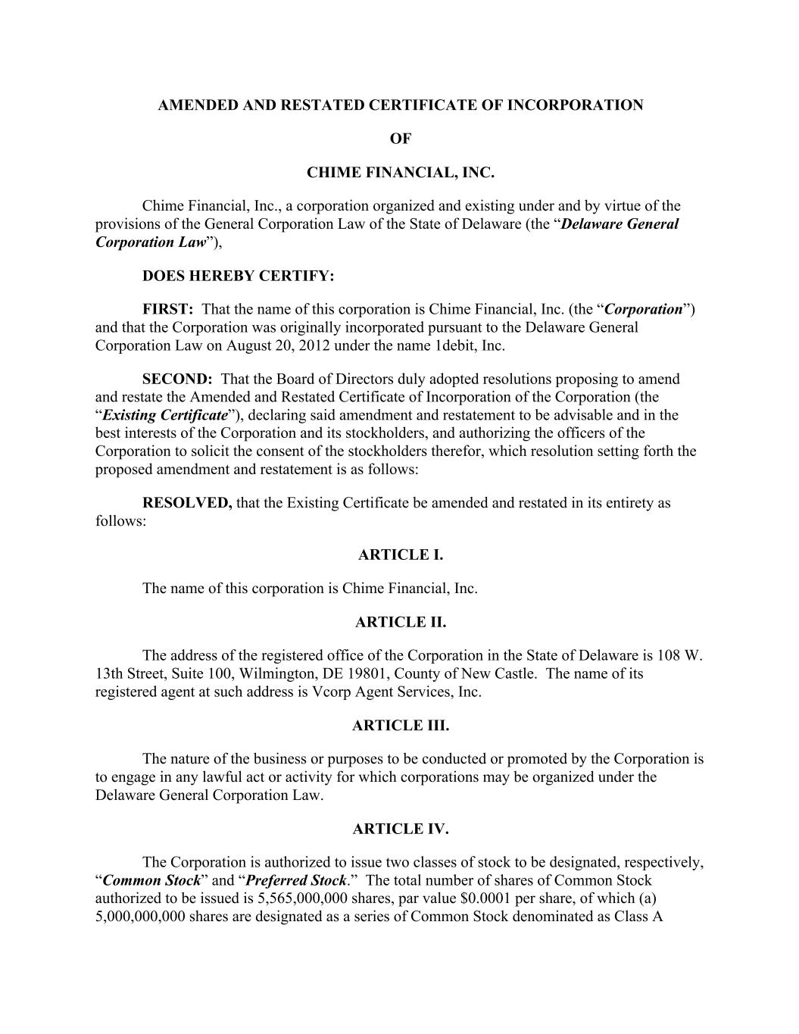

AMENDED AND RESTATED CERTIFICATE OF INCORPORATION OF CHIME FINANCIAL, INC. Chime Financial, Inc., a corporation organized and existing under and by virtue of the provisions of the General Corporation Law of the State of Delaware (the “Delaware General Corporation Law”), DOES HEREBY CERTIFY: FIRST: That the name of this corporation is Chime Financial, Inc. (the “Corporation”) and that the Corporation was originally incorporated pursuant to the Delaware General Corporation Law on August 20, 2012 under the name 1debit, Inc. SECOND: That the Board of Directors duly adopted resolutions proposing to amend and restate the Amended and Restated Certificate of Incorporation of the Corporation (the “Existing Certificate”), declaring said amendment and restatement to be advisable and in the best interests of the Corporation and its stockholders, and authorizing the officers of the Corporation to solicit the consent of the stockholders therefor, which resolution setting forth the proposed amendment and restatement is as follows: RESOLVED, that the Existing Certificate be amended and restated in its entirety as follows: ARTICLE I. The name of this corporation is Chime Financial, Inc. ARTICLE II. The address of the registered office of the Corporation in the State of Delaware is 108 W. 13th Street, Suite 100, Wilmington, DE 19801, County of New Castle. The name of its registered agent at such address is Vcorp Agent Services, Inc. ARTICLE III. The nature of the business or purposes to be conducted or promoted by the Corporation is to engage in any lawful act or activity for which corporations may be organized under the Delaware General Corporation Law. ARTICLE IV. The Corporation is authorized to issue two classes of stock to be designated, respectively, “Common Stock” and “Preferred Stock.” The total number of shares of Common Stock authorized to be issued is 5,565,000,000 shares, par value $0.0001 per share, of which (a) 5,000,000,000 shares are designated as a series of Common Stock denominated as Class A

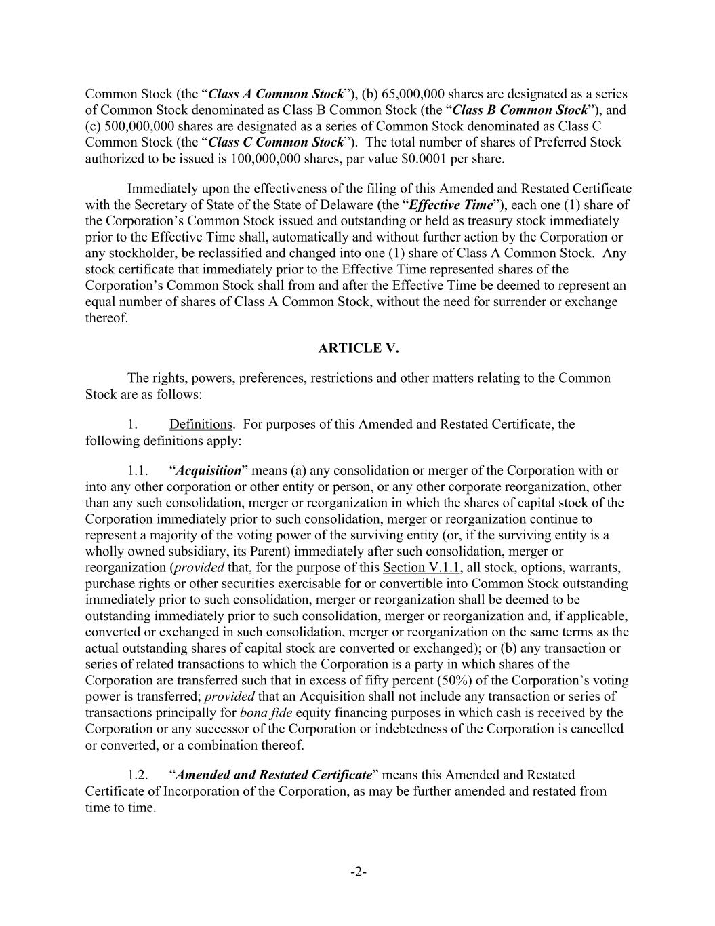
-2- Common Stock (the “Class A Common Stock”), (b) 65,000,000 shares are designated as a series of Common Stock denominated as Class B Common Stock (the “Class B Common Stock”), and (c) 500,000,000 shares are designated as a series of Common Stock denominated as Class C Common Stock (the “Class C Common Stock”). The total number of shares of Preferred Stock authorized to be issued is 100,000,000 shares, par value $0.0001 per share. Immediately upon the effectiveness of the filing of this Amended and Restated Certificate with the Secretary of State of the State of Delaware (the “Effective Time”), each one (1) share of the Corporation’s Common Stock issued and outstanding or held as treasury stock immediately prior to the Effective Time shall, automatically and without further action by the Corporation or any stockholder, be reclassified and changed into one (1) share of Class A Common Stock. Any stock certificate that immediately prior to the Effective Time represented shares of the Corporation’s Common Stock shall from and after the Effective Time be deemed to represent an equal number of shares of Class A Common Stock, without the need for surrender or exchange thereof. ARTICLE V. The rights, powers, preferences, restrictions and other matters relating to the Common Stock are as follows: 1. Definitions. For purposes of this Amended and Restated Certificate, the following definitions apply: 1.1. “Acquisition” means (a) any consolidation or merger of the Corporation with or into any other corporation or other entity or person, or any other corporate reorganization, other than any such consolidation, merger or reorganization in which the shares of capital stock of the Corporation immediately prior to such consolidation, merger or reorganization continue to represent a majority of the voting power of the surviving entity (or, if the surviving entity is a wholly owned subsidiary, its Parent) immediately after such consolidation, merger or reorganization (provided that, for the purpose of this Section V.1.1, all stock, options, warrants, purchase rights or other securities exercisable for or convertible into Common Stock outstanding immediately prior to such consolidation, merger or reorganization shall be deemed to be outstanding immediately prior to such consolidation, merger or reorganization and, if applicable, converted or exchanged in such consolidation, merger or reorganization on the same terms as the actual outstanding shares of capital stock are converted or exchanged); or (b) any transaction or series of related transactions to which the Corporation is a party in which shares of the Corporation are transferred such that in excess of fifty percent (50%) of the Corporation’s voting power is transferred; provided that an Acquisition shall not include any transaction or series of transactions principally for bona fide equity financing purposes in which cash is received by the Corporation or any successor of the Corporation or indebtedness of the Corporation is cancelled or converted, or a combination thereof. 1.2. “Amended and Restated Certificate” means this Amended and Restated Certificate of Incorporation of the Corporation, as may be further amended and restated from time to time.

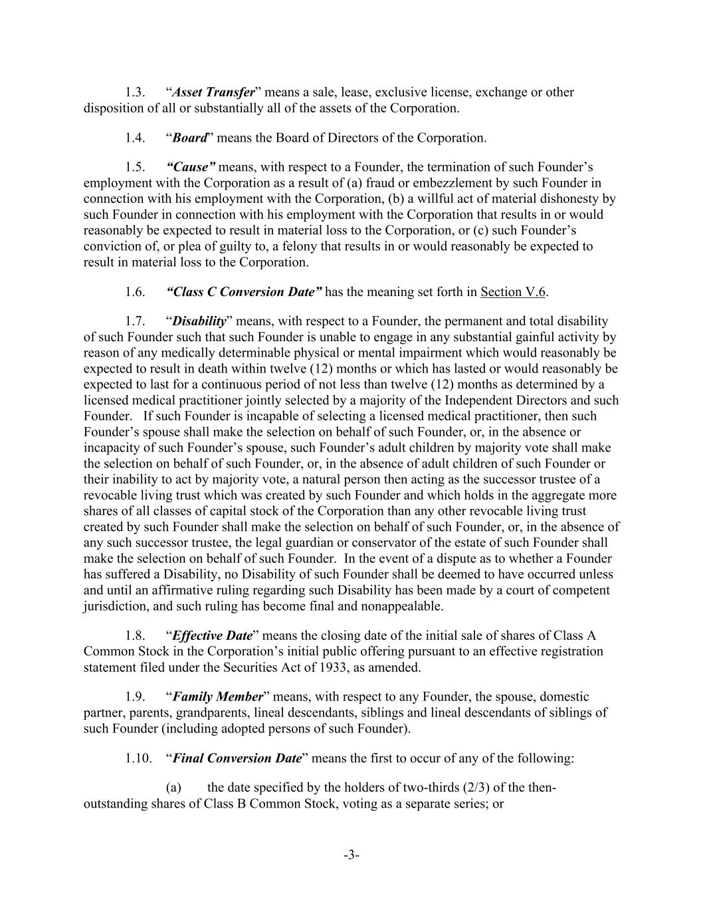
-3- 1.3. “Asset Transfer” means a sale, lease, exclusive license, exchange or other disposition of all or substantially all of the assets of the Corporation. 1.4. “Board” means the Board of Directors of the Corporation. 1.5. “Cause” means, with respect to a Founder, the termination of such Founder’s employment with the Corporation as a result of (a) fraud or embezzlement by such Founder in connection with his employment with the Corporation, (b) a willful act of material dishonesty by such Founder in connection with his employment with the Corporation that results in or would reasonably be expected to result in material loss to the Corporation, or (c) such Founder’s conviction of, or plea of guilty to, a felony that results in or would reasonably be expected to result in material loss to the Corporation. 1.6. “Class C Conversion Date” has the meaning set forth in Section V.6. 1.7. “Disability” means, with respect to a Founder, the permanent and total disability of such Founder such that such Founder is unable to engage in any substantial gainful activity by reason of any medically determinable physical or mental impairment which would reasonably be expected to result in death within twelve (12) months or which has lasted or would reasonably be expected to last for a continuous period of not less than twelve (12) months as determined by a licensed medical practitioner jointly selected by a majority of the Independent Directors and such Founder. If such Founder is incapable of selecting a licensed medical practitioner, then such Founder’s spouse shall make the selection on behalf of such Founder, or, in the absence or incapacity of such Founder’s spouse, such Founder’s adult children by majority vote shall make the selection on behalf of such Founder, or, in the absence of adult children of such Founder or their inability to act by majority vote, a natural person then acting as the successor trustee of a revocable living trust which was created by such Founder and which holds in the aggregate more shares of all classes of capital stock of the Corporation than any other revocable living trust created by such Founder shall make the selection on behalf of such Founder, or, in the absence of any such successor trustee, the legal guardian or conservator of the estate of such Founder shall make the selection on behalf of such Founder. In the event of a dispute as to whether a Founder has suffered a Disability, no Disability of such Founder shall be deemed to have occurred unless and until an affirmative ruling regarding such Disability has been made by a court of competent jurisdiction, and such ruling has become final and nonappealable. 1.8. “Effective Date” means the closing date of the initial sale of shares of Class A Common Stock in the Corporation’s initial public offering pursuant to an effective registration statement filed under the Securities Act of 1933, as amended. 1.9. “Family Member” means, with respect to any Founder, the spouse, domestic partner, parents, grandparents, lineal descendants, siblings and lineal descendants of siblings of such Founder (including adopted persons of such Founder). 1.10. “Final Conversion Date” means the first to occur of any of the following: (a) the date specified by the holders of two-thirds (2/3) of the then- outstanding shares of Class B Common Stock, voting as a separate series; or

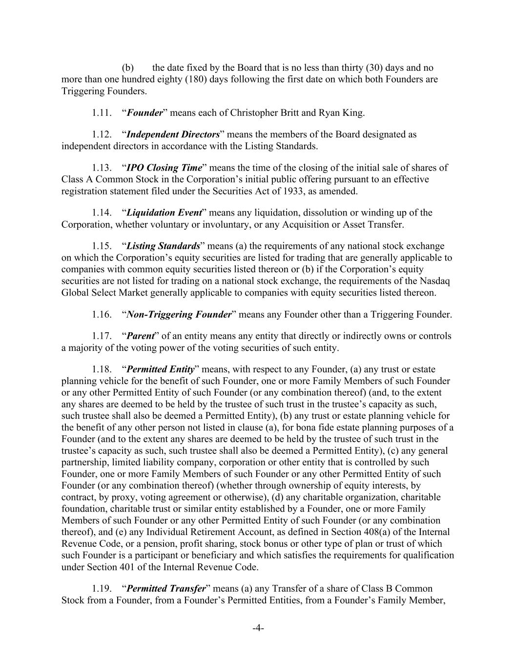
-4- (b) the date fixed by the Board that is no less than thirty (30) days and no more than one hundred eighty (180) days following the first date on which both Founders are Triggering Founders. 1.11. “Founder” means each of Christopher Britt and Ryan King. 1.12. “Independent Directors” means the members of the Board designated as independent directors in accordance with the Listing Standards. 1.13. “IPO Closing Time” means the time of the closing of the initial sale of shares of Class A Common Stock in the Corporation’s initial public offering pursuant to an effective registration statement filed under the Securities Act of 1933, as amended. 1.14. “Liquidation Event” means any liquidation, dissolution or winding up of the Corporation, whether voluntary or involuntary, or any Acquisition or Asset Transfer. 1.15. “Listing Standards” means (a) the requirements of any national stock exchange on which the Corporation’s equity securities are listed for trading that are generally applicable to companies with common equity securities listed thereon or (b) if the Corporation’s equity securities are not listed for trading on a national stock exchange, the requirements of the Nasdaq Global Select Market generally applicable to companies with equity securities listed thereon. 1.16. “Non-Triggering Founder” means any Founder other than a Triggering Founder. 1.17. “Parent” of an entity means any entity that directly or indirectly owns or controls a majority of the voting power of the voting securities of such entity. 1.18. “Permitted Entity” means, with respect to any Founder, (a) any trust or estate planning vehicle for the benefit of such Founder, one or more Family Members of such Founder or any other Permitted Entity of such Founder (or any combination thereof) (and, to the extent any shares are deemed to be held by the trustee of such trust in the trustee’s capacity as such, such trustee shall also be deemed a Permitted Entity), (b) any trust or estate planning vehicle for the benefit of any other person not listed in clause (a), for bona fide estate planning purposes of a Founder (and to the extent any shares are deemed to be held by the trustee of such trust in the trustee’s capacity as such, such trustee shall also be deemed a Permitted Entity), (c) any general partnership, limited liability company, corporation or other entity that is controlled by such Founder, one or more Family Members of such Founder or any other Permitted Entity of such Founder (or any combination thereof) (whether through ownership of equity interests, by contract, by proxy, voting agreement or otherwise), (d) any charitable organization, charitable foundation, charitable trust or similar entity established by a Founder, one or more Family Members of such Founder or any other Permitted Entity of such Founder (or any combination thereof), and (e) any Individual Retirement Account, as defined in Section 408(a) of the Internal Revenue Code, or a pension, profit sharing, stock bonus or other type of plan or trust of which such Founder is a participant or beneficiary and which satisfies the requirements for qualification under Section 401 of the Internal Revenue Code. 1.19. “Permitted Transfer” means (a) any Transfer of a share of Class B Common Stock from a Founder, from a Founder’s Permitted Entities, from a Founder’s Family Member,

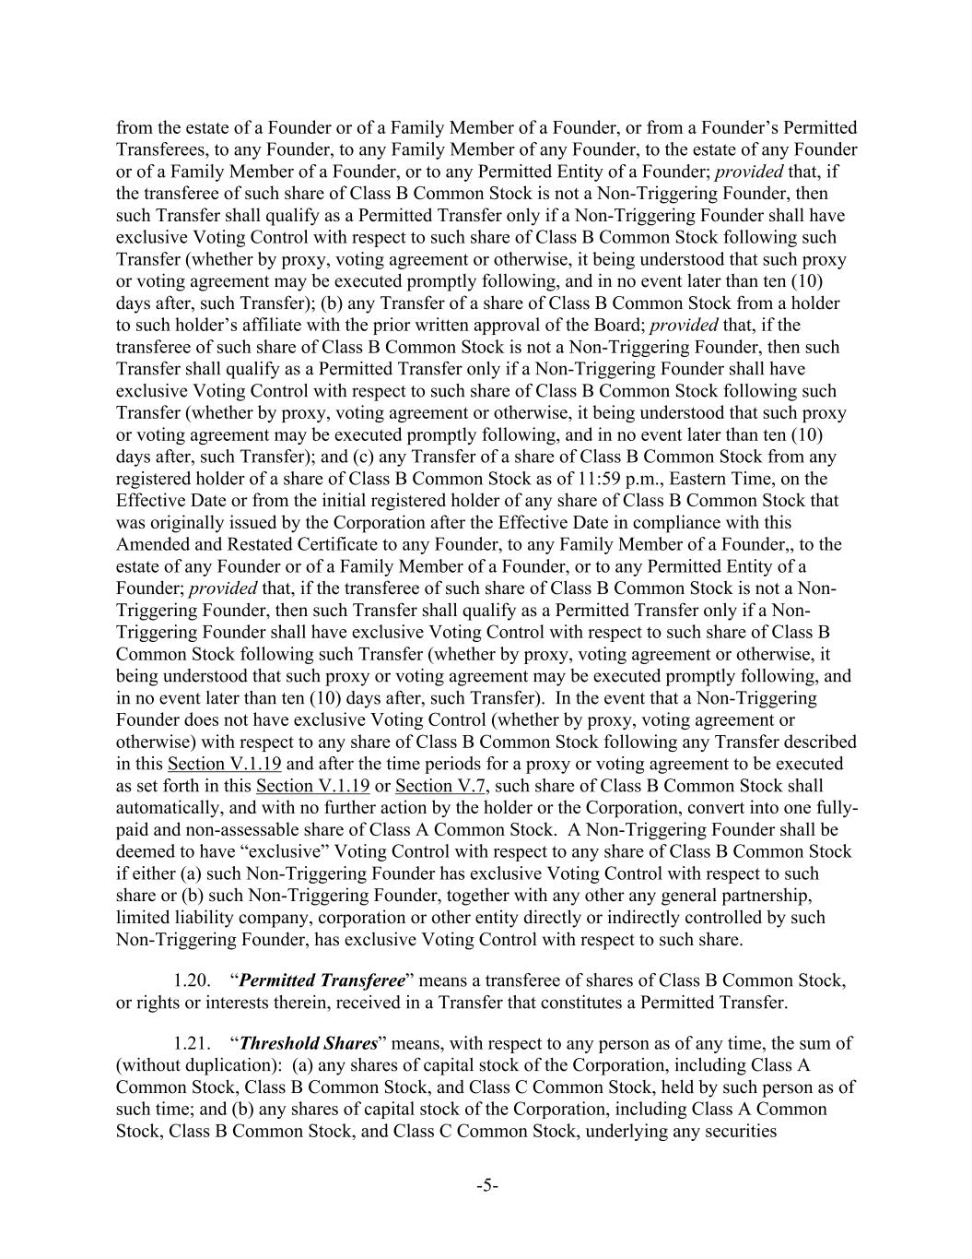
-5- from the estate of a Founder or of a Family Member of a Founder, or from a Founder’s Permitted Transferees, to any Founder, to any Family Member of any Founder, to the estate of any Founder or of a Family Member of a Founder, or to any Permitted Entity of a Founder; provided that, if the transferee of such share of Class B Common Stock is not a Non-Triggering Founder, then such Transfer shall qualify as a Permitted Transfer only if a Non-Triggering Founder shall have exclusive Voting Control with respect to such share of Class B Common Stock following such Transfer (whether by proxy, voting agreement or otherwise, it being understood that such proxy or voting agreement may be executed promptly following, and in no event later than ten (10) days after, such Transfer); (b) any Transfer of a share of Class B Common Stock from a holder to such holder’s affiliate with the prior written approval of the Board; provided that, if the transferee of such share of Class B Common Stock is not a Non-Triggering Founder, then such Transfer shall qualify as a Permitted Transfer only if a Non-Triggering Founder shall have exclusive Voting Control with respect to such share of Class B Common Stock following such Transfer (whether by proxy, voting agreement or otherwise, it being understood that such proxy or voting agreement may be executed promptly following, and in no event later than ten (10) days after, such Transfer); and (c) any Transfer of a share of Class B Common Stock from any registered holder of a share of Class B Common Stock as of 11:59 p.m., Eastern Time, on the Effective Date or from the initial registered holder of any share of Class B Common Stock that was originally issued by the Corporation after the Effective Date in compliance with this Amended and Restated Certificate to any Founder, to any Family Member of a Founder,, to the estate of any Founder or of a Family Member of a Founder, or to any Permitted Entity of a Founder; provided that, if the transferee of such share of Class B Common Stock is not a Non- Triggering Founder, then such Transfer shall qualify as a Permitted Transfer only if a Non- Triggering Founder shall have exclusive Voting Control with respect to such share of Class B Common Stock following such Transfer (whether by proxy, voting agreement or otherwise, it being understood that such proxy or voting agreement may be executed promptly following, and in no event later than ten (10) days after, such Transfer). In the event that a Non-Triggering Founder does not have exclusive Voting Control (whether by proxy, voting agreement or otherwise) with respect to any share of Class B Common Stock following any Transfer described in this Section V.1.19 and after the time periods for a proxy or voting agreement to be executed as set forth in this Section V.1.19 or Section V.7, such share of Class B Common Stock shall automatically, and with no further action by the holder or the Corporation, convert into one fully- paid and non-assessable share of Class A Common Stock. A Non-Triggering Founder shall be deemed to have “exclusive” Voting Control with respect to any share of Class B Common Stock if either (a) such Non-Triggering Founder has exclusive Voting Control with respect to such share or (b) such Non-Triggering Founder, together with any other any general partnership, limited liability company, corporation or other entity directly or indirectly controlled by such Non-Triggering Founder, has exclusive Voting Control with respect to such share. 1.20. “Permitted Transferee” means a transferee of shares of Class B Common Stock, or rights or interests therein, received in a Transfer that constitutes a Permitted Transfer. 1.21. “Threshold Shares” means, with respect to any person as of any time, the sum of (without duplication): (a) any shares of capital stock of the Corporation, including Class A Common Stock, Class B Common Stock, and Class C Common Stock, held by such person as of such time; and (b) any shares of capital stock of the Corporation, including Class A Common Stock, Class B Common Stock, and Class C Common Stock, underlying any securities

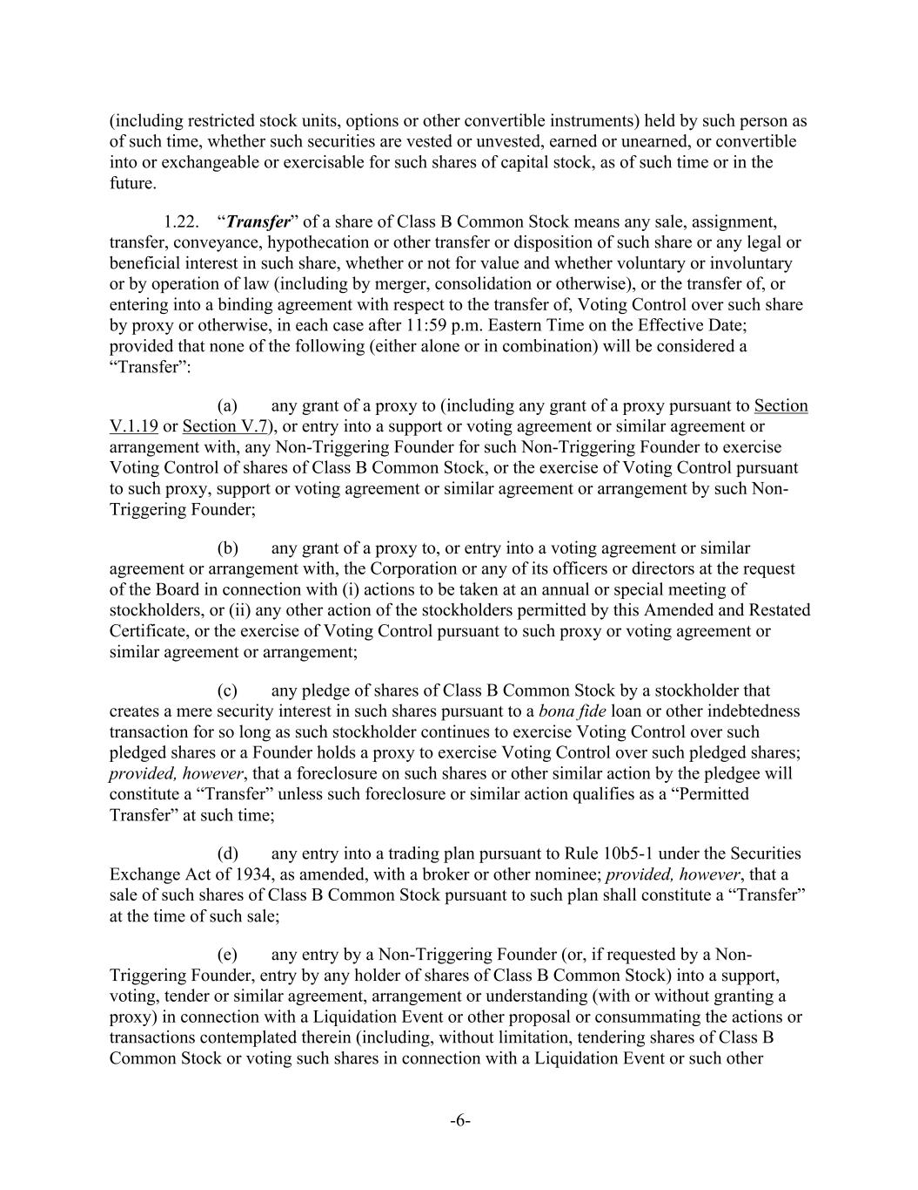
-6- (including restricted stock units, options or other convertible instruments) held by such person as of such time, whether such securities are vested or unvested, earned or unearned, or convertible into or exchangeable or exercisable for such shares of capital stock, as of such time or in the future. 1.22. “Transfer” of a share of Class B Common Stock means any sale, assignment, transfer, conveyance, hypothecation or other transfer or disposition of such share or any legal or beneficial interest in such share, whether or not for value and whether voluntary or involuntary or by operation of law (including by merger, consolidation or otherwise), or the transfer of, or entering into a binding agreement with respect to the transfer of, Voting Control over such share by proxy or otherwise, in each case after 11:59 p.m. Eastern Time on the Effective Date; provided that none of the following (either alone or in combination) will be considered a “Transfer”: (a) any grant of a proxy to (including any grant of a proxy pursuant to Section V.1.19 or Section V.7), or entry into a support or voting agreement or similar agreement or arrangement with, any Non-Triggering Founder for such Non-Triggering Founder to exercise Voting Control of shares of Class B Common Stock, or the exercise of Voting Control pursuant to such proxy, support or voting agreement or similar agreement or arrangement by such Non- Triggering Founder; (b) any grant of a proxy to, or entry into a voting agreement or similar agreement or arrangement with, the Corporation or any of its officers or directors at the request of the Board in connection with (i) actions to be taken at an annual or special meeting of stockholders, or (ii) any other action of the stockholders permitted by this Amended and Restated Certificate, or the exercise of Voting Control pursuant to such proxy or voting agreement or similar agreement or arrangement; (c) any pledge of shares of Class B Common Stock by a stockholder that creates a mere security interest in such shares pursuant to a bona fide loan or other indebtedness transaction for so long as such stockholder continues to exercise Voting Control over such pledged shares or a Founder holds a proxy to exercise Voting Control over such pledged shares; provided, however, that a foreclosure on such shares or other similar action by the pledgee will constitute a “Transfer” unless such foreclosure or similar action qualifies as a “Permitted Transfer” at such time; (d) any entry into a trading plan pursuant to Rule 10b5-1 under the Securities Exchange Act of 1934, as amended, with a broker or other nominee; provided, however, that a sale of such shares of Class B Common Stock pursuant to such plan shall constitute a “Transfer” at the time of such sale; (e) any entry by a Non-Triggering Founder (or, if requested by a Non- Triggering Founder, entry by any holder of shares of Class B Common Stock) into a support, voting, tender or similar agreement, arrangement or understanding (with or without granting a proxy) in connection with a Liquidation Event or other proposal or consummating the actions or transactions contemplated therein (including, without limitation, tendering shares of Class B Common Stock or voting such shares in connection with a Liquidation Event or such other

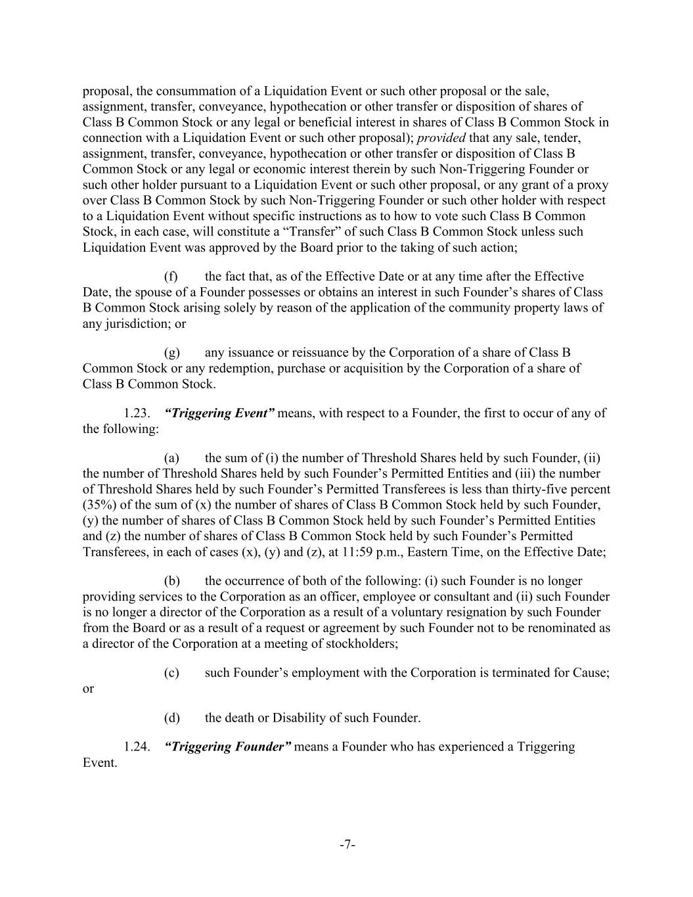
-7- proposal, the consummation of a Liquidation Event or such other proposal or the sale, assignment, transfer, conveyance, hypothecation or other transfer or disposition of shares of Class B Common Stock or any legal or beneficial interest in shares of Class B Common Stock in connection with a Liquidation Event or such other proposal); provided that any sale, tender, assignment, transfer, conveyance, hypothecation or other transfer or disposition of Class B Common Stock or any legal or economic interest therein by such Non-Triggering Founder or such other holder pursuant to a Liquidation Event or such other proposal, or any grant of a proxy over Class B Common Stock by such Non-Triggering Founder or such other holder with respect to a Liquidation Event without specific instructions as to how to vote such Class B Common Stock, in each case, will constitute a “Transfer” of such Class B Common Stock unless such Liquidation Event was approved by the Board prior to the taking of such action; (f) the fact that, as of the Effective Date or at any time after the Effective Date, the spouse of a Founder possesses or obtains an interest in such Founder’s shares of Class B Common Stock arising solely by reason of the application of the community property laws of any jurisdiction; or (g) any issuance or reissuance by the Corporation of a share of Class B Common Stock or any redemption, purchase or acquisition by the Corporation of a share of Class B Common Stock. 1.23. “Triggering Event” means, with respect to a Founder, the first to occur of any of the following: (a) the sum of (i) the number of Threshold Shares held by such Founder, (ii) the number of Threshold Shares held by such Founder’s Permitted Entities and (iii) the number of Threshold Shares held by such Founder’s Permitted Transferees is less than thirty-five percent (35%) of the sum of (x) the number of shares of Class B Common Stock held by such Founder, (y) the number of shares of Class B Common Stock held by such Founder’s Permitted Entities and (z) the number of shares of Class B Common Stock held by such Founder’s Permitted Transferees, in each of cases (x), (y) and (z), at 11:59 p.m., Eastern Time, on the Effective Date; (b) the occurrence of both of the following: (i) such Founder is no longer providing services to the Corporation as an officer, employee or consultant and (ii) such Founder is no longer a director of the Corporation as a result of a voluntary resignation by such Founder from the Board or as a result of a request or agreement by such Founder not to be renominated as a director of the Corporation at a meeting of stockholders; (c) such Founder’s employment with the Corporation is terminated for Cause; or (d) the death or Disability of such Founder. 1.24. “Triggering Founder” means a Founder who has experienced a Triggering Event.

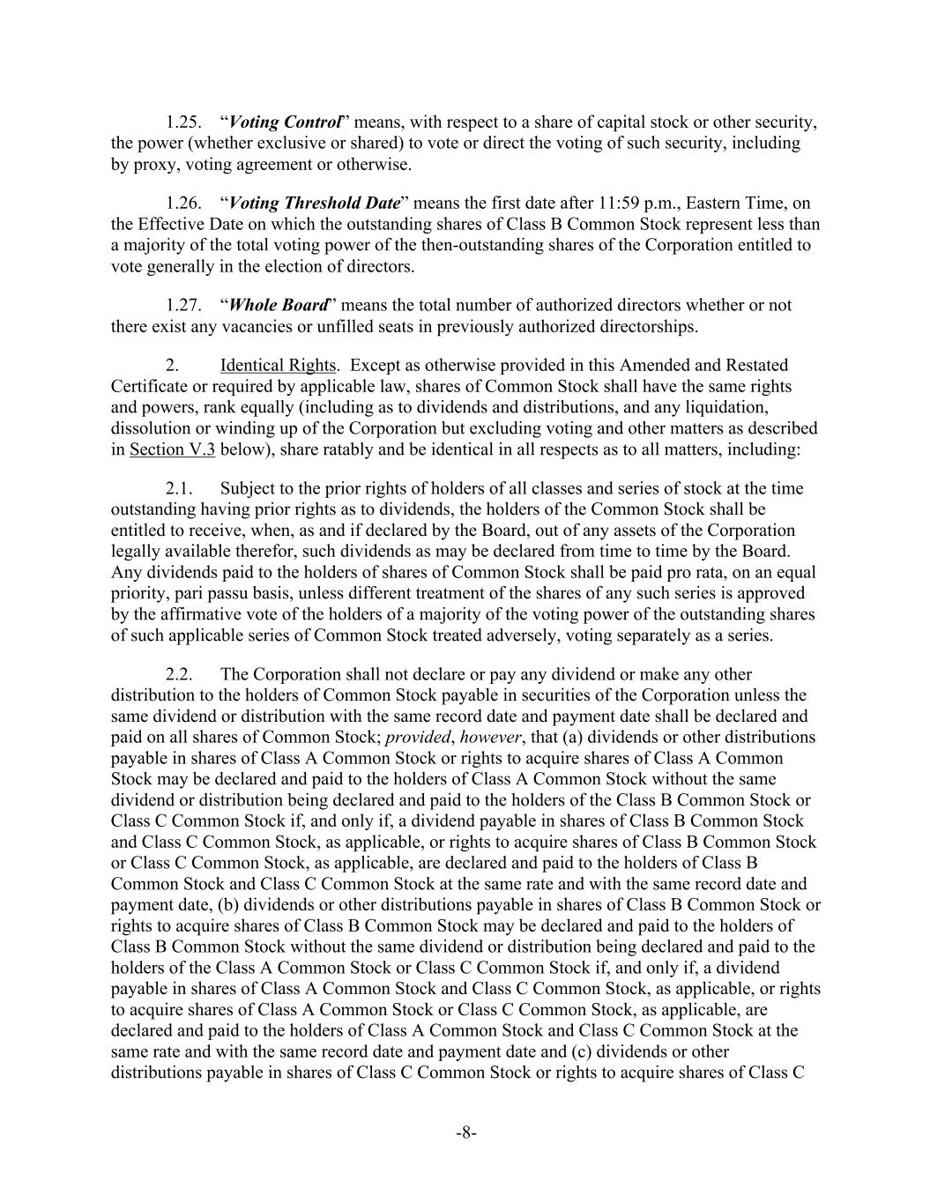
-8- 1.25. “Voting Control” means, with respect to a share of capital stock or other security, the power (whether exclusive or shared) to vote or direct the voting of such security, including by proxy, voting agreement or otherwise. 1.26. “Voting Threshold Date” means the first date after 11:59 p.m., Eastern Time, on the Effective Date on which the outstanding shares of Class B Common Stock represent less than a majority of the total voting power of the then-outstanding shares of the Corporation entitled to vote generally in the election of directors. 1.27. “Whole Board” means the total number of authorized directors whether or not there exist any vacancies or unfilled seats in previously authorized directorships. 2. Identical Rights. Except as otherwise provided in this Amended and Restated Certificate or required by applicable law, shares of Common Stock shall have the same rights and powers, rank equally (including as to dividends and distributions, and any liquidation, dissolution or winding up of the Corporation but excluding voting and other matters as described in Section V.3 below), share ratably and be identical in all respects as to all matters, including: 2.1. Subject to the prior rights of holders of all classes and series of stock at the time outstanding having prior rights as to dividends, the holders of the Common Stock shall be entitled to receive, when, as and if declared by the Board, out of any assets of the Corporation legally available therefor, such dividends as may be declared from time to time by the Board. Any dividends paid to the holders of shares of Common Stock shall be paid pro rata, on an equal priority, pari passu basis, unless different treatment of the shares of any such series is approved by the affirmative vote of the holders of a majority of the voting power of the outstanding shares of such applicable series of Common Stock treated adversely, voting separately as a series. 2.2. The Corporation shall not declare or pay any dividend or make any other distribution to the holders of Common Stock payable in securities of the Corporation unless the same dividend or distribution with the same record date and payment date shall be declared and paid on all shares of Common Stock; provided, however, that (a) dividends or other distributions payable in shares of Class A Common Stock or rights to acquire shares of Class A Common Stock may be declared and paid to the holders of Class A Common Stock without the same dividend or distribution being declared and paid to the holders of the Class B Common Stock or Class C Common Stock if, and only if, a dividend payable in shares of Class B Common Stock and Class C Common Stock, as applicable, or rights to acquire shares of Class B Common Stock or Class C Common Stock, as applicable, are declared and paid to the holders of Class B Common Stock and Class C Common Stock at the same rate and with the same record date and payment date, (b) dividends or other distributions payable in shares of Class B Common Stock or rights to acquire shares of Class B Common Stock may be declared and paid to the holders of Class B Common Stock without the same dividend or distribution being declared and paid to the holders of the Class A Common Stock or Class C Common Stock if, and only if, a dividend payable in shares of Class A Common Stock and Class C Common Stock, as applicable, or rights to acquire shares of Class A Common Stock or Class C Common Stock, as applicable, are declared and paid to the holders of Class A Common Stock and Class C Common Stock at the same rate and with the same record date and payment date and (c) dividends or other distributions payable in shares of Class C Common Stock or rights to acquire shares of Class C

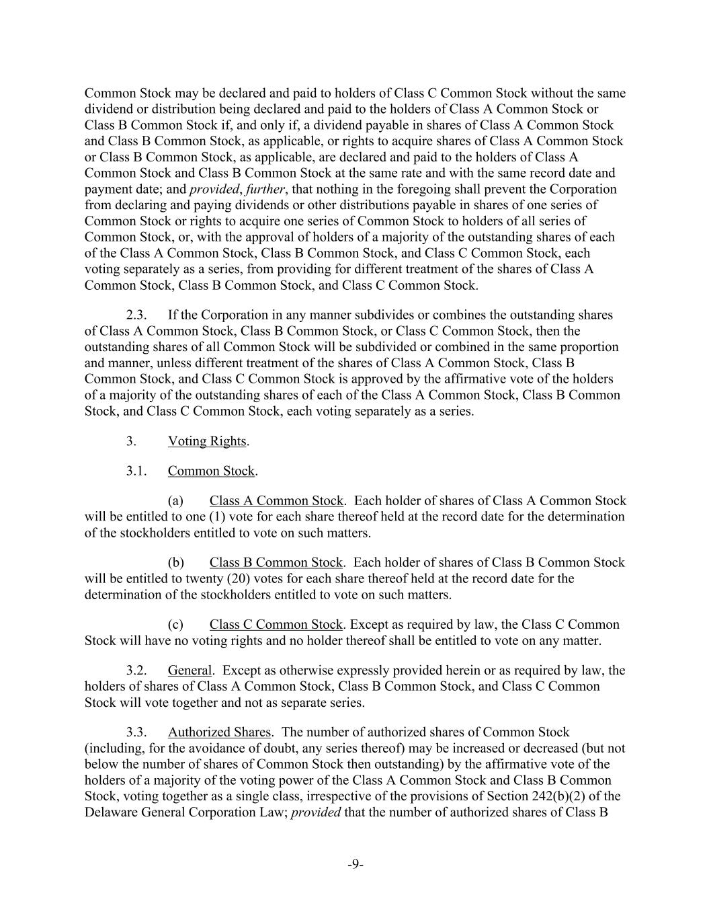
-9- Common Stock may be declared and paid to holders of Class C Common Stock without the same dividend or distribution being declared and paid to the holders of Class A Common Stock or Class B Common Stock if, and only if, a dividend payable in shares of Class A Common Stock and Class B Common Stock, as applicable, or rights to acquire shares of Class A Common Stock or Class B Common Stock, as applicable, are declared and paid to the holders of Class A Common Stock and Class B Common Stock at the same rate and with the same record date and payment date; and provided, further, that nothing in the foregoing shall prevent the Corporation from declaring and paying dividends or other distributions payable in shares of one series of Common Stock or rights to acquire one series of Common Stock to holders of all series of Common Stock, or, with the approval of holders of a majority of the outstanding shares of each of the Class A Common Stock, Class B Common Stock, and Class C Common Stock, each voting separately as a series, from providing for different treatment of the shares of Class A Common Stock, Class B Common Stock, and Class C Common Stock. 2.3. If the Corporation in any manner subdivides or combines the outstanding shares of Class A Common Stock, Class B Common Stock, or Class C Common Stock, then the outstanding shares of all Common Stock will be subdivided or combined in the same proportion and manner, unless different treatment of the shares of Class A Common Stock, Class B Common Stock, and Class C Common Stock is approved by the affirmative vote of the holders of a majority of the outstanding shares of each of the Class A Common Stock, Class B Common Stock, and Class C Common Stock, each voting separately as a series. 3. Voting Rights. 3.1. Common Stock. (a) Class A Common Stock. Each holder of shares of Class A Common Stock will be entitled to one (1) vote for each share thereof held at the record date for the determination of the stockholders entitled to vote on such matters. (b) Class B Common Stock. Each holder of shares of Class B Common Stock will be entitled to twenty (20) votes for each share thereof held at the record date for the determination of the stockholders entitled to vote on such matters. (c) Class C Common Stock. Except as required by law, the Class C Common Stock will have no voting rights and no holder thereof shall be entitled to vote on any matter. 3.2. General. Except as otherwise expressly provided herein or as required by law, the holders of shares of Class A Common Stock, Class B Common Stock, and Class C Common Stock will vote together and not as separate series. 3.3. Authorized Shares. The number of authorized shares of Common Stock (including, for the avoidance of doubt, any series thereof) may be increased or decreased (but not below the number of shares of Common Stock then outstanding) by the affirmative vote of the holders of a majority of the voting power of the Class A Common Stock and Class B Common Stock, voting together as a single class, irrespective of the provisions of Section 242(b)(2) of the Delaware General Corporation Law; provided that the number of authorized shares of Class B

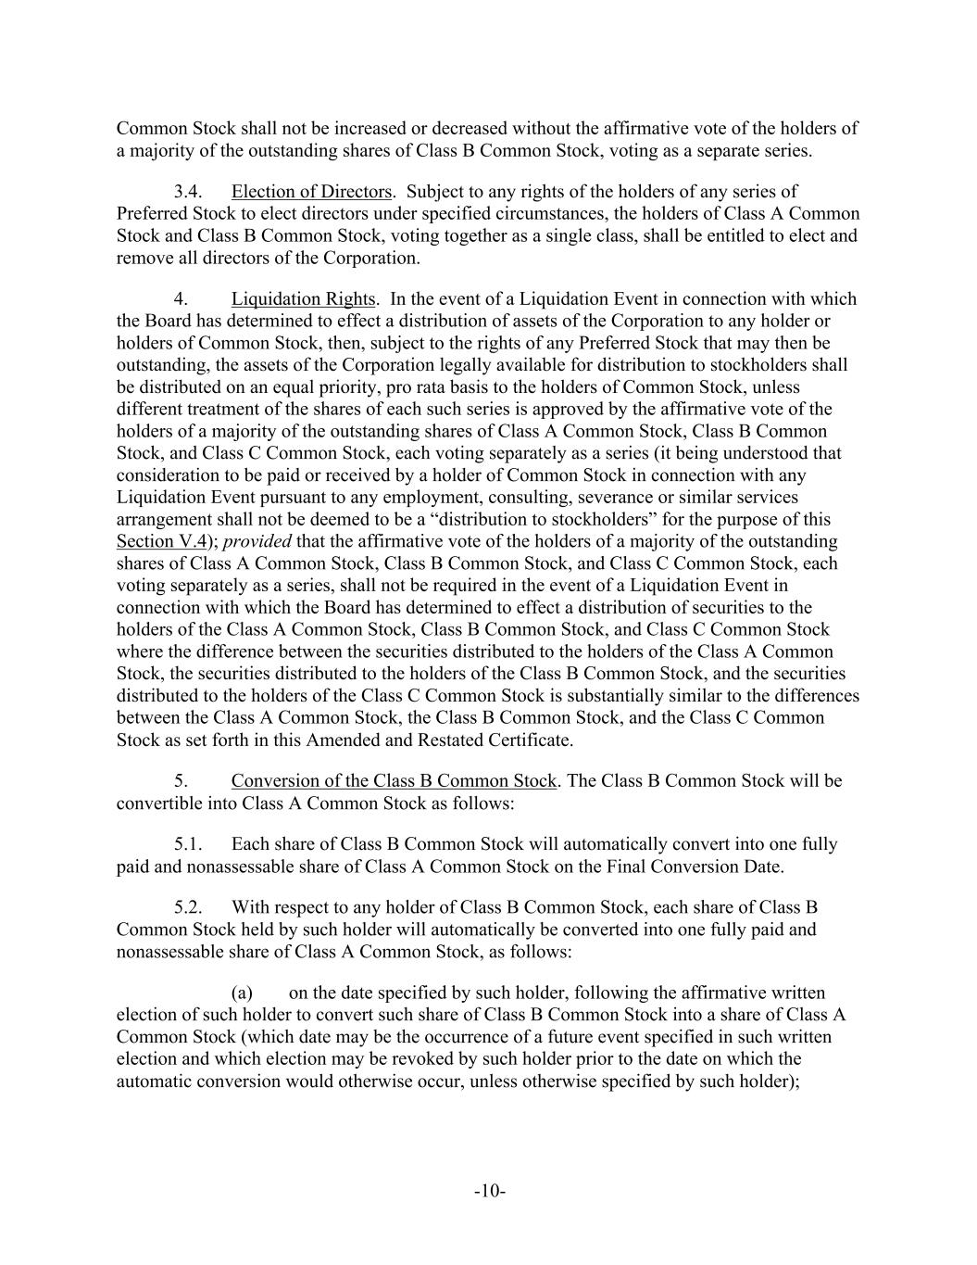
-10- Common Stock shall not be increased or decreased without the affirmative vote of the holders of a majority of the outstanding shares of Class B Common Stock, voting as a separate series. 3.4. Election of Directors. Subject to any rights of the holders of any series of Preferred Stock to elect directors under specified circumstances, the holders of Class A Common Stock and Class B Common Stock, voting together as a single class, shall be entitled to elect and remove all directors of the Corporation. 4. Liquidation Rights. In the event of a Liquidation Event in connection with which the Board has determined to effect a distribution of assets of the Corporation to any holder or holders of Common Stock, then, subject to the rights of any Preferred Stock that may then be outstanding, the assets of the Corporation legally available for distribution to stockholders shall be distributed on an equal priority, pro rata basis to the holders of Common Stock, unless different treatment of the shares of each such series is approved by the affirmative vote of the holders of a majority of the outstanding shares of Class A Common Stock, Class B Common Stock, and Class C Common Stock, each voting separately as a series (it being understood that consideration to be paid or received by a holder of Common Stock in connection with any Liquidation Event pursuant to any employment, consulting, severance or similar services arrangement shall not be deemed to be a “distribution to stockholders” for the purpose of this Section V.4); provided that the affirmative vote of the holders of a majority of the outstanding shares of Class A Common Stock, Class B Common Stock, and Class C Common Stock, each voting separately as a series, shall not be required in the event of a Liquidation Event in connection with which the Board has determined to effect a distribution of securities to the holders of the Class A Common Stock, Class B Common Stock, and Class C Common Stock where the difference between the securities distributed to the holders of the Class A Common Stock, the securities distributed to the holders of the Class B Common Stock, and the securities distributed to the holders of the Class C Common Stock is substantially similar to the differences between the Class A Common Stock, the Class B Common Stock, and the Class C Common Stock as set forth in this Amended and Restated Certificate. 5. Conversion of the Class B Common Stock. The Class B Common Stock will be convertible into Class A Common Stock as follows: 5.1. Each share of Class B Common Stock will automatically convert into one fully paid and nonassessable share of Class A Common Stock on the Final Conversion Date. 5.2. With respect to any holder of Class B Common Stock, each share of Class B Common Stock held by such holder will automatically be converted into one fully paid and nonassessable share of Class A Common Stock, as follows: (a) on the date specified by such holder, following the affirmative written election of such holder to convert such share of Class B Common Stock into a share of Class A Common Stock (which date may be the occurrence of a future event specified in such written election and which election may be revoked by such holder prior to the date on which the automatic conversion would otherwise occur, unless otherwise specified by such holder);

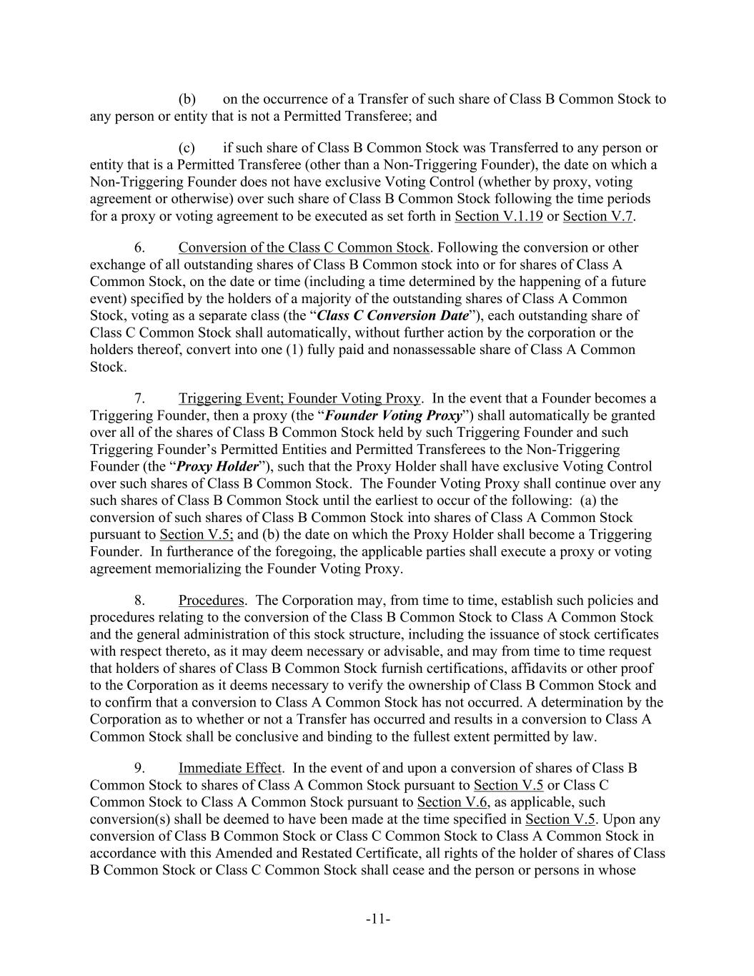
-11- (b) on the occurrence of a Transfer of such share of Class B Common Stock to any person or entity that is not a Permitted Transferee; and (c) if such share of Class B Common Stock was Transferred to any person or entity that is a Permitted Transferee (other than a Non-Triggering Founder), the date on which a Non-Triggering Founder does not have exclusive Voting Control (whether by proxy, voting agreement or otherwise) over such share of Class B Common Stock following the time periods for a proxy or voting agreement to be executed as set forth in Section V.1.19 or Section V.7. 6. Conversion of the Class C Common Stock. Following the conversion or other exchange of all outstanding shares of Class B Common stock into or for shares of Class A Common Stock, on the date or time (including a time determined by the happening of a future event) specified by the holders of a majority of the outstanding shares of Class A Common Stock, voting as a separate class (the “Class C Conversion Date”), each outstanding share of Class C Common Stock shall automatically, without further action by the corporation or the holders thereof, convert into one (1) fully paid and nonassessable share of Class A Common Stock. 7. Triggering Event; Founder Voting Proxy. In the event that a Founder becomes a Triggering Founder, then a proxy (the “Founder Voting Proxy”) shall automatically be granted over all of the shares of Class B Common Stock held by such Triggering Founder and such Triggering Founder’s Permitted Entities and Permitted Transferees to the Non-Triggering Founder (the “Proxy Holder”), such that the Proxy Holder shall have exclusive Voting Control over such shares of Class B Common Stock. The Founder Voting Proxy shall continue over any such shares of Class B Common Stock until the earliest to occur of the following: (a) the conversion of such shares of Class B Common Stock into shares of Class A Common Stock pursuant to Section V.5; and (b) the date on which the Proxy Holder shall become a Triggering Founder. In furtherance of the foregoing, the applicable parties shall execute a proxy or voting agreement memorializing the Founder Voting Proxy. 8. Procedures. The Corporation may, from time to time, establish such policies and procedures relating to the conversion of the Class B Common Stock to Class A Common Stock and the general administration of this stock structure, including the issuance of stock certificates with respect thereto, as it may deem necessary or advisable, and may from time to time request that holders of shares of Class B Common Stock furnish certifications, affidavits or other proof to the Corporation as it deems necessary to verify the ownership of Class B Common Stock and to confirm that a conversion to Class A Common Stock has not occurred. A determination by the Corporation as to whether or not a Transfer has occurred and results in a conversion to Class A Common Stock shall be conclusive and binding to the fullest extent permitted by law. 9. Immediate Effect. In the event of and upon a conversion of shares of Class B Common Stock to shares of Class A Common Stock pursuant to Section V.5 or Class C Common Stock to Class A Common Stock pursuant to Section V.6, as applicable, such conversion(s) shall be deemed to have been made at the time specified in Section V.5. Upon any conversion of Class B Common Stock or Class C Common Stock to Class A Common Stock in accordance with this Amended and Restated Certificate, all rights of the holder of shares of Class B Common Stock or Class C Common Stock shall cease and the person or persons in whose

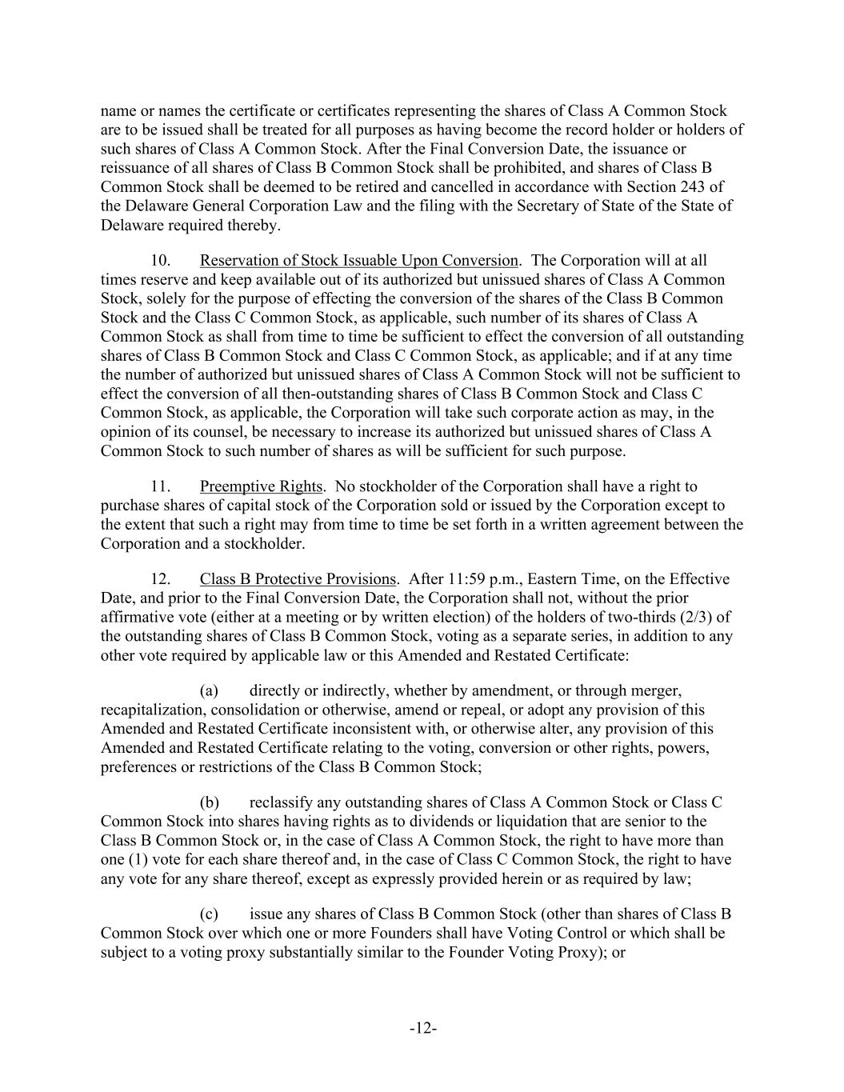
-12- name or names the certificate or certificates representing the shares of Class A Common Stock are to be issued shall be treated for all purposes as having become the record holder or holders of such shares of Class A Common Stock. After the Final Conversion Date, the issuance or reissuance of all shares of Class B Common Stock shall be prohibited, and shares of Class B Common Stock shall be deemed to be retired and cancelled in accordance with Section 243 of the Delaware General Corporation Law and the filing with the Secretary of State of the State of Delaware required thereby. 10. Reservation of Stock Issuable Upon Conversion. The Corporation will at all times reserve and keep available out of its authorized but unissued shares of Class A Common Stock, solely for the purpose of effecting the conversion of the shares of the Class B Common Stock and the Class C Common Stock, as applicable, such number of its shares of Class A Common Stock as shall from time to time be sufficient to effect the conversion of all outstanding shares of Class B Common Stock and Class C Common Stock, as applicable; and if at any time the number of authorized but unissued shares of Class A Common Stock will not be sufficient to effect the conversion of all then-outstanding shares of Class B Common Stock and Class C Common Stock, as applicable, the Corporation will take such corporate action as may, in the opinion of its counsel, be necessary to increase its authorized but unissued shares of Class A Common Stock to such number of shares as will be sufficient for such purpose. 11. Preemptive Rights. No stockholder of the Corporation shall have a right to purchase shares of capital stock of the Corporation sold or issued by the Corporation except to the extent that such a right may from time to time be set forth in a written agreement between the Corporation and a stockholder. 12. Class B Protective Provisions. After 11:59 p.m., Eastern Time, on the Effective Date, and prior to the Final Conversion Date, the Corporation shall not, without the prior affirmative vote (either at a meeting or by written election) of the holders of two-thirds (2/3) of the outstanding shares of Class B Common Stock, voting as a separate series, in addition to any other vote required by applicable law or this Amended and Restated Certificate: (a) directly or indirectly, whether by amendment, or through merger, recapitalization, consolidation or otherwise, amend or repeal, or adopt any provision of this Amended and Restated Certificate inconsistent with, or otherwise alter, any provision of this Amended and Restated Certificate relating to the voting, conversion or other rights, powers, preferences or restrictions of the Class B Common Stock; (b) reclassify any outstanding shares of Class A Common Stock or Class C Common Stock into shares having rights as to dividends or liquidation that are senior to the Class B Common Stock or, in the case of Class A Common Stock, the right to have more than one (1) vote for each share thereof and, in the case of Class C Common Stock, the right to have any vote for any share thereof, except as expressly provided herein or as required by law; (c) issue any shares of Class B Common Stock (other than shares of Class B Common Stock over which one or more Founders shall have Voting Control or which shall be subject to a voting proxy substantially similar to the Founder Voting Proxy); or

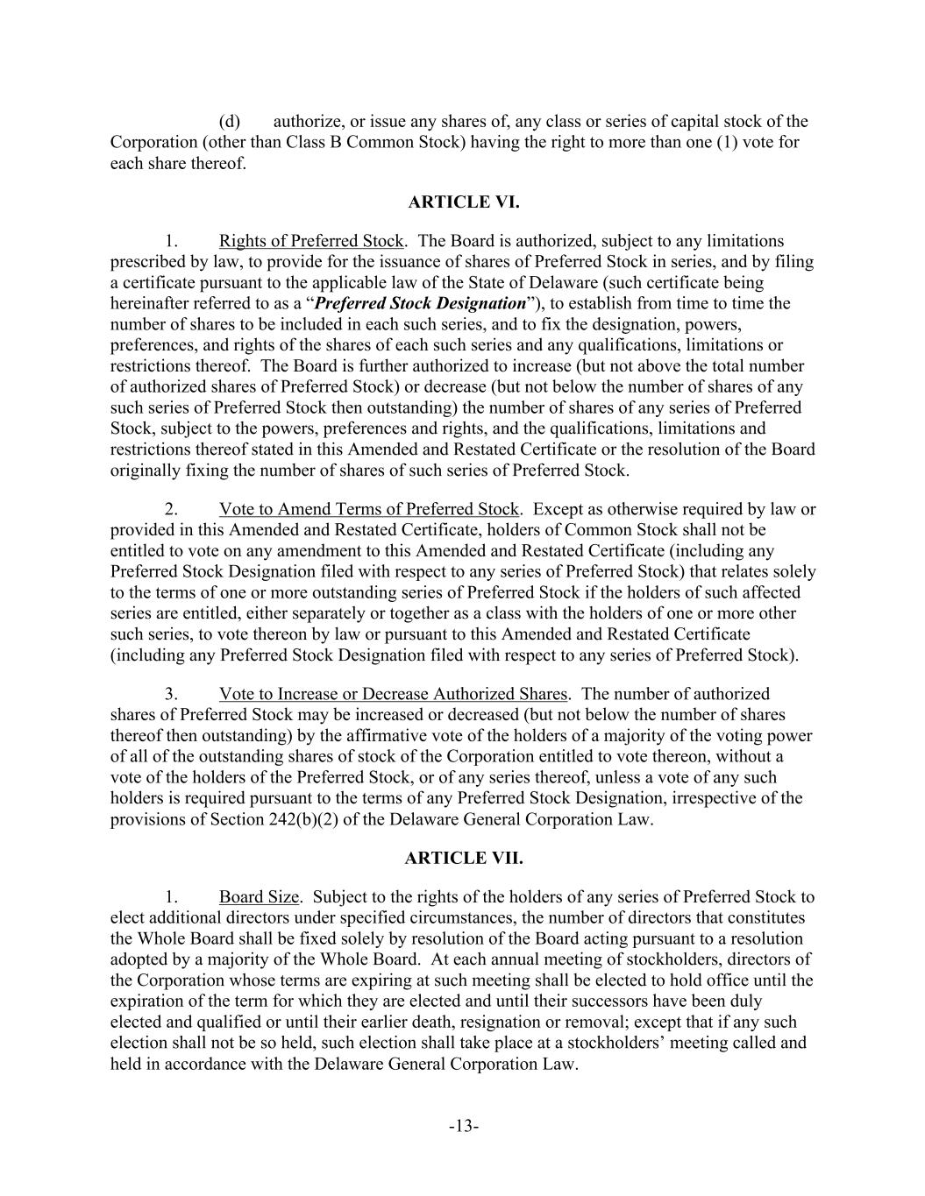
-13- (d) authorize, or issue any shares of, any class or series of capital stock of the Corporation (other than Class B Common Stock) having the right to more than one (1) vote for each share thereof. ARTICLE VI. 1. Rights of Preferred Stock. The Board is authorized, subject to any limitations prescribed by law, to provide for the issuance of shares of Preferred Stock in series, and by filing a certificate pursuant to the applicable law of the State of Delaware (such certificate being hereinafter referred to as a “Preferred Stock Designation”), to establish from time to time the number of shares to be included in each such series, and to fix the designation, powers, preferences, and rights of the shares of each such series and any qualifications, limitations or restrictions thereof. The Board is further authorized to increase (but not above the total number of authorized shares of Preferred Stock) or decrease (but not below the number of shares of any such series of Preferred Stock then outstanding) the number of shares of any series of Preferred Stock, subject to the powers, preferences and rights, and the qualifications, limitations and restrictions thereof stated in this Amended and Restated Certificate or the resolution of the Board originally fixing the number of shares of such series of Preferred Stock. 2. Vote to Amend Terms of Preferred Stock. Except as otherwise required by law or provided in this Amended and Restated Certificate, holders of Common Stock shall not be entitled to vote on any amendment to this Amended and Restated Certificate (including any Preferred Stock Designation filed with respect to any series of Preferred Stock) that relates solely to the terms of one or more outstanding series of Preferred Stock if the holders of such affected series are entitled, either separately or together as a class with the holders of one or more other such series, to vote thereon by law or pursuant to this Amended and Restated Certificate (including any Preferred Stock Designation filed with respect to any series of Preferred Stock). 3. Vote to Increase or Decrease Authorized Shares. The number of authorized shares of Preferred Stock may be increased or decreased (but not below the number of shares thereof then outstanding) by the affirmative vote of the holders of a majority of the voting power of all of the outstanding shares of stock of the Corporation entitled to vote thereon, without a vote of the holders of the Preferred Stock, or of any series thereof, unless a vote of any such holders is required pursuant to the terms of any Preferred Stock Designation, irrespective of the provisions of Section 242(b)(2) of the Delaware General Corporation Law. ARTICLE VII. 1. Board Size. Subject to the rights of the holders of any series of Preferred Stock to elect additional directors under specified circumstances, the number of directors that constitutes the Whole Board shall be fixed solely by resolution of the Board acting pursuant to a resolution adopted by a majority of the Whole Board. At each annual meeting of stockholders, directors of the Corporation whose terms are expiring at such meeting shall be elected to hold office until the expiration of the term for which they are elected and until their successors have been duly elected and qualified or until their earlier death, resignation or removal; except that if any such election shall not be so held, such election shall take place at a stockholders’ meeting called and held in accordance with the Delaware General Corporation Law.

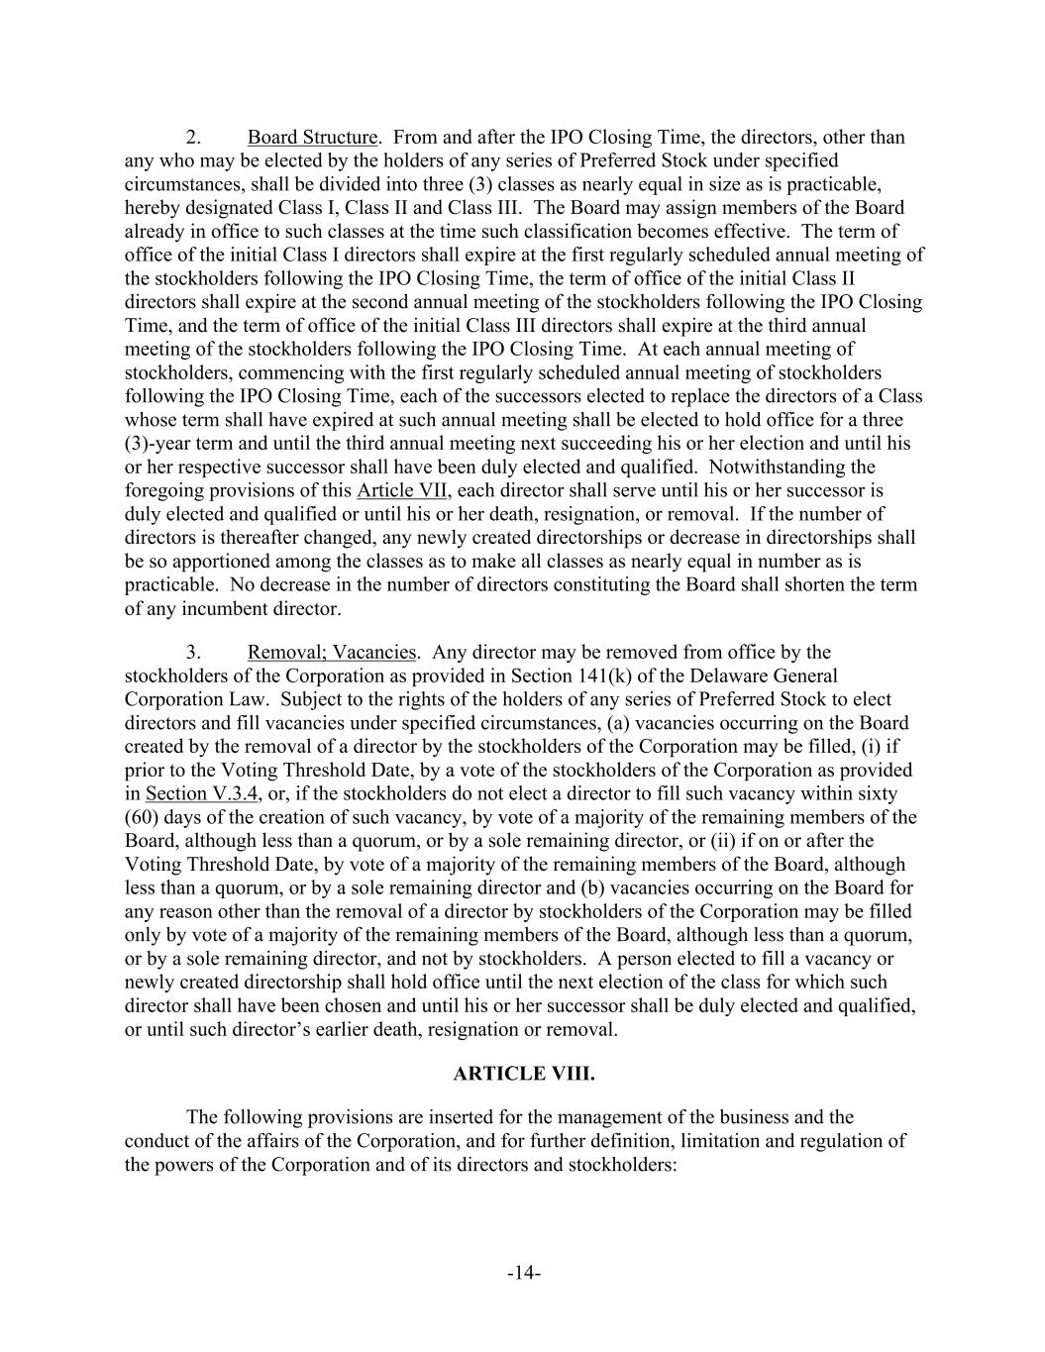
-14- 2. Board Structure. From and after the IPO Closing Time, the directors, other than any who may be elected by the holders of any series of Preferred Stock under specified circumstances, shall be divided into three (3) classes as nearly equal in size as is practicable, hereby designated Class I, Class II and Class III. The Board may assign members of the Board already in office to such classes at the time such classification becomes effective. The term of office of the initial Class I directors shall expire at the first regularly scheduled annual meeting of the stockholders following the IPO Closing Time, the term of office of the initial Class II directors shall expire at the second annual meeting of the stockholders following the IPO Closing Time, and the term of office of the initial Class III directors shall expire at the third annual meeting of the stockholders following the IPO Closing Time. At each annual meeting of stockholders, commencing with the first regularly scheduled annual meeting of stockholders following the IPO Closing Time, each of the successors elected to replace the directors of a Class whose term shall have expired at such annual meeting shall be elected to hold office for a three (3)-year term and until the third annual meeting next succeeding his or her election and until his or her respective successor shall have been duly elected and qualified. Notwithstanding the foregoing provisions of this Article VII, each director shall serve until his or her successor is duly elected and qualified or until his or her death, resignation, or removal. If the number of directors is thereafter changed, any newly created directorships or decrease in directorships shall be so apportioned among the classes as to make all classes as nearly equal in number as is practicable. No decrease in the number of directors constituting the Board shall shorten the term of any incumbent director. 3. Removal; Vacancies. Any director may be removed from office by the stockholders of the Corporation as provided in Section 141(k) of the Delaware General Corporation Law. Subject to the rights of the holders of any series of Preferred Stock to elect directors and fill vacancies under specified circumstances, (a) vacancies occurring on the Board created by the removal of a director by the stockholders of the Corporation may be filled, (i) if prior to the Voting Threshold Date, by a vote of the stockholders of the Corporation as provided in Section V.3.4, or, if the stockholders do not elect a director to fill such vacancy within sixty (60) days of the creation of such vacancy, by vote of a majority of the remaining members of the Board, although less than a quorum, or by a sole remaining director, or (ii) if on or after the Voting Threshold Date, by vote of a majority of the remaining members of the Board, although less than a quorum, or by a sole remaining director and (b) vacancies occurring on the Board for any reason other than the removal of a director by stockholders of the Corporation may be filled only by vote of a majority of the remaining members of the Board, although less than a quorum, or by a sole remaining director, and not by stockholders. A person elected to fill a vacancy or newly created directorship shall hold office until the next election of the class for which such director shall have been chosen and until his or her successor shall be duly elected and qualified, or until such director’s earlier death, resignation or removal. ARTICLE VIII. The following provisions are inserted for the management of the business and the conduct of the affairs of the Corporation, and for further definition, limitation and regulation of the powers of the Corporation and of its directors and stockholders:

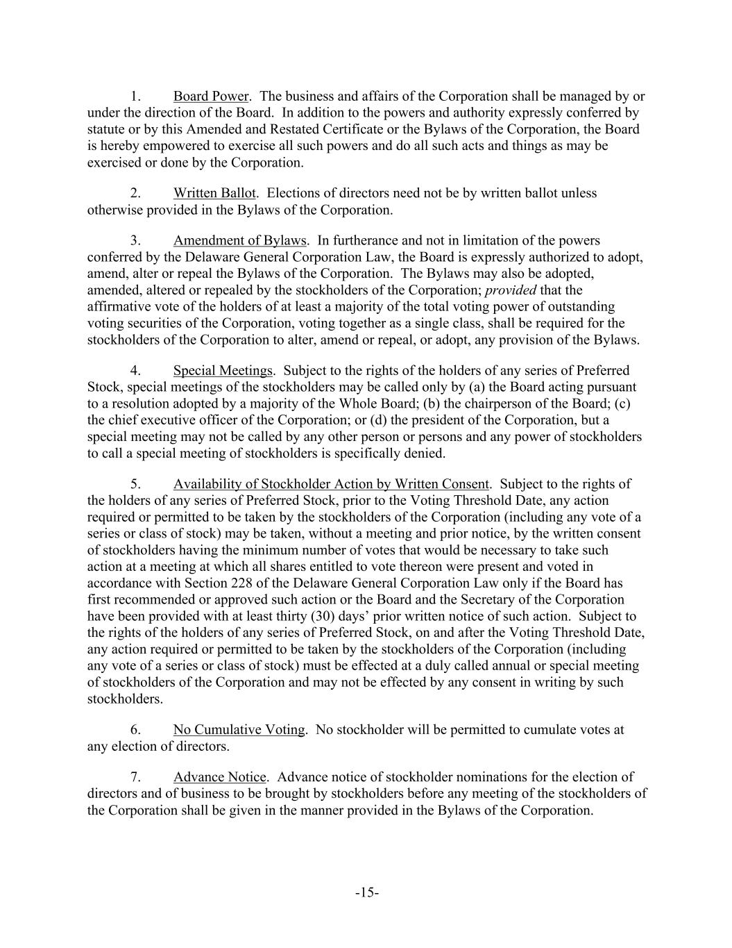
-15- 1. Board Power. The business and affairs of the Corporation shall be managed by or under the direction of the Board. In addition to the powers and authority expressly conferred by statute or by this Amended and Restated Certificate or the Bylaws of the Corporation, the Board is hereby empowered to exercise all such powers and do all such acts and things as may be exercised or done by the Corporation. 2. Written Ballot. Elections of directors need not be by written ballot unless otherwise provided in the Bylaws of the Corporation. 3. Amendment of Bylaws. In furtherance and not in limitation of the powers conferred by the Delaware General Corporation Law, the Board is expressly authorized to adopt, amend, alter or repeal the Bylaws of the Corporation. The Bylaws may also be adopted, amended, altered or repealed by the stockholders of the Corporation; provided that the affirmative vote of the holders of at least a majority of the total voting power of outstanding voting securities of the Corporation, voting together as a single class, shall be required for the stockholders of the Corporation to alter, amend or repeal, or adopt, any provision of the Bylaws. 4. Special Meetings. Subject to the rights of the holders of any series of Preferred Stock, special meetings of the stockholders may be called only by (a) the Board acting pursuant to a resolution adopted by a majority of the Whole Board; (b) the chairperson of the Board; (c) the chief executive officer of the Corporation; or (d) the president of the Corporation, but a special meeting may not be called by any other person or persons and any power of stockholders to call a special meeting of stockholders is specifically denied. 5. Availability of Stockholder Action by Written Consent. Subject to the rights of the holders of any series of Preferred Stock, prior to the Voting Threshold Date, any action required or permitted to be taken by the stockholders of the Corporation (including any vote of a series or class of stock) may be taken, without a meeting and prior notice, by the written consent of stockholders having the minimum number of votes that would be necessary to take such action at a meeting at which all shares entitled to vote thereon were present and voted in accordance with Section 228 of the Delaware General Corporation Law only if the Board has first recommended or approved such action or the Board and the Secretary of the Corporation have been provided with at least thirty (30) days’ prior written notice of such action. Subject to the rights of the holders of any series of Preferred Stock, on and after the Voting Threshold Date, any action required or permitted to be taken by the stockholders of the Corporation (including any vote of a series or class of stock) must be effected at a duly called annual or special meeting of stockholders of the Corporation and may not be effected by any consent in writing by such stockholders. 6. No Cumulative Voting. No stockholder will be permitted to cumulate votes at any election of directors. 7. Advance Notice. Advance notice of stockholder nominations for the election of directors and of business to be brought by stockholders before any meeting of the stockholders of the Corporation shall be given in the manner provided in the Bylaws of the Corporation.

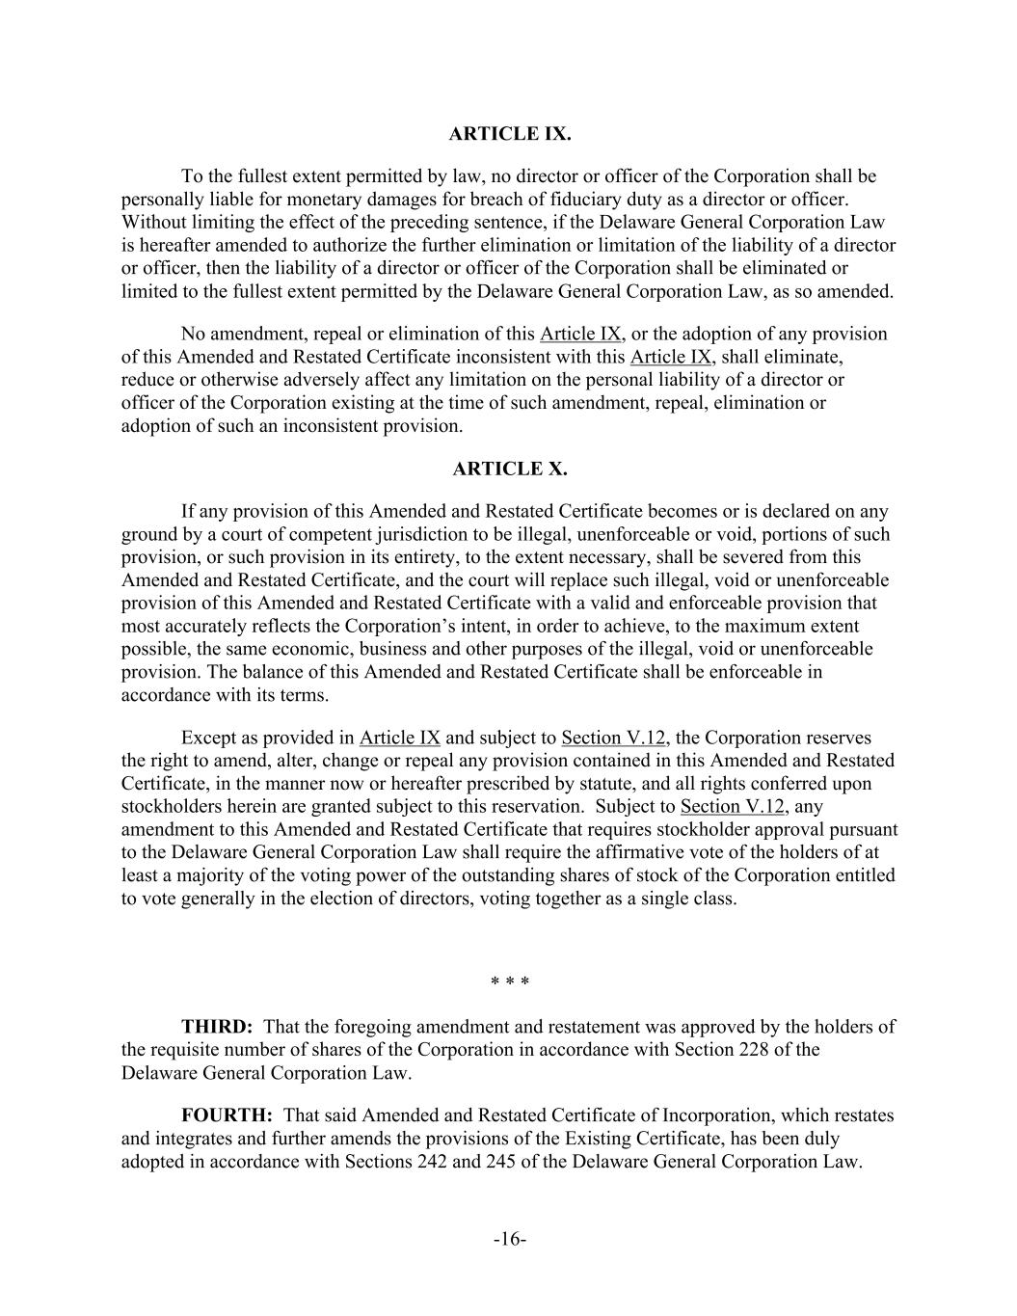
-16- ARTICLE IX. To the fullest extent permitted by law, no director or officer of the Corporation shall be personally liable for monetary damages for breach of fiduciary duty as a director or officer. Without limiting the effect of the preceding sentence, if the Delaware General Corporation Law is hereafter amended to authorize the further elimination or limitation of the liability of a director or officer, then the liability of a director or officer of the Corporation shall be eliminated or limited to the fullest extent permitted by the Delaware General Corporation Law, as so amended. No amendment, repeal or elimination of this Article IX, or the adoption of any provision of this Amended and Restated Certificate inconsistent with this Article IX, shall eliminate, reduce or otherwise adversely affect any limitation on the personal liability of a director or officer of the Corporation existing at the time of such amendment, repeal, elimination or adoption of such an inconsistent provision. ARTICLE X. If any provision of this Amended and Restated Certificate becomes or is declared on any ground by a court of competent jurisdiction to be illegal, unenforceable or void, portions of such provision, or such provision in its entirety, to the extent necessary, shall be severed from this Amended and Restated Certificate, and the court will replace such illegal, void or unenforceable provision of this Amended and Restated Certificate with a valid and enforceable provision that most accurately reflects the Corporation’s intent, in order to achieve, to the maximum extent possible, the same economic, business and other purposes of the illegal, void or unenforceable provision. The balance of this Amended and Restated Certificate shall be enforceable in accordance with its terms. Except as provided in Article IX and subject to Section V.12, the Corporation reserves the right to amend, alter, change or repeal any provision contained in this Amended and Restated Certificate, in the manner now or hereafter prescribed by statute, and all rights conferred upon stockholders herein are granted subject to this reservation. Subject to Section V.12, any amendment to this Amended and Restated Certificate that requires stockholder approval pursuant to the Delaware General Corporation Law shall require the affirmative vote of the holders of at least a majority of the voting power of the outstanding shares of stock of the Corporation entitled to vote generally in the election of directors, voting together as a single class. * * * THIRD: That the foregoing amendment and restatement was approved by the holders of the requisite number of shares of the Corporation in accordance with Section 228 of the Delaware General Corporation Law. FOURTH: That said Amended and Restated Certificate of Incorporation, which restates and integrates and further amends the provisions of the Existing Certificate, has been duly adopted in accordance with Sections 242 and 245 of the Delaware General Corporation Law.


-17- IN WITNESS WHEREOF, this Amended and Restated Certificate of Incorporation has been duly executed by a duly authorized officer of the Corporation on this 13th day of June, 2025. /s/ Christopher Britt Christopher Britt, Chief Executive Officer

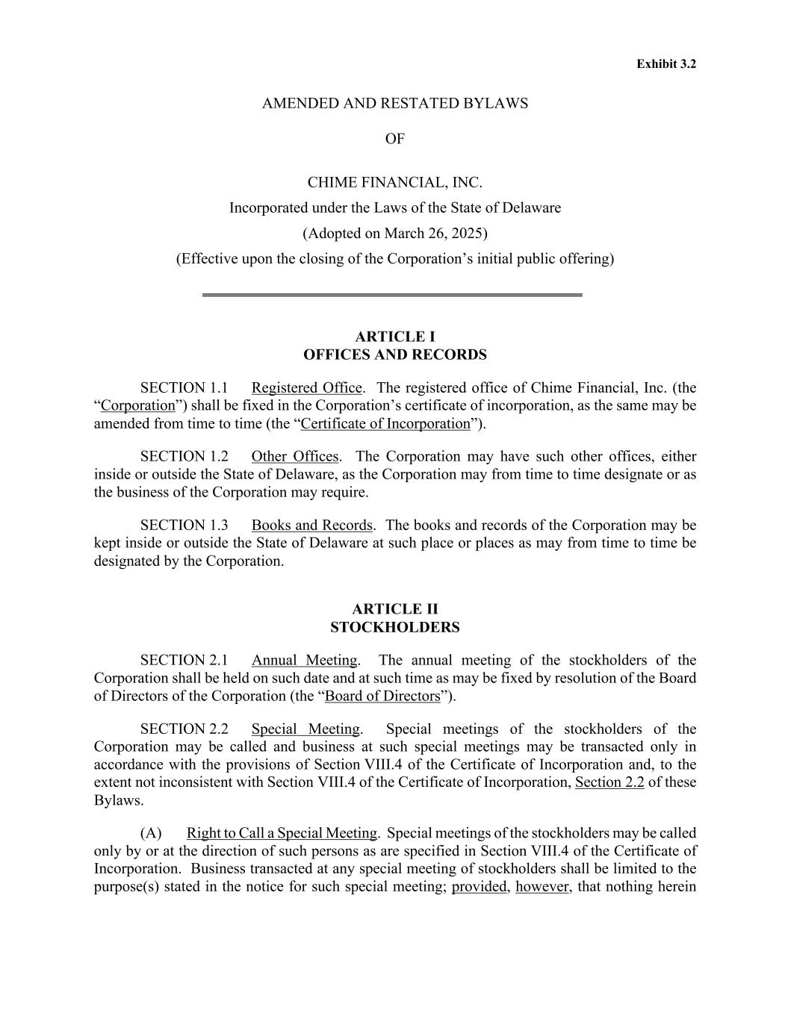
Exhibit 3.2 AMENDED AND RESTATED BYLAWS OF CHIME FINANCIAL, INC. Incorporated under the Laws of the State of Delaware (Adopted on March 26, 2025) (Effective upon the closing of the Corporation’s initial public offering) OFFICES AND RECORDS SECTION 1.1 Registered Office. The registered office of Chime Financial, Inc. (the “Corporation”) shall be fixed in the Corporation’s certificate of incorporation, as the same may be amended from time to time (the “Certificate of Incorporation”). SECTION 1.2 Other Offices. The Corporation may have such other offices, either inside or outside the State of Delaware, as the Corporation may from time to time designate or as the business of the Corporation may require. SECTION 1.3 Books and Records. The books and records of the Corporation may be kept inside or outside the State of Delaware at such place or places as may from time to time be designated by the Corporation. STOCKHOLDERS SECTION 2.1 Annual Meeting. The annual meeting of the stockholders of the Corporation shall be held on such date and at such time as may be fixed by resolution of the Board of Directors of the Corporation (the “Board of Directors”). SECTION 2.2 Special Meeting. Special meetings of the stockholders of the Corporation may be called and business at such special meetings may be transacted only in accordance with the provisions of Section VIII.4 of the Certificate of Incorporation and, to the extent not inconsistent with Section VIII.4 of the Certificate of Incorporation, Section 2.2 of these Bylaws. (A) Right to Call a Special Meeting. Special meetings of the stockholders may be called only by or at the direction of such persons as are specified in Section VIII.4 of the Certificate of Incorporation. Business transacted at any special meeting of stockholders shall be limited to the purpose(s) stated in the notice for such special meeting; provided, however, that nothing herein

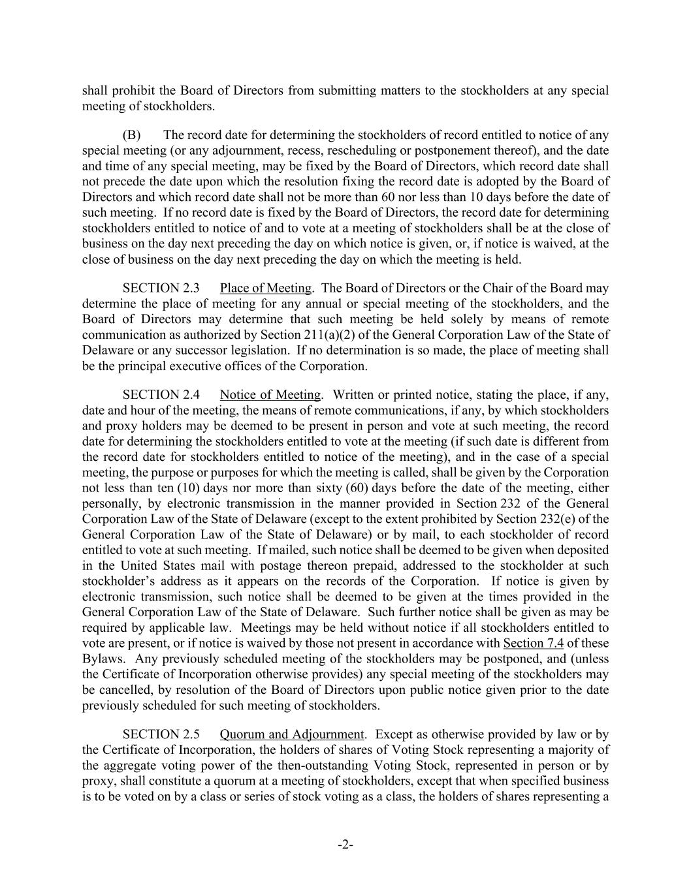
-2- shall prohibit the Board of Directors from submitting matters to the stockholders at any special meeting of stockholders. (B) The record date for determining the stockholders of record entitled to notice of any special meeting (or any adjournment, recess, rescheduling or postponement thereof), and the date and time of any special meeting, may be fixed by the Board of Directors, which record date shall not precede the date upon which the resolution fixing the record date is adopted by the Board of Directors and which record date shall not be more than 60 nor less than 10 days before the date of such meeting. If no record date is fixed by the Board of Directors, the record date for determining stockholders entitled to notice of and to vote at a meeting of stockholders shall be at the close of business on the day next preceding the day on which notice is given, or, if notice is waived, at the close of business on the day next preceding the day on which the meeting is held. SECTION 2.3 Place of Meeting. The Board of Directors or the Chair of the Board may determine the place of meeting for any annual or special meeting of the stockholders, and the Board of Directors may determine that such meeting be held solely by means of remote communication as authorized by Section 211(a)(2) of the General Corporation Law of the State of Delaware or any successor legislation. If no determination is so made, the place of meeting shall be the principal executive offices of the Corporation. SECTION 2.4 Notice of Meeting. Written or printed notice, stating the place, if any, date and hour of the meeting, the means of remote communications, if any, by which stockholders and proxy holders may be deemed to be present in person and vote at such meeting, the record date for determining the stockholders entitled to vote at the meeting (if such date is different from the record date for stockholders entitled to notice of the meeting), and in the case of a special meeting, the purpose or purposes for which the meeting is called, shall be given by the Corporation not less than ten (10) days nor more than sixty (60) days before the date of the meeting, either personally, by electronic transmission in the manner provided in Section 232 of the General Corporation Law of the State of Delaware (except to the extent prohibited by Section 232(e) of the General Corporation Law of the State of Delaware) or by mail, to each stockholder of record entitled to vote at such meeting. If mailed, such notice shall be deemed to be given when deposited in the United States mail with postage thereon prepaid, addressed to the stockholder at such stockholder’s address as it appears on the records of the Corporation. If notice is given by electronic transmission, such notice shall be deemed to be given at the times provided in the General Corporation Law of the State of Delaware. Such further notice shall be given as may be required by applicable law. Meetings may be held without notice if all stockholders entitled to vote are present, or if notice is waived by those not present in accordance with Section 7.4 of these Bylaws. Any previously scheduled meeting of the stockholders may be postponed, and (unless the Certificate of Incorporation otherwise provides) any special meeting of the stockholders may be cancelled, by resolution of the Board of Directors upon public notice given prior to the date previously scheduled for such meeting of stockholders. SECTION 2.5 Quorum and Adjournment. Except as otherwise provided by law or by the Certificate of Incorporation, the holders of shares of Voting Stock representing a majority of the aggregate voting power of the then-outstanding Voting Stock, represented in person or by proxy, shall constitute a quorum at a meeting of stockholders, except that when specified business is to be voted on by a class or series of stock voting as a class, the holders of shares representing a

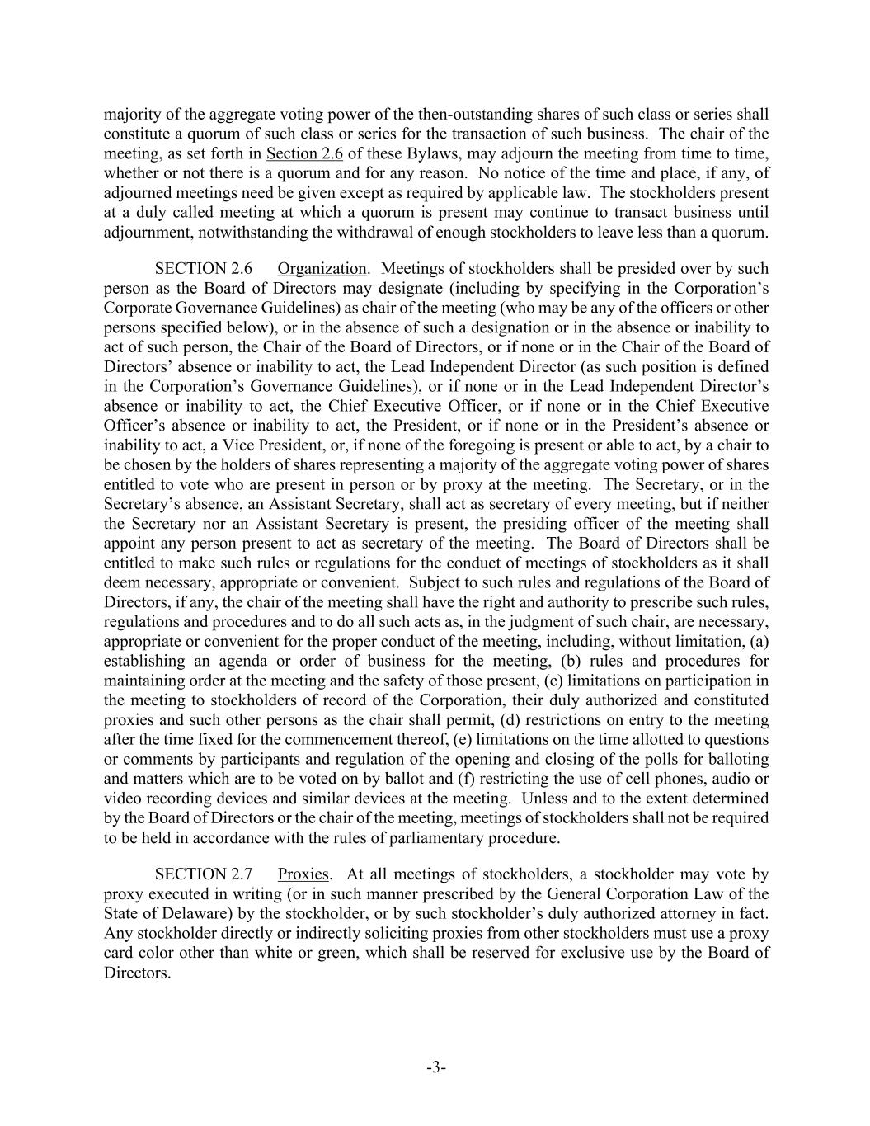
-3- majority of the aggregate voting power of the then-outstanding shares of such class or series shall constitute a quorum of such class or series for the transaction of such business. The chair of the meeting, as set forth in Section 2.6 of these Bylaws, may adjourn the meeting from time to time, whether or not there is a quorum and for any reason. No notice of the time and place, if any, of adjourned meetings need be given except as required by applicable law. The stockholders present at a duly called meeting at which a quorum is present may continue to transact business until adjournment, notwithstanding the withdrawal of enough stockholders to leave less than a quorum. SECTION 2.6 Organization. Meetings of stockholders shall be presided over by such person as the Board of Directors may designate (including by specifying in the Corporation’s Corporate Governance Guidelines) as chair of the meeting (who may be any of the officers or other persons specified below), or in the absence of such a designation or in the absence or inability to act of such person, the Chair of the Board of Directors, or if none or in the Chair of the Board of Directors’ absence or inability to act, the Lead Independent Director (as such position is defined in the Corporation’s Governance Guidelines), or if none or in the Lead Independent Director’s absence or inability to act, the Chief Executive Officer, or if none or in the Chief Executive Officer’s absence or inability to act, the President, or if none or in the President’s absence or inability to act, a Vice President, or, if none of the foregoing is present or able to act, by a chair to be chosen by the holders of shares representing a majority of the aggregate voting power of shares entitled to vote who are present in person or by proxy at the meeting. The Secretary, or in the Secretary’s absence, an Assistant Secretary, shall act as secretary of every meeting, but if neither the Secretary nor an Assistant Secretary is present, the presiding officer of the meeting shall appoint any person present to act as secretary of the meeting. The Board of Directors shall be entitled to make such rules or regulations for the conduct of meetings of stockholders as it shall deem necessary, appropriate or convenient. Subject to such rules and regulations of the Board of Directors, if any, the chair of the meeting shall have the right and authority to prescribe such rules, regulations and procedures and to do all such acts as, in the judgment of such chair, are necessary, appropriate or convenient for the proper conduct of the meeting, including, without limitation, (a) establishing an agenda or order of business for the meeting, (b) rules and procedures for maintaining order at the meeting and the safety of those present, (c) limitations on participation in the meeting to stockholders of record of the Corporation, their duly authorized and constituted proxies and such other persons as the chair shall permit, (d) restrictions on entry to the meeting after the time fixed for the commencement thereof, (e) limitations on the time allotted to questions or comments by participants and regulation of the opening and closing of the polls for balloting and matters which are to be voted on by ballot and (f) restricting the use of cell phones, audio or video recording devices and similar devices at the meeting. Unless and to the extent determined by the Board of Directors or the chair of the meeting, meetings of stockholders shall not be required to be held in accordance with the rules of parliamentary procedure. SECTION 2.7 Proxies. At all meetings of stockholders, a stockholder may vote by proxy executed in writing (or in such manner prescribed by the General Corporation Law of the State of Delaware) by the stockholder, or by such stockholder’s duly authorized attorney in fact. Any stockholder directly or indirectly soliciting proxies from other stockholders must use a proxy card color other than white or green, which shall be reserved for exclusive use by the Board of Directors.

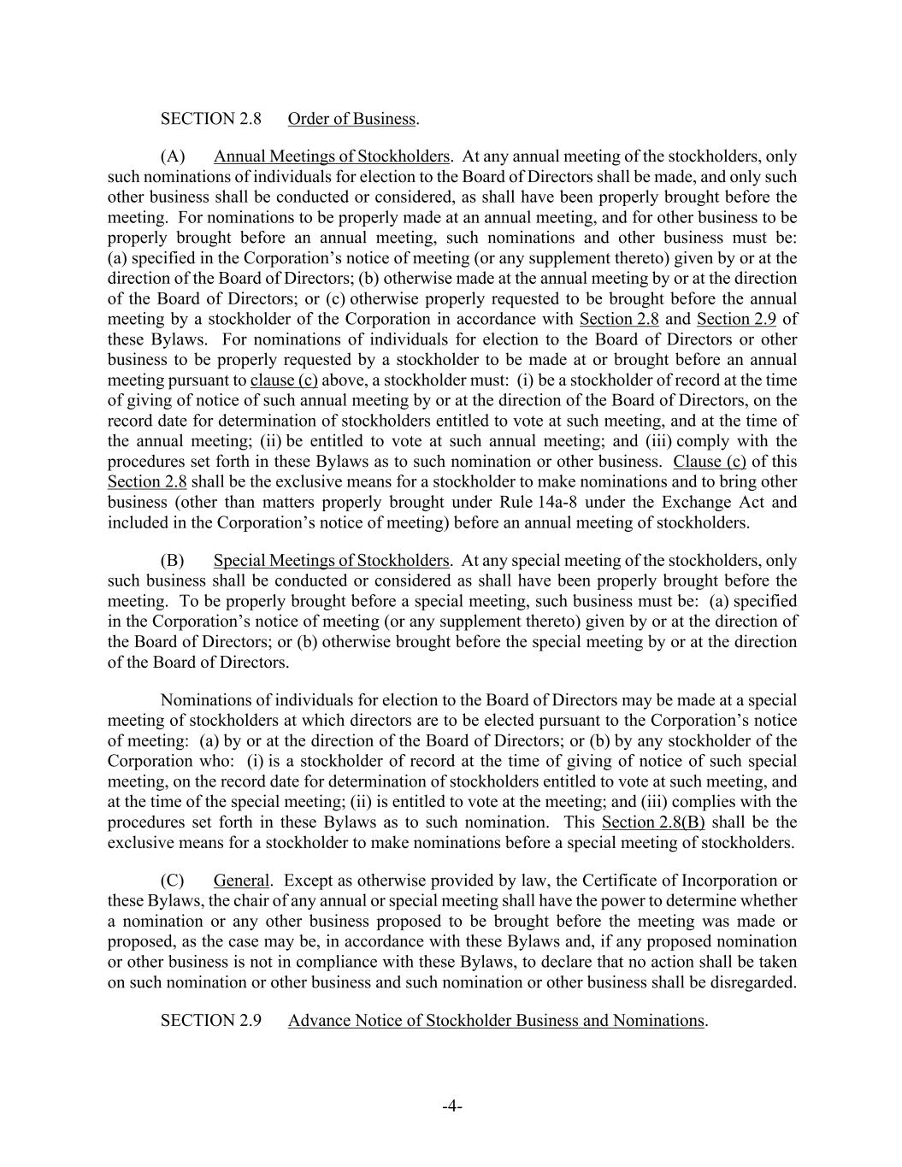
-4- SECTION 2.8 Order of Business. (A) Annual Meetings of Stockholders. At any annual meeting of the stockholders, only such nominations of individuals for election to the Board of Directors shall be made, and only such other business shall be conducted or considered, as shall have been properly brought before the meeting. For nominations to be properly made at an annual meeting, and for other business to be properly brought before an annual meeting, such nominations and other business must be: (a) specified in the Corporation’s notice of meeting (or any supplement thereto) given by or at the direction of the Board of Directors; (b) otherwise made at the annual meeting by or at the direction of the Board of Directors; or (c) otherwise properly requested to be brought before the annual meeting by a stockholder of the Corporation in accordance with Section 2.8 and Section 2.9 of these Bylaws. For nominations of individuals for election to the Board of Directors or other business to be properly requested by a stockholder to be made at or brought before an annual meeting pursuant to clause (c) above, a stockholder must: (i) be a stockholder of record at the time of giving of notice of such annual meeting by or at the direction of the Board of Directors, on the record date for determination of stockholders entitled to vote at such meeting, and at the time of the annual meeting; (ii) be entitled to vote at such annual meeting; and (iii) comply with the procedures set forth in these Bylaws as to such nomination or other business. Clause (c) of this Section 2.8 shall be the exclusive means for a stockholder to make nominations and to bring other business (other than matters properly brought under Rule 14a-8 under the Exchange Act and included in the Corporation’s notice of meeting) before an annual meeting of stockholders. (B) Special Meetings of Stockholders. At any special meeting of the stockholders, only such business shall be conducted or considered as shall have been properly brought before the meeting. To be properly brought before a special meeting, such business must be: (a) specified in the Corporation’s notice of meeting (or any supplement thereto) given by or at the direction of the Board of Directors; or (b) otherwise brought before the special meeting by or at the direction of the Board of Directors. Nominations of individuals for election to the Board of Directors may be made at a special meeting of stockholders at which directors are to be elected pursuant to the Corporation’s notice of meeting: (a) by or at the direction of the Board of Directors; or (b) by any stockholder of the Corporation who: (i) is a stockholder of record at the time of giving of notice of such special meeting, on the record date for determination of stockholders entitled to vote at such meeting, and at the time of the special meeting; (ii) is entitled to vote at the meeting; and (iii) complies with the procedures set forth in these Bylaws as to such nomination. This Section 2.8(B) shall be the exclusive means for a stockholder to make nominations before a special meeting of stockholders. (C) General. Except as otherwise provided by law, the Certificate of Incorporation or these Bylaws, the chair of any annual or special meeting shall have the power to determine whether a nomination or any other business proposed to be brought before the meeting was made or proposed, as the case may be, in accordance with these Bylaws and, if any proposed nomination or other business is not in compliance with these Bylaws, to declare that no action shall be taken on such nomination or other business and such nomination or other business shall be disregarded. SECTION 2.9 Advance Notice of Stockholder Business and Nominations.

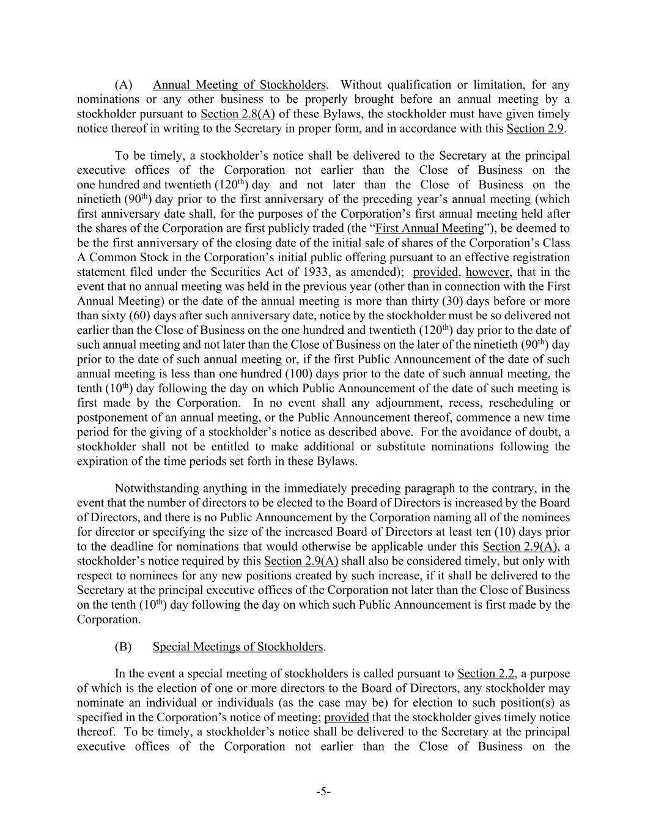
-5- (A) Annual Meeting of Stockholders. Without qualification or limitation, for any nominations or any other business to be properly brought before an annual meeting by a stockholder pursuant to Section 2.8(A) of these Bylaws, the stockholder must have given timely notice thereof in writing to the Secretary in proper form, and in accordance with this Section 2.9. To be timely, a stockholder’s notice shall be delivered to the Secretary at the principal executive offices of the Corporation not earlier than the Close of Business on the one hundred and twentieth (120th) day and not later than the Close of Business on the ninetieth (90th) day prior to the first anniversary of the preceding year’s annual meeting (which first anniversary date shall, for the purposes of the Corporation’s first annual meeting held after the shares of the Corporation are first publicly traded (the “First Annual Meeting”), be deemed to be the first anniversary of the closing date of the initial sale of shares of the Corporation’s Class A Common Stock in the Corporation’s initial public offering pursuant to an effective registration statement filed under the Securities Act of 1933, as amended); provided, however, that in the event that no annual meeting was held in the previous year (other than in connection with the First Annual Meeting) or the date of the annual meeting is more than thirty (30) days before or more than sixty (60) days after such anniversary date, notice by the stockholder must be so delivered not earlier than the Close of Business on the one hundred and twentieth (120th) day prior to the date of such annual meeting and not later than the Close of Business on the later of the ninetieth (90th) day prior to the date of such annual meeting or, if the first Public Announcement of the date of such annual meeting is less than one hundred (100) days prior to the date of such annual meeting, the tenth (10th) day following the day on which Public Announcement of the date of such meeting is first made by the Corporation. In no event shall any adjournment, recess, rescheduling or postponement of an annual meeting, or the Public Announcement thereof, commence a new time period for the giving of a stockholder’s notice as described above. For the avoidance of doubt, a stockholder shall not be entitled to make additional or substitute nominations following the expiration of the time periods set forth in these Bylaws. Notwithstanding anything in the immediately preceding paragraph to the contrary, in the event that the number of directors to be elected to the Board of Directors is increased by the Board of Directors, and there is no Public Announcement by the Corporation naming all of the nominees for director or specifying the size of the increased Board of Directors at least ten (10) days prior to the deadline for nominations that would otherwise be applicable under this Section 2.9(A), a stockholder’s notice required by this Section 2.9(A) shall also be considered timely, but only with respect to nominees for any new positions created by such increase, if it shall be delivered to the Secretary at the principal executive offices of the Corporation not later than the Close of Business on the tenth (10th) day following the day on which such Public Announcement is first made by the Corporation. (B) Special Meetings of Stockholders. In the event a special meeting of stockholders is called pursuant to Section 2.2, a purpose of which is the election of one or more directors to the Board of Directors, any stockholder may nominate an individual or individuals (as the case may be) for election to such position(s) as specified in the Corporation’s notice of meeting; provided that the stockholder gives timely notice thereof. To be timely, a stockholder’s notice shall be delivered to the Secretary at the principal executive offices of the Corporation not earlier than the Close of Business on the

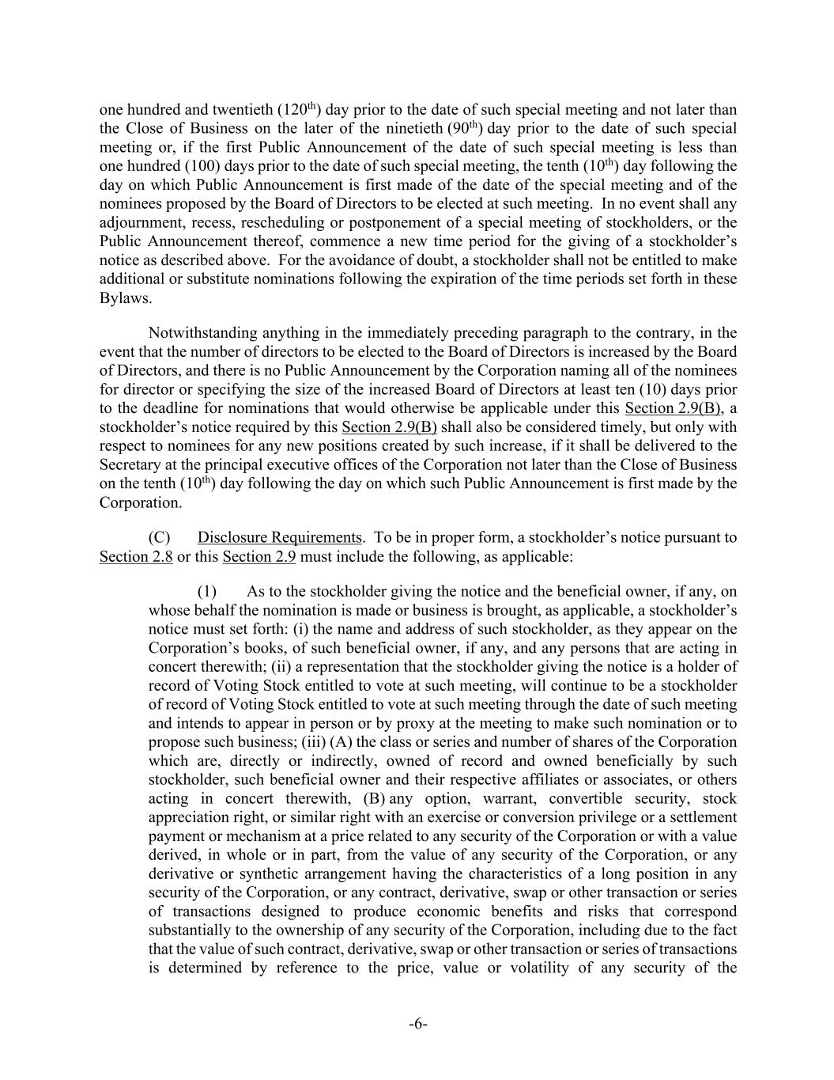
-6- one hundred and twentieth (120th) day prior to the date of such special meeting and not later than the Close of Business on the later of the ninetieth (90th) day prior to the date of such special meeting or, if the first Public Announcement of the date of such special meeting is less than one hundred (100) days prior to the date of such special meeting, the tenth (10th) day following the day on which Public Announcement is first made of the date of the special meeting and of the nominees proposed by the Board of Directors to be elected at such meeting. In no event shall any adjournment, recess, rescheduling or postponement of a special meeting of stockholders, or the Public Announcement thereof, commence a new time period for the giving of a stockholder’s notice as described above. For the avoidance of doubt, a stockholder shall not be entitled to make additional or substitute nominations following the expiration of the time periods set forth in these Bylaws. Notwithstanding anything in the immediately preceding paragraph to the contrary, in the event that the number of directors to be elected to the Board of Directors is increased by the Board of Directors, and there is no Public Announcement by the Corporation naming all of the nominees for director or specifying the size of the increased Board of Directors at least ten (10) days prior to the deadline for nominations that would otherwise be applicable under this Section 2.9(B), a stockholder’s notice required by this Section 2.9(B) shall also be considered timely, but only with respect to nominees for any new positions created by such increase, if it shall be delivered to the Secretary at the principal executive offices of the Corporation not later than the Close of Business on the tenth (10th) day following the day on which such Public Announcement is first made by the Corporation. (C) Disclosure Requirements. To be in proper form, a stockholder’s notice pursuant to Section 2.8 or this Section 2.9 must include the following, as applicable: (1) As to the stockholder giving the notice and the beneficial owner, if any, on whose behalf the nomination is made or business is brought, as applicable, a stockholder’s notice must set forth: (i) the name and address of such stockholder, as they appear on the Corporation’s books, of such beneficial owner, if any, and any persons that are acting in concert therewith; (ii) a representation that the stockholder giving the notice is a holder of record of Voting Stock entitled to vote at such meeting, will continue to be a stockholder of record of Voting Stock entitled to vote at such meeting through the date of such meeting and intends to appear in person or by proxy at the meeting to make such nomination or to propose such business; (iii) (A) the class or series and number of shares of the Corporation which are, directly or indirectly, owned of record and owned beneficially by such stockholder, such beneficial owner and their respective affiliates or associates, or others acting in concert therewith, (B) any option, warrant, convertible security, stock appreciation right, or similar right with an exercise or conversion privilege or a settlement payment or mechanism at a price related to any security of the Corporation or with a value derived, in whole or in part, from the value of any security of the Corporation, or any derivative or synthetic arrangement having the characteristics of a long position in any security of the Corporation, or any contract, derivative, swap or other transaction or series of transactions designed to produce economic benefits and risks that correspond substantially to the ownership of any security of the Corporation, including due to the fact that the value of such contract, derivative, swap or other transaction or series of transactions is determined by reference to the price, value or volatility of any security of the

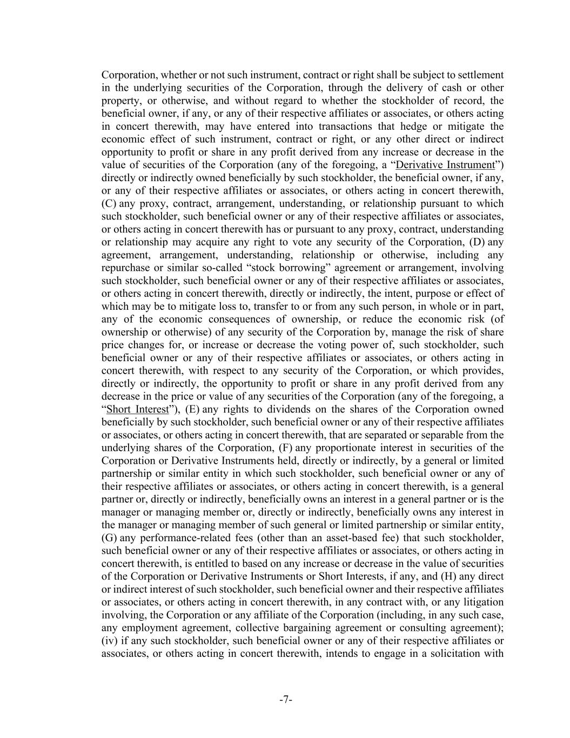
-7- Corporation, whether or not such instrument, contract or right shall be subject to settlement in the underlying securities of the Corporation, through the delivery of cash or other property, or otherwise, and without regard to whether the stockholder of record, the beneficial owner, if any, or any of their respective affiliates or associates, or others acting in concert therewith, may have entered into transactions that hedge or mitigate the economic effect of such instrument, contract or right, or any other direct or indirect opportunity to profit or share in any profit derived from any increase or decrease in the value of securities of the Corporation (any of the foregoing, a “Derivative Instrument”) directly or indirectly owned beneficially by such stockholder, the beneficial owner, if any, or any of their respective affiliates or associates, or others acting in concert therewith, (C) any proxy, contract, arrangement, understanding, or relationship pursuant to which such stockholder, such beneficial owner or any of their respective affiliates or associates, or others acting in concert therewith has or pursuant to any proxy, contract, understanding or relationship may acquire any right to vote any security of the Corporation, (D) any agreement, arrangement, understanding, relationship or otherwise, including any repurchase or similar so-called “stock borrowing” agreement or arrangement, involving such stockholder, such beneficial owner or any of their respective affiliates or associates, or others acting in concert therewith, directly or indirectly, the intent, purpose or effect of which may be to mitigate loss to, transfer to or from any such person, in whole or in part, any of the economic consequences of ownership, or reduce the economic risk (of ownership or otherwise) of any security of the Corporation by, manage the risk of share price changes for, or increase or decrease the voting power of, such stockholder, such beneficial owner or any of their respective affiliates or associates, or others acting in concert therewith, with respect to any security of the Corporation, or which provides, directly or indirectly, the opportunity to profit or share in any profit derived from any decrease in the price or value of any securities of the Corporation (any of the foregoing, a “Short Interest”), (E) any rights to dividends on the shares of the Corporation owned beneficially by such stockholder, such beneficial owner or any of their respective affiliates or associates, or others acting in concert therewith, that are separated or separable from the underlying shares of the Corporation, (F) any proportionate interest in securities of the Corporation or Derivative Instruments held, directly or indirectly, by a general or limited partnership or similar entity in which such stockholder, such beneficial owner or any of their respective affiliates or associates, or others acting in concert therewith, is a general partner or, directly or indirectly, beneficially owns an interest in a general partner or is the manager or managing member or, directly or indirectly, beneficially owns any interest in the manager or managing member of such general or limited partnership or similar entity, (G) any performance-related fees (other than an asset-based fee) that such stockholder, such beneficial owner or any of their respective affiliates or associates, or others acting in concert therewith, is entitled to based on any increase or decrease in the value of securities of the Corporation or Derivative Instruments or Short Interests, if any, and (H) any direct or indirect interest of such stockholder, such beneficial owner and their respective affiliates or associates, or others acting in concert therewith, in any contract with, or any litigation involving, the Corporation or any affiliate of the Corporation (including, in any such case, any employment agreement, collective bargaining agreement or consulting agreement); (iv) if any such stockholder, such beneficial owner or any of their respective affiliates or associates, or others acting in concert therewith, intends to engage in a solicitation with

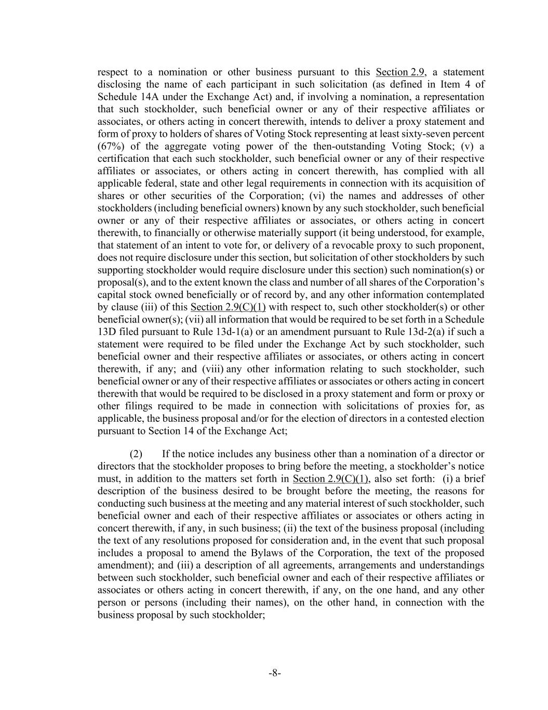
-8- respect to a nomination or other business pursuant to this Section 2.9, a statement disclosing the name of each participant in such solicitation (as defined in Item 4 of Schedule 14A under the Exchange Act) and, if involving a nomination, a representation that such stockholder, such beneficial owner or any of their respective affiliates or associates, or others acting in concert therewith, intends to deliver a proxy statement and form of proxy to holders of shares of Voting Stock representing at least sixty-seven percent (67%) of the aggregate voting power of the then-outstanding Voting Stock; (v) a certification that each such stockholder, such beneficial owner or any of their respective affiliates or associates, or others acting in concert therewith, has complied with all applicable federal, state and other legal requirements in connection with its acquisition of shares or other securities of the Corporation; (vi) the names and addresses of other stockholders (including beneficial owners) known by any such stockholder, such beneficial owner or any of their respective affiliates or associates, or others acting in concert therewith, to financially or otherwise materially support (it being understood, for example, that statement of an intent to vote for, or delivery of a revocable proxy to such proponent, does not require disclosure under this section, but solicitation of other stockholders by such supporting stockholder would require disclosure under this section) such nomination(s) or proposal(s), and to the extent known the class and number of all shares of the Corporation’s capital stock owned beneficially or of record by, and any other information contemplated by clause (iii) of this Section 2.9(C)(1) with respect to, such other stockholder(s) or other beneficial owner(s); (vii) all information that would be required to be set forth in a Schedule 13D filed pursuant to Rule 13d-1(a) or an amendment pursuant to Rule 13d-2(a) if such a statement were required to be filed under the Exchange Act by such stockholder, such beneficial owner and their respective affiliates or associates, or others acting in concert therewith, if any; and (viii) any other information relating to such stockholder, such beneficial owner or any of their respective affiliates or associates or others acting in concert therewith that would be required to be disclosed in a proxy statement and form or proxy or other filings required to be made in connection with solicitations of proxies for, as applicable, the business proposal and/or for the election of directors in a contested election pursuant to Section 14 of the Exchange Act; (2) If the notice includes any business other than a nomination of a director or directors that the stockholder proposes to bring before the meeting, a stockholder’s notice must, in addition to the matters set forth in Section 2.9(C)(1), also set forth: (i) a brief description of the business desired to be brought before the meeting, the reasons for conducting such business at the meeting and any material interest of such stockholder, such beneficial owner and each of their respective affiliates or associates or others acting in concert therewith, if any, in such business; (ii) the text of the business proposal (including the text of any resolutions proposed for consideration and, in the event that such proposal includes a proposal to amend the Bylaws of the Corporation, the text of the proposed amendment); and (iii) a description of all agreements, arrangements and understandings between such stockholder, such beneficial owner and each of their respective affiliates or associates or others acting in concert therewith, if any, on the one hand, and any other person or persons (including their names), on the other hand, in connection with the business proposal by such stockholder;

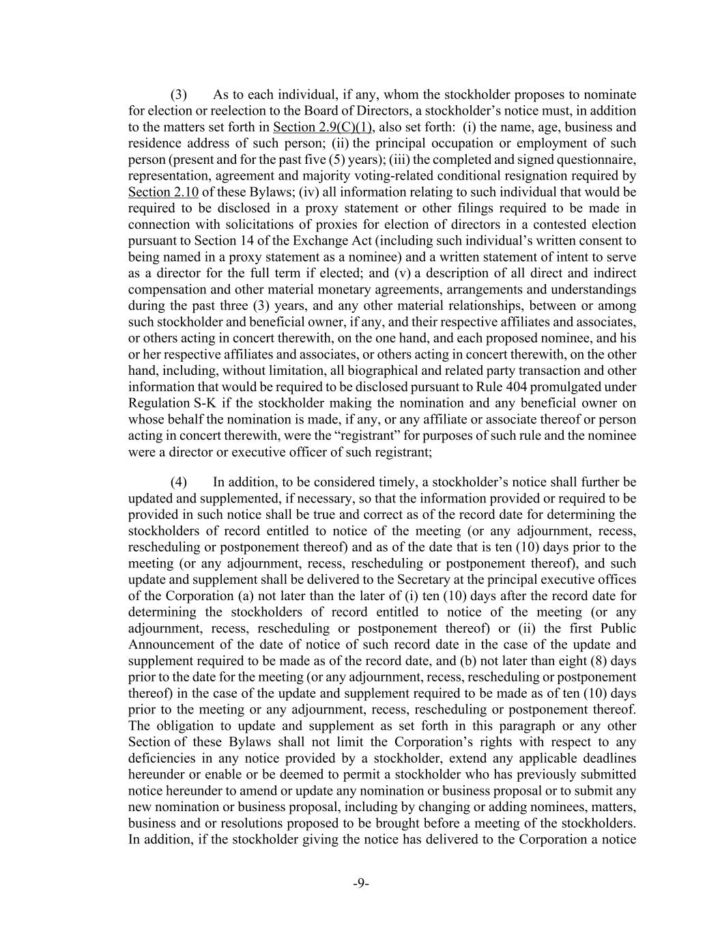
-9- (3) As to each individual, if any, whom the stockholder proposes to nominate for election or reelection to the Board of Directors, a stockholder’s notice must, in addition to the matters set forth in Section 2.9(C)(1), also set forth: (i) the name, age, business and residence address of such person; (ii) the principal occupation or employment of such person (present and for the past five (5) years); (iii) the completed and signed questionnaire, representation, agreement and majority voting-related conditional resignation required by Section 2.10 of these Bylaws; (iv) all information relating to such individual that would be required to be disclosed in a proxy statement or other filings required to be made in connection with solicitations of proxies for election of directors in a contested election pursuant to Section 14 of the Exchange Act (including such individual’s written consent to being named in a proxy statement as a nominee) and a written statement of intent to serve as a director for the full term if elected; and (v) a description of all direct and indirect compensation and other material monetary agreements, arrangements and understandings during the past three (3) years, and any other material relationships, between or among such stockholder and beneficial owner, if any, and their respective affiliates and associates, or others acting in concert therewith, on the one hand, and each proposed nominee, and his or her respective affiliates and associates, or others acting in concert therewith, on the other hand, including, without limitation, all biographical and related party transaction and other information that would be required to be disclosed pursuant to Rule 404 promulgated under Regulation S-K if the stockholder making the nomination and any beneficial owner on whose behalf the nomination is made, if any, or any affiliate or associate thereof or person acting in concert therewith, were the “registrant” for purposes of such rule and the nominee were a director or executive officer of such registrant; (4) In addition, to be considered timely, a stockholder’s notice shall further be updated and supplemented, if necessary, so that the information provided or required to be provided in such notice shall be true and correct as of the record date for determining the stockholders of record entitled to notice of the meeting (or any adjournment, recess, rescheduling or postponement thereof) and as of the date that is ten (10) days prior to the meeting (or any adjournment, recess, rescheduling or postponement thereof), and such update and supplement shall be delivered to the Secretary at the principal executive offices of the Corporation (a) not later than the later of (i) ten (10) days after the record date for determining the stockholders of record entitled to notice of the meeting (or any adjournment, recess, rescheduling or postponement thereof) or (ii) the first Public Announcement of the date of notice of such record date in the case of the update and supplement required to be made as of the record date, and (b) not later than eight (8) days prior to the date for the meeting (or any adjournment, recess, rescheduling or postponement thereof) in the case of the update and supplement required to be made as of ten (10) days prior to the meeting or any adjournment, recess, rescheduling or postponement thereof. The obligation to update and supplement as set forth in this paragraph or any other Section of these Bylaws shall not limit the Corporation’s rights with respect to any deficiencies in any notice provided by a stockholder, extend any applicable deadlines hereunder or enable or be deemed to permit a stockholder who has previously submitted notice hereunder to amend or update any nomination or business proposal or to submit any new nomination or business proposal, including by changing or adding nominees, matters, business and or resolutions proposed to be brought before a meeting of the stockholders. In addition, if the stockholder giving the notice has delivered to the Corporation a notice

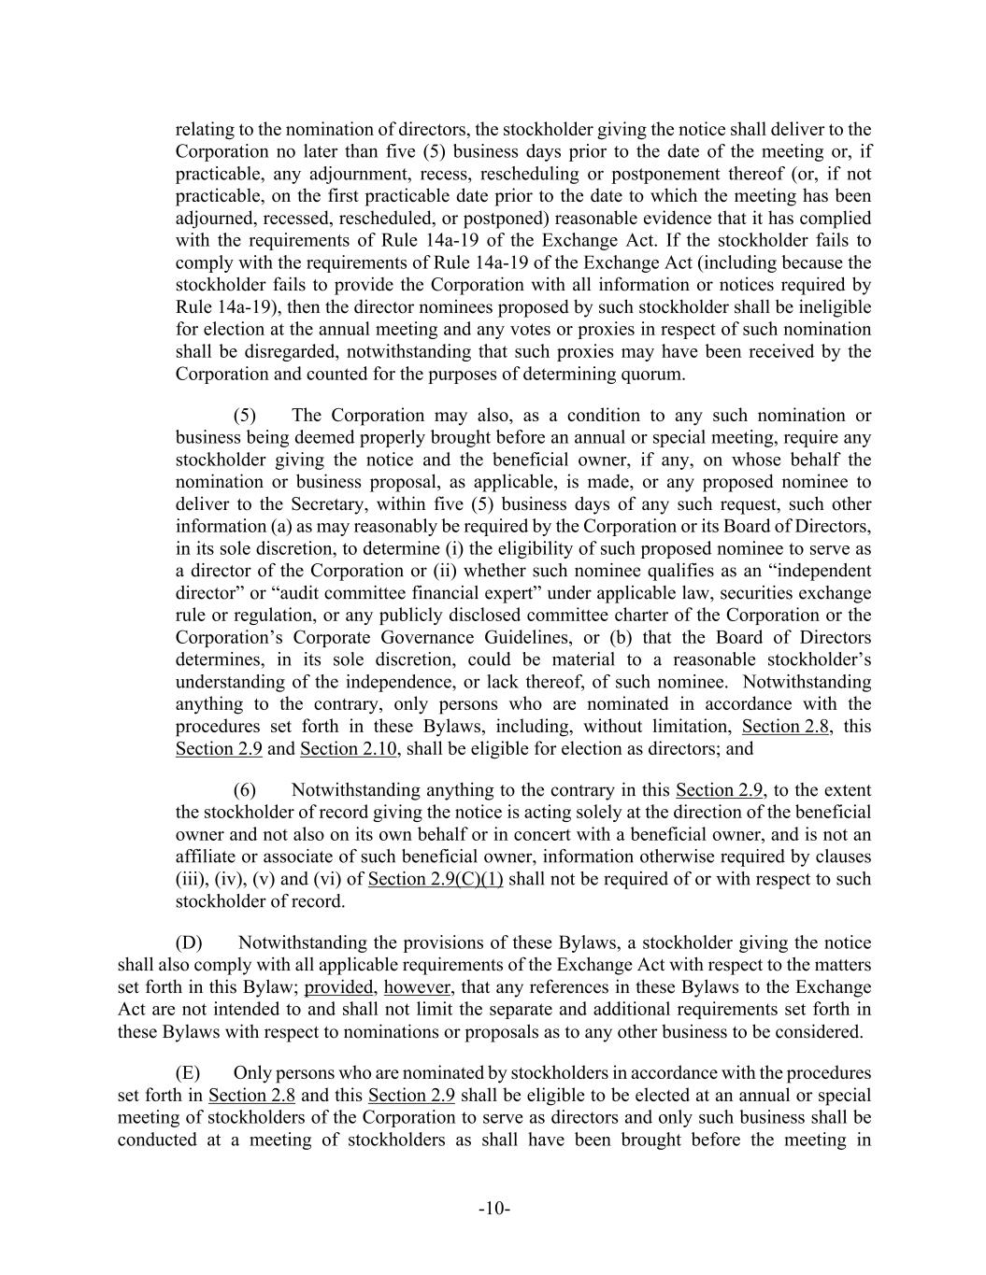
-10- relating to the nomination of directors, the stockholder giving the notice shall deliver to the Corporation no later than five (5) business days prior to the date of the meeting or, if practicable, any adjournment, recess, rescheduling or postponement thereof (or, if not practicable, on the first practicable date prior to the date to which the meeting has been adjourned, recessed, rescheduled, or postponed) reasonable evidence that it has complied with the requirements of Rule 14a-19 of the Exchange Act. If the stockholder fails to comply with the requirements of Rule 14a-19 of the Exchange Act (including because the stockholder fails to provide the Corporation with all information or notices required by Rule 14a-19), then the director nominees proposed by such stockholder shall be ineligible for election at the annual meeting and any votes or proxies in respect of such nomination shall be disregarded, notwithstanding that such proxies may have been received by the Corporation and counted for the purposes of determining quorum. (5) The Corporation may also, as a condition to any such nomination or business being deemed properly brought before an annual or special meeting, require any stockholder giving the notice and the beneficial owner, if any, on whose behalf the nomination or business proposal, as applicable, is made, or any proposed nominee to deliver to the Secretary, within five (5) business days of any such request, such other information (a) as may reasonably be required by the Corporation or its Board of Directors, in its sole discretion, to determine (i) the eligibility of such proposed nominee to serve as a director of the Corporation or (ii) whether such nominee qualifies as an “independent director” or “audit committee financial expert” under applicable law, securities exchange rule or regulation, or any publicly disclosed committee charter of the Corporation or the Corporation’s Corporate Governance Guidelines, or (b) that the Board of Directors determines, in its sole discretion, could be material to a reasonable stockholder’s understanding of the independence, or lack thereof, of such nominee. Notwithstanding anything to the contrary, only persons who are nominated in accordance with the procedures set forth in these Bylaws, including, without limitation, Section 2.8, this Section 2.9 and Section 2.10, shall be eligible for election as directors; and (6) Notwithstanding anything to the contrary in this Section 2.9, to the extent the stockholder of record giving the notice is acting solely at the direction of the beneficial owner and not also on its own behalf or in concert with a beneficial owner, and is not an affiliate or associate of such beneficial owner, information otherwise required by clauses (iii), (iv), (v) and (vi) of Section 2.9(C)(1) shall not be required of or with respect to such stockholder of record. (D) Notwithstanding the provisions of these Bylaws, a stockholder giving the notice shall also comply with all applicable requirements of the Exchange Act with respect to the matters set forth in this Bylaw; provided, however, that any references in these Bylaws to the Exchange Act are not intended to and shall not limit the separate and additional requirements set forth in these Bylaws with respect to nominations or proposals as to any other business to be considered. (E) Only persons who are nominated by stockholders in accordance with the procedures set forth in Section 2.8 and this Section 2.9 shall be eligible to be elected at an annual or special meeting of stockholders of the Corporation to serve as directors and only such business shall be conducted at a meeting of stockholders as shall have been brought before the meeting in

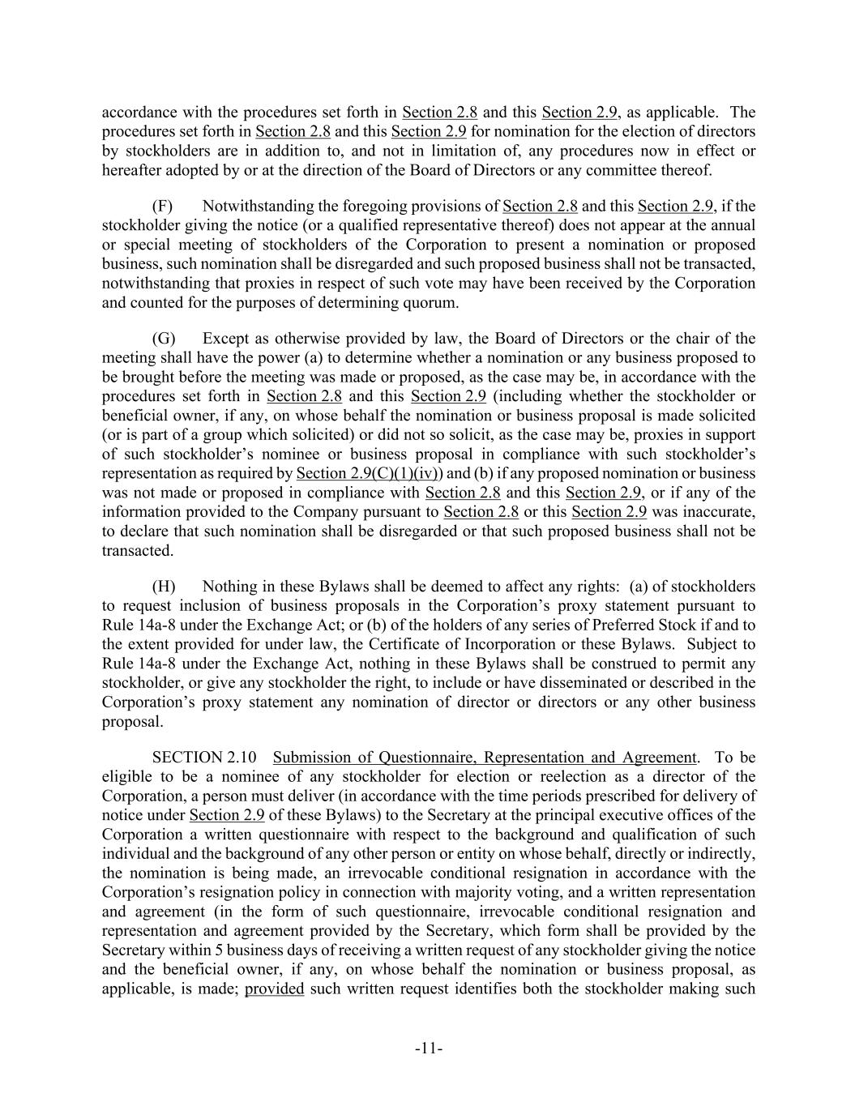
-11- accordance with the procedures set forth in Section 2.8 and this Section 2.9, as applicable. The procedures set forth in Section 2.8 and this Section 2.9 for nomination for the election of directors by stockholders are in addition to, and not in limitation of, any procedures now in effect or hereafter adopted by or at the direction of the Board of Directors or any committee thereof. (F) Notwithstanding the foregoing provisions of Section 2.8 and this Section 2.9, if the stockholder giving the notice (or a qualified representative thereof) does not appear at the annual or special meeting of stockholders of the Corporation to present a nomination or proposed business, such nomination shall be disregarded and such proposed business shall not be transacted, notwithstanding that proxies in respect of such vote may have been received by the Corporation and counted for the purposes of determining quorum. (G) Except as otherwise provided by law, the Board of Directors or the chair of the meeting shall have the power (a) to determine whether a nomination or any business proposed to be brought before the meeting was made or proposed, as the case may be, in accordance with the procedures set forth in Section 2.8 and this Section 2.9 (including whether the stockholder or beneficial owner, if any, on whose behalf the nomination or business proposal is made solicited (or is part of a group which solicited) or did not so solicit, as the case may be, proxies in support of such stockholder’s nominee or business proposal in compliance with such stockholder’s representation as required by Section 2.9(C)(1)(iv)) and (b) if any proposed nomination or business was not made or proposed in compliance with Section 2.8 and this Section 2.9, or if any of the information provided to the Company pursuant to Section 2.8 or this Section 2.9 was inaccurate, to declare that such nomination shall be disregarded or that such proposed business shall not be transacted. (H) Nothing in these Bylaws shall be deemed to affect any rights: (a) of stockholders to request inclusion of business proposals in the Corporation’s proxy statement pursuant to Rule 14a-8 under the Exchange Act; or (b) of the holders of any series of Preferred Stock if and to the extent provided for under law, the Certificate of Incorporation or these Bylaws. Subject to Rule 14a-8 under the Exchange Act, nothing in these Bylaws shall be construed to permit any stockholder, or give any stockholder the right, to include or have disseminated or described in the Corporation’s proxy statement any nomination of director or directors or any other business proposal. SECTION 2.10 Submission of Questionnaire, Representation and Agreement. To be eligible to be a nominee of any stockholder for election or reelection as a director of the Corporation, a person must deliver (in accordance with the time periods prescribed for delivery of notice under Section 2.9 of these Bylaws) to the Secretary at the principal executive offices of the Corporation a written questionnaire with respect to the background and qualification of such individual and the background of any other person or entity on whose behalf, directly or indirectly, the nomination is being made, an irrevocable conditional resignation in accordance with the Corporation’s resignation policy in connection with majority voting, and a written representation and agreement (in the form of such questionnaire, irrevocable conditional resignation and representation and agreement provided by the Secretary, which form shall be provided by the Secretary within 5 business days of receiving a written request of any stockholder giving the notice and the beneficial owner, if any, on whose behalf the nomination or business proposal, as applicable, is made; provided such written request identifies both the stockholder making such

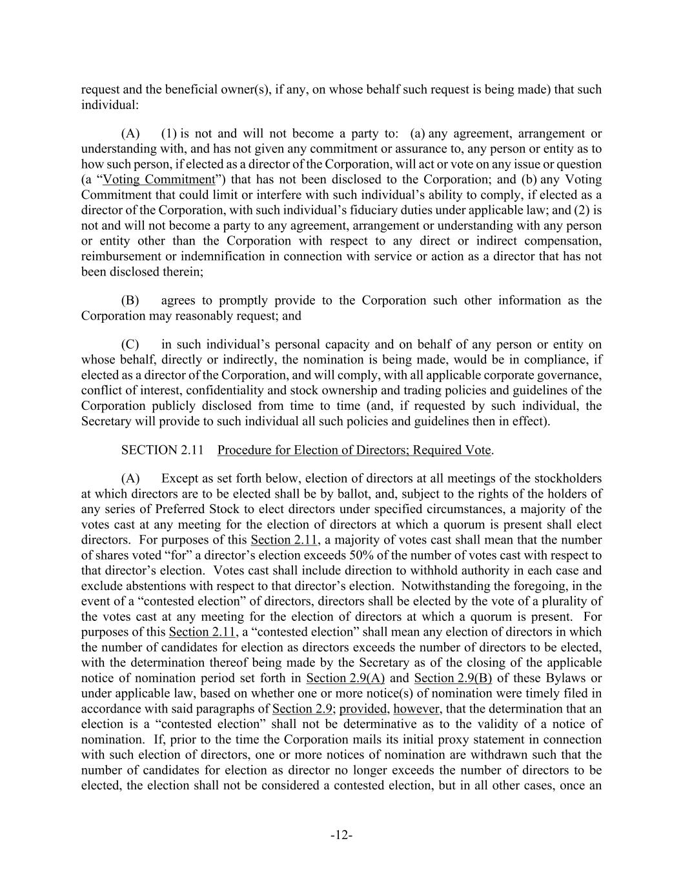
-12- request and the beneficial owner(s), if any, on whose behalf such request is being made) that such individual: (A) (1) is not and will not become a party to: (a) any agreement, arrangement or understanding with, and has not given any commitment or assurance to, any person or entity as to how such person, if elected as a director of the Corporation, will act or vote on any issue or question (a “Voting Commitment”) that has not been disclosed to the Corporation; and (b) any Voting Commitment that could limit or interfere with such individual’s ability to comply, if elected as a director of the Corporation, with such individual’s fiduciary duties under applicable law; and (2) is not and will not become a party to any agreement, arrangement or understanding with any person or entity other than the Corporation with respect to any direct or indirect compensation, reimbursement or indemnification in connection with service or action as a director that has not been disclosed therein; (B) agrees to promptly provide to the Corporation such other information as the Corporation may reasonably request; and (C) in such individual’s personal capacity and on behalf of any person or entity on whose behalf, directly or indirectly, the nomination is being made, would be in compliance, if elected as a director of the Corporation, and will comply, with all applicable corporate governance, conflict of interest, confidentiality and stock ownership and trading policies and guidelines of the Corporation publicly disclosed from time to time (and, if requested by such individual, the Secretary will provide to such individual all such policies and guidelines then in effect). SECTION 2.11 Procedure for Election of Directors; Required Vote. (A) Except as set forth below, election of directors at all meetings of the stockholders at which directors are to be elected shall be by ballot, and, subject to the rights of the holders of any series of Preferred Stock to elect directors under specified circumstances, a majority of the votes cast at any meeting for the election of directors at which a quorum is present shall elect directors. For purposes of this Section 2.11, a majority of votes cast shall mean that the number of shares voted “for” a director’s election exceeds 50% of the number of votes cast with respect to that director’s election. Votes cast shall include direction to withhold authority in each case and exclude abstentions with respect to that director’s election. Notwithstanding the foregoing, in the event of a “contested election” of directors, directors shall be elected by the vote of a plurality of the votes cast at any meeting for the election of directors at which a quorum is present. For purposes of this Section 2.11, a “contested election” shall mean any election of directors in which the number of candidates for election as directors exceeds the number of directors to be elected, with the determination thereof being made by the Secretary as of the closing of the applicable notice of nomination period set forth in Section 2.9(A) and Section 2.9(B) of these Bylaws or under applicable law, based on whether one or more notice(s) of nomination were timely filed in accordance with said paragraphs of Section 2.9; provided, however, that the determination that an election is a “contested election” shall not be determinative as to the validity of a notice of nomination. If, prior to the time the Corporation mails its initial proxy statement in connection with such election of directors, one or more notices of nomination are withdrawn such that the number of candidates for election as director no longer exceeds the number of directors to be elected, the election shall not be considered a contested election, but in all other cases, once an

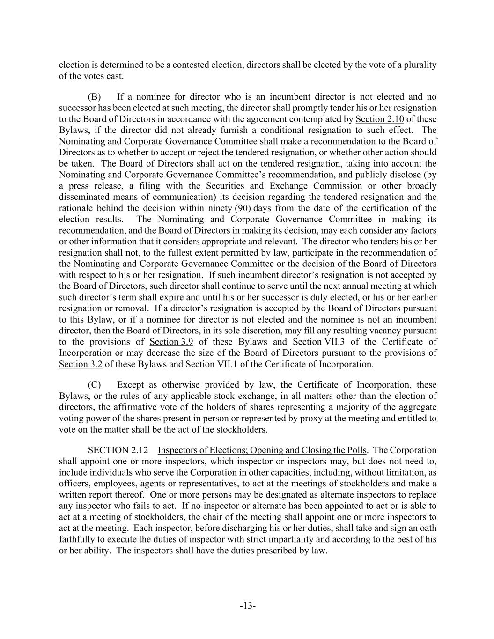
-13- election is determined to be a contested election, directors shall be elected by the vote of a plurality of the votes cast. (B) If a nominee for director who is an incumbent director is not elected and no successor has been elected at such meeting, the director shall promptly tender his or her resignation to the Board of Directors in accordance with the agreement contemplated by Section 2.10 of these Bylaws, if the director did not already furnish a conditional resignation to such effect. The Nominating and Corporate Governance Committee shall make a recommendation to the Board of Directors as to whether to accept or reject the tendered resignation, or whether other action should be taken. The Board of Directors shall act on the tendered resignation, taking into account the Nominating and Corporate Governance Committee’s recommendation, and publicly disclose (by a press release, a filing with the Securities and Exchange Commission or other broadly disseminated means of communication) its decision regarding the tendered resignation and the rationale behind the decision within ninety (90) days from the date of the certification of the election results. The Nominating and Corporate Governance Committee in making its recommendation, and the Board of Directors in making its decision, may each consider any factors or other information that it considers appropriate and relevant. The director who tenders his or her resignation shall not, to the fullest extent permitted by law, participate in the recommendation of the Nominating and Corporate Governance Committee or the decision of the Board of Directors with respect to his or her resignation. If such incumbent director’s resignation is not accepted by the Board of Directors, such director shall continue to serve until the next annual meeting at which such director’s term shall expire and until his or her successor is duly elected, or his or her earlier resignation or removal. If a director’s resignation is accepted by the Board of Directors pursuant to this Bylaw, or if a nominee for director is not elected and the nominee is not an incumbent director, then the Board of Directors, in its sole discretion, may fill any resulting vacancy pursuant to the provisions of Section 3.9 of these Bylaws and Section VII.3 of the Certificate of Incorporation or may decrease the size of the Board of Directors pursuant to the provisions of Section 3.2 of these Bylaws and Section VII.1 of the Certificate of Incorporation. (C) Except as otherwise provided by law, the Certificate of Incorporation, these Bylaws, or the rules of any applicable stock exchange, in all matters other than the election of directors, the affirmative vote of the holders of shares representing a majority of the aggregate voting power of the shares present in person or represented by proxy at the meeting and entitled to vote on the matter shall be the act of the stockholders. SECTION 2.12 Inspectors of Elections; Opening and Closing the Polls. The Corporation shall appoint one or more inspectors, which inspector or inspectors may, but does not need to, include individuals who serve the Corporation in other capacities, including, without limitation, as officers, employees, agents or representatives, to act at the meetings of stockholders and make a written report thereof. One or more persons may be designated as alternate inspectors to replace any inspector who fails to act. If no inspector or alternate has been appointed to act or is able to act at a meeting of stockholders, the chair of the meeting shall appoint one or more inspectors to act at the meeting. Each inspector, before discharging his or her duties, shall take and sign an oath faithfully to execute the duties of inspector with strict impartiality and according to the best of his or her ability. The inspectors shall have the duties prescribed by law.

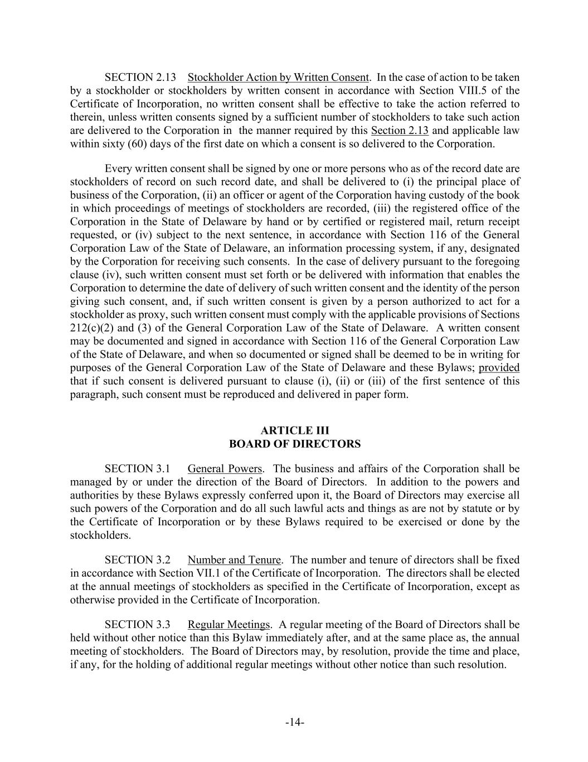
-14- SECTION 2.13 Stockholder Action by Written Consent. In the case of action to be taken by a stockholder or stockholders by written consent in accordance with Section VIII.5 of the Certificate of Incorporation, no written consent shall be effective to take the action referred to therein, unless written consents signed by a sufficient number of stockholders to take such action are delivered to the Corporation in the manner required by this Section 2.13 and applicable law within sixty (60) days of the first date on which a consent is so delivered to the Corporation. Every written consent shall be signed by one or more persons who as of the record date are stockholders of record on such record date, and shall be delivered to (i) the principal place of business of the Corporation, (ii) an officer or agent of the Corporation having custody of the book in which proceedings of meetings of stockholders are recorded, (iii) the registered office of the Corporation in the State of Delaware by hand or by certified or registered mail, return receipt requested, or (iv) subject to the next sentence, in accordance with Section 116 of the General Corporation Law of the State of Delaware, an information processing system, if any, designated by the Corporation for receiving such consents. In the case of delivery pursuant to the foregoing clause (iv), such written consent must set forth or be delivered with information that enables the Corporation to determine the date of delivery of such written consent and the identity of the person giving such consent, and, if such written consent is given by a person authorized to act for a stockholder as proxy, such written consent must comply with the applicable provisions of Sections 212(c)(2) and (3) of the General Corporation Law of the State of Delaware. A written consent may be documented and signed in accordance with Section 116 of the General Corporation Law of the State of Delaware, and when so documented or signed shall be deemed to be in writing for purposes of the General Corporation Law of the State of Delaware and these Bylaws; provided that if such consent is delivered pursuant to clause (i), (ii) or (iii) of the first sentence of this paragraph, such consent must be reproduced and delivered in paper form. BOARD OF DIRECTORS SECTION 3.1 General Powers. The business and affairs of the Corporation shall be managed by or under the direction of the Board of Directors. In addition to the powers and authorities by these Bylaws expressly conferred upon it, the Board of Directors may exercise all such powers of the Corporation and do all such lawful acts and things as are not by statute or by the Certificate of Incorporation or by these Bylaws required to be exercised or done by the stockholders. SECTION 3.2 Number and Tenure. The number and tenure of directors shall be fixed in accordance with Section VII.1 of the Certificate of Incorporation. The directors shall be elected at the annual meetings of stockholders as specified in the Certificate of Incorporation, except as otherwise provided in the Certificate of Incorporation. SECTION 3.3 Regular Meetings. A regular meeting of the Board of Directors shall be held without other notice than this Bylaw immediately after, and at the same place as, the annual meeting of stockholders. The Board of Directors may, by resolution, provide the time and place, if any, for the holding of additional regular meetings without other notice than such resolution.

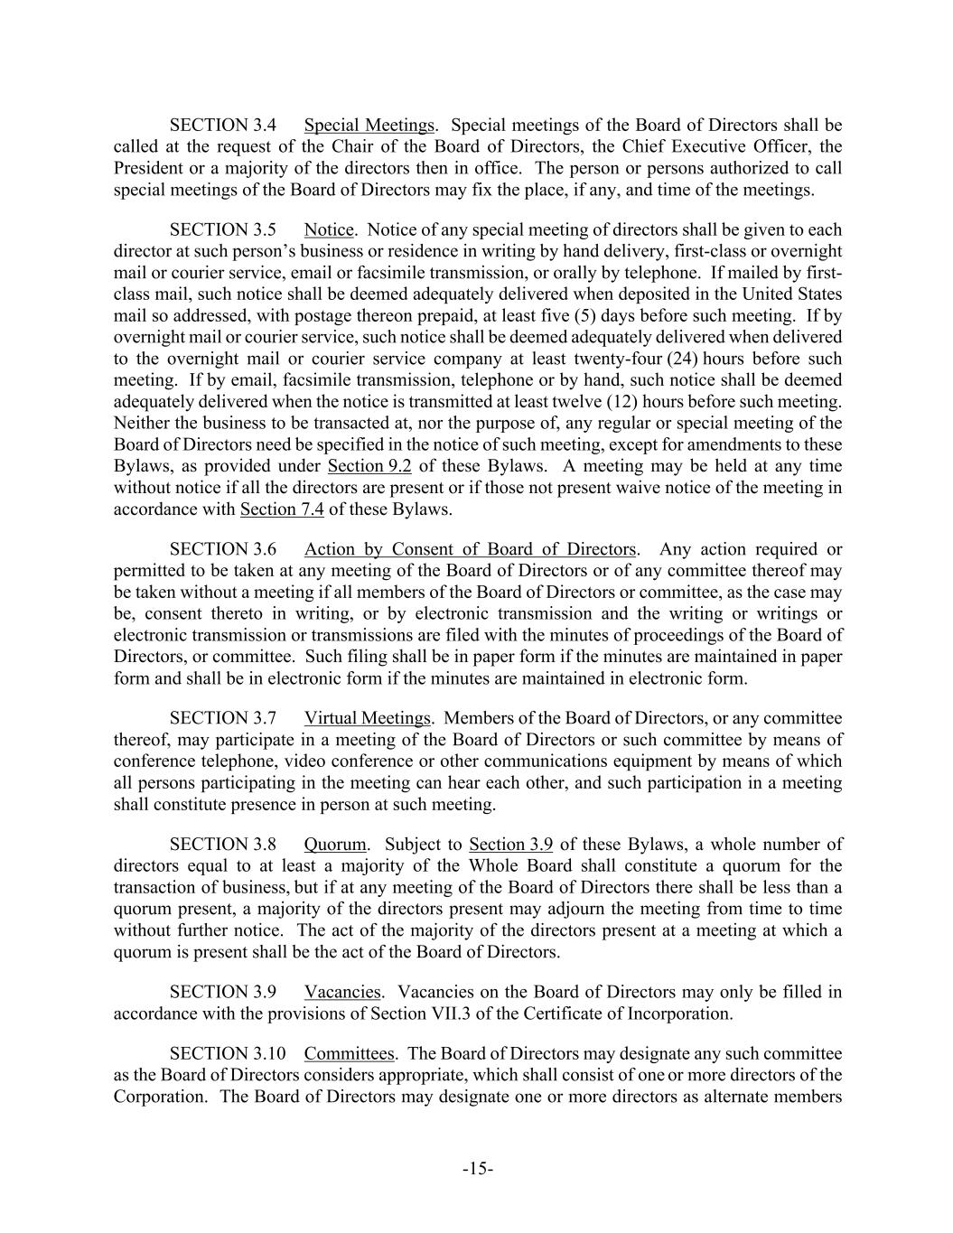
-15- SECTION 3.4 Special Meetings. Special meetings of the Board of Directors shall be called at the request of the Chair of the Board of Directors, the Chief Executive Officer, the President or a majority of the directors then in office. The person or persons authorized to call special meetings of the Board of Directors may fix the place, if any, and time of the meetings. SECTION 3.5 Notice. Notice of any special meeting of directors shall be given to each director at such person’s business or residence in writing by hand delivery, first-class or overnight mail or courier service, email or facsimile transmission, or orally by telephone. If mailed by first- class mail, such notice shall be deemed adequately delivered when deposited in the United States mail so addressed, with postage thereon prepaid, at least five (5) days before such meeting. If by overnight mail or courier service, such notice shall be deemed adequately delivered when delivered to the overnight mail or courier service company at least twenty-four (24) hours before such meeting. If by email, facsimile transmission, telephone or by hand, such notice shall be deemed adequately delivered when the notice is transmitted at least twelve (12) hours before such meeting. Neither the business to be transacted at, nor the purpose of, any regular or special meeting of the Board of Directors need be specified in the notice of such meeting, except for amendments to these Bylaws, as provided under Section 9.2 of these Bylaws. A meeting may be held at any time without notice if all the directors are present or if those not present waive notice of the meeting in accordance with Section 7.4 of these Bylaws. SECTION 3.6 Action by Consent of Board of Directors. Any action required or permitted to be taken at any meeting of the Board of Directors or of any committee thereof may be taken without a meeting if all members of the Board of Directors or committee, as the case may be, consent thereto in writing, or by electronic transmission and the writing or writings or electronic transmission or transmissions are filed with the minutes of proceedings of the Board of Directors, or committee. Such filing shall be in paper form if the minutes are maintained in paper form and shall be in electronic form if the minutes are maintained in electronic form. SECTION 3.7 Virtual Meetings. Members of the Board of Directors, or any committee thereof, may participate in a meeting of the Board of Directors or such committee by means of conference telephone, video conference or other communications equipment by means of which all persons participating in the meeting can hear each other, and such participation in a meeting shall constitute presence in person at such meeting. SECTION 3.8 Quorum. Subject to Section 3.9 of these Bylaws, a whole number of directors equal to at least a majority of the Whole Board shall constitute a quorum for the transaction of business, but if at any meeting of the Board of Directors there shall be less than a quorum present, a majority of the directors present may adjourn the meeting from time to time without further notice. The act of the majority of the directors present at a meeting at which a quorum is present shall be the act of the Board of Directors. SECTION 3.9 Vacancies. Vacancies on the Board of Directors may only be filled in accordance with the provisions of Section VII.3 of the Certificate of Incorporation. SECTION 3.10 Committees. The Board of Directors may designate any such committee as the Board of Directors considers appropriate, which shall consist of one or more directors of the Corporation. The Board of Directors may designate one or more directors as alternate members

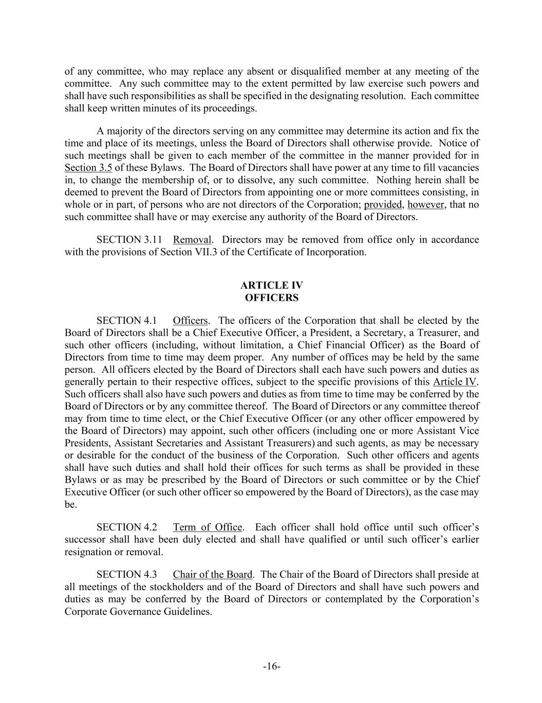
-16- of any committee, who may replace any absent or disqualified member at any meeting of the committee. Any such committee may to the extent permitted by law exercise such powers and shall have such responsibilities as shall be specified in the designating resolution. Each committee shall keep written minutes of its proceedings. A majority of the directors serving on any committee may determine its action and fix the time and place of its meetings, unless the Board of Directors shall otherwise provide. Notice of such meetings shall be given to each member of the committee in the manner provided for in Section 3.5 of these Bylaws. The Board of Directors shall have power at any time to fill vacancies in, to change the membership of, or to dissolve, any such committee. Nothing herein shall be deemed to prevent the Board of Directors from appointing one or more committees consisting, in whole or in part, of persons who are not directors of the Corporation; provided, however, that no such committee shall have or may exercise any authority of the Board of Directors. SECTION 3.11 Removal. Directors may be removed from office only in accordance with the provisions of Section VII.3 of the Certificate of Incorporation. OFFICERS SECTION 4.1 Officers. The officers of the Corporation that shall be elected by the Board of Directors shall be a Chief Executive Officer, a President, a Secretary, a Treasurer, and such other officers (including, without limitation, a Chief Financial Officer) as the Board of Directors from time to time may deem proper. Any number of offices may be held by the same person. All officers elected by the Board of Directors shall each have such powers and duties as generally pertain to their respective offices, subject to the specific provisions of this Article IV. Such officers shall also have such powers and duties as from time to time may be conferred by the Board of Directors or by any committee thereof. The Board of Directors or any committee thereof may from time to time elect, or the Chief Executive Officer (or any other officer empowered by the Board of Directors) may appoint, such other officers (including one or more Assistant Vice Presidents, Assistant Secretaries and Assistant Treasurers) and such agents, as may be necessary or desirable for the conduct of the business of the Corporation. Such other officers and agents shall have such duties and shall hold their offices for such terms as shall be provided in these Bylaws or as may be prescribed by the Board of Directors or such committee or by the Chief Executive Officer (or such other officer so empowered by the Board of Directors), as the case may be. SECTION 4.2 Term of Office. Each officer shall hold office until such officer’s successor shall have been duly elected and shall have qualified or until such officer’s earlier resignation or removal. SECTION 4.3 Chair of the Board. The Chair of the Board of Directors shall preside at all meetings of the stockholders and of the Board of Directors and shall have such powers and duties as may be conferred by the Board of Directors or contemplated by the Corporation’s Corporate Governance Guidelines.

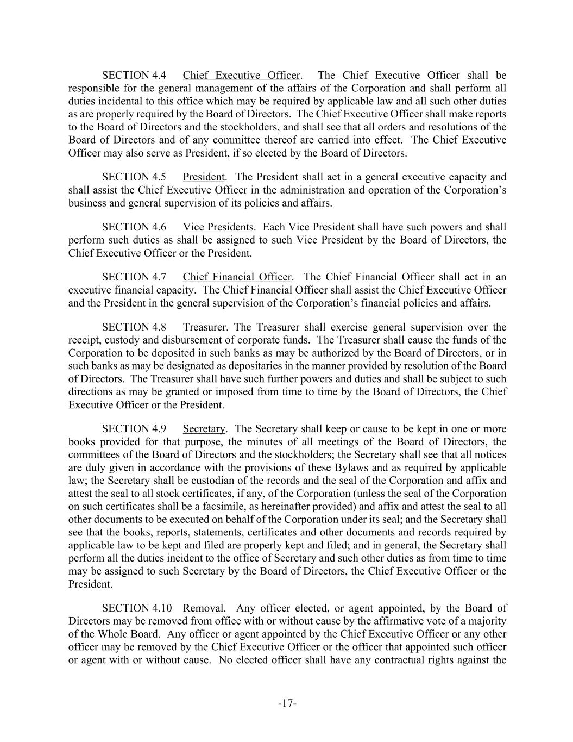
-17- SECTION 4.4 Chief Executive Officer. The Chief Executive Officer shall be responsible for the general management of the affairs of the Corporation and shall perform all duties incidental to this office which may be required by applicable law and all such other duties as are properly required by the Board of Directors. The Chief Executive Officer shall make reports to the Board of Directors and the stockholders, and shall see that all orders and resolutions of the Board of Directors and of any committee thereof are carried into effect. The Chief Executive Officer may also serve as President, if so elected by the Board of Directors. SECTION 4.5 President. The President shall act in a general executive capacity and shall assist the Chief Executive Officer in the administration and operation of the Corporation’s business and general supervision of its policies and affairs. SECTION 4.6 Vice Presidents. Each Vice President shall have such powers and shall perform such duties as shall be assigned to such Vice President by the Board of Directors, the Chief Executive Officer or the President. SECTION 4.7 Chief Financial Officer. The Chief Financial Officer shall act in an executive financial capacity. The Chief Financial Officer shall assist the Chief Executive Officer and the President in the general supervision of the Corporation’s financial policies and affairs. SECTION 4.8 Treasurer. The Treasurer shall exercise general supervision over the receipt, custody and disbursement of corporate funds. The Treasurer shall cause the funds of the Corporation to be deposited in such banks as may be authorized by the Board of Directors, or in such banks as may be designated as depositaries in the manner provided by resolution of the Board of Directors. The Treasurer shall have such further powers and duties and shall be subject to such directions as may be granted or imposed from time to time by the Board of Directors, the Chief Executive Officer or the President. SECTION 4.9 Secretary. The Secretary shall keep or cause to be kept in one or more books provided for that purpose, the minutes of all meetings of the Board of Directors, the committees of the Board of Directors and the stockholders; the Secretary shall see that all notices are duly given in accordance with the provisions of these Bylaws and as required by applicable law; the Secretary shall be custodian of the records and the seal of the Corporation and affix and attest the seal to all stock certificates, if any, of the Corporation (unless the seal of the Corporation on such certificates shall be a facsimile, as hereinafter provided) and affix and attest the seal to all other documents to be executed on behalf of the Corporation under its seal; and the Secretary shall see that the books, reports, statements, certificates and other documents and records required by applicable law to be kept and filed are properly kept and filed; and in general, the Secretary shall perform all the duties incident to the office of Secretary and such other duties as from time to time may be assigned to such Secretary by the Board of Directors, the Chief Executive Officer or the President. SECTION 4.10 Removal. Any officer elected, or agent appointed, by the Board of Directors may be removed from office with or without cause by the affirmative vote of a majority of the Whole Board. Any officer or agent appointed by the Chief Executive Officer or any other officer may be removed by the Chief Executive Officer or the officer that appointed such officer or agent with or without cause. No elected officer shall have any contractual rights against the

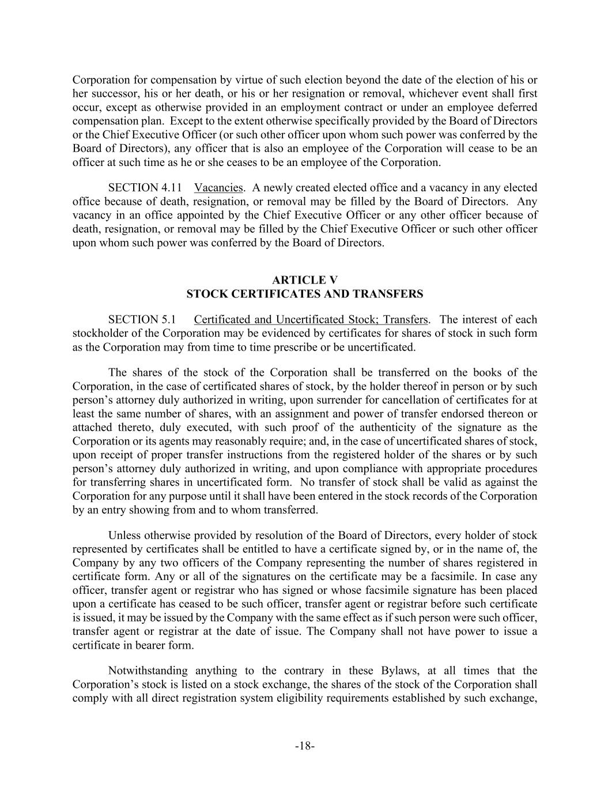
-18- Corporation for compensation by virtue of such election beyond the date of the election of his or her successor, his or her death, or his or her resignation or removal, whichever event shall first occur, except as otherwise provided in an employment contract or under an employee deferred compensation plan. Except to the extent otherwise specifically provided by the Board of Directors or the Chief Executive Officer (or such other officer upon whom such power was conferred by the Board of Directors), any officer that is also an employee of the Corporation will cease to be an officer at such time as he or she ceases to be an employee of the Corporation. SECTION 4.11 Vacancies. A newly created elected office and a vacancy in any elected office because of death, resignation, or removal may be filled by the Board of Directors. Any vacancy in an office appointed by the Chief Executive Officer or any other officer because of death, resignation, or removal may be filled by the Chief Executive Officer or such other officer upon whom such power was conferred by the Board of Directors. STOCK CERTIFICATES AND TRANSFERS SECTION 5.1 Certificated and Uncertificated Stock; Transfers. The interest of each stockholder of the Corporation may be evidenced by certificates for shares of stock in such form as the Corporation may from time to time prescribe or be uncertificated. The shares of the stock of the Corporation shall be transferred on the books of the Corporation, in the case of certificated shares of stock, by the holder thereof in person or by such person’s attorney duly authorized in writing, upon surrender for cancellation of certificates for at least the same number of shares, with an assignment and power of transfer endorsed thereon or attached thereto, duly executed, with such proof of the authenticity of the signature as the Corporation or its agents may reasonably require; and, in the case of uncertificated shares of stock, upon receipt of proper transfer instructions from the registered holder of the shares or by such person’s attorney duly authorized in writing, and upon compliance with appropriate procedures for transferring shares in uncertificated form. No transfer of stock shall be valid as against the Corporation for any purpose until it shall have been entered in the stock records of the Corporation by an entry showing from and to whom transferred. Unless otherwise provided by resolution of the Board of Directors, every holder of stock represented by certificates shall be entitled to have a certificate signed by, or in the name of, the Company by any two officers of the Company representing the number of shares registered in certificate form. Any or all of the signatures on the certificate may be a facsimile. In case any officer, transfer agent or registrar who has signed or whose facsimile signature has been placed upon a certificate has ceased to be such officer, transfer agent or registrar before such certificate is issued, it may be issued by the Company with the same effect as if such person were such officer, transfer agent or registrar at the date of issue. The Company shall not have power to issue a certificate in bearer form. Notwithstanding anything to the contrary in these Bylaws, at all times that the Corporation’s stock is listed on a stock exchange, the shares of the stock of the Corporation shall comply with all direct registration system eligibility requirements established by such exchange,

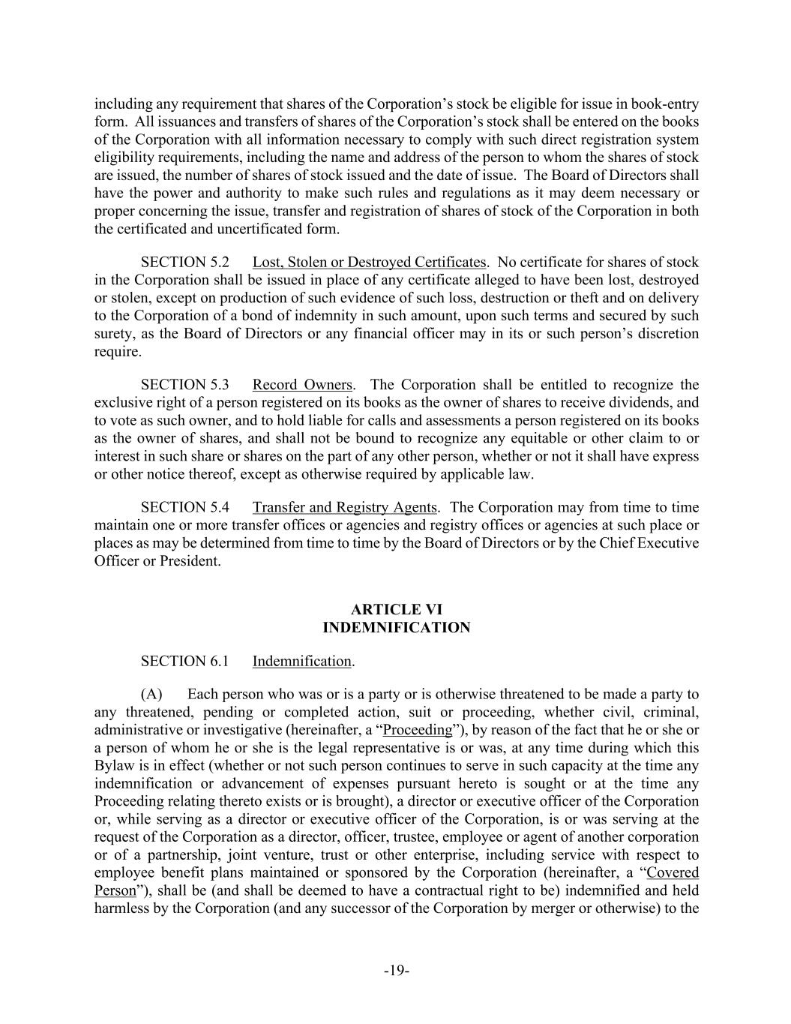
-19- including any requirement that shares of the Corporation’s stock be eligible for issue in book-entry form. All issuances and transfers of shares of the Corporation’s stock shall be entered on the books of the Corporation with all information necessary to comply with such direct registration system eligibility requirements, including the name and address of the person to whom the shares of stock are issued, the number of shares of stock issued and the date of issue. The Board of Directors shall have the power and authority to make such rules and regulations as it may deem necessary or proper concerning the issue, transfer and registration of shares of stock of the Corporation in both the certificated and uncertificated form. SECTION 5.2 Lost, Stolen or Destroyed Certificates. No certificate for shares of stock in the Corporation shall be issued in place of any certificate alleged to have been lost, destroyed or stolen, except on production of such evidence of such loss, destruction or theft and on delivery to the Corporation of a bond of indemnity in such amount, upon such terms and secured by such surety, as the Board of Directors or any financial officer may in its or such person’s discretion require. SECTION 5.3 Record Owners. The Corporation shall be entitled to recognize the exclusive right of a person registered on its books as the owner of shares to receive dividends, and to vote as such owner, and to hold liable for calls and assessments a person registered on its books as the owner of shares, and shall not be bound to recognize any equitable or other claim to or interest in such share or shares on the part of any other person, whether or not it shall have express or other notice thereof, except as otherwise required by applicable law. SECTION 5.4 Transfer and Registry Agents. The Corporation may from time to time maintain one or more transfer offices or agencies and registry offices or agencies at such place or places as may be determined from time to time by the Board of Directors or by the Chief Executive Officer or President. INDEMNIFICATION SECTION 6.1 Indemnification. (A) Each person who was or is a party or is otherwise threatened to be made a party to any threatened, pending or completed action, suit or proceeding, whether civil, criminal, administrative or investigative (hereinafter, a “Proceeding”), by reason of the fact that he or she or a person of whom he or she is the legal representative is or was, at any time during which this Bylaw is in effect (whether or not such person continues to serve in such capacity at the time any indemnification or advancement of expenses pursuant hereto is sought or at the time any Proceeding relating thereto exists or is brought), a director or executive officer of the Corporation or, while serving as a director or executive officer of the Corporation, is or was serving at the request of the Corporation as a director, officer, trustee, employee or agent of another corporation or of a partnership, joint venture, trust or other enterprise, including service with respect to employee benefit plans maintained or sponsored by the Corporation (hereinafter, a “Covered Person”), shall be (and shall be deemed to have a contractual right to be) indemnified and held harmless by the Corporation (and any successor of the Corporation by merger or otherwise) to the

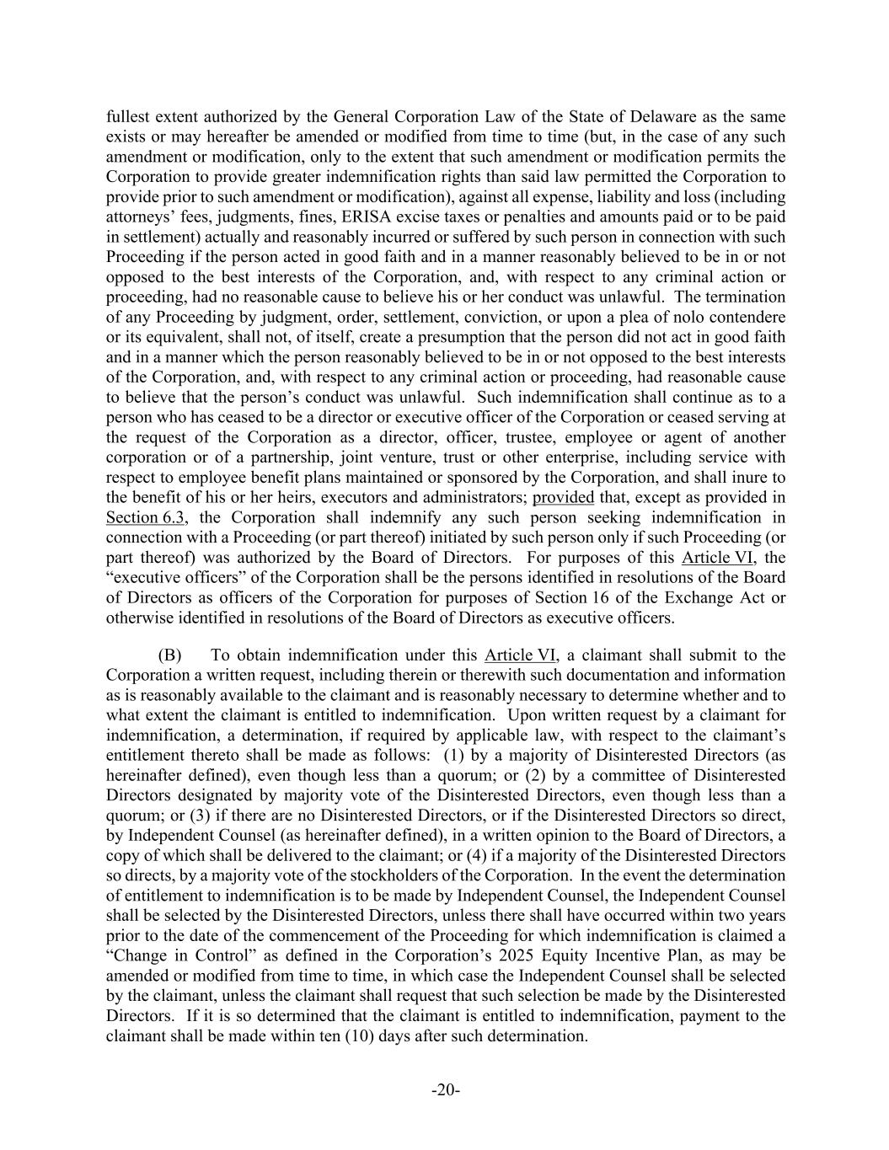
-20- fullest extent authorized by the General Corporation Law of the State of Delaware as the same exists or may hereafter be amended or modified from time to time (but, in the case of any such amendment or modification, only to the extent that such amendment or modification permits the Corporation to provide greater indemnification rights than said law permitted the Corporation to provide prior to such amendment or modification), against all expense, liability and loss (including attorneys’ fees, judgments, fines, ERISA excise taxes or penalties and amounts paid or to be paid in settlement) actually and reasonably incurred or suffered by such person in connection with such Proceeding if the person acted in good faith and in a manner reasonably believed to be in or not opposed to the best interests of the Corporation, and, with respect to any criminal action or proceeding, had no reasonable cause to believe his or her conduct was unlawful. The termination of any Proceeding by judgment, order, settlement, conviction, or upon a plea of nolo contendere or its equivalent, shall not, of itself, create a presumption that the person did not act in good faith and in a manner which the person reasonably believed to be in or not opposed to the best interests of the Corporation, and, with respect to any criminal action or proceeding, had reasonable cause to believe that the person’s conduct was unlawful. Such indemnification shall continue as to a person who has ceased to be a director or executive officer of the Corporation or ceased serving at the request of the Corporation as a director, officer, trustee, employee or agent of another corporation or of a partnership, joint venture, trust or other enterprise, including service with respect to employee benefit plans maintained or sponsored by the Corporation, and shall inure to the benefit of his or her heirs, executors and administrators; provided that, except as provided in Section 6.3, the Corporation shall indemnify any such person seeking indemnification in connection with a Proceeding (or part thereof) initiated by such person only if such Proceeding (or part thereof) was authorized by the Board of Directors. For purposes of this Article VI, the “executive officers” of the Corporation shall be the persons identified in resolutions of the Board of Directors as officers of the Corporation for purposes of Section 16 of the Exchange Act or otherwise identified in resolutions of the Board of Directors as executive officers. (B) To obtain indemnification under this Article VI, a claimant shall submit to the Corporation a written request, including therein or therewith such documentation and information as is reasonably available to the claimant and is reasonably necessary to determine whether and to what extent the claimant is entitled to indemnification. Upon written request by a claimant for indemnification, a determination, if required by applicable law, with respect to the claimant’s entitlement thereto shall be made as follows: (1) by a majority of Disinterested Directors (as hereinafter defined), even though less than a quorum; or (2) by a committee of Disinterested Directors designated by majority vote of the Disinterested Directors, even though less than a quorum; or (3) if there are no Disinterested Directors, or if the Disinterested Directors so direct, by Independent Counsel (as hereinafter defined), in a written opinion to the Board of Directors, a copy of which shall be delivered to the claimant; or (4) if a majority of the Disinterested Directors so directs, by a majority vote of the stockholders of the Corporation. In the event the determination of entitlement to indemnification is to be made by Independent Counsel, the Independent Counsel shall be selected by the Disinterested Directors, unless there shall have occurred within two years prior to the date of the commencement of the Proceeding for which indemnification is claimed a “Change in Control” as defined in the Corporation’s 2025 Equity Incentive Plan, as may be amended or modified from time to time, in which case the Independent Counsel shall be selected by the claimant, unless the claimant shall request that such selection be made by the Disinterested Directors. If it is so determined that the claimant is entitled to indemnification, payment to the claimant shall be made within ten (10) days after such determination.

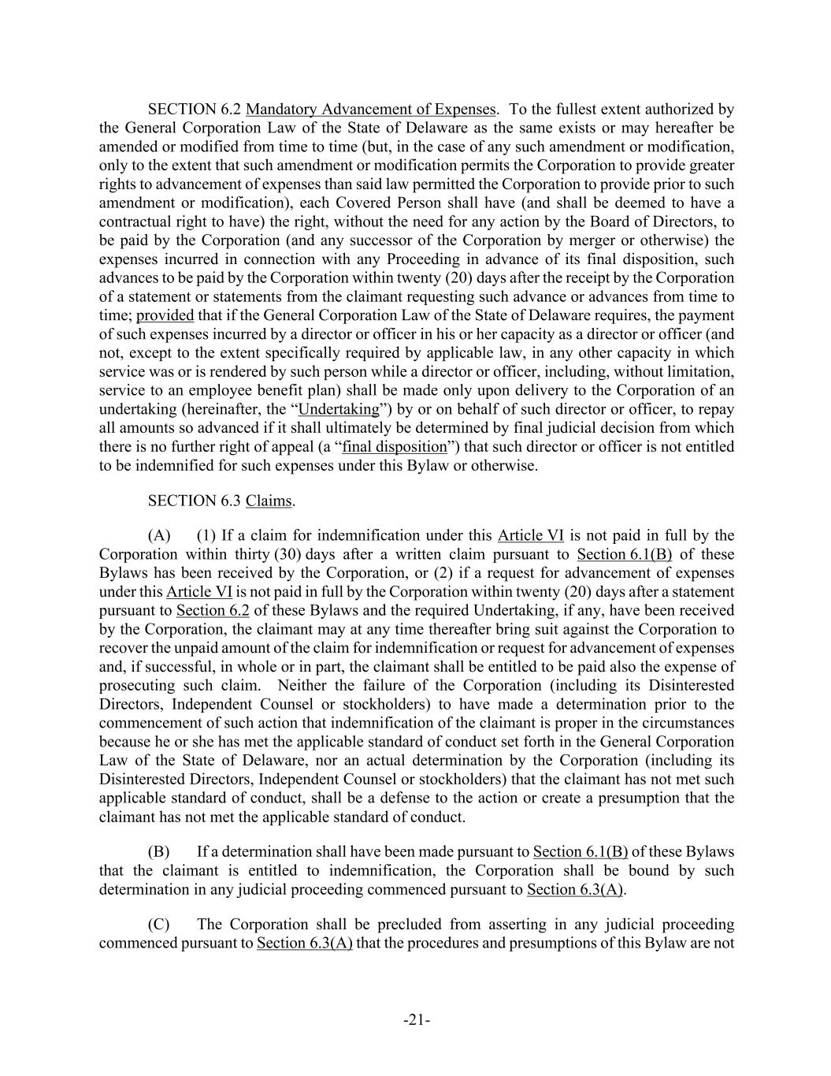
-21- SECTION 6.2 Mandatory Advancement of Expenses. To the fullest extent authorized by the General Corporation Law of the State of Delaware as the same exists or may hereafter be amended or modified from time to time (but, in the case of any such amendment or modification, only to the extent that such amendment or modification permits the Corporation to provide greater rights to advancement of expenses than said law permitted the Corporation to provide prior to such amendment or modification), each Covered Person shall have (and shall be deemed to have a contractual right to have) the right, without the need for any action by the Board of Directors, to be paid by the Corporation (and any successor of the Corporation by merger or otherwise) the expenses incurred in connection with any Proceeding in advance of its final disposition, such advances to be paid by the Corporation within twenty (20) days after the receipt by the Corporation of a statement or statements from the claimant requesting such advance or advances from time to time; provided that if the General Corporation Law of the State of Delaware requires, the payment of such expenses incurred by a director or officer in his or her capacity as a director or officer (and not, except to the extent specifically required by applicable law, in any other capacity in which service was or is rendered by such person while a director or officer, including, without limitation, service to an employee benefit plan) shall be made only upon delivery to the Corporation of an undertaking (hereinafter, the “Undertaking”) by or on behalf of such director or officer, to repay all amounts so advanced if it shall ultimately be determined by final judicial decision from which there is no further right of appeal (a “final disposition”) that such director or officer is not entitled to be indemnified for such expenses under this Bylaw or otherwise. SECTION 6.3 Claims. (A) (1) If a claim for indemnification under this Article VI is not paid in full by the Corporation within thirty (30) days after a written claim pursuant to Section 6.1(B) of these Bylaws has been received by the Corporation, or (2) if a request for advancement of expenses under this Article VI is not paid in full by the Corporation within twenty (20) days after a statement pursuant to Section 6.2 of these Bylaws and the required Undertaking, if any, have been received by the Corporation, the claimant may at any time thereafter bring suit against the Corporation to recover the unpaid amount of the claim for indemnification or request for advancement of expenses and, if successful, in whole or in part, the claimant shall be entitled to be paid also the expense of prosecuting such claim. Neither the failure of the Corporation (including its Disinterested Directors, Independent Counsel or stockholders) to have made a determination prior to the commencement of such action that indemnification of the claimant is proper in the circumstances because he or she has met the applicable standard of conduct set forth in the General Corporation Law of the State of Delaware, nor an actual determination by the Corporation (including its Disinterested Directors, Independent Counsel or stockholders) that the claimant has not met such applicable standard of conduct, shall be a defense to the action or create a presumption that the claimant has not met the applicable standard of conduct. (B) If a determination shall have been made pursuant to Section 6.1(B) of these Bylaws that the claimant is entitled to indemnification, the Corporation shall be bound by such determination in any judicial proceeding commenced pursuant to Section 6.3(A). (C) The Corporation shall be precluded from asserting in any judicial proceeding commenced pursuant to Section 6.3(A) that the procedures and presumptions of this Bylaw are not

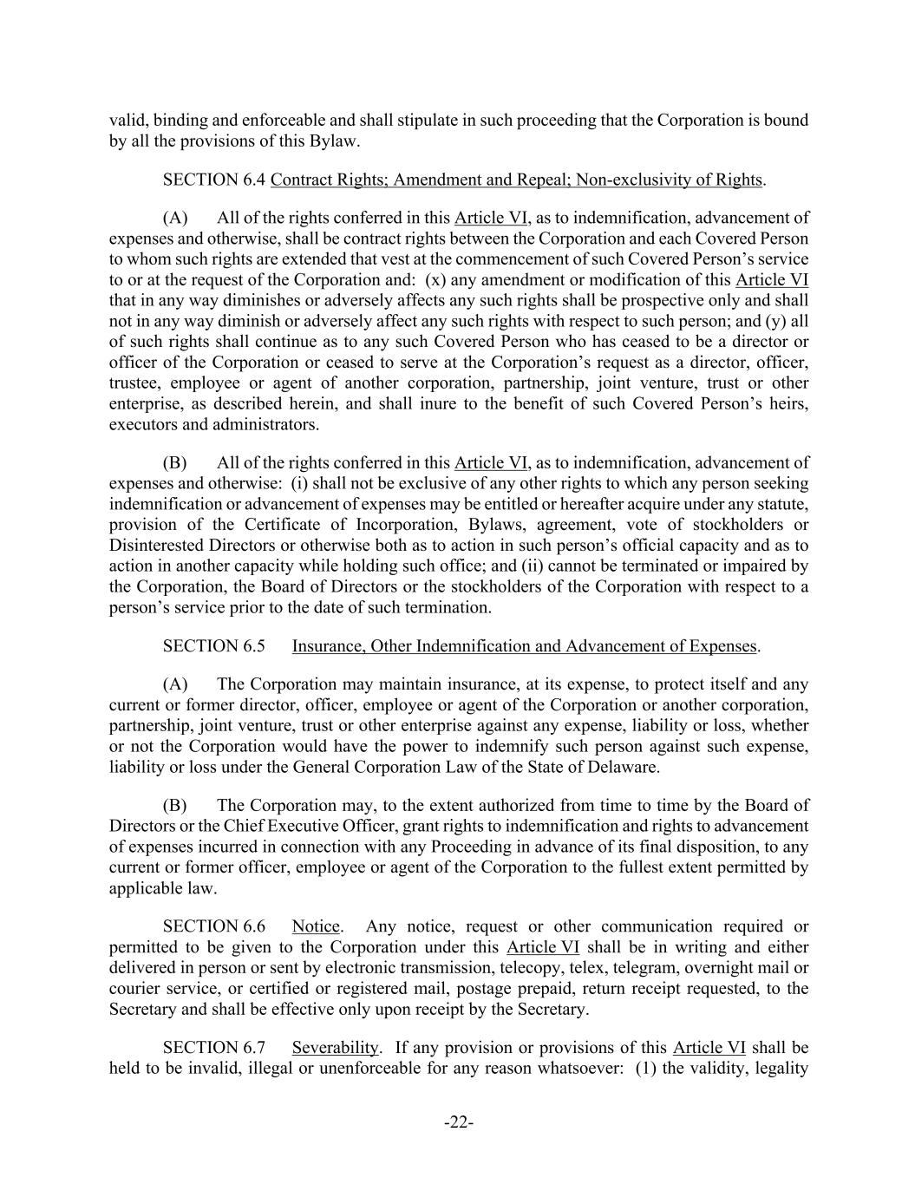
-22- valid, binding and enforceable and shall stipulate in such proceeding that the Corporation is bound by all the provisions of this Bylaw. SECTION 6.4 Contract Rights; Amendment and Repeal; Non-exclusivity of Rights. (A) All of the rights conferred in this Article VI, as to indemnification, advancement of expenses and otherwise, shall be contract rights between the Corporation and each Covered Person to whom such rights are extended that vest at the commencement of such Covered Person’s service to or at the request of the Corporation and: (x) any amendment or modification of this Article VI that in any way diminishes or adversely affects any such rights shall be prospective only and shall not in any way diminish or adversely affect any such rights with respect to such person; and (y) all of such rights shall continue as to any such Covered Person who has ceased to be a director or officer of the Corporation or ceased to serve at the Corporation’s request as a director, officer, trustee, employee or agent of another corporation, partnership, joint venture, trust or other enterprise, as described herein, and shall inure to the benefit of such Covered Person’s heirs, executors and administrators. (B) All of the rights conferred in this Article VI, as to indemnification, advancement of expenses and otherwise: (i) shall not be exclusive of any other rights to which any person seeking indemnification or advancement of expenses may be entitled or hereafter acquire under any statute, provision of the Certificate of Incorporation, Bylaws, agreement, vote of stockholders or Disinterested Directors or otherwise both as to action in such person’s official capacity and as to action in another capacity while holding such office; and (ii) cannot be terminated or impaired by the Corporation, the Board of Directors or the stockholders of the Corporation with respect to a person’s service prior to the date of such termination. SECTION 6.5 Insurance, Other Indemnification and Advancement of Expenses. (A) The Corporation may maintain insurance, at its expense, to protect itself and any current or former director, officer, employee or agent of the Corporation or another corporation, partnership, joint venture, trust or other enterprise against any expense, liability or loss, whether or not the Corporation would have the power to indemnify such person against such expense, liability or loss under the General Corporation Law of the State of Delaware. (B) The Corporation may, to the extent authorized from time to time by the Board of Directors or the Chief Executive Officer, grant rights to indemnification and rights to advancement of expenses incurred in connection with any Proceeding in advance of its final disposition, to any current or former officer, employee or agent of the Corporation to the fullest extent permitted by applicable law. SECTION 6.6 Notice. Any notice, request or other communication required or permitted to be given to the Corporation under this Article VI shall be in writing and either delivered in person or sent by electronic transmission, telecopy, telex, telegram, overnight mail or courier service, or certified or registered mail, postage prepaid, return receipt requested, to the Secretary and shall be effective only upon receipt by the Secretary. SECTION 6.7 Severability. If any provision or provisions of this Article VI shall be held to be invalid, illegal or unenforceable for any reason whatsoever: (1) the validity, legality

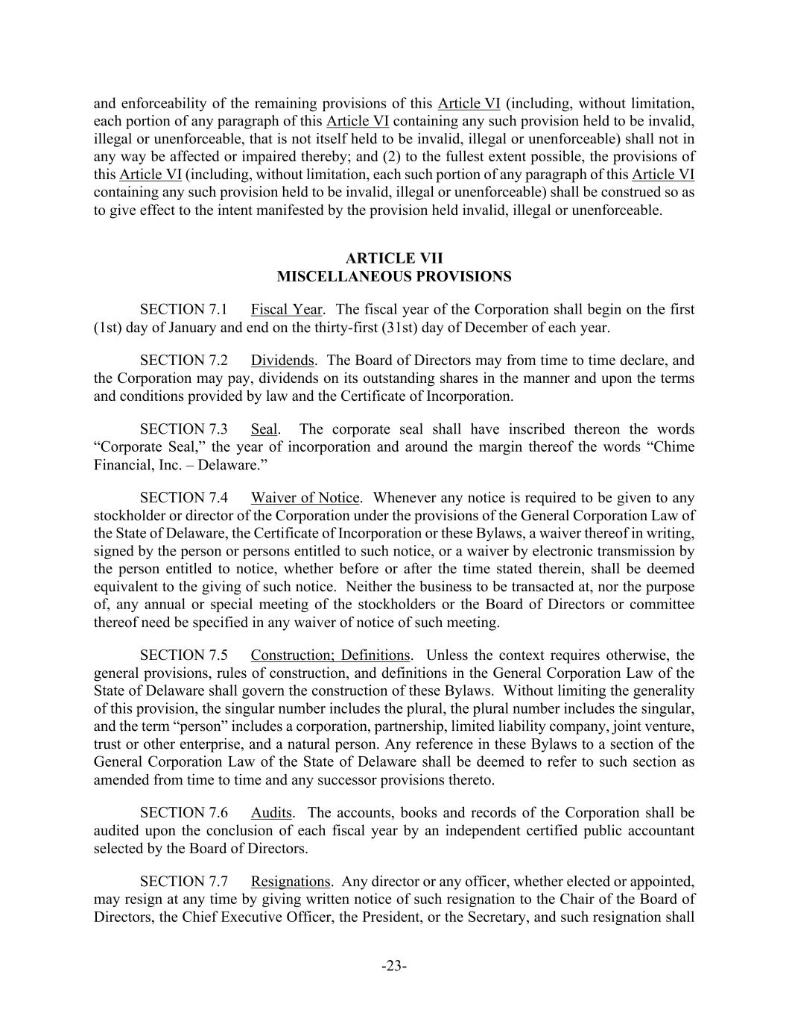
-23- and enforceability of the remaining provisions of this Article VI (including, without limitation, each portion of any paragraph of this Article VI containing any such provision held to be invalid, illegal or unenforceable, that is not itself held to be invalid, illegal or unenforceable) shall not in any way be affected or impaired thereby; and (2) to the fullest extent possible, the provisions of this Article VI (including, without limitation, each such portion of any paragraph of this Article VI containing any such provision held to be invalid, illegal or unenforceable) shall be construed so as to give effect to the intent manifested by the provision held invalid, illegal or unenforceable. MISCELLANEOUS PROVISIONS SECTION 7.1 Fiscal Year. The fiscal year of the Corporation shall begin on the first (1st) day of January and end on the thirty-first (31st) day of December of each year. SECTION 7.2 Dividends. The Board of Directors may from time to time declare, and the Corporation may pay, dividends on its outstanding shares in the manner and upon the terms and conditions provided by law and the Certificate of Incorporation. SECTION 7.3 Seal. The corporate seal shall have inscribed thereon the words “Corporate Seal,” the year of incorporation and around the margin thereof the words “Chime Financial, Inc. – Delaware.” SECTION 7.4 Waiver of Notice. Whenever any notice is required to be given to any stockholder or director of the Corporation under the provisions of the General Corporation Law of the State of Delaware, the Certificate of Incorporation or these Bylaws, a waiver thereof in writing, signed by the person or persons entitled to such notice, or a waiver by electronic transmission by the person entitled to notice, whether before or after the time stated therein, shall be deemed equivalent to the giving of such notice. Neither the business to be transacted at, nor the purpose of, any annual or special meeting of the stockholders or the Board of Directors or committee thereof need be specified in any waiver of notice of such meeting. SECTION 7.5 Construction; Definitions. Unless the context requires otherwise, the general provisions, rules of construction, and definitions in the General Corporation Law of the State of Delaware shall govern the construction of these Bylaws. Without limiting the generality of this provision, the singular number includes the plural, the plural number includes the singular, and the term “person” includes a corporation, partnership, limited liability company, joint venture, trust or other enterprise, and a natural person. Any reference in these Bylaws to a section of the General Corporation Law of the State of Delaware shall be deemed to refer to such section as amended from time to time and any successor provisions thereto. SECTION 7.6 Audits. The accounts, books and records of the Corporation shall be audited upon the conclusion of each fiscal year by an independent certified public accountant selected by the Board of Directors. SECTION 7.7 Resignations. Any director or any officer, whether elected or appointed, may resign at any time by giving written notice of such resignation to the Chair of the Board of Directors, the Chief Executive Officer, the President, or the Secretary, and such resignation shall

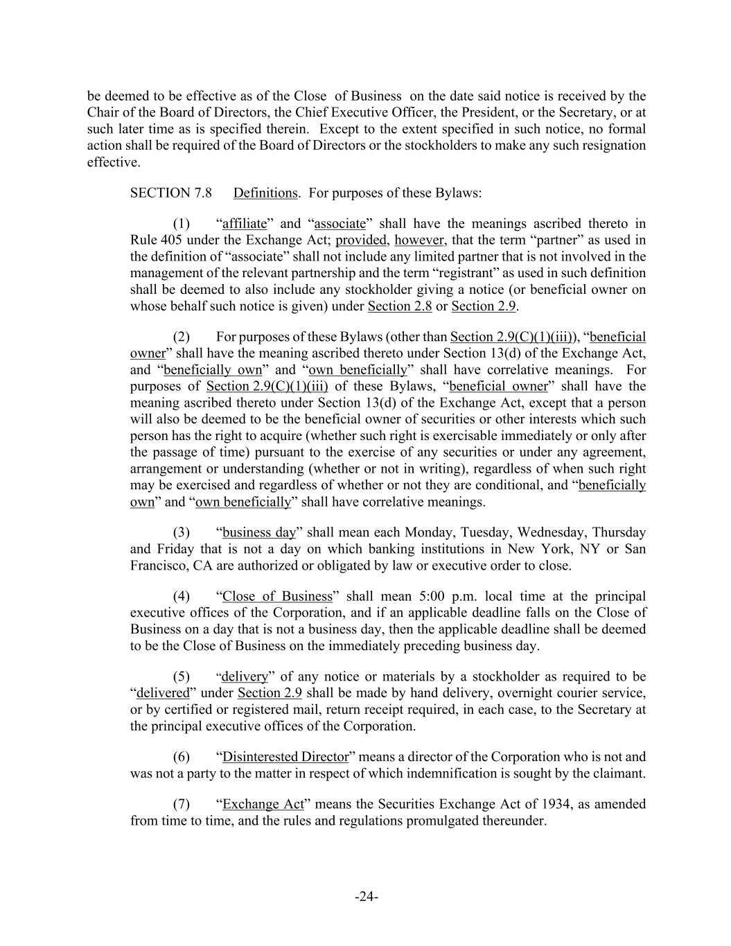
-24- be deemed to be effective as of the Close of Business on the date said notice is received by the Chair of the Board of Directors, the Chief Executive Officer, the President, or the Secretary, or at such later time as is specified therein. Except to the extent specified in such notice, no formal action shall be required of the Board of Directors or the stockholders to make any such resignation effective. SECTION 7.8 Definitions. For purposes of these Bylaws: (1) “affiliate” and “associate” shall have the meanings ascribed thereto in Rule 405 under the Exchange Act; provided, however, that the term “partner” as used in the definition of “associate” shall not include any limited partner that is not involved in the management of the relevant partnership and the term “registrant” as used in such definition shall be deemed to also include any stockholder giving a notice (or beneficial owner on whose behalf such notice is given) under Section 2.8 or Section 2.9. (2) For purposes of these Bylaws (other than Section 2.9(C)(1)(iii)), “beneficial owner” shall have the meaning ascribed thereto under Section 13(d) of the Exchange Act, and “beneficially own” and “own beneficially” shall have correlative meanings. For purposes of Section 2.9(C)(1)(iii) of these Bylaws, “beneficial owner” shall have the meaning ascribed thereto under Section 13(d) of the Exchange Act, except that a person will also be deemed to be the beneficial owner of securities or other interests which such person has the right to acquire (whether such right is exercisable immediately or only after the passage of time) pursuant to the exercise of any securities or under any agreement, arrangement or understanding (whether or not in writing), regardless of when such right may be exercised and regardless of whether or not they are conditional, and “beneficially own” and “own beneficially” shall have correlative meanings. (3) “business day” shall mean each Monday, Tuesday, Wednesday, Thursday and Friday that is not a day on which banking institutions in New York, NY or San Francisco, CA are authorized or obligated by law or executive order to close. (4) “Close of Business” shall mean 5:00 p.m. local time at the principal executive offices of the Corporation, and if an applicable deadline falls on the Close of Business on a day that is not a business day, then the applicable deadline shall be deemed to be the Close of Business on the immediately preceding business day. (5) “delivery” of any notice or materials by a stockholder as required to be “delivered” under Section 2.9 shall be made by hand delivery, overnight courier service, or by certified or registered mail, return receipt required, in each case, to the Secretary at the principal executive offices of the Corporation. (6) “Disinterested Director” means a director of the Corporation who is not and was not a party to the matter in respect of which indemnification is sought by the claimant. (7) “Exchange Act” means the Securities Exchange Act of 1934, as amended from time to time, and the rules and regulations promulgated thereunder.

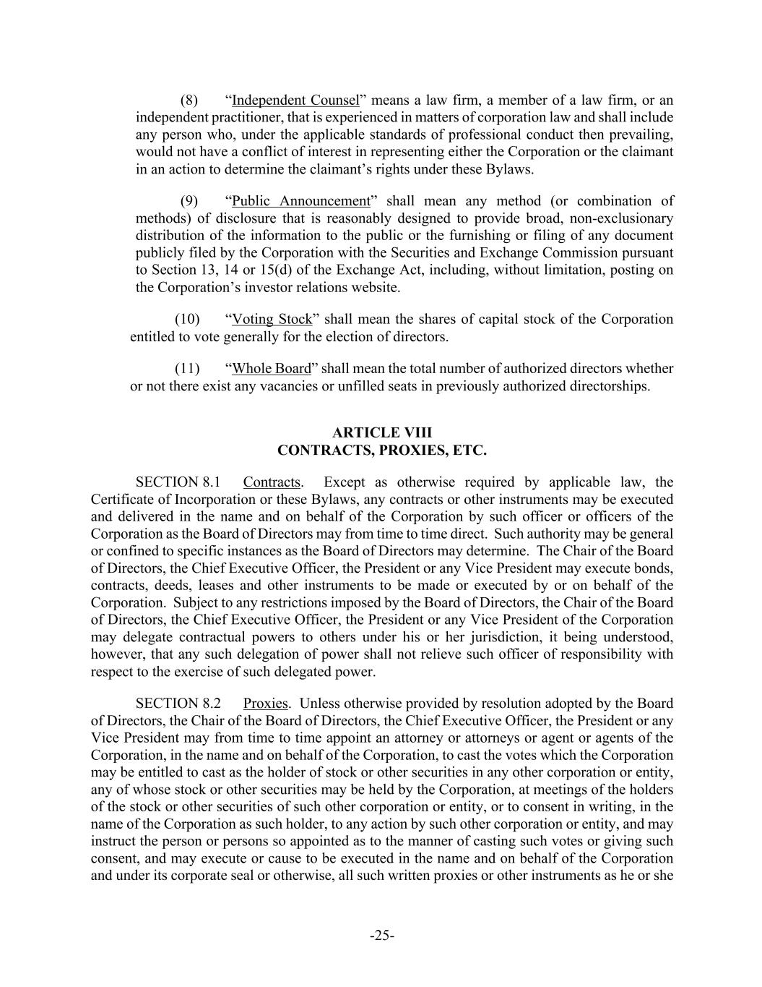
-25- (8) “Independent Counsel” means a law firm, a member of a law firm, or an independent practitioner, that is experienced in matters of corporation law and shall include any person who, under the applicable standards of professional conduct then prevailing, would not have a conflict of interest in representing either the Corporation or the claimant in an action to determine the claimant’s rights under these Bylaws. (9) “Public Announcement” shall mean any method (or combination of methods) of disclosure that is reasonably designed to provide broad, non-exclusionary distribution of the information to the public or the furnishing or filing of any document publicly filed by the Corporation with the Securities and Exchange Commission pursuant to Section 13, 14 or 15(d) of the Exchange Act, including, without limitation, posting on the Corporation’s investor relations website. (10) “Voting Stock” shall mean the shares of capital stock of the Corporation entitled to vote generally for the election of directors. (11) “Whole Board” shall mean the total number of authorized directors whether or not there exist any vacancies or unfilled seats in previously authorized directorships. CONTRACTS, PROXIES, ETC. SECTION 8.1 Contracts. Except as otherwise required by applicable law, the Certificate of Incorporation or these Bylaws, any contracts or other instruments may be executed and delivered in the name and on behalf of the Corporation by such officer or officers of the Corporation as the Board of Directors may from time to time direct. Such authority may be general or confined to specific instances as the Board of Directors may determine. The Chair of the Board of Directors, the Chief Executive Officer, the President or any Vice President may execute bonds, contracts, deeds, leases and other instruments to be made or executed by or on behalf of the Corporation. Subject to any restrictions imposed by the Board of Directors, the Chair of the Board of Directors, the Chief Executive Officer, the President or any Vice President of the Corporation may delegate contractual powers to others under his or her jurisdiction, it being understood, however, that any such delegation of power shall not relieve such officer of responsibility with respect to the exercise of such delegated power. SECTION 8.2 Proxies. Unless otherwise provided by resolution adopted by the Board of Directors, the Chair of the Board of Directors, the Chief Executive Officer, the President or any Vice President may from time to time appoint an attorney or attorneys or agent or agents of the Corporation, in the name and on behalf of the Corporation, to cast the votes which the Corporation may be entitled to cast as the holder of stock or other securities in any other corporation or entity, any of whose stock or other securities may be held by the Corporation, at meetings of the holders of the stock or other securities of such other corporation or entity, or to consent in writing, in the name of the Corporation as such holder, to any action by such other corporation or entity, and may instruct the person or persons so appointed as to the manner of casting such votes or giving such consent, and may execute or cause to be executed in the name and on behalf of the Corporation and under its corporate seal or otherwise, all such written proxies or other instruments as he or she

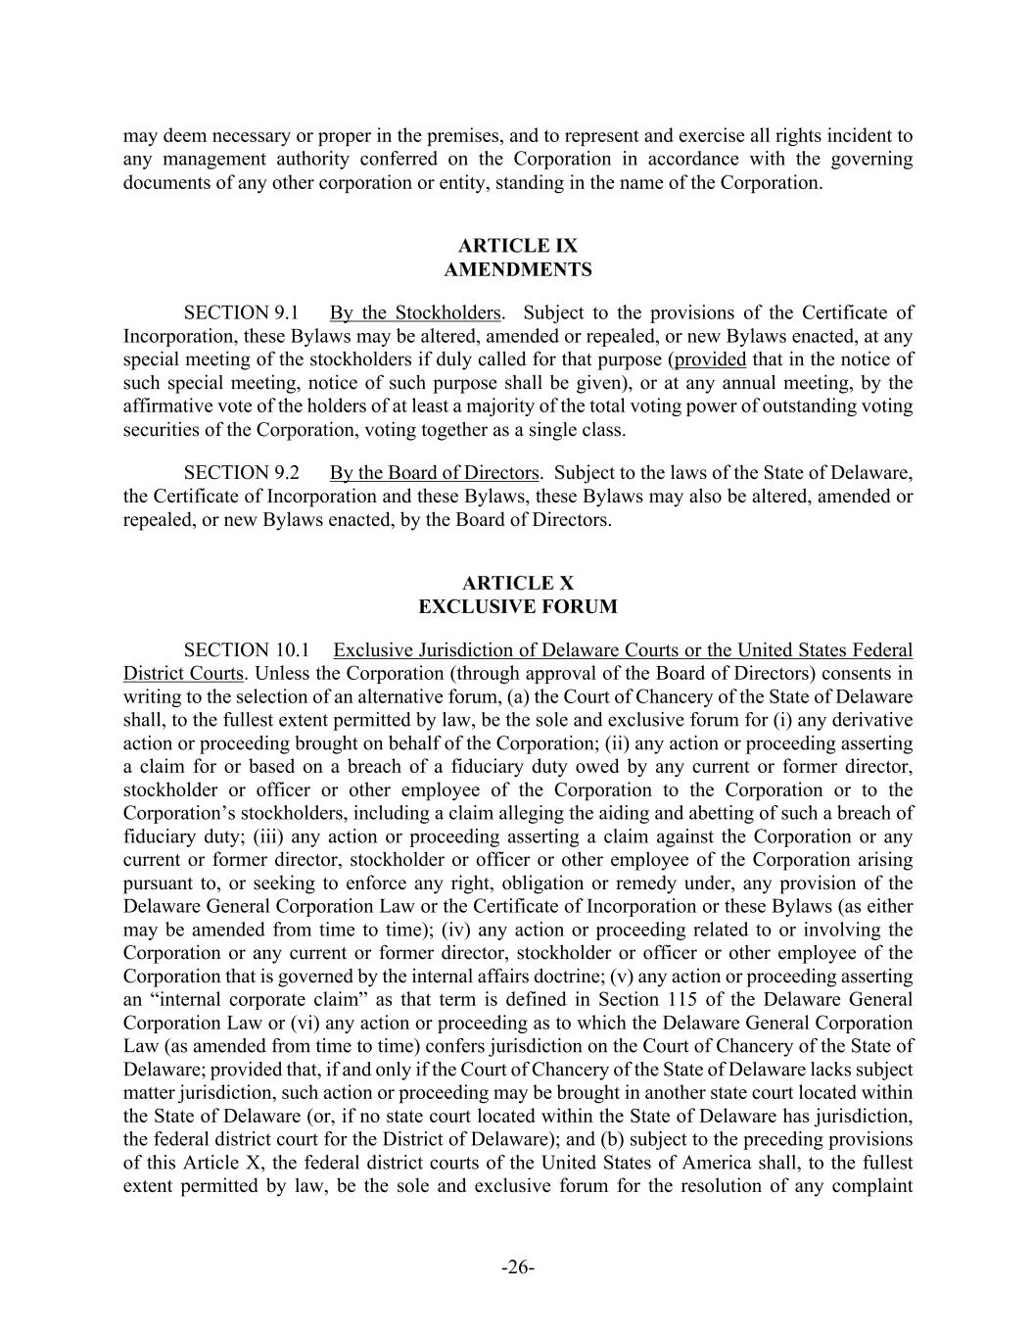
-26- may deem necessary or proper in the premises, and to represent and exercise all rights incident to any management authority conferred on the Corporation in accordance with the governing documents of any other corporation or entity, standing in the name of the Corporation. AMENDMENTS SECTION 9.1 By the Stockholders. Subject to the provisions of the Certificate of Incorporation, these Bylaws may be altered, amended or repealed, or new Bylaws enacted, at any special meeting of the stockholders if duly called for that purpose (provided that in the notice of such special meeting, notice of such purpose shall be given), or at any annual meeting, by the affirmative vote of the holders of at least a majority of the total voting power of outstanding voting securities of the Corporation, voting together as a single class. SECTION 9.2 By the Board of Directors. Subject to the laws of the State of Delaware, the Certificate of Incorporation and these Bylaws, these Bylaws may also be altered, amended or repealed, or new Bylaws enacted, by the Board of Directors. EXCLUSIVE FORUM SECTION 10.1 Exclusive Jurisdiction of Delaware Courts or the United States Federal District Courts. Unless the Corporation (through approval of the Board of Directors) consents in writing to the selection of an alternative forum, (a) the Court of Chancery of the State of Delaware shall, to the fullest extent permitted by law, be the sole and exclusive forum for (i) any derivative action or proceeding brought on behalf of the Corporation; (ii) any action or proceeding asserting a claim for or based on a breach of a fiduciary duty owed by any current or former director, stockholder or officer or other employee of the Corporation to the Corporation or to the Corporation’s stockholders, including a claim alleging the aiding and abetting of such a breach of fiduciary duty; (iii) any action or proceeding asserting a claim against the Corporation or any current or former director, stockholder or officer or other employee of the Corporation arising pursuant to, or seeking to enforce any right, obligation or remedy under, any provision of the Delaware General Corporation Law or the Certificate of Incorporation or these Bylaws (as either may be amended from time to time); (iv) any action or proceeding related to or involving the Corporation or any current or former director, stockholder or officer or other employee of the Corporation that is governed by the internal affairs doctrine; (v) any action or proceeding asserting an “internal corporate claim” as that term is defined in Section 115 of the Delaware General Corporation Law or (vi) any action or proceeding as to which the Delaware General Corporation Law (as amended from time to time) confers jurisdiction on the Court of Chancery of the State of Delaware; provided that, if and only if the Court of Chancery of the State of Delaware lacks subject matter jurisdiction, such action or proceeding may be brought in another state court located within the State of Delaware (or, if no state court located within the State of Delaware has jurisdiction, the federal district court for the District of Delaware); and (b) subject to the preceding provisions of this Article X, the federal district courts of the United States of America shall, to the fullest extent permitted by law, be the sole and exclusive forum for the resolution of any complaint

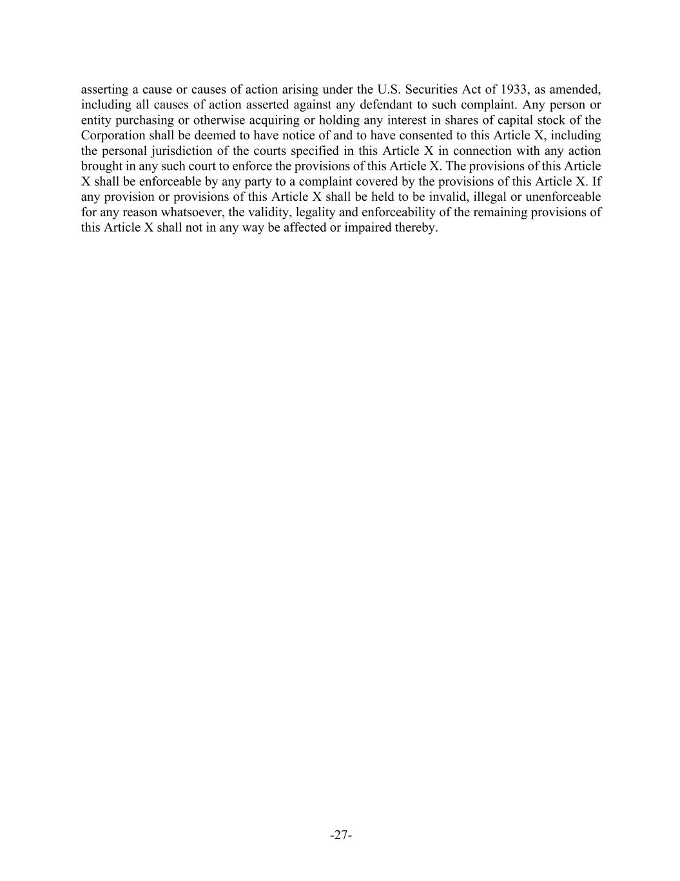
-27- asserting a cause or causes of action arising under the U.S. Securities Act of 1933, as amended, including all causes of action asserted against any defendant to such complaint. Any person or entity purchasing or otherwise acquiring or holding any interest in shares of capital stock of the Corporation shall be deemed to have notice of and to have consented to this Article X, including the personal jurisdiction of the courts specified in this Article X in connection with any action brought in any such court to enforce the provisions of this Article X. The provisions of this Article X shall be enforceable by any party to a complaint covered by the provisions of this Article X. If any provision or provisions of this Article X shall be held to be invalid, illegal or unenforceable for any reason whatsoever, the validity, legality and enforceability of the remaining provisions of this Article X shall not in any way be affected or impaired thereby.

Exhibit 10.21

CERTAIN INFORMATION IN THIS EXHIBIT HAS BEEN REDACTED BECAUSE IT IS BOTH (I) NOT MATERIAL AND (II) INFORMATION THAT THE REGISTRANT TREATS AS PRIVATE OR CONFIDENTIAL. [***] INDICATES THAT INFORMATION HAS BEEN REDACTED.
–Execution Copy
MASTER SERVICES AGREEMENT
This MASTER SERVICES AGREEMENT (the “Agreement”) dated June 9, 2023, and effective as of July 1, 2023 (the “Effective Date”) is by and between Chime Financial, Inc. (“Client”), whose principal office is located at 101 California, #500, San Francisco CA 94111 and The Bancorp Bank, N.A. (the “Bank”) a nationally chartered bank with its principal offices at 6100 S. Old Village Place, Sioux Falls, South Dakota 57108. Client and Bank are collectively referred to the “Parties” and are individually referred to as a “Party.”
RECITALS
(a) Bank is a nationally-chartered bank which intends to offer Programs and perform other activities as set forth in this Agreement. Bank and any of its successors, subsidiaries, and assigns are collectively referred to as “Bank” throughout this Agreement.
(b) Client is in the business of developing, marketing, and servicing consumer relationships, including relationships involving consumer banking and payment services.
(c) Bank desires to (i) retain Client to continue to provide certain marketing and program management services, (ii) have Client market Programs, issued by Bank in accordance with this Agreement.
(d) Client desires to continue to provide its marketing services to Bank and to serve as the Bank’s limited agent solely for the purposes of marketing and servicing the Bank’s Programs to Client’s Customers and in accordance herewith.
(e) Bank and Client are parties to the Amended and Restated Private Label Account Program Services Agreement dated on or about February 16, 2020, as amended (“Prior Agreement”). Bank and Parties desire to amend and restate the Prior Agreement in its entirety, together with all amendments thereto.
(f) Bank and Client are entering into this Agreement to document the terms and conditions applicable to the development, marketing, and servicing of new and existing Financial Products and Services.
TERMS OF AGREEMENT
NOW, THEREFORE, in consideration of the mutual covenants and conditions hereinafter set forth, the Parties hereto, intending to be legally bound, agree as follows:

1
Master Services Agreement
CONFIDENTIAL AND PROPRIETARY
1.CERTAIN DEFINITIONS.
Except as otherwise specifically indicated, the following terms shall have the following meanings in this Agreement (such meanings to be equally applicable to both the singular and plural forms of the terms defined):
(a) “ACH” means the Automated Clearing House network.
(b) “Account” means a demand deposit account, savings account, credit card account and/or a loan account originated by Bank on behalf of a Customer.
(c) “Account Agreement” means the contract setting forth the terms and conditions applicable to the consumer Accounts as between the Bank and a Customer, including all disclosures required by law as well as the terms and conditions applicable to the Card issued in connection therewith.
(d) “Account Income” means all fee revenue received from a Customer including but not limited to transaction fees, balance inquiry fees, Card fees, or other fees as specified in the Account Agreement.
(e) “Addendum” means added terms to this Agreement governing specific terms of various Programs or product types subject to this Agreement. For avoidance of doubt, any reference to “Agreement” shall include any applicable Addendums.
(f) “Affiliate” means, with respect to any Person, each Person who directly or indirectly controls, is controlled by or is under common control with a Party. For the purpose of this definition, the term “control” (including with correlative meanings, the terms controlling, controlled by and under common control with) means the power to direct the management or policies of such Person or Party, directly or indirectly, through the ownership of twenty-five percent (25%) or more of a class of voting securities, by contract or otherwise.
(g) “Applicable Law” means, to the extent applicable to a Party, a particular Program, or made applicable by virtue of this Agreement, (i) Consumer Protection Laws, (ii) Data Security and Privacy Laws, (iii) the Rules, (iv) any order issued by a court having jurisdiction over a Party (v) any applicable international, federal, state, or local law, including without limitation, the Bank Secrecy Act and its implementing regulations including, 31 CFR 1022.210, 31 CFR 1022.320, 31CFR 1022.420, any and all sanctions or regulations enforced by OFAC, and statutes or regulations of any state relating to card issuance, money transmission or unclaimed property, that are applicable to the marketing, issuance, sale, authorization or usage of the Cards (including, but not limited to, Title IV of the Credit Card Accountability Responsibility and Disclosure Act of 2009, Section 920 of the Electronic Fund Transfer Act, as amended, and the Prepaid Access Rule), and (vi) any other regulation, rule, supervisory guidance, directive, or interpretation promulgated or published by a Regulatory Authority.
2
Master Services Agreement
CONFIDENTIAL AND PROPRIETARY
(h) “Asset Based Program” means any Program offered pursuant to a Program Addendum and applicable Program Authorization Letter which involves the Bank extending credit
3
Master Services Agreement
CONFIDENTIAL AND PROPRIETARY
or other liquidity and holding such credit or other liquidity on its balance sheet, which may include credit card accounts, loan accounts, and overdraft or similar programs.
(i) “Bank Fees and Assessments” has the meaning set forth in in an Exhibit to the applicable Addendum.
(j) “Bank Transaction Fees” has the meaning set forth in an Exhibit to the applicable Addendum.
(k) “Business Day” means Monday through Friday, excluding federal holidays.
(l) “Card” means any access device issued and/or sold by Bank to a Customer pursuant to the Prior Agreement or this Agreement, used for the purchase of goods and services by accessing the available balance in an Account through a Network.
(m) “Client Funded Asset Account” means the balance of any funds held in a Negative Balance Funding Account (as defined in an applicable Addendum) or an account which is used as collateral against Accounts originated pursuant to an Asset Based Program, or as further set forth in Exhibit A of this Agreement.
(n) “Consumer Protection Laws” means the laws applicable to a Consumer for each Financial Product or Service established primarily for personal, family, or household purposes.
(o) “Customer” means any person obtaining an Account under the Agreement pursuant to the Account-opening standards set forth in the Rules.
(p) “Customer Agreement” means the agreement between Bank and a Customer governing the terms and use of a Financial Product or Service.
(q) “Customer Disclosures” means the Customer Agreement, Cards (to the extent applicable), and any other terms and conditions or disclosures required by Applicable Law for participation in a Program or using a Financial Product or Service.
(r) “Customer Funds” means the balance of funds held by Bank on behalf of a Customer.
(s) “Data Security and Privacy Laws” means the federal banking agencies’ Interagency Guidelines Establishing Standards for Safeguarding Consumer Information and the Interagency Guidelines Establishing Information Security Standards, 12 CFR 1016 (Regulation P), any other applicable federal or state law regarding protection of Nonpublic Personal Information, and to the extent applicable, the General Data Protection Regulation (GDPR).
4
Master Services Agreement
CONFIDENTIAL AND PROPRIETARY
(t) “Deposit” has the meaning set forth in Section 3(1) of the Federal Deposit Insurance Act, 12 U.S.C. § 1813(1).
(u) “Deposit Amount” means the amount of funds a Customer deposits into an Account.
5
Master Services Agreement
CONFIDENTIAL AND PROPRIETARY
(v) “Deposit Network” means any third-party network approved by Bank and over which cash Deposits are accepted through a Processor and subsequently settled with the Bank.
(w) “Due Diligence” means the process of evaluating or auditing a Subcontractor or other third party in order to identify any potential risks of doing business with such entity.
(x) “Financial Products and Services” means the products or services offered by Bank and serviced by Client pursuant to this Agreement, as set forth in the applicable Addendum.
(y) “Funding Failure” means the failure of a Deposit Amount to be effectively credited to any Program Account, for any reason, including but not limited to a lack of sufficient funds on deposit to cover the sum of the Deposits, an ACH reject, the failure of any Deposit Network to fund a Deposit or any other cause.
(z) “Graphic Standards” means all standards, policies, and other requirements adopted by a Network or Bank from time to time with respect to use of its Marks.
(aa) “Interchange” or “Interchange Fee” means the fee paid to the Bank as issuer of the Card by an acquiring financial institution for a Transaction, as established by a Network.
(bb) “Intellectual Property Rights” means, with respect to each Party, all (i) intellectual property rights of any kind, worldwide, including utility patents, design patents, utility models, and all applications for the foregoing; (ii) published works of authorship, registered copyrights, and all registrations and applications for the foregoing; (iii) proprietary software, technology and documentation; (iv) documented trade secrets; and (v) other proprietary information or materials, in whatever form.
(cc) “Mark” means the service marks and trademarks of a Network, Bank or Client, and includes but not is limited to, the names and other distinctive marks or logos, which identify a Network, Client or Bank.
(dd) “Membership” means the membership in a Network and licensing rights thereto obtained by Bank.
(ee) “Network” means any third-party network over which funds are transferred or Transactions and Settlements are processed (including but not limited to MasterCard, VISA, Discover, Maestro, Interlink, Pulse, STAR, Cirrus, Plus, MoneyPass, Allpoint, Green Dot, Western Union, MoneyGram, Visa Readylink, MasterCard RePower, Ingo, Nacha).
(ff) “Nonpublic Personal Information” means “non-public personal information” as defined in the Gramm-Leach-Bliley Act and implementing regulations, or any other protected Consumer-identifying information under Applicable Law; including, without limitation, a
6
Master Services Agreement
CONFIDENTIAL AND PROPRIETARY
Consumer’s name, address, or telephone number in conjunction with the Consumer’s social security number, driver’s license number, account number, credit or debit card number, or a personal identification number or password that would permit access to the Consumer’s account, or any combination of components of Consumer information that would allow someone to log onto or access a Consumer’s account, such as a username and password, password and account
7
Master Services Agreement
CONFIDENTIAL AND PROPRIETARY
number, transaction information regarding the Consumer account, or any other information provided to Bank or Client by a Consumer in connection with the Program.
(gg) “Person” means any legal person, including any individual, corporation, limited liability company, partnership, joint venture, association, joint-stock company, trust, unincorporated organization, governmental entity or other entity of any nature.
(hh) “Processing Services” means those services that are described in an Exhibit to the applicable Addendum and which are necessary to issue and service the Accounts, including, but not limited to, the processing necessary for Card Transactions, in accordance with the Rules of any Network and Regulatory Authority.
(ii) “Processor” means a third-party provider of payment processing or recordkeeping services relied upon by Bank and Client in connection with any Programs contemplated by this Agreement. “Processor” shall also mean Client in the event that Client is approved by Bank to provide Processing Services pursuant to Section 3.6 of this Agreement.
(jj) “Program” means the marketing, evaluation, processing, administration, supervision, servicing, and maintenance of the Accounts established under this Agreement, and the phrase “Account Program” shall mean a unique Account marketing effort approved by Bank pursuant to a Program Authorization Letter.
(kk) “Program Account” shall have the meaning described in Section 2.6 of this Agreement.
(ll) “Program Authorization Letter” means a letter from Bank authorizing the development and launch of an Account Program. Any Program Authorization Letter shall set forth the general parameters, features, and any special terms under which the Account Program is authorized under. For clarity, all Program Authorization Letters approved under the Prior Agreement continue to be approved under this Agreement.
(mm) “Program Collateral” means all Customer Disclosures and Solicitation Materials relating to a Program.
(nn) “Program Management Fee” means the fee paid by Bank to Client for the marketing and program management services as determined in an Exhibit to the applicable Addendum.
(oo) “Program Revenues” means all Account Income and Interchange Fee revenues generated by or accruing to the Bank under a Program.
8
Master Services Agreement
CONFIDENTIAL AND PROPRIETARY
(pp) “Program Website” means the website (s) or mobile application(s) through which the Program is marketed to Customers and the website or websites utilized by Customers to provide information about, and access to, their Accounts.
(qq) “Regulatory Authority” means, as the context requires, any Network; the Federal Reserve Board (FRB); the Office of the Comptroller of the Currency (OCC), the Consumer
9
Master Services Agreement
CONFIDENTIAL AND PROPRIETARY
Financial Protection Bureau (CFPB); Federal Trade Commission (FTC); the Federal Financial Institutions Examination Council (FFIEC); and any other Federal or state regulator or agency having jurisdiction over Bank, Client, or Financial Products and Services. It may also include, as the circumstances dictate, any non-U.S. authority having or exercising jurisdiction related to the issuance, sale, authorization or usage of Financial Products and Services provided under this Agreement.
(rr) “Required Reports” means the reports required by Bank to properly implement and monitor a Program, as set forth in an Exhibit to the applicable Addendum.
(ss) “Rules” means (i) the by-laws and operating rules of any Network, including all standards, policies, and other requirements adopted by a Network or Bank from time to time with respect to use of its Marks, (ii) any applicable rule or requirement of any Network related to the issuance, sale, authorization or usage of products or services to be provided under this Agreement, (iii) the published standards of the World Wide Web Consortium’s (W3C) related to digital content accessibility, and (iv) the published regulations of any Regulatory Authority and the policies and procedures of Bank, as promulgated by Bank’s Board of Directors or Bank senior management in good faith to ensure the continued safety and soundness of Bank.
(tt) “Settlement” means the movement of funds between Bank and Network members in accordance with the Rules.
(uu) “Solicitation Material” means the advertisements, brochures, applications, marketing materials, telemarketing scripts and any other written materials relating to a Program, including point of purchase displays, television advertisements, radio advertisements, electronic web pages, electronic web links, Program Websites, and any other type of advertisement, marketing material, or interactive media related to the Program or any other materials sent to, or viewed by, a Customer or prospective Customer from time to time. For clarity, all Solicitation Materials approved under the Prior Agreement continue to be approved under this Agreement.
(vv) “Subcontractor” means any Bank-approved Processor, servicer, reseller, or other third party contracted with Client to perform Client’s obligations under this Agreement on behalf of Client.
(ww) “Transaction” means a transaction that is processed through a Network and its members or through Processor, Bank or Client, including, without limitation, deposits, purchases, cash withdrawals, ACH transfers, disputes and refunds.
(xx) “Wind Down Period” means the period from the date of termination or expiration of the Agreement through the date that the Parties have completed the Wind-Down Plan for the Programs entirely pursuant to Section 10.
10
Master Services Agreement
CONFIDENTIAL AND PROPRIETARY
(yy) “Wind-Down Plan” has the meaning set forth in Section 10.2.
(zz) “Successor Bank” has the meaning set forth in Section 10.1.
11
Master Services Agreement
CONFIDENTIAL AND PROPRIETARY
2.PROGRAMS GENERALLY
2.0 Purpose. The purpose of this Agreement is to offer Programs, marketed by Client and issued by Bank. It is designed to offer Customers convenient and secure Financial Products and Services.
2.1 Amendment and Restatement. The Prior Agreement is hereby amended in its entirety and restated herein in this Agreement. Such amendment and restatement is effective upon the Effective Date. The Prior Agreement shall be of no further force and effect upon the Effective Date, except nothing in this Section 2.1 shall affect any obligations incurred by a Party under the Prior Agreement prior to the Effective Date. For clarity, nothing in this Agreement is intended to constitute an express or implied waiver (unless otherwise set forth in this Agreement) of any rights or remedies arising prior to the Effective Date that either Client or Bank may possess in connection with the Prior Agreement, all of which are hereby expressly reserved.
2.2 Bank Oversight and Control. Bank and Client hereby each acknowledge and agree the products and services offered under the Program pursuant to this Agreement are products of Bank. Client recognizes and acknowledges that Bank shall have control and oversight over the Program pursuant to Applicable Law. Bank shall have the final determination as to any material changes that may be required or advisable under Applicable Law. Bank recognizes and acknowledges that Client (i) offers products and services independent of the Program including through third parties, which may now or in the future include lending products and services, and (ii) shall create and maintain an integrated relationship with Customers and potential Customers in connection with such non-Program products and services. As between Bank and Client, Client shall have control and oversight over such non-Program products and services, and the final determination of any material changes that may be required or advisable under Applicable Law, provided that such non-Program products and services do not use any Bank Marks. Bank shall provide commercially reasonable cooperation and assistance with Client’s efforts to integrate non-Program and Program products, services and features, including those connected to lending products and services, to offer Customers and potential Customers an enhanced and seamless user experience.
2.3 Appointment of Client. Bank hereby appoints Client as its authorized delegate and representative to (A) assist Bank in the development and marketing of the Program(s), (B) market the Accounts on behalf of Bank, and (C) perform services and contract with sub-contractors to support for the Program, all in accordance with the terms of this Agreement. Bank further appoints Client as its agent for the purpose of performing certain duties in maintaining compliance with OFAC sanctions and regulations and the Bank Secrecy Act.
2.4 Customer Approval. All Customers shall be approved and qualified in accordance with the Rules for purposes of receiving an Account, which will include, but not be limited to, Customer information collection, due diligence and identity verification. Bank reserves the right
12
Master Services Agreement
CONFIDENTIAL AND PROPRIETARY
to deny Customer approval in accordance with Applicable Law or Rule, and in its sole discretion so long as such denial is not prohibited by Applicable Law, and Client agrees to cooperate with Bank in implementing the Customer approval or denial process required by Bank for the Program, as Bank may amend from time to time with sixty (60) days’ written notice to Client (or earlier to the extent required by Applicable Law).
13
Master Services Agreement
CONFIDENTIAL AND PROPRIETARY
2.5 Account Solicitation and Distribution. Client will market Accounts in accordance with the terms of this Agreement, in accordance with Applicable Law and the Rules, and subject to the terms and conditions of any Program Authorization Letter.
2.6 Establishment of Program Accounts. Bank and Client shall set up and maintain various internal ledger accounts at Bank (“Program Accounts”) as Bank and Client may deem necessary and appropriate in connection with the Program, including, but not limited to, Program Accounts for purposes of facilitating the flow of funds, including receiving Customer Deposits, and the payment of Settlement to the Network. The Parties acknowledge and agree that the Account information, including the balance calculation and all debits and credits related thereto, shall be maintained by the Processor on Bank’s behalf as provided in an Exhibit to the applicable Addendum.
2.7 Account Deposits and Delivery of Customer Payments. All mechanisms for the transmission of Deposits to fund the Accounts will be as set forth in this Agreement or the applicable Program Authorization Letter, which may be updated from time to time by mutual written agreement of Client and Bank without need to formally amend the Agreement or Program Authorization Letter, including in connection with Deposit mechanisms to be utilized by Bank. No Deposit mechanism may be utilized unless approved by Bank in writing. To the extent Client receives any Deposits or other sums in connection with the Accounts, Client or Client’s agent shall hold such funds in trust for the benefit of Bank and immediately forward the same to Bank via wire, ACH transfer or as otherwise specified in the applicable Program Authorization Letter.
2.8 Program Modification.
(a) In the event that Client and/or Bank reasonably determines that Applicable Law requires a modification to any Program contemplated by this Agreement, including, without limitation, a determination that Applicable Laws have been modified or passed in a jurisdiction that prohibit or place restrictions on the sale or distribution of Programs in the manner agreed, then the determining Party shall provide the other Party with written notice of such determination, and each Party shall cause itself and its agents, vendors, and/or third party service providers to take reasonable steps to avoid violating such Applicable Law, which the Parties acknowledge and agree may require suspending or terminating Programs in certain jurisdictions, and the actual out-of-pocket costs of taking such reasonable steps shall be borne solely by Client.
(b) Client may suggest changes to a Program at any time, subject to the prior written approval of Bank and any approvals or non-objection letters required by a Regulatory Authority. Bank agrees to consider such suggested changes in good faith and shall provide Client with commercially reasonable cooperation and assistance with any Bank approved changes, and that it shall provide any approval or disapproval of such requested changes within sixty (60) days of such made request, unless a longer period is required by a Regulatory Authority. Unless otherwise agreed to in writing by the Parties, Client shall be responsible for all costs associated with any such changes suggested by Client and approved by Bank. The Parties shall work
14
Master Services Agreement
CONFIDENTIAL AND PROPRIETARY
together reasonably and in good faith, taking into account any legally-binding effective date with respect to any change in a Program and the legal, compliance and reputation risks to the Parties, to implement the modification and/or terminate the affected Program(s) (if applicable) in the manner and time period specified by Client and approved by Bank.
15
Master Services Agreement
CONFIDENTIAL AND PROPRIETARY
2.9 Implementation of Ongoing Due Diligence and Audit Recommendations; Limitations of Bank Approval. All approval rights of Bank set forth in this Agreement are ongoing and, accordingly, notwithstanding Bank’s initial approval of any activity, process, policy, procedure, Account Program, Account Agreement, Solicitation Material, function, third party, or subcontractor Bank may revoke such approval or condition the ongoing effectiveness of such approval to the extent Bank reasonably determines that such approval may violate Applicable Law or the Rules. Where Bank seeks to revoke or condition an approval, Bank shall provide Client with a minimum of sixty (60) days’ notice and provide a written explanation as to the reasons for such revocation or conditioning, unless a shorter period is required by Applicable Law, Regulatory Authority, or Bank’s safety and soundness standards. Client shall comply with any such revocations or conditions within a timeframe determined by mutual agreement of the Parties.
2.10 Asset Based Programs.
(a) Asset Based Program Thresholds. Subject to the terms and conditions in this Agreement, from and after the Program Start Date and during the Term of this Agreement, any Renewal Term, and any Wind-Down Period, if applicable, Bank agrees that it shall originate and hold Accounts originated under any Asset Based Program on its balance sheet, including on an aggregated basis all Client Affiliates’ Asset Based Programs, not to exceed on an aggregated basis $750 million dollars (the “Asset Based Program Threshold Limit”). The Parties acknowledge and agree that, within [***] of execution of this Agreement, the Parties will work together in good faith to identify and develop a mutually agreed upon plan to build capital market outlets for loans and other non-credit liquidity products originated by Bank under an Asset Based Program, including but not limited to asset sales and asset-backed securitizations. For the avoidance of doubt, no Accounts originated under an Asset Based Program shall be sold, securitized, or otherwise transfer or change economic ownership except and until as may be provided under such agreement, and subject to any terms and conditions set forth therein.
(b) Asset Based Program Threshold Limits. At any time during the Term of this Agreement, if the aggregate principal balance of Accounts originated under an Asset Based Program and held by Bank (“Aggregate Account Balance”) exceeds the then-current Asset Based Program Threshold Limit [***], Bank may, in its sole discretion, either (a) increase the Asset Based Program Threshold Limit; (b) implement other methods mutually agreed by the Parties in writing to continue the Program if/when the Aggregate Account Balance meets the Asset Based Program Threshold Limit; or (c) upon [***] prior written notice to Client, suspend originations of Accounts related to an Asset Based Program.
(c) Review of Program Threshold Limit. In the event that the Aggregate Account Balance is nearing the Asset Based Program Threshold Limit (and no later than the date at which the Aggregate Account Balance reaches [***] of the Asset Based Program Threshold Limit), the Parties shall mutually review the Asset Based Program Threshold Limit. Bank may, in its sole
16
Master Services Agreement
CONFIDENTIAL AND PROPRIETARY
discretion, elect to increase the Asset Based Program Threshold Limit following such review. If Bank does not elect to increase the Asset Based Program Threshold Limit following such review, the Parties shall mutually discuss methods to continue the Asset Based Program if/when the Aggregate Account Balance meets the Asset Based Program Threshold Limit (including, but not limited to, offering participations of any extensions of credit or liquidity that would cause the
17
Master Services Agreement
CONFIDENTIAL AND PROPRIETARY
Aggregate Account Balance to exceed the Asset Based Program Threshold Limit; provided, however, that any such offering of participations shall be mutually agreed to by the parties in writing).
(d) Termination Right. Client may terminate any Asset Based Program addendum (without payment of a termination fee or other penalty) upon one hundred twenty (120) days’ written notice to Bank, provided all of the following conditions are met: (i) Bank does not elect to increase the Asset Based Program Threshold Limit; (ii) the Parties are unable to agree on methods to continue the Asset Based Program once the Aggregate Account Balance meets the Asset Based Program Threshold Limit; and (iii) the Aggregate Account Balance exceeds the Asset Based Program Threshold Limit, and Bank suspends extensions of credit to Accounts.
3.DUTIES OF CLIENT
3.0 Program Development and Implementation.
(a) Client will develop Account Programs, Solicitation Materials, and marketing efforts for the marketing of Accounts. Each Account Program, Solicitation Material, or marketing effort (other than Account Programs, Solicitation Materials or marketing efforts approved under the Prior Agreement) is subject to the review and approval of Bank and, at Bank’s discretion, Bank’s execution of a Program Authorization Letter, and such other documents as Bank may require. Bank agrees to review such proposals in accordance with Exhibit B. The Program Authorization Letter shall be generally in the form set forth in an exhibit to the applicable Addendum. Bank reserves the right, in its reasonable discretion, to refuse approval of any new Account Program or marketing proposal that, in its reasonable opinion presents unacceptable financial or reputation risk or is not consistent with the Rules or may be reasonably deemed to be in inconsistent with or violation of Applicable Law. Client acknowledges and agrees that Bank may condition its execution of any Program Authorization Letter for a new marketing effort on amendments to the fees set forth in an exhibit to the applicable Addendum, provided the Bank and Client agree to negotiate such fees in good faith. Client acknowledges that the features of the Accounts shall be generally consistent with the features outlined in an exhibit to the applicable Addendum, which Bank may modify upon reasonable notice to Chime if necessary to comply with Applicable Law, or to ensure the safety and soundness of Bank, and Client may not modify or amend without the Bank’s prior written consent, which shall not be unreasonably withheld, conditioned, or delayed.
3.1 Program Collateral and Account Agreements. Client shall market Programs to prospective Customers, subject to Applicable Law, and in accordance with this Agreement and any Addendum.
(a) Client shall be responsible for, including all expenses associated with, the manufacturing and printing of all Program Collateral and Account Agreements. All such
18
Master Services Agreement
CONFIDENTIAL AND PROPRIETARY
Program Collateral and Account Agreements shall comply with Applicable Law, all Rules, identify Bank as the issuer of the Account and shall include such other names and Marks as may be required to conform to Graphic Standards, Regulatory Authority and Rules. Any design for a co-branded Card associated with the Account shall also be subject to Bank’s prior review and approval.
19
Master Services Agreement
CONFIDENTIAL AND PROPRIETARY
(b) Client shall market Accounts to prospective Customers, subject to Applicable Law, any Rules, and in accordance with this Agreement and any Program Authorization Letter.
(c) During the term of this Agreement, in accordance with Exhibit B, Client shall propose all previously unapproved marketing plans to Bank for prior review, approval, or disapproval in advance of its release or use in the marketplace. Client’s submissions to Bank shall include, but not be limited to, all Program Collateral, Account Agreements, and Solicitation Materials, including the Program Websites, and mobile applications. Bank shall not intentionally delay or unreasonably withhold its review and approval of proposed Program Collateral, Account Agreements, and Solicitation Materials, such review to be completed within the time frame set forth in Exhibit B. Notwithstanding Bank’s initial approval of the form of any Account Agreement, Bank shall have the right, in its sole discretion, from time to time upon one-hundred and twenty (120) days’ prior written notice to Client (or such shorter notice period as Client may agree, or with thirty (30) days’ advance notice in the event of a change that is required in order to comply with Applicable Law), to change, alter or amend the Account Agreement. The cost of any changes to the Account Agreement for any reason, including any changes necessitated by Client’s actions or requests (other than discretionary changes imposed by Bank not otherwise required by Applicable Law) shall be borne by Client.
(d) Client shall be responsible for the delivery and implementation of any necessary amendments to the Account Agreement under this Agreement and for ensuring that the amendment of the Account Agreement is accomplished in compliance with all Applicable Law.
(e) Distribution of Cards and Account Agreements. Client shall be responsible for the distribution of any Cards and Account Agreements as may be described in any Program Authorization Letter. Client shall ensure that any and all Cards are handled, shipped and distributed in accordance with Applicable Law and the Rules. Client agrees that it shall implement any and all inventory management controls required by the Rules for any and all Cards that are maintained in its possession or in the possession of any third party contracted by the Client. Client agrees that it will send inventory reports as may be requested by the Bank from time to time.
(f) Bank shall use commercially reasonable efforts to ensure Client obtains all Network approvals, as Bank or such Network may require. Client shall be responsible for costs related to such approval as outlined in the applicable Addendum, including, but not limited to, any costs relating to any Independent Sales Organization (“ISO”) registration required in connection with the Program. It is expressly understood that approval by a Network may be established by Bank as a condition precedent to the commencement of any Account Program and the issuance of a Program Authorization Letter.
(g) Bank grants to Client a nonexclusive, royalty free, nontransferable right and license to use certain Marks (owned by Bank or its licensors) in accordance with the Account Agreements, Solicitation Materials, and marketing methods approved in the Program
20
Master Services Agreement
CONFIDENTIAL AND PROPRIETARY
Authorization Letter. The use of the Marks by Client without the prior written consent of the Bank is prohibited.
(h) Client shall be solely responsible for ensuring that the Account Agreement, the Solicitation Materials, the marketing methods, the Deposit mechanisms, all aspects of the Program Website, and all other aspects of the Program comply with Applicable Law, including, but not
21
Master Services Agreement
CONFIDENTIAL AND PROPRIETARY
limited to, the Truth in Savings Act, Regulation DD, the Expedited Funds Availability Act, Regulation CC, the Electronic Funds Transfer Act, Regulation E, and the provisions of the Federal Deposit Insurance Act. It is expressly understood that Bank’s review and approval of any aspect of the Program or materials shall be for Bank’s independent purposes and shall not constitute an approval or certification to Client for purposes of Client’s independent obligation to ensure compliance with Applicable Law.
(i) Notwithstanding Bank’s initial approval of the form of any Customer Disclosures, Bank shall have the right, in its sole discretion, from time to time upon sixty (60) days’ prior written notice to Client (or such shorter notice period as Client may agree or as may be required by Applicable Law, Regulatory Authority, or Bank’s safety and soundness standards), to require a change, alteration or amendment to Customer Disclosures. The Parties shall meet in good faith to discuss such requests and shall use commercially reasonable efforts to mutually agree upon a change, alteration, or amendment to such Customer Disclosures. Notwithstanding the foregoing, such changes or alterations or amendments may be required with no advance notice in the event of a change that is required in order to comply with Applicable Law, Regulatory Authority, or Bank’s safety and soundness standards and the cost of any changes to the Customer Disclosures for any reason, including any changes necessitated by Client’s actions or requests (other than discretionary changes imposed by Bank not otherwise required by Applicable Law) shall be borne by Client.
(j) In the event that the Customer Disclosures are deemed to not be compliant with any Applicable Law at any time after delivery thereof to a Customer, Client shall immediately deliver to such Customers amended Customer Disclosures that comply with Applicable Law.
3.2 Termination of Accounts. Client acknowledges that the Accounts are issued and held by Bank and shall be subject to cancellation at any time by Bank, in accordance with this Agreement, the Account Agreement or as required or permitted by Applicable Law, or, on a case-by-case basis, where the Bank believes a Customer is using the Account and/or the associated Card for fraudulent or illegal purposes. Conversely, Bank acknowledges that Client maintains independent customer relationships with Customers, and Client may have independent reasons to suggest suspension or cancellation of an Account or Card by Bank. As such, where Client (i) reasonably believes in good faith that a Customer may be using the Account and/or Card for fraudulent or illegal purposes; or (ii) otherwise intends to suspend or terminate its independent customer relationship with a Customer due to actual or suspected fraud or illegal purposes, it shall notify Bank. Upon receipt of notice of termination of this Agreement for any reason, Client shall, at its sole expense, provide written certification of destruction of any unused Cards, under dual control, by a third party approved by the Bank all in keeping with the Rules as set forth by the applicable Network as it pertains to the shipping and destruction of Cards.
22
Master Services Agreement
CONFIDENTIAL AND PROPRIETARY
3.3 Customer Service. Client specifically acknowledges and agrees that all customer service provided to Customers in connection with any Program, whether provided by Client or through a Bank-approved Subcontractor, shall comply with Applicable Law. Client shall be responsible for all customer service obligations related to the Accounts. The customer service shall be provided in accordance with the requirements this section, any applicable Program Authorization Letter,
23
Master Services Agreement
CONFIDENTIAL AND PROPRIETARY
and in accordance with the specified service level standards as set forth in an Exhibit to the applicable Addendum.
(a) Client agrees that to the extent that it provides customer service directly, it shall: (i) provide a mechanism such that Bank may monitor Client’s customer service practices through remote call monitoring, (ii) provide Bank with reports of its customer service activities and service level performance in such frequency and format as may be reasonably required by Bank, (iii) have a quality assurance and monitoring program approved by the parties which is appropriate for the scope of services being provided, (iv) provide call center reporting in such frequency and format as may be reasonably required by Bank, (v) conduct annually, compliance training as approved by the Bank, including but not limited to: BSA/AML, Regulation E, Truth in Savings, Regulation DD, Regulation CC, Expedited Funds Availability Act, and Electronic Funds Transfer Act , and (vi) forward all oral dispute claims in accordance with Section 3.3(e), below.
(b) Client may contract with a third-party service provider to perform the customer service activities with Bank’s prior written approval. At a minimum, Client shall ensure that the third party: (i) is subject to the Bank’s initial and on-going due diligence standards, (ii) is subject to periodic audit and examination by the Bank, (iii) must adhere to the applicable minimum service level standards as set forth in an Exhibit to the applicable Addendum, (iv) must have a quality assurance and monitoring program appropriate for the scope of services being provided, (v) must conduct annual compliance training as approved by the Bank (in accordance with Section 3.11) (vi) must forward all oral dispute claims in accordance with Section 3.7 of the Agreement, (vii) must provide for remote call monitoring by the Client and/or the Bank, (viii) must provide [***] call center reporting, and (iv) is subject to termination without penalty for non-performance or breach of the agreement. Pursuant to Section 9.2(a)(i) hereof and subject to the cure period described therein, Bank may hold Client in breach of this Section 3.3(b) if (y) the third party service provider provides customer service and notifies Bank in writing that such third party service provider is terminating its agreement(s) with Client due to Client’s breach of its agreement(s) with such third party service provider, and (z) Client has not arranged for other provision of customer service satisfactory to Bank in its reasonable discretion.
(c) Client acknowledges and agrees that its engagement of a third party to provide customer service shall not absolve Client of its obligations hereunder. Client specifically acknowledges and agrees that all customer service provided to Customers in connection with any Program, whether provided by Client or through an approved third-party service provider, shall comply with Applicable Law, including but not limited to Section 5 of the Federal Trade Commission Act and Regulation AA, Regulation DD, and Regulation E as may be applicable.
(d) In the event that Client (or its Bank-approved subcontractor) receives a complaint in any form from a Customer or non-Customer in connection with the Program, and such complaint is addressed to Client, then Client shall resolve all such complaints pursuant to the
24
Master Services Agreement
CONFIDENTIAL AND PROPRIETARY
Bank’s complaint policy as provided by Bank from time to time (“Complaint Policy”). Client may propose specific exceptions from the Complaint Policy, which the Bank shall consider in good-faith. Bank may approve or decline any such proposed exceptions in its sole reasonable discretion, and Bank’s decision shall be communicated to Client in writing. In the event that Client (or its Bank-approved subcontractor) receives a complaint in any form from a Customer or non-
25
Master Services Agreement
CONFIDENTIAL AND PROPRIETARY
Customer, and such complaint is addressed to Bank, then Client shall promptly forward such complaint to Bank for Bank’s handling and response. Each Party shall provide reasonable cooperation to the other Party in the resolution of all Customer and non-Customer complaints received in connection with the Program, including, but not limited to, in assessing and evaluating the frequency, nature or underlying causes for any complaints or inquiries received from Customers and non-Customers.
(e) Customer Error Resolution. Client agrees that in the event it or the Processor receives from a Customer an oral or written notice of “error” as defined in 12 CFR 1005.11(a) of Regulation E, Client will a) contract with a Bank-approved third-party (“Dispute Management Provider”), and/or b) upon written approval from Bank, use Client’s own internal team, to promptly respond to such inquiries in accordance with the terms of the Account Agreement and Regulation E, and the Rules established by the Bank. Client shall retain directly, or through the Dispute Management Provider, for the period required by Regulation E or any other Applicable Law with a longer record retention requirement all error-related information, all error-resolution communications, records, account notes and other supporting documentation related to a notice of “error”, and shall provide the same to Bank as it may reasonably request from time to time. To the extent Bank responds to any such errors. Client shall use reasonable efforts to cooperate with Bank in the reasonable resolution of any customer or Customer-reported error, all in accordance with Applicable Law. Unless Bank has provided its written approval for Client to provide dispute management services pursuant to this Section 3.3(e), and pursuant to Section 9.2(a)(i) hereof and subject to the cure period described therein, Bank may hold Client in breach of this Section 3.3 if (i) the Dispute Management Provider provides notice to Bank that Dispute Management Provider is terminating its agreement(s) with Client due to Client’s breach of such agreement(s) with the Dispute Management Provider, and (ii) Client has not contracted with an alternative Dispute Management Provider approved by the Bank and pursuant to the terms of this Section 3.3(e).
3.4 Deposit Mechanism. Only mechanisms to fund Deposits to the Accounts approved by Bank in writing in the Program Authorization Letter (or as may otherwise be approved by Bank in writing) may be utilized to collect and transfer Deposit Amounts from Customers to Bank. No Deposit mechanism, including Deposit acceptance locations, networks or other related features may be used in connection with any Account Program unless pre- approved by Bank. Client shall be solely responsible for ensuring that any Deposit mechanism, including the involvement of Client and any third parties in connection with the same, is in compliance with Applicable Law. Notwithstanding anything to the contrary in this Agreement, Bank acknowledges and agrees that Customers will have the option under the Program to move Deposits directly or through Client into accounts held at other financial institutions; provided, however, such Deposit movement shall be subject to the Rules and Bank’s safety and soundness.
26
Master Services Agreement
CONFIDENTIAL AND PROPRIETARY
3.5 Account Funding.
(a) Liability for Funding Failures. Except to the extent directly caused by the actions of the Bank, Client shall be responsible for all Funding Failures. In the event of a Funding Failure in connection with any Account Program, Client shall, within [***] after receiving notice of such Funding Failure from Bank, fully fund any shortfall in any Program Account.
27
Master Services Agreement
CONFIDENTIAL AND PROPRIETARY
(b) Client shall ensure that the relevant Program Account or Accounts at Bank have balances at all times equal to or exceeding the total balances of the Accounts as noted on the records of the Processor.
3.6 Processing Services.
(a) Processor Agreement. Client shall and will at all times maintain a contract with a Processor approved in writing by Bank (“Processor Agreement”) for purposes of providing Processing Services; provided that, notwithstanding anything to the contrary in the Agreement, Client may directly perform any Processing Services (including, but not limited to, Client directly processing NACHA files related to inbound/outbound ACHs), subject to written approval by Bank that Client’s direct Processing Services comply with Bank’s standards for processors, with such approval not to be unreasonably withheld. For the avoidance of doubt, Galileo Financial Technologies, LLC is approved by Bank. Unless otherwise agreed or amended by the provisions of any Program Authorization Letter, a Processor Agreement shall provide for the Processing Services as described in an Exhibit to the applicable Addendum or Program Authorization Letter in connection with the Accounts. Such Processor Agreement shall also specifically provide that Bank, Client and Processor shall enter into a tri-party agreement whereby Bank shall be entitled to rely upon and enforce as a third-party beneficiary the provisions of the Processing Agreement in the event of a breach of this Agreement by Client. Client shall cause Processor to provide Bank all Customer data, those reports provided by Processor to Client, and any additional reports that the Bank may reasonably request either on a regular scheduled basis or as periodically requested by Bank. Client shall be solely responsible for all fees and costs incurred under the Processor Agreement, including, but not limited to, all fees and costs related to the reporting to be provided to Bank. In no event may Client terminate any contractual relationship with Processor without the consent of Bank. Unless Bank has provided its written approval for Client to provide Processing Services pursuant to this Section 3.6, and pursuant to Section 9.2(a)(i) hereof and subject to the cure period described therein, Bank may hold Client in breach of this Section 3.6 if (i) the Processor provides notice to Bank that Processor is terminating the Processing Agreement due to Client’s breach of the Processing Agreement, and (ii) Client has not contracted with an alternative Processor approved by the Bank and pursuant to the terms of this Section 3.6.
(b) Processor Service Interruptions. In the event that Processor or any other Client subcontractor experiences any non-scheduled service interruption that impairs a Customer’s ability to access Account information or perform Transactions (“Service Interruption”), Client shall promptly inform Bank of such Service Interruption. Client shall make commercially reasonable efforts to resolve the Service Interruption as promptly as possible, in addition to taking all reasonable actions to remediate the root cause of the Service Interruption. Client shall perform a root cause analysis of the Service Interruption and promptly provide Bank a report
28
Master Services Agreement
CONFIDENTIAL AND PROPRIETARY
detailing the root cause analysis and the actions taken by Client to resolve the Service Interruption and remediate the root cause of the Service Interruption. In the event of a Service Interruption, Bank may perform an audit of the Service Interruption, and Client’s resolution and remediation of the root causes of the Service Interruption. Such audit shall not be subject to the audit frequency limitations of Section 3.10(c) of this Agreement.
29
Master Services Agreement
CONFIDENTIAL AND PROPRIETARY
3.7 Complaints. Client agrees that in the event it or any Subcontractor receives notice of a complaint or legal proceeding from a Regulatory Authority, or other regulatory or consumer advocacy agency relating to this Agreement or a Program, or to the extent that such complaint or legal proceeding may have a materially adverse impact on a Program, it will promptly forward such complaint to Bank.
3.8 Service Level Agreements. Any and all expected offerings and performance levels related to a Program as set forth in an Addendum (the “Service Levels”) shall be provided in a professional manner in accordance with industry standards, allowing for appropriate monitoring, [***] reporting, and penalties for performance outside of parameters. Client shall ensure that the Services are provided in accordance with the minimum standards outlined in an Exhibit to the applicable Addendum, (a “Service Level Agreement”).
3.9 Negative Balances, Customer Fraud and Fraud Recovery. Client agrees that it shall be responsible for and liable to Bank for all direct or indirect losses or expenses of any kind incurred on or arising out of any Customer Account including, without limitation, negative balances, unauthorized Transactions, chargebacks, force posted Transactions, fraud, unauthorized withdrawals or funds transfers from any Account, identity theft, Deposit Failures, or Bank’s efforts at fraud or unauthorized Transaction recovery under Applicable Law, provided that Client shall not be responsible for or liable for any losses arising directly out of Bank’s violations of Applicable Law, gross negligence or willful misconduct. In the event that a Party wishes to attempt to locate and prosecute the perpetrator of any unauthorized activity or fraud, the other Party shall provide reasonable cooperation in such efforts. The Party initiating such efforts shall bear the costs thereof.
3.10 Recordkeeping; Reporting; and Audit Rights.
(a) Client shall, within a reasonable time after Bank’s request, and to the extent it has or should have such information in its possession or under its control (directly or through a Subcontractor), provide Bank with the Required Reports as set forth in the applicable Addendum. Unless otherwise agreed, for each applicable Program and to the extent such reports are or should be maintained or in its possession, Client will keep complete records reflecting Required Reports and shall retain all Required Reports for the time period required by Applicable Law, and in any event, for no less than [***] after the termination of any Customer Agreement or Program, whichever is later.
(b) Client agrees that at Bank’s sole discretion, Bank, its authorized representatives, or agents and any Regulatory Authority (collectively an “Auditing Party”), shall have the right to inspect, audit, and examine all of Client’s facilities, records and personnel relating to Program or this Agreement. The Auditing Party shall have the right to make abstracts from, inspect, copy, or audit Client’s books, accounts, data, reports, papers, and computer records directly pertaining to the subject matter of the Agreement, and Client shall make all such facilities, records, personnel, books, accounts, data, reports, papers, and computer records available to the Auditing Party for the purpose of conducting such inspections and audits. Client shall additionally furnish
30
Master Services Agreement
CONFIDENTIAL AND PROPRIETARY
Bank, at Client’s expense, with audited financial statements prepared by a certified public accountant and any such other information an Auditing Party may from time-to-time reasonably request with respect to the financial condition of Client. Client shall also secure and contractually protect the right of an Auditing Party to audit the books and records of any Subcontractor.
31
Master Services Agreement
CONFIDENTIAL AND PROPRIETARY
(c) Any such audit will be conducted at mutually agreed upon times, upon reasonable prior written notice (no [***]), and in a manner designed to minimize any disruption of Client’s normal business activities; provided, however, that in agreeing to times for the audit, the Client shall be reasonable in scheduling, and shall not delay any audit for more than [***] from the date first proposed by Bank. The Parties agree that the audit rights hereunder will be exercised during normal business hours and no more than once in any [***] period.
(d) Client agrees to submit to any examination which may be required by any Regulatory Authority with audit and examination authority over Bank to the fullest extent requested by such Regulatory Authority. Client shall also provide to Bank any information requested by any Regulatory Authority in connection with their audit or review and shall reasonably cooperate with such Regulatory Authority in connection with any audit or review.
(e) Client will coordinate with Bank in performing periodic due diligence regarding any third party service providers contracted with Client in connection with the Program. Client shall periodically contact, and will, if necessary, meet personally with third party service providers to discuss any performance and operations issues. Client will provide Bank with reports regarding its ongoing monitoring as Bank may reasonably request.
3.11 Compliance Program. Client shall develop, and/or implement, as necessary, a sound, risk-based compliance management system, including a comprehensive written compliance program (the “Compliance Program”) to ensure that all products and services offered by Client comply with Applicable Law, including but not limited to Consumer Protection Laws (as applicable to the Program). Without limiting the foregoing, Client shall develop and implement an OFAC compliance program (including, without limitation, monitoring and blocking IP addresses, Customers, and Transactions in regions and jurisdictions subject to sanctions) to ensure compliance with Applicable Law. In addition, Client’s Compliance Officer will provide an attestation of compliance at the request of Bank, at least annually.
(a) Bank Secrecy Act Compliance. Client has or shall (upon execution of this Agreement) implement and maintain a Bank approved anti-money laundering (AML) and anti-terrorism financing (ATF) compliance program which is appropriate for the nature and scope of the Program, the activities of Client, and the obligations to be performed by Client or the Processor hereunder. Any such program shall be developed in accordance with Applicable Law, including appropriate policies and procedures. Client shall implement measures to verify the identity of all Customers and prospective Customers consistent with Applicable Law and the Rules, including the development of an appropriate customer identification program as approved by Bank. In the event Client performs any identity verification functions, Client shall within three (3) business days of a request from Bank produce any documentation that was provided and relied upon in order to verify the identity of a Customer.
32
Master Services Agreement
CONFIDENTIAL AND PROPRIETARY
(b) Company Compliance Officer. Client shall appoint a qualified compliance officer (“Compliance Officer”) who demonstrates the requisite knowledge and experience to administer and oversee the Compliance Program. The Compliance Officer’s duties and responsibilities shall be clearly defined in the Compliance Program, which at a minimum shall include the obligation that all new Program proposals, Program enhancements and Customer Disclosures be reviewed and approved by the Compliance Officer or a qualified member of the Compliance Officer’s staff
33
Master Services Agreement
CONFIDENTIAL AND PROPRIETARY
prior to submission to the Bank for Bank’s review and approval. The Compliance Program shall also grant the Compliance Officer sufficient authority and independence to cross departmental lines, have access to all areas of the company’s operations, and effect corrective action. The Compliance Officer shall be provided with ongoing training, as well as sufficient time and adequate resources to perform the job function. The Compliance Officer shall be responsible for providing periodic presentations to the Bank regarding the results of the internal Compliance Program.
(c) Program Training. The Client shall ensure that Client’s Compliance Program provides for the establishment and implementation of an effective training program for appropriate personnel that includes regular, specific, comprehensive training on applicable Consumer Protection Laws for employees having responsibilities that relate to Consumer Protection Laws, including those individuals who are involved in the marketing, promotion, implementation of a Program, as well as all senior management. Client shall also be responsible for providing Program training to Subcontractors of Client who are involved in the marketing, promotion, implementation, or servicing Programs. In all cases, unless otherwise agreed, the costs of such training shall be borne by Client.
(d) As between Bank and Client, Client will report as the payor of any promotional award amounts as interest or miscellaneous income (as determined by Chime in their reasonable discretion) to the payee in accordance with IRC §§ 6049 and 6041(“Tax Reporting Requirements”). Bank agrees to work with Client to facilitate such Tax Reporting on behalf of, and as directed by Client, for tax year 2023 and any subsequent years as may be mutually agreed upon by the Parties. Notwithstanding the foregoing, the Parties understand and agree that in order for Client to comply with the Tax Reporting Requirements, the Parties must first agree on process and resourcing associated with such Tax Reporting Requirements, and that the Parties will work in good faith to come to an understanding regarding such process and resourcing. The Parties acknowledge and agree that a failure by the Parties to understand process and resourcing associated with such Tax Reporting Requirements for the tax year 2023 shall not be a breach of this Agreement which triggers a termination right for either Party, and that Bank shall continue to perform Tax Reporting obligations in accordance with the processes in place as of the Effective Date.
3.12 Data Security.
(a) Client’s operations relating to its obligations under this Agreement shall be compliant with the Payment Card Industry Data Security Standards (“PCI-DSS”), if applicable to Client and as interpreted and applied by Bank in its sole discretion, including the appropriate level within the PCI-DSS covering Client’s operations. Client shall be assessed annually for compliance with PCI-DSS by a qualified security assessor approved by the PCI Security Standards Council (a “QSA”). A copy of the PCI-DSS Report on Compliance shall be provided to Bank upon completion of the assessment.
34
Master Services Agreement
CONFIDENTIAL AND PROPRIETARY
(b) Client shall employ appropriate measures designed to meet the objectives of the security and confidentiality guidelines of Data Security and Privacy Laws, including, but not limited to, the implementation of appropriate policies, procedures, and other measures designed to protect against unauthorized access to or use of Customer information maintained by Client that
35
Master Services Agreement
CONFIDENTIAL AND PROPRIETARY
could result in substantial harm or inconvenience to any Customer and the proper disposal of Customer information. Client shall further develop and maintain a response program in accordance with Data Security and Privacy Laws that shall take appropriate actions to address incidents of unauthorized access to Customer or other information, including notification to Bank and Customers as soon as possible following any such incident. Client shall further ensure that any Subcontractor having access to Customer information shall maintain similar security measures and response programs.
(c) If Bank approves Client’s engagement of a Subcontractor to perform any of its Duties and such Subcontractor has access to or handles, transmits, possesses or stores Nonpublic Personal Information or data subject to PCI-DSS, then Client will (in addition to any other requirements set forth in this Agreement or mandated by Bank at a later date) have a written agreement with such Subcontractor that includes an acknowledgement by the Subcontractor that it is responsible for and will comply with all Applicable Law regarding the security of Nonpublic Personal Information and PCI-DSS information the Subcontractor possesses or otherwise stores, processes or transmits. Additionally, for PCI-DSS applicable Programs, Client will (i) contractually require that such Subcontractor is compliant with PCI-DSS at the appropriate level with PCI-DSS covering the Subcontractor’s operations and role, and (ii) contractually require that the Subcontractor will be assessed annually for compliance with PCI-DSS by an approved QSA and that a copy of the PCI-DSS report shall be provided to Bank upon completion of the assessment.
3.13 Digital Content Accessibility.
(a) Client’s operations relating to its obligations under this Agreement and any Addendum shall be in conformance with the World Wide Web Consortium’s (W3C) Digital Content Accessibility Standards (“WCAG”), as may be updated from time to time, if applicable to Client and as interpreted and applied by Bank in its sole reasonable discretion.
(b) Client shall ensure effective communication and access to electronic and information communication technology resources for individuals with disabilities including: (1) delivery of all applicable services and products in compliance with Web Content Accessibility Guidelines 2.0, Level AA or Section 508 Standards for Electronic and Information Technology as applicable); (2) upon request, provide Bank with its accessibility testing results and written documentation verifying accessibility; (3) promptly respond to and resolve accessibility complaints; and (4) indemnify and hold Bank harmless in the event of claims arising from inaccessibility.
(c) Client shall implement appropriate policies, procedures, and other measures designed to ensure conformance with subsections (a) and (b), above.
3.14 Subcontractors.
36
Master Services Agreement
CONFIDENTIAL AND PROPRIETARY
(a) Client will not, without Bank’s prior written consent, outsource or otherwise subcontract with Subcontractors for the provision of any of its duties under this Agreement. Bank shall have the right to conduct Due Diligence on all proposed Subcontractors at its sole discretion prior to granting such written approval. Bank’s review and approval shall not be unreasonably
37
Master Services Agreement
CONFIDENTIAL AND PROPRIETARY
withheld or delayed. Any such consent to or approval of a Subcontractor shall not release Client of its obligations to Bank under this Agreement, and Client shall remain fully liable to Bank for any breach of this Agreement caused by a Subcontractor.
(b) Client will coordinate with Bank in performing periodic Due Diligence regarding any Bank-approved Subcontractor contracted with Client. Client shall periodically contact, and will, if necessary, meet personally with Subcontractors to discuss any performance and operations issues. Client will provide Bank with reports regarding its ongoing monitoring as Bank may reasonably request.
(c) Client will comply with and perform its obligations under any ancillary agreement or agreements with Bank or any Subcontractor, including but not limited to any Processor, which is now or in the future will be executed in connection with any Program offered pursuant hereto.
(d) Client shall promptly deliver to Bank complete and correct copies of all of the items the Bank requires to perform its ongoing Due Diligence review of Subcontractors, and in any case within thirty (30) days of Bank’s request at any time during the Term of this Agreement. Client’s information furnished to Bank, subject to any limitation stated therein, will fairly represent the financial condition, operations and data security controls of the Subcontractor at the time the same are furnished, and all other information, reports and other papers furnished Bank will be, at the time the same are furnished, accurate and complete in all material respects and complete insofar as completeness may be necessary to give Bank a true and accurate knowledge of the subject matter.
(e) Bank and Client agree to continue to work together in good faith to review and refine the Subcontractor and customer service provider onboarding process for such Subcontractors and customer service providers that require Bank review and approval. For the avoidance of doubt, and notwithstanding the foregoing, Client and Bank have developed mutually agreed upon timelines for Bank’s approval of certain Subcontractors or customer service providers as set forth in the Program Service Level Addendum (“Program SLAs”), attached hereto as Exhibit B. The Parties agree that the timelines and scope of approvals set forth in Exhibit B may be modified upon mutual agreement between the Parties and documented by individuals authorized to make such modifications.
3.15 Model Risk Management
Where the Client utilizes a model as defined by OCC Bulletin 2011-12, “Sound Practices for Model Risk Management: Supervisory Guidance on Model Risk Management” to provide Bank sponsored Programs, the following apply:
(a) Client shall maintain a documented Model Risk Management (“MRM”) Policy and program that assists Bank in adhering to its obligations relating to the oversight and
38
Master Services Agreement
CONFIDENTIAL AND PROPRIETARY
management of risks related to the use of third-party models as outlined in the “Third Party Model and Data” section within the OCC Comptroller’s Handbook for Model Risk Management (Version 1.0, August 2021), as may be amended from time to time. Client will provide all current copies of the MRM Policy to the Bank.
39
Master Services Agreement
CONFIDENTIAL AND PROPRIETARY
(b) Client must obtain Bank approval prior to utilizing or modifying a model to support any products which utilize any balance sheet activity provided by Bank as outlined in Schedule 6 of Exhibit A to the Agreement or as may be directed by any Regulatory Authority (each, a “Qualified MRM Product”). Such approval shall not be unduly withheld by Bank.
(c) Client shall promptly deliver to Bank complete and correct copies of all of the items the Bank requires to perform its own initial and ongoing Due Diligence review of the model and respond to regulator inquiries.
(d) Client agrees that to the extent that Bank determines that a model validation is required as it relates to Qualified MRM Products, Bank shall select, and Client shall approve (approval not to be unreasonably withheld) an independent third party to complete the model validation. Bank shall retain final decision and authority regarding the scope of the model validation, as well as receive copies of all validation results and Client shall be responsible for all expenses associated with the independent validation of models.
(e) Client must resolve any identified MRM deficiencies within a commercially reasonable timeframe and manner collectively determined with the Bank or such shorter period as may be directed by a Regulatory Authority.
3.19 Fair and Responsible Banking Services
The Client, for Designated Products (defined below), is required to implement a formal documented Fair and Responsible Banking Services risk management program that at a minimum meets the standards described in the OCC Fair Lending Handbook, as well as comply with other applicable Federal and State Fair Lending requirements and addresses how discrimination (e.g., overt, disparate treatment, disparate impact, steering) in any aspect of the transaction is prevented. The Fair and Responsible Banking risk management program, at a minimum, should cover the following:
(a) A Fair and Responsible Banking Services policy that address making Designated Products, available to all applicants that meet the business requirements in a fair and consistent manner within the confines of safe and sound practices. The policy should comply with applicable fair lending laws and regulations including, but not limited to, Equal Credit Opportunity Act (ECOA), Fair Credit Reporting Act (FCRA), and the prohibition on Unfair, Deceptive, or Abusive Acts or Practices (UDAAP).
(b) Fair and Responsible Banking Services training for new employees as well as periodic training, at least annually, for all employees who have involvement in product creation, management and servicing of Designated Products.
(c) Risk assessment and testing that evaluates risks and provides appropriate oversight throughout each stage of the product life cycle of Designated Products.
40
Master Services Agreement
CONFIDENTIAL AND PROPRIETARY
(d) The Bank shall select and Client shall approve (approval not to be unreasonably withheld), if Bank deems necessary, based on Client’s use of a model (as defined by OCC Bulletin 2011-12), traditional underwriting standards, and/ or a decision tree, whether or not defined as
41
Master Services Agreement
CONFIDENTIAL AND PROPRIETARY
model; third-party consultant, assessor, or qualified individual (a “Consultant”), to complete a fair lending analysis that includes statistical analysis (including regression testing, if appropriate) or other industry appropriate analyses to evaluate potential disparate impact on a traditionally protected class. Client shall provide to Consultant any information reasonably requested to complete such review and Client shall be responsible for all expenses associated with the analysis described herein.
(e) For purposes of this Agreement, the term “Designated Products” shall include, without limitation, Credit Builder, SpotMe, My Paycheck, and any other credit or liquidity products funded by Bank and that Bank determines in its reasonable discretion are subject to a Fair and Responsible Banking Services policy, or as may be otherwise directed by a Regulatory Authority.
(f) Client shall provide all current copies of the Fair and Responsible Banking Services risk management program to the Bank.
(g) The Bank shall share with Client the results of Consultant’s statistical analysis/regression testing for review, discussion and, if necessary, issue remediation.
(h) Client must work with Bank to resolve identified deficiencies in a timeframe and manner collectively determined with the Bank or such shorter period as may be directed by a Regulatory Authority.
3.20 Program Volume Forecasts. Beginning on the Effective Date, Client shall provide Bank, on a mutually agreed upon cadence, with a reasonable, good faith [***] forecast, of projected Program volumes for such following [***] period (a “Program Volume Forecast”), and Client shall use commercially reasonable efforts to market the Programs to achieve the Program Volume Forecast. Based upon the Program Volume Forecast, Bank shall provide to Client no less than [***] prior written notice of any reasonably anticipated constraints in its ability to fulfill such Program Volume Forecast. Should Bank become unable to support Program volumes as set forth in a Program Volume Forecast, the Parties agree to use commercially reasonable efforts to resolve such inability.
4.CLIENT REPRESENTATIONS, WARRANTIES, AND COVENANTS
4.1 Representations and Warranties. Client represents and warrants to Bank as follows:
(a) This Agreement is valid, binding and enforceable against Client in accordance with its terms, except as such enforceability may be limited by laws governing creditors’ rights and general principles of equity.
42
Master Services Agreement
CONFIDENTIAL AND PROPRIETARY
(b) Bank is a Nationally-Chartered bank, is validly existing and in good standing, and is duly qualified and is properly authorized or licensed to do business in each jurisdiction in which the nature of Bank’s activities makes such authorization or licensure necessary. Neither the execution of this Agreement nor Bank’s performance of its obligations hereunder requires any consent, authorization, approval, license, or other action by or in respect of, or filing with, any third party or any Regulatory Authority.
43
Master Services Agreement
CONFIDENTIAL AND PROPRIETARY
(c) Client has the full power and authority to execute and deliver this Agreement and to perform all its obligations under this Agreement. The provisions of this Agreement and the performance by Client of its obligations under this Agreement are not in conflict with Client’s Articles of Incorporation, bylaws or any other agreement, contract, lease or obligation to which Client is a party or by which it is bound.
(d) Neither Client nor any Principal of Client has been subject to the following:
(i) Criminal conviction (except minor traffic offenses and other petty offenses) in the United States of America or in any foreign country;
(ii) Federal or state tax lien, or any foreign tax lien;
(iii) Administrative or enforcement proceedings commenced by the Securities and Exchange Commission, any state securities regulatory authority, Federal Trade commission, federal or state bank regulator, or any other state or federal Regulatory Authority in the United States or in any other country; or
(iv) Restraining order, decree, injunction, or judgment in any proceeding or lawsuit, alleging fraud or deceptive practice on the part of Client or any Principal thereof.
For this subsection (d), the word “Principal” shall include any person directly or indirectly owning ten percent (10%) or more of Client, any officer or director of Client, or any person actively participating in the control of Client’s business.
(e) There is not pending or threatened against Client any litigation or proceeding, the outcome of which might materially adversely affect the continuing operations of Client.
(f) Client has delivered to Bank complete and correct copies of all of the items the Bank requires to perform its initial and ongoing Due Diligence review of Client. Client’s information, subject to any limitation stated therein, which have been or which hereafter will be furnished to Bank to induce it to enter into this Agreement do or will fairly represent the financial condition, operations and data security controls of the Client, and all other information, reports and other papers furnished Bank will be, at the time the same are furnished, accurate and complete in all material respects and complete insofar as completeness may be necessary to give Bank a true and accurate knowledge of the subject matter.
4.2 Covenants. Client covenants and agrees with Bank as follows:
44
Master Services Agreement
CONFIDENTIAL AND PROPRIETARY
(a) Client is and will at all times continue to perform its obligations under this Agreement in compliance with all Applicable Laws, the Rules, and any rules, orders and regulations issued by any Regulatory Authority that apply to the matters and transactions contemplated by this Agreement (except to the extent Bank has expressly agreed to undertake compliance obligations under this Agreement). To the extent permitted by Applicable Law and any Regulatory Authority, Client will be responsible for all fines and penalties assessed by any
45
Master Services Agreement
CONFIDENTIAL AND PROPRIETARY
Regulatory Authority due to Client’s actions, inactions or omissions, but only to the extent such fines or penalties were not the result of any action or inaction by Bank.
(b) Client has received an electronic copy of the applicable Network Rules, which may be amended by the Network from time to time and shall ensure that any employees, agents, third party sellers and vendors who may be involved in the distribution or management of the Debit Card aspects of the Program receive the same.
(c) Client will own or will obtain and at all times maintain appropriate licenses to, any and all intellectual property affecting any aspect of the Program contemplated by this Agreement, including all trademarks, copyrights, software and patents.
(d) Client shall ensure that any Solicitation Material, Account Agreement, marketing methods, or other aspects of the Program will not violate any intellectual property rights of any third party.
(e) Client will promptly give written notice to Bank of any event which would reasonably be expected to have a materially adverse effect on the continuing operations of Client and any pending material litigation and other material proceedings before governmental bodies or officials directly involving Client.
(f) As soon as possible, and in any event within one hundred twenty (120) days after the end of Client’s fiscal year, commencing January 1, 2024, and within one hundred twenty (120) days of the end of each fiscal year thereafter, Client will provide Bank such information as Bank may reasonably request to perform an annual due diligence review to confirm Client’s compliance with the terms of this Agreement, in accordance with the guidelines established by the Bank’s management and Board of Directors. Additionally, Client agrees to provide Bank with such information on a more frequent and periodic basis as Bank may reasonably require.
(g) Client will not, without Bank’s prior written consent, alter or amend any Account Agreement, Solicitation Material, marketing methods, or other terms of any Account Program, except as otherwise provided in this Agreement; provided, however, this Section 4.2(g) shall not apply to non-material grammatical, ministerial, or punctuation edits.
(h) To the extent that the Payment Card Industry Data Security- Standards (“PCI-DSS”) applies to Client, Client agrees that its operations relating to its obligations under this Agreement shall be compliant with the PCI-DSS. Beginning on the date that PCI-DSS becomes applicable to Client, Client shall be assessed annually for compliance with PCI-DSS by a qualified security assessor approved by the PCI Security Standards Council (a “QSA”). A copy of the PCI-DSS Report on Compliance shall be provided to Bank upon completion of the assessment.
(i) Client will not, without Bank’s prior written consent, outsource or otherwise subcontract with third parties for the provision of Client’s Duties under this Agreement.
46
Master Services Agreement
CONFIDENTIAL AND PROPRIETARY
“Duties” means those material obligations Client has agreed to undertake pursuant to the Agreement, the failure of which by Client or a third party to perform would reasonably be expected to result in Customer or non-Customer complaints, and shall include, but not be limited to, obligations related to customer service, dispute resolution and Processing Services. Bank shall have the right to
47
Master Services Agreement
CONFIDENTIAL AND PROPRIETARY
conduct due diligence on all proposed subcontractors or other third-party service providers that Client selects to perform its Duties at Bank’s sole discretion prior to granting such written approval, with such approval not to be unreasonably withheld or delayed. However, any such consent of subcontracting of Duties shall not release Client of its obligations to Bank under this Agreement and Client shall remain fully liable to Bank for any breach of the Agreement caused by a subcontractor. If Bank approves Client’s engagement of a third party service provider to perform any of Client’s Duties and such third party has access to or handles, transmits, possesses or stores Customer data or information, then Client shall ensure (in addition to any other requirements set forth in the Agreement) that: (i) Client has a written agreement with such third party that acknowledges that the third party is responsible for the security of Customer data the third party possesses or otherwise stores, processes or transmits on behalf of Customers, (ii) contractually require such third party to be compliant with PCI-DSS at the appropriate level with PCI-DSS covering the third party ‘s operations and role to the extent that PCI-DSS is applicable to such third-party, (iii) contractually require that, to the extent that PCI-DSS is applicable to such third-party, the third party will be assessed annually for compliance with PCI-DSS by a qualified security assessor approved by the PCI Security Standards Council (a “QSA”) and that a copy of the PCI-DSS Report on Compliance shall be provided to Bank upon completion of the assessment. In the event that Client’s agreements with third parties are not in compliance with the PCI-DSS-related requirements of this Section 4.2(i), Client shall have [***] following the Effective Date to amend such agreements to comply with this Section 4.2(i). For the avoidance of doubt, Client shall not be deemed in breach for noncompliance with the PCI-DSS-related requirements of this Section 4.2(i) for a period of [***] from the Effective Date.
(j) Client agrees that any government entity with regulatory or supervisory authority over Bank (collectively the “Auditing Party”), shall have the right to inspect, audit, and examine all of Client’s facilities, records and personnel relating to the Program at any time during normal business hours upon reasonable notice. If required pursuant to the supervisory authority over Bank of the Auditing Party, the Auditing Party shall have the right to make abstracts from Client’s books, accounts, data, reports, papers, and computer records directly pertaining to the subject matter of the Agreement, and Client shall make all such facilities, records, personnel, books, accounts, data, reports, papers, and computer records available to the Auditing Party for the purpose of conducting such inspections and audits.
(k) Client shall promptly deliver to Bank complete and correct copies of all of the items the Bank reasonably requires to perform its ongoing due diligence review, and in any case within thirty (30) days of Bank’s request at any time during the term of this Agreement; provided, however, that Bank shall make commercially reasonably efforts consistent with Applicable Law, rules and regulations, to limit the burden of such requests on Client. Client’s information furnished to Bank, subject to any limitation stated therein, will fairly represent the financial condition, operations and data security controls of the Client at the time the same are
48
Master Services Agreement
CONFIDENTIAL AND PROPRIETARY
furnished, and all other information, reports and other papers furnished Bank will be, at the time the same are furnished, accurate and complete in all material respects and complete insofar as completeness may be reasonably necessary to give Bank a true and accurate knowledge of the subject matter.
49
Master Services Agreement
CONFIDENTIAL AND PROPRIETARY
(l) Client agrees that it shall promptly respond to and remedy any deficiencies or incorporate any recommendations identified in any audit conducted in accordance with Section 3.10, Section 4.2(j) or ongoing due diligence conducted by Bank in accordance with Section 4.2(k).
(m) Client shall employ appropriate measures designed to meet the objectives of the security and confidentiality guidelines of the federal banking agencies’ Interagency Guidelines Establishing Standards for Safeguarding Consumer Information and the Interagency Guidelines Establishing Information Security Standards including, but not limited to, the implementation of appropriate policies, procedures, and other measures designed to protect against unauthorized access to or use of customer information maintained by Client that could result in substantial harm or inconvenience to any Customer and the proper disposal of Customer information. Client shall further develop and maintain a response program consistent with accepted industry and Regulatory Authority standards to address data security incidents, and Client shall take appropriate actions to address incidents of unauthorized access to Customer or other information, including notification to Bank and Customers promptly following discovery and confirmation of any such incident. Client shall further ensure that any third party service provider having access to customer information relating to Customer shall maintain similar security measures and response programs.
(n) Client shall, while this Agreement is in effect, prepare and maintain disaster recovery, business resumption, and contingency plans appropriate for the nature and scope of the Program, the activities of Client, and the obligations to be performed by Client hereunder. The plans shall be sufficient to enable Client to promptly resume the performance of its obligations hereunder in the event of a natural disaster, destruction of Client s facilities or operations, utility or communication failures, or similar interruption in the operations of Client or the operations of a third party which in turn materially affect the operations of Client. Client shall make available to Bank copies of all such disaster recovery, business resumption, and contingency plans and shall make available to Bank copies of any changes thereto. Client shall periodically test such disaster recovery, business resumption, and contingency plans as may be appropriate and prudent in light of the nature and scope of the activities and operations of Client and its obligations hereunder and shall promptly provide Bank with results of any such tests.
(o) Client shall develop and implement an Identity Theft Prevention Program (the “IDTP”) designed to detect, prevent, and mitigate identity theft in connection with the Program. The IDTP shall be designed to comply with the provisions of 12 CFR 334.90-334.91, as well as the Interagency Guidelines on Identity Theft Detection, Prevention, and Mitigation set forth at Appendix J to 12 CFR Part 334 and Appendix J to 12 CFR Part 571. Client shall submit the proposed IDTP to Bank for its prior review and approval, which shall not be unreasonably delayed or withheld. Bank reserves the right, in its sole discretion, to refuse approval of any
50
Master Services Agreement
CONFIDENTIAL AND PROPRIETARY
proposed IDTP, but solely on the grounds that, in Bank’s written legal opinion, the proposed IDTP is not in keeping with the Rules or is in violation of Applicable Law.
(p) Client shall obtain Bank’s prior written review and approval of any financial product marketed to Customers if the new financial product utilizes Bank’s Marks.
51
Master Services Agreement
CONFIDENTIAL AND PROPRIETARY
5.DUTIES OF BANK
5.0 Marketing Certification Program. Bank has developed and maintains a marketing certification program to provide Bank clients to pursue a streamlined Bank review process for Solicitation Materials (“Certification Program”). Client shall be permitted to participate provided that Client meets the qualification criteria to participate in the Certification Program, Bank shall not unreasonably decline Client’s participation in the Certification Program. For the avoidance of doubt, and notwithstanding the foregoing, Client and Bank are developing mutually agreed upon timelines for Bank’s approval of certain Solicitation Materials as set forth in the Program SLAs, attached hereto as Exhibit B. The Parties agree that the timelines and scope of approvals set forth in Exhibit B may be modified upon mutual written agreement between the Parties and documented by individuals authorized to make such modifications.
5.1 Concept, Program Modification and Enhancement Approval. Client and Bank have developed mutually agreed upon timelines for Bank’s approval of certain Program concepts as set forth in the Program SLAs, attached hereto as Exhibit B. The Parties agree that the timelines and scope of approvals set forth in Exhibit B may be modified upon mutual written agreement between the Parties and documented by individuals authorized to make such modifications
5.2 Other Program Process Modifications and Enhancement Approval Guidelines. Bank and Client agree within a commercially reasonable time following the Effective Date of the Agreement to establish mutually agreed upon guidelines and standards under which Client may be allowed to implement upon written notice to Bank, but without prior approval, certain Program and process modifications and enhancements including recurring promotions, third party marketing partners and limited employee testing. Bank and Client agree guidelines will be developed, documented and be mutually agreed upon prior to any implementation.
5.3 Certification and Administrative Fees. Bank shall be responsible for any annual fees relating to Bank Memberships.
5.4 Memberships in Networks. Bank shall use its best efforts to obtain and maintain at its sole expense the required license with each applicable Network, and shall timely pay all normal fees, dues, and assessments associated therewith; provided, however, Client shall be responsible for paying Network fees as described in an Exhibit to the applicable Addendum. Any fees, fines, or charges assessed by any Network as a result of the failure of any aspect of the Program to comply with the Rules shall be the responsibility of Client. Bank shall retain its Membership in Network in good standing and shall abide in all material respects by all of the Network Rules applicable to Bank.
5.5 Account Issuance. Bank shall establish Accounts in accordance with this Agreement and subject to Applicable Law and Network Rules, with the understanding that the Accounts are, and shall at all times remain, the property of Bank. Nothing herein shall be interpreted to require
52
Master Services Agreement
CONFIDENTIAL AND PROPRIETARY
Bank to establish a certain number of Accounts and Bank shall have the right to terminate marketing and origination of new Accounts pursuant to the Rules or Bank’s safety and soundness; provided, however, the Bank and Client shall engage in good faith negotiations to attempt to resolve Bank’s concerns prior to the termination right set forth in this Section 5.5 becoming effective.
53
Master Services Agreement
CONFIDENTIAL AND PROPRIETARY
5.6 Program Development. Bank shall review and approve or disapprove any of Client’s proposed: (i) changes to the Account Agreement; (ii) new Account Agreement; (iii) Solicitation Materials; and (iv) and all other Client proposals, within 10 (10) business days, and in keeping with any service level agreements outlined in this Agreement or in any other agreement.
5.7 Program Accounts. Bank, and Client as may be necessary, shall establish and maintain various Program Accounts.
The purpose of such Program Accounts shall include receiving Customer Deposits to the Accounts holding Program Revenues, and facilitating Settlement of Transactions in connection with any Account Program approved by Bank under this Agreement, the Bank shall maintain in a fiduciary manner in a trust or custodial account associated with the Account Program all Deposit Amounts that have been deposited by Customers, the name of such Program Account shall indicate that the funds are being held for such purpose. The identities of each of the Customers for whose benefit such funds are being held shall be readily identifiable by Bank, either directly or through the Processor.
5.8 Notices. To the extent permitted by Applicable Law, Bank shall deliver to Client a copy of all material notices of violation that it receives from any Network, or any party relating to this Agreement.
5.9 Changes to Rules Adopted by Bank. Bank may adopt new Rules relating to the published policies and procedures of Bank or change existing Rules relating to the policies and procedures of Bank from time to time by giving thirty (30) days’ prior written notice to Client, provided that Client shall have a commercially reasonable amount of time to comply with any new Rules or changes to existing Rules.
5.10 Reporting. To the extent that such information is not privileged, or disclosure is not otherwise prohibited by Applicable Law, or a Regulatory Authority, Bank shall provide Client with reports on a quarterly basis that shall include the following as they relate to Bank’s operation of the Program or ability to perform its obligations under this Agreement:
(a) Key risk, compliance, and fraud metrics that Bank currently reports on including, if applicable, summaries thereof;
(b) The results of any internal or external risk and compliance reviews and audits related to the Programs, or any such reviews that could impact the Programs, including but not limited to reviews related to regulatory sanctions, security, privacy, business continuity and disaster recovery planning, third party risk, operational resilience, and any other risk or regulatory reviews in connection with the Program(s);
(c) The number and nature of Customer complaints, Customer service calls, and other communications from Customers received by Bank in connection with the Program.
54
Master Services Agreement
CONFIDENTIAL AND PROPRIETARY
(d) On a quarterly basis throughout the Term or as may otherwise be agreed upon by the Parties, the Parties agree to meet, to review various Bank financial metrics related to the Bank’s
55
Master Services Agreement
CONFIDENTIAL AND PROPRIETARY
liquidity, capital, and credit that may have a material impact on Bank’s ability to support its obligations under this Agreement and any related Addendum.
5.10 Escheat. Bank shall facilitate escheatment reporting to the states as required by Applicable Law in connection with the Accounts. Bank shall be responsible for compliance with state unclaimed property laws as they relate to the Accounts. Bank represents it has adequate reporting systems established to identify accounts that would meet the criteria under the various state unclaimed property laws, and will facilitate the reporting and remittance of funds as required.
5.11 License. Bank grants to Client a nonexclusive, royalty free, nontransferable right and license to use certain Marks (owned by Bank or its licensors) in the geographic locations permitted furtherance of a Program pursuant to a Program Authorization Letter. The use of the Marks by Client without the prior written consent of the Bank is prohibited.
5.12 Use of Client Marks. Except as expressly set forth herein, Bank may not use Client Marks without Client’s express written consent in each proposed instance of use.
6.BANK REPRESENTATIONS AND WARRANTIES
Bank represents and warrants to Client as follows:
(a) This Agreement is valid, binding, and enforceable against Bank in accordance with its terms, except as such enforceability may be limited by laws governing creditors’ rights and general principles of equity.
(b) Bank is a corporation duly incorporated, validly existing and in good standing under the laws of the State of Delaware and is duly qualified and is properly authorized or licensed to do business in each jurisdiction in which the nature of Bank’s activities makes such authorization or licensure necessary. Neither the execution of this Agreement nor Bank’s performance of its obligations hereunder requires any consent, authorization, approval, license, or other action by or in respect of, or filing with, any third party or any Regulatory Authority.
(c) Bank has the full power and authority to execute and deliver this Agreement and to perform all its obligations under this Agreement. The provisions of this Agreement and the performance by Bank of its obligations under this Agreement are not in conflict with Bank’s charter, bylaws or any other agreement, contract, lease or obligation to which Bank is a party or by which it is bound.
(d) There is not pending or threatened against Bank any litigation or proceeding, the outcome of which might materially adversely affect the continuing operations of Bank.
56
Master Services Agreement
CONFIDENTIAL AND PROPRIETARY
(e) Bank has the legal right to use and permit Client to use, to the extent set forth herein, the Bank Marks.
7.COVENANTS OF BANK
(a) Covenants. Bank covenants and agrees with Client as follows:
57
Master Services Agreement
CONFIDENTIAL AND PROPRIETARY
(b) Bank is, and will at all times continue to perform its obligations under this Agreement, and is in compliance with all Applicable Laws, the Rules, and any rules, orders and regulations issued by the Regulatory Authorities that relate to the matters and transactions contemplated by this Agreement (except to the extent Client has expressly agreed to undertake compliance obligations under this Agreement). Bank will be responsible for all fines and penalties assessed by any Regulatory Authority due to Bank’s actions, inactions or omissions provided that such fine or penalty is not caused by or a result of any acts or omissions of Client;
(c) Any litigation or court proceedings filed against Bank and, to the extent permissible, any summary of communications with Regulatory Authorities, relating to an Account or its use, or otherwise relating to the Program, will be immediately reported to Client. Such report shall include a copy of the court papers or proceedings;
(d) Bank shall remain (i) a federally-insured financial institution, and (ii) in good standing with (x) each Regulatory Authority with jurisdiction over it, and (y) each Network or other electronic payment network which it may be a member of or registered with from time to time;
(e) Bank shall make best efforts to ensure that (i) each separate Account established for each Customer shall qualify for deposit insurance and (ii) all deposits shall remain insured by the Federal Deposit Insurance Corporation (“FDIC”) in accordance with Applicable Law; provided, however, Client acknowledges that any decision regarding deposit insurance applicability rests solely with the FDIC;
(f) Bank shall maintain the minimum capital ratios required to be a well-capitalized institution, as defined under the prompt corrective actions provisions of the Federal Deposit Insurance Act; and
(g) Bank shall comply with its privacy policy and Applicable Law in connection with the Program. Bank’s privacy policy or other applicable policies shall include a response program whereby Bank shall take appropriate actions to address incidents of unauthorized access to Customer Information, including notification to Client and affected Customers (to the extent that such communication with affected Customers is required by Applicable Law) as soon as possible following any such incident. Bank will notify Client promptly upon Bank’s receipt of information regarding an actual or suspected data security breach impacting Customer Information, whether the same is experienced directly by Bank or by Bank’s third party service providers, and Bank will contractually require its third party service providers with access to Customer Information to do the same.
8.PROGRAM FEES AND COMPENSATION
58
Master Services Agreement
CONFIDENTIAL AND PROPRIETARY
8.0 Program Fees. All Program Revenues shall accrue to the benefit of the Bank. In consideration of Client’s Program Management services under this Agreement, Bank shall pay Client a Program Management Fee for the provision of its services as set forth in an Exhibit A or any mutually agreed upon Program or services Addendum.
59
Master Services Agreement
CONFIDENTIAL AND PROPRIETARY
9.TERM AND TERMINATION
9.1 Termination of Agreement Without Cause.
(a) The Term of this Agreement shall commence from the Effective Date as stated therein and shall continue for five (5) years (the “Initial Term”), unless terminated earlier as provided below. After the Initial Term, this Agreement shall automatically extend for additional one-year periods (each a “Renewal Term”) unless a Party provides the other Party with a notice of non-renewal three hundred and sixty-five (365) days prior to the expiration of the then current Term. Such Initial Term together with any Renewal Term shall collectively be referred to as the “Term.”
(b) Subject to Section 9.3, below, and no earlier than the thirteenth (13th) month following commencement of the Initial Term, Client shall have the right to provide Bank with notice of its intent to terminate this Agreement without cause, which termination shall not be effective until at least three hundred and sixty-five (365) days following Bank’s receipt thereof.
9.2 Termination for Cause.
(a) Either Party shall have the right to terminate this Agreement for cause:
(i) In the case of a material breach of any duty or obligation under this Agreement (so long as such breach is not due to the actions or inaction of the terminating Party), but only if the breach continues for a period of [***] after the breaching Party receives written notice from the non-breaching Party specifying the breach. In the event such breach is not cured during the period, then this Agreement may be terminated.
(b) Either Party may immediately terminate this Agreement for cause upon written notice to the other in the event of the following:
(i) Discovery that any financial statement, representation, warranty, statement or certificate furnished to it by the other Party in connection with or arising out of this Agreement is materially adverse to the terminating Party and intentionally untrue as of the date made or delivered.
(ii) The commencement by the other Party of any proceeding or filing of any petition seeking relief under Title 11 of the United States Code or any other Federal, state or foreign bankruptcy, insolvency, liquidation or similar law, application for or consenting to the appointment of a receiver, trustee, custodian, sequestrator or similar official for such Party or for a substantial part of its property or assets; a general assignment for the benefit of creditors, or taking corporate action for the purpose of effecting any of the foregoing.
60
Master Services Agreement
CONFIDENTIAL AND PROPRIETARY
(iii) The commencement by any person against the other Party of an involuntary proceeding or the other Party is the subject of an involuntary petition in a court of competent jurisdiction seeking: relief in respect of the other Party, or of a substantial part of its property or assets under Title 11 of the United States Code or any other Federal, state or foreign bankruptcy, insolvency, receivership or similar law; the appointment of a
61
Master Services Agreement
CONFIDENTIAL AND PROPRIETARY
receiver, trustee, custodian, sequestrator or similar office for the other Party or for a substantial part of its property or assets; or the winding up or liquidation, of the other Party, if such proceeding or petition shall continue un-dismissed for [***] or an order or decree approving or ordering any of the foregoing shall continue unstayed and in effect for [***].
(iv) Upon any change to or enactment of any Applicable Law or Rules which would render any portion of the Program illegal, or otherwise have a material adverse effect upon the Program.
(v) A material violation by the other Party of any Rules or Applicable Law in connection with the performance of this Agreement.
(vi) Upon direction to the terminating Party from any Regulatory Authority or Network for such Party to cease to materially limit performance of such Party’s obligations under this Agreement
(c) Bank may immediately terminate this Agreement for cause upon written notice to Client in the event of the following:
(i) Bank’s management or board of directors reasonably determines that the continued performance by the Bank of its obligations under this Agreement is materially not consistent with safe and sound banking practices; provided, however, upon such determination, Bank shall provide notice, to the extent permitted by Applicable Law, to Client of such determination and a reasonably detailed basis therefor, and shall work in good-faith with Client to resolve Bank’s concerns prior to terminating the Agreement to the extent consistent with the Bank’s safety and soundness.
(ii) Bank receives direction from any Regulatory Authority to cease or materially limit performance of the obligations under this Agreement.
(d) Client may terminate this Agreement for cause upon written notice to Bank in the event of the following:
(i) Any Change of Control of Bank as defined herein. For purposes of this Agreement, a “Change of Control” shall mean, with respect to the other Party, any transaction or series of transactions (as a result of a tender offer, merger, consolidation, reorganization, recapitalization, stock acquisition or otherwise) that results in:
(A) any Person or “group” (within the meaning of Section 13(d)(3) of the Securities Exchange Act of 1934, as amended, and the rules and regulations promulgated thereunder acquiring, directly or indirectly, a majority of the combined voting power of the outstanding securities of such other Party (or its
62
Master Services Agreement
CONFIDENTIAL AND PROPRIETARY
Controlling Parent (as defined below), if there is one) entitled to vote generally in the election of directors (or any equivalent governing body); provided, however, that any merger or consolidation of Bank with and into any of Client’s direct or indirect subsidiaries or parent companies or direct or indirect subsidiaries of such parent company, shall not constitute a “Change of Control” hereunder if the
63
Master Services Agreement
CONFIDENTIAL AND PROPRIETARY
Controlling Parent prior to such merger or consolidation shall, after giving effect to such merger or consolidation, own and control, directly or indirectly and beneficially and of record, not less than a majority of the combined voting power of the outstanding securities of the surviving entity from such merger or consolidation entitled to vote generally in the election of directors (or equivalent governing body);
(B) the sale, lease, license, exchange, conveyance, transfer or other disposition of all or substantially all of the assets of Bank (or its Controlling Parent, if there is one), or
(C) the Controlling Parent (if there is one) ceases to own, directly or indirectly and beneficially and of record, a majority of the combined voting power of the outstanding securities of Bank entitled to vote generally in the election of directors (or any equivalent governing body). “Controlling Parent” means, with respect to Bank, the ultimate Person (if any) that owns and controls as of the Effective Date, directly or indirectly, and beneficially and of record, a majority of the combined voting power of the outstanding securities of Bank entitled to vote generally in the election of directors (or equivalent governing body);
(ii) following the issuance of any order involving Bank that materially and adversely impacts the Program or Client, provided that such action, proceeding, investigation or inquiry in not the direct result of an act or inaction of Client, including but not limited to any formal cease and desist order, consent order, censure or other action of a Regulatory Authority.
(e) In the event that Client reasonably determines that Bank’s financial condition materially and adversely impacts the Bank’s ability to support Client’s Programs, and such financial condition is not improved within [***] following receipt of written notice to Bank of Client’s determination thereof, Client may terminate this Agreement upon one hundred eighty (180) days’ prior written notice to Bank.
9.3 Payments Upon Termination The Parties agree that, in the event Client terminates this Agreement without cause during the [***] in accordance with Section 9.1(b), or in the event Bank terminates this Agreement under Section 9.2(a) or Sections 9.2(b)(i), 9.2(b)(iii) or 9.2(b)(v)-(vi), during the [***] Client shall pay Bank, [***]. The Parties further agree that, in the event Client terminates this Agreement without cause during [***], Client shall pay [***]. Client further agrees that in the event Client terminates this Agreement pursuant to Section 9.2(d)(i) during [***], Client shall pay [***] Bank acknowledges and agrees that if it terminates this Agreement pursuant to Section 9.2(a) or Sections 9.2(b)(i), 9.2(b)(iii) or 9.2(b)(v)-(vi): (i) its exclusive remedy for any breach related to such termination is as set forth in this Section 9.3, and (ii) it waives any claims or causes of action against Client relating to such termination or breach
64
Master Services Agreement
CONFIDENTIAL AND PROPRIETARY
of this Agreement. Each Party recognizes and acknowledges that the fees set forth in this Section 9.3 are not intended as a forfeiture or penalty but are intended to constitute liquidated damages to the Bank.
9.4 Notwithstanding anything to the contrary in this Agreement, any monthly fees paid by Client to Bank for the continued receipt of recurring ACH credits, forwarding deposits to a
65
Master Services Agreement
CONFIDENTIAL AND PROPRIETARY
Successor Bank, and provision of instructions for Notification of Change, as may be set forth in an Addendum to this Agreement, shall be credited towards the monthly fees paid by Client under Section 9.3. In the event of any Termination for Cause by Client, except for any termination by Client pursuant to Section 9.2(d) Client shall be liable only to pay Bank [***].
10.ACCOUNT TRANSFER OPTION AND WIND DOWN PERIOD
10.1 Account Transfer Option. Each Program, as set forth in an Addendum to this Agreement, may give Client the right to purchase the applicable Accounts and Program upon termination of such Addendum and direct the transfer of such Accounts and Program to a successor qualified financial institution (a “Successor Bank”) (the “Account Transfer Option”). Details of such Account Transfer Option shall be set forth in the applicable Addendum, and shall set forth the rights and obligations of the Parties in the event that Client exercises such Account Transfer Option, including but not limited to a mutually agreed upon wind down period (the “Wind Down Period”)
10.2 Wind Down
Upon termination or expiration of this Agreement, or in the event that the Parties agree upon a Wind Down Period pursuant to Section 10.1 and the applicable Addendum, and provided that the Parties have obtained all required Regulatory Authority and Network approvals, as applicable, then the Parties shall use commercially reasonable efforts to negotiate in good faith and mutually agree upon a wind down plan (the “Wind-Down Plan”) that is:
(a) is structured to minimize Customer disruption, avoid Customer attrition, and prevent any interruption of the Program services or degradation in the quality of Program services during the Wind Down Period, which shall be as long as necessary to protect and transfer all of Confidential Information including all Customer information;
(b) specifies which employees, subcontractors, agents and personnel of Client and Bank and other resources shall perform the Wind Down Plan services and all tasks and resources necessary to effect such disengagement as efficiently as possible and in a manner consistent with any election by Client to transfer the Accounts to a Successor Bank;
(c) specifies a timetable and process for effecting such disengagement in:
(i) a safe, sound and efficient manner,
(ii) a manner reasonably intended to minimize Account attrition and provide a seamless Customer experiences, including conversion of tranches of Accounts on a staggered basis, and
66
Master Services Agreement
CONFIDENTIAL AND PROPRIETARY
(iii) compliance with Applicable Law, including the process and timing for providing and/or obtaining all necessary regulatory notices and approval; and
67
Master Services Agreement
CONFIDENTIAL AND PROPRIETARY
(d) sets forth a communication plan for communicating with Customers regarding the disengagement matters contemplated by the Wind-Down Plan, and neither Party shall communicate with Customers regarding such matters other than as contemplated by the Wind-Down Plan, except that neither Party shall be permitted to prohibit the other Party from sending a communication that is required pursuant to Applicable Law; provided that the communicating Party shall provide the other Party with as much advance notice as reasonably possible prior to issuance of any such legally required communication or notice promptly following such action if advance notice is not permitted by Applicable Law.
(e) If the Wind-Down Plan arises from Bank terminating for cause under the Agreement, then in addition to items (a) – (d) above, the Wind-Down plan shall also include all necessary steps to effect the transfer to Bank of control of the applicable Program. Without in any way limiting the foregoing, upon expiration or any termination of this Agreement, in whole or in part, Bank will, at Client’s request, continue to allow Client to access and use the Program after the date of such termination or expiration to effectuate an orderly transition from the Program services. During such period, the then-existing fees will continue to be in effect and the terms of this Agreement shall survive and continue to govern the Parties’ rights and obligations with respect to the Program.
10.3 Following termination or expiration of this Agreement and expiration of the Wind Down Period, each Party shall (i) return, or destroy in the event it is not commercially practicable to return, all property belonging to the other Parties (including Confidential Information not reasonably necessary to operate any Program) which is in its possession or control at the time of termination, and (ii) discontinue the use of and return, or destroy in the event it is not commercially practicable to return, to the other Parties, or at the request of the other Parties destroy, all written and printed Program Materials bearing the other Parties’ name and logo. Nothing herein will require Bank to return anything arising from or relating to the Programs, other than property that is defined hereunder as Client Confidential Information, or other than property that relates exclusively to a Program that is being transferred to a Successor Bank. Without limiting the aforesaid, the Parties agree that Bank shall be entitled to retain all information required by Applicable Law, Regulatory Authority, and/or Bank’s safety and soundness standards.
11.CONFIDENTIALITY
11.1 Confidential Information. The term “Confidential Information” shall mean this Agreement and all proprietary information, data, trade secrets, business information and other information of any kind whatsoever which (a) a Party (“Discloser”) discloses, in writing, orally or visually, to the other Party (“Recipient”) or to which Recipient obtains access in connection with the negotiation and performance of this Agreement, and which (b) relates to (i) the Discloser, (ii) in the case of Client, Bank and its customers and or associates, or (iii) Customers who have made Sensitive Customer Information available to Bank and/or Client. “Sensitive
68
Master Services Agreement
CONFIDENTIAL AND PROPRIETARY
Customer Information” shall include “non-public personal information” as defined in the Gramm-Leach-Bliley Act and implementing regulations; including, without limitation, a Customer’s name, address, or telephone number in conjunction with the Customer’s social security number, driver’s license number, account number, credit or debit card number, or a personal identification number or password that would permit access to the Customer’s account, or any combination of components of Customer
69
Master Services Agreement
CONFIDENTIAL AND PROPRIETARY
information that would allow someone to log onto or access a Customer’s account, such as a username and password, password and account number, Transaction information regarding the Account, or any other information provided to Bank or Client by a Customer in connection with the Program.
11.2 Sensitive Customer Information. Client acknowledges that Bank has a legal responsibility to its customers to keep Sensitive Customer Information strictly confidential in accordance with Applicable Law. Bank acknowledges that Client has a responsibility to do likewise. In addition to the other requirements set forth in this section regarding Confidential Information, Sensitive Customer Information shall also be subject to the additional restrictions set forth in this subsection. The Recipient shall not disclose or use Sensitive Customer Information other than to carry out the purposes for which the Discloser or one of its affiliates disclosed such Sensitive Customer Information to Recipient. Recipient shall not disclose to a third-party or otherwise use any Sensitive Customer Information unless the Customer’s permission has been secured, to the Discloser’s reasonable satisfaction, through a means that complies with 15 U.S.C. §§ 6801-09 and applicable regulations, or the disclosure is otherwise permitted by Applicable Law. In the absence of the permission of the Customer, Recipient shall not disclose any Sensitive Customer Information other than on a “need to know basis and then only to: (a) affiliates of Discloser; (b)its employees or officers; (c) affiliates of Recipient provided that such affiliates shall be restricted in use and re-disclosure of the Sensitive Customer Information to the same extent as Recipient; (d) to carefully selected subcontractors provided that such subcontractors shall have entered into a confidentiality agreement no less restrictive than the terms hereof; (e) to independent contractors, agents, and consultants hired or engaged by Recipient, provided that all such persons are subject to a confidentiality agreement which shall be no less restrictive than the provisions of this section; or (f) pursuant to the exceptions set forth in 15 U.S.C. 68021 and accompanying regulations which disclosures are made in the ordinary course of business. The restrictions set forth herein shall apply during the term and after the termination of this Agreement. For the purposes of this section, Customers shall be customers of Bank.
11.3 Compliance with Privacy Laws. Each Party shall comply with Applicable Law with regard to privacy of Sensitive Customer Information.
11.4 Use of Confidential Information. Neither Party shall use the Confidential Information of the other Party, except as specifically permitted in this Agreement.
11.5 Disclosure to Employees and Agents. Client, as Recipient, hereby agrees on behalf of itself and its employees, officers, affiliates and subcontractors that Confidential Information will not be disclosed or made available to any person for any reason whatsoever, other than other than on a “need to know basis” and then only to: (a) its employees and officers; (b) subcontractors and other third-Parties specifically permitted under this Agreement, provided that all such persons are subject to a confidentiality agreement which shall be no less restrictive than the provisions of this
70
Master Services Agreement
CONFIDENTIAL AND PROPRIETARY
section; (c) independent contractors, agents, and consultants hired or engaged by Bank, provided that all such persons are subject to a confidentiality agreement which shall be no less restrictive than the provisions of this section; and (d) as required by law or as otherwise permitted by this Agreement, either during the term of this Agreement or after the termination of this Agreement. Bank, as Recipient, hereby agrees on behalf of itself and its employees, officers, affiliates and
71
Master Services Agreement
CONFIDENTIAL AND PROPRIETARY
subcontractors that Confidential Information will not be disclosed or made available to any person for any reason whatsoever, other than on a “need to know basis” and then only to: (a) individuals that have been approved by Client; or (b) as required by law or as otherwise permitted by this Agreement, either during the term of this Agreement or after the termination of this Agreement. Prior to any disclosure of Confidential Information as required by law, the Recipient shall (i) notify the Discloser of any, actual or threatened legal compulsion of disclosure, and any actual legal obligation of disclosure immediately upon becoming so obligated, and (ii) cooperate with the Discloser’s reasonable, lawful efforts to resist, limit or delay disclosure. Nothing in this section shall require any notice or other action by Bank in connection with request or demands for Confidential Information with request by any Regulatory Authority.
11.6 Information Security. Each Party warrants that it has established an information security program which contains appropriate measures designed to (i) ensure the security and confidentiality of Sensitive Customer Information; (ii) protect against any unanticipated threats or hazards to the security or integrity of such information; and (iii) protect against the unauthorized access to or use of such information that could result in substantial harm or inconvenience to any customer. In the event a Party discovers any unauthorized access to any Sensitive Customer Information, such Party shall take appropriate actions to address such unauthorized access, including but not limited to promptly notifying the other Party of any such incident.
11.7 Return/Destruction of Materials. Upon the termination of this Agreement, or at any time upon the request of a Party, the other Party shall return or at the requesting Party’s election, destroy, all Confidential Information, including Customer Information, in the possession of such Party or in the possession of any third party over which such Party has or may exercise control.
11.8 Exceptions. With the exception of the obligations related to Customer Information, the obligations of confidentiality in this section shall not apply to any information which a Party rightfully has in its possession when disclosed to it by the other Party, information which a Party independently develops, information which is or becomes known to the public other than by breach of this section or information rightfully received by a Party from a third party without the obligation of confidentiality.
11.9 Media Releases. All media releases, public announcements and public disclosures by either Party, or their representatives, employees or agents, relating to this Agreement or the name or logo of Client, Bank, any Bank affiliate or supplier, including, without limitation, promotional or marketing material, but not including any disclosure required by legal, accounting or regulatory requirements beyond the reasonable control of the releasing Party, shall be coordinated with and approved by the other Party in writing prior to the release thereof.
11.10 Non-Disparagement. Each Party covenants and agrees that it, or their representatives, employees or agents will not directly or indirectly, verbally or in writing, make statements to any third party which detract from or reflect adversely on the other Party’s reputation or its business,
72
Master Services Agreement
CONFIDENTIAL AND PROPRIETARY
services, or products, or defame or make disparaging statements regarding the other Party’s business, service or products, or its directors, officers, employees or agents. Disparaging statements shall be defined as any statement, whether expressed as fact or opinion, that a reasonable person would consider impugning or call into question in a negative manner the business or personal ethics, reputation, character or integrity of the other Party or its directors,
73
Master Services Agreement
CONFIDENTIAL AND PROPRIETARY
officers, employees, or agents, or impugn or call into question in a negative manner the quality of the other Party’s products, services or practices. This Agreement does not preclude the Parties from making statements that may be required by legal process, Applicable Law, or any Regulatory Authority with jurisdiction over the parties.
12.DATA OWNERSHIP
12.1 Pre-Application Information. The Parties acknowledge and agree that prior to a Customer submitting an application to Bank for an Account, all information collected by Client from such Customer, including nonpublic personal information as defined under the Gramm-Leach-Bliley Act (“Customer Personal Information), is information of Client, subject to Client’s privacy policy and procedures.
12.2 Account Application Information. Once a Customer submits an application for an Account to Bank, all Customer Personal Information submitted on such application is jointly owned by Bank and Client, and may be used for each Party’s own separate purposes pursuant to such Party’s individual privacy policy and consistent with the limitations on such use set forth in this Agreement, so long as the Customer is provided a disclosure to such effect prior to any Customer Personal Information being provided by Customer on an Account application. In the event that Customer Personal Information is collected without providing such disclosure, such Customer Personal Information shall be the sole property of Bank, and Client shall only use such Customer Personal Information in connection with performing its obligations under the Agreement and as otherwise directed or permitted by Bank in writing. Bank shall consider in good-faith any request by Client for Bank to share Customer Personal Information with Client for Client’s purposes unrelated to this Agreement in accordance with Applicable Law.
12.3 Account Transaction Information. Except as otherwise provided herein, Bank shall solely own any information derived from a Customer’s use of an Account, including, but not limited to, any Account transaction information and Account balance information (“Account Information”). For the avoidance of doubt, Account Information shall not include other information that constitutes Customer Personal Information. Client shall only use Account Information for the purposes of performing its obligations under the Agreement and as otherwise directed or permitted by Bank in writing. Notwithstanding the foregoing, Bank acknowledges and agrees that each Customer is also a customer on Client’s platform, and Client may request a Customer to provide the Customer’s affirmative authorization to allow Client to use such Customer’s Account Information for Client’s specified purpose(s) unrelated to the Agreement. If the Customer so affirmatively authorizes such use of the Customer’s Account Information, Client may use such Customer’s Account Information for Client’s own purposes unrelated to the Agreement. Notwithstanding anything to the contrary herein, the Parties acknowledge that Customer Personal Information or Account Information shall not be deemed to include publicly available information or such other non-personally identifiable information a party has otherwise obtained outside of this Agreement.
74
Master Services Agreement
CONFIDENTIAL AND PROPRIETARY
12.4 Bank Use of Customer Personal Information. Bank acknowledges and agrees that Bank may not use or share Customer Personal Information for any purpose other than in connection with the Agreement and Bank’s responsibilities and obligations related to the Program and Accounts. Following Bank’s sale of an Account or after termination or expiration of the Agreement, Bank
75
Master Services Agreement
CONFIDENTIAL AND PROPRIETARY
shall not sell, distribute or otherwise directly or indirectly use or store Customer Personal Information (except as may be required by Applicable Law or Regulatory Authority). For the avoidance of doubt and without limiting the generality of the foregoing, Bank acknowledges Bank may not use or share Customer Personal Information for the purposes of soliciting Customers for any non-Program; provided, however, nothing in this Section 12.4 shall prevent Bank from soliciting consumers for Bank-issued products using information obtained independently of the Agreement.
13.INSURANCE
13.1 At all times during the term of this Agreement, Client shall secure and maintain at its sole cost and expense the following minimum insurance coverage with financially sound and nationally reputable insurers with a minimum of A.M. Best Financial Strength Rating of A and Financial Size Rating of X. The requirements for such insurance coverage are as follows:
(a) Client shall ensure that Bank and the Bancorp, Inc., the parent company of Bank, are at all times named as additional insured’s on a primary basis under the Client’s Cyber Liability, Professional Liability and Commercial General Liability insurance with no Insured versus Insured exclusion relating to claims brought by The Bancorp, Inc. and/or Bank against Client. Client shall ensure that The Bancorp, Inc. and Bank are at all times named as loss payees under the Crime insurance. If any insurance is written on a Claims-Made form, the retroactive date shall be prior to the Effective Date and shall remain in force for a minimum of [***] after the expiration or termination of this Agreement. Coverage territory shall include claims brought in the United States and worldwide, if applicable. Each policy shall include a provision providing 30 days advance written notice to Bank of any material change or cancellation in coverage or limits. Client agrees to provide Bank with a Certificate of Insurance evidencing such required insurance upon Bank’s request. Upon Bank’s request, Client agrees to provide copies of the required insurance policies. Client agrees to maintain other types of insurance and/or additional amounts as is reasonable within the industry providing comparable coverages. Client shall require permitted subcontractors and clients of Client to maintain similar insurance as Client is required to maintain hereunder. Except for workers’ compensation, Client agrees to waive, and will require its insurers to waive, all rights of subrogation against Bank. Client agrees that its deductible or retention under each insurance policy or policies shall not exceed a total of [***].
(b) Client shall secure and maintain the following minimum insurance coverages:
(i) Professional Liability (Error and Omissions) [***] per occurrence/ [***] aggregate)
(ii) Commercial General Liability ([***] per occurrence/ [***] aggregate)
76
Master Services Agreement
CONFIDENTIAL AND PROPRIETARY
(iii) Workers’ Compensation as required by Applicable Law
(c) Cyber Liability ([***] per occurrence/[***] aggregate) which shall include:
(i) Security and Privacy Breach Coverage,
77
Master Services Agreement
CONFIDENTIAL AND PROPRIETARY
(ii) Media Coverage;
(iii) Network Interruption Coverage including:
1.Extra Expenses that would not have been incurred by for a cyber security breach; and
2.Business income losses resulting from a cyber breach (e.g. denial of service).
(iv) Crisis Management Coverage including:
1.Forensic Costs;
2.Public Relations Expenses;
3.Privacy Notification Expenses; and
4.Credit Monitoring Expenses.
5.Regulatory Proceedings Coverage; and
6.PCI Fines & Penalties Coverage.
13.2 Subcontractors. Client shall cause its third parties approved by Bank to maintain appropriate insurance coverages based on the scope and nature of the services provided by such third parties.
14.LIMITATION OF LIABILITY
14.1 No Special Damages. UNLESS OTHERWISE AGREED, IN NO EVENT SHALL EITHER PARTY BE LIABLE TO THE OTHER WHETHER IN CONTRACT, TORT, EQUITY OR OTHERWISE FOR ANY INDIRECT, INCIDENTAL, CONSEQUENTIAL, SPECIAL, PUNITIVE OR EXEMPLARY DAMAGES, INCLUDING, BUT NOT LIMITED TO, LOST PROFITS, EVEN IF SUCH PARTY HAS KNOWLEDGE OF THE POSSIBILITY OF SUCH DAMAGES ARISING FROM OR RELATED TO THIS AGREEMENT PROVIDED, HOWEVER, THAT THE LIMITATIONS SET FORTH IN THIS SECTION SHALL NOT APPLY TO OR IN ANY WAY LIMIT THE INDEMNITY OBLIGATIONS UNDER THIS AGREEMENT.
14.2 Disclaimers of Warranties. EACH OF BANK AND CLIENT SPECIFICALLY DISCLAIMS ALL WARRANTIES OF ANY KIND, EXPRESS OR IMPLIED, ARISING OUT OF OR RELATED TO THIS AGREEMENT, INCLUDING WITHOUT LIMITATION, ANY
78
Master Services Agreement
CONFIDENTIAL AND PROPRIETARY
WARRANTY OF MARKETABILITY, FITNESS FOR A PARTICULAR PURPOSE OR NON-INFRINGEMENT, AND IMPLIED WARRANTIES ARISING FROM COURSE OF DEALING OR COURSE OF PERFORMANCE, EACH OF WHICH IS HEREBY EXCLUDED BY AGREEMENT OF THE PARTIES.
79
Master Services Agreement
CONFIDENTIAL AND PROPRIETARY
15.DISPUTES
15.1 Duty to Notify. In the event of any dispute, controversy, or claim between the Parties arising out of or relating to this Agreement or the construction, interpretation, performance, breach, termination, enforceability or validity thereof (hereinafter, a “Dispute”), the Party raising such Dispute shall notify the other promptly and no later than [***] from the date of its discovery of the Dispute. In the case of a Dispute relating to amounts paid under an Addendum or similar matter, the failure of a Party to notify the other Party of such Dispute within [***] from the date of its receipt shall result in such matter being deemed undisputed and accepted by the Party attempting to raise such Dispute.
15.2 Cooperation to Resolve Disputes. The Parties shall cooperate and attempt in good faith to resolve any Dispute promptly by negotiating between persons who have authority to settle the Dispute and who are at a higher level of management than the persons with direct responsibility for administration and performance of the provisions or obligations of this Agreement that are the subject of the Dispute.
15.3 Arbitration. Any Dispute which cannot otherwise be resolved as provided in paragraph Sections 15.1 or 15.2 above shall be resolved by arbitration conducted in accordance with the commercial arbitration rules of the American Arbitration Association, and judgment upon the award rendered by the arbitral tribunal may be entered in any court having jurisdiction thereof. The arbitration tribunal shall consist of a single arbitrator mutually agreed upon by the Parties, or in the absence of such agreement within [***] from the first referral of the dispute to the American Arbitration Association, designated by the American Arbitration Association. The place of arbitration shall be Wilmington, Delaware, unless the Parties shall have agreed to another location within [***] from the first referral of the dispute to the American Arbitration Association. The arbitral award shall be final and binding, the Parties waive any right to appeal the arbitral award; to the extent a right to appeal may be lawfully waived. Each Party retains the right to seek judicial assistance: (i) to compel arbitration, (ii) to obtain interim measures of protection prior to or pending arbitration, (iii) to seek injunctive relief in the courts of any jurisdiction as may be necessary and appropriate to protect the unauthorized disclosure of its proprietary or confidential information, and (iv) to enforce any decision of the arbitrator, including the final award. In no event shall either Party be entitled to punitive, exemplary or similar damages.
15.4 Confidentiality of Proceedings. The arbitration proceedings contemplated by this section shall be as confidential and private as permitted by law, provided however that Bank is permitted to disclose the proceedings to accountants, legal counsel and professional advisors. To that end, the Parties shall not disclose the existence, content or results of any proceedings conducted in accordance with this section, and materials submitted in connection with such proceedings shall not be admissible in any other proceeding, provided, however, that this confidentiality provision
80
Master Services Agreement
CONFIDENTIAL AND PROPRIETARY
shall not prevent a petition to vacate or enforce an arbitral award, and shall not bar disclosures required by any laws or regulations.
16.INDEMNIFICATION
16.1 Indemnification.
81
Master Services Agreement
CONFIDENTIAL AND PROPRIETARY
(a) Client covenants and agrees to indemnify and hold harmless Bank, its parent, subsidiaries or affiliates, and their respective officers, directors, employees and permitted assigns, as such, against any direct losses or expenses arising from any legal action, claim, demand or proceedings brought against any of them as a result of any misrepresentation, breach of warranty, Customer claim, or failure to fulfill a covenant of this Agreement on the part of Client, any act or omission of Client or its providers which violates any by-laws, Rules, or Applicable Law, any claim relating to obligations owed to or by Client or any third party retained by it, or any claim by a Customer or prospective Customer relating to the Program; provided, that this provision shall not apply if such claim arises out of (i) an act of fraud, embezzlement or criminal activity by Bank or its representatives, (ii) gross negligence, willful misconduct or bad faith by Bank or its representatives, or (iii) the failure of Bank or its representatives to comply with, or to perform its obligations under, this Agreement.
(b) Bank covenants and agrees to indemnify and hold harmless Client and its parent, subsidiaries or affiliates, and their respective officers, directors, employees, and permitted assigns, as such, against any direct, losses or expenses arising from any third party legal action, claim, demand, or proceedings brought against any of them as a result of any misrepresentation, breach of warranty, or failure to fulfill a covenant of this Agreement on the part of Bank (including any Customer claim arising therefrom), any act or omission of Bank or its providers which violates any law, by-laws or Applicable Law, or any claim relating to obligations owed to or by Bank or any third party retained by it (except to the extent that Client has agreed to fulfill such obligation under this Agreement), provided, that this provision shall not apply if such claim arises out of (i) an act of fraud, embezzlement or criminal activity by Client or its representatives, (ii) gross negligence, willful misconduct or bad faith by Client or its representatives, or (iii) the failure of Client or its representatives to comply with, or to perform its obligations under, this Agreement.
(c) If any claim or demand is asserted against any Party or Parties (individually or collectively, the “Indemnified Party”) by any person who is not a Party to this Agreement in respect of which the Indemnified Party may be entitled to indemnification under the provisions of subsections (a) or (b) above, written notice of such claim or demand shall promptly be given to any Party or Parties (individually or collectively, the “Indemnifying Party”) from whom indemnification may be sought. The Indemnifying Party shall have the right, by notifying the Indemnified Party within [***] of its receipt of the notice of the claim or demand, to assume the entire control (subject to the right of the Indemnified Party to Participate at the Indemnified Party’s expense and with counsel of the Indemnified Party’s choice) of the defense, compromise or settlement of the matter, including, at the Indemnifying Party’s expense, employment of counsel of the Indemnifying Party’s choice. Any counsel retained by the Indemnifying Party for such purposes shall be reasonably acceptable to the Indemnified Party. The Indemnifying Party shall institute and maintain any such defense diligently and reasonably and shall keep the Indemnified Party fully advised as to the status thereof. If the Indemnifying Party gives notice to
82
Master Services Agreement
CONFIDENTIAL AND PROPRIETARY
any Indemnified Party that the Indemnifying Party will assume control of the defense, compromise or settlement of the matter the Indemnifying Party will be deemed to have waived all defenses to the claims for indemnification by the Indemnified Party with respect to that matter. The Indemnified Party shall have the right to employ its own counsel if the Indemnified Party so elects to assume such defense, but the fees and expense of such counsel shall be at the Indemnified Party’s expense, unless (i) the employment of such counsel shall have been authorized in writing by the
83
Master Services Agreement
CONFIDENTIAL AND PROPRIETARY
Indemnifying Party; (ii) such Indemnified Party shall have reasonably concluded that the interests of such parties are conflicting such that it would be inappropriate for the same counsel to represent both parties or shall have reasonably concluded that the ability of the parties to prevail in the defense of any claim are improved if separate counsel represents the Indemnified Party (in which case the Indemnifying Party shall not have the right to direct the defense of such action on behalf of the Indemnified Party), and in either of such events such reasonable fees and expenses shall be borne by the Indemnifying Party; and (iii) the Indemnifying Party shall have reasonably concluded that it is necessary to institute separate litigation, whether in the same or another court, in order to defend the claims asserted against it; or (iv) the Indemnifying Party shall have not employed counsel reasonably acceptable to the Indemnified Party to take charge of the defense or such action after electing to assume the defense thereof. Any damages to the assets or business of the Indemnified Party caused by a failure of the Indemnifying Party to defend, compromise or settle a claim or demand in a reasonable and expeditious manner, after the indemnifying Party has given notice that it will assume control of the defense, compromise or settlement of the matter, shall be included in the damages for which the Indemnifying Party shall be obligated to indemnify the Indemnified Party.
(d) The provisions of this Section 16.1 shall survive termination or expiration of this Agreement.
16.2 Disclosure.
(a) Each Party shall promptly notify the other of any action, suit, proceeding, facts and circumstances, and the threat of reasonable prospect of same, which might give rise to any indemnification hereunder or which might materially and adversely affect either Party’s ability to perform this Agreement.
(b) Each Party represents and warrants to the other that it has no knowledge of any pending or threatened suit, action, arbitration or other proceedings of a legal, administrative or regulatory nature, or any governmental investigation, against it or any of its affiliates or any officer, director, or employee which has not been previously disclosed in writing and which would materially and adversely affect its financial condition, or its ability to perform this Agreement. The provisions of this Section 16.2 shall survive termination or expiration of this Agreement.
17.SET-OFF AND OTHER BANK REMEDIES
In the event of any failure by Client to perform any of its obligations hereunder or under any Addendum hereto, Bank shall have all rights and remedies available to it at law or in equity except as otherwise provided herein. Without limiting the generality of the foregoing, Client acknowledges that Bank shall have a contractual and statutory right of set-off against, any and all Program Accounts or other accounts, Program Revenues, funds, monies, and other properties of Client at Bank or which come into possession of Bank including, without limitation, any fees payable by Bank to Client pursuant to this Agreement, for the purpose of satisfying the
84
Master Services Agreement
CONFIDENTIAL AND PROPRIETARY
obligations of Client hereunder. Client agrees that none of Client’s deposits at Bank shall be considered “special” deposits unavailable for set-off by Bank unless Bank has specifically so agreed in a separate writing. Client further agrees that the rights and remedies of Bank described herein are in addition to all other rights which Bank may have at law or equity. The Parties acknowledge and
85
Master Services Agreement
CONFIDENTIAL AND PROPRIETARY
agree that all Customer Funds shall be held in trust for the benefit of the Customers, and that neither Bank nor Client shall have an equitable interest in Customer Funds and such Customer Funds will not be used for any other purpose, including set-off.
18.GENERAL PROVISIONS
18.1 Intellectual Property.
(a) Bank acknowledges and agrees that any copyright, patent, trademark and other proprietary right, title and interest in and to any product, service or business process relating thereto that is provided by Client (collectively, “Client IP”) are and will remain the exclusive property of Client. Bank acknowledges that it does not acquire any ownership rights in and to Client IP, and nothing contained in this Agreement shall be construed as granting, by implication, estoppel or otherwise, any assignment, transfer or license to Bank of such right, title and interest.
(b) Client acknowledges and agrees that any copyright, patent, trademark and other proprietary right, title and interest in and to the Program and any product, service or business process relating thereto that is provided by Bank (collectively, “Bank IP”) are and will remain the exclusive property of Bank. Client acknowledges that it does not acquire any ownership rights in and to Bank IP, and nothing contained in this Agreement shall be construed as granting, by implication, estoppel or otherwise, any assignment, transfer or license to Client of such right, title and interest.
18.2 Legal Compliance. Each Party represents and warrants to the other that it is familiar with the requirements of all Applicable Law, including consumer protection laws applicable to it which relate to the Program and its obligations hereunder, and agrees that it will comply, in all material respects, with all such laws and regulations and all other Applicable Laws and regulations relating to its activities under this Agreement, now and in the future. The provisions of this Section 18.2 shall not, however, alter the responsibilities of the Parties to ensure compliance with respect to various aspects of the Program as detailed in separate sections of this Agreement and in accordance with Applicable Law.
18.3 Relationship of Parties. Bank and Client agree they are independent contractors to each other in performing their respective obligations hereunder. Nothing in this Agreement or in the working relationship being established and developed hereunder shall be deemed, nor shall it cause, Bank and Client to be treated as partners, joint ventures, or otherwise as joint associates for profit.
18.4 No Exclusivity. Nothing in this Agreement shall prohibit Bank or Client from operating any other programs in addition to the Programs governed by the terms of this Agreement.
18.5 Regulatory Examinations and Financial Information. Client agrees to submit to any examination which may be required by any Regulatory Authority with audit and examination
86
Master Services Agreement
CONFIDENTIAL AND PROPRIETARY
authority over Bank, to the fullest extent of such Regulatory Authority. Client shall also provide to Bank any information, which may be required by any Regulatory Authority in connection with their audit or review of Bank or the Program and shall reasonably cooperate with such Regulatory Authority in connection with any audit or review of Bank. Client shall also acknowledge the right
87
Master Services Agreement
CONFIDENTIAL AND PROPRIETARY
of Bank and any Regulatory Authority to audit the books and records of any Processor or other third party service provider involved in the Program. Client shall furnish Bank, at Client’s expense and upon Bank’s written request, quarterly financial statements in the form required by Client’s Board of Directors and Applicable Law. In the event that Client has audited financial statements, Client shall provide Bank such audited financial statements on an annual basis. Client shall also provide such other information as Regulatory Authorities, or the Network may from time-to-time reasonably request with respect to the financial condition of Client and such other information as Bank may from time to time reasonably request with respect to third Parties contracted with Client in connection with the Program.
18.6 Governing Law. This Agreement shall be governed by the internal laws, and not by the laws regarding conflicts of laws, of the State of Delaware. Any dispute between the Parties regarding this Agreement shall be venued in the state or federal district courts located in Delaware. Each Party hereby submits to the jurisdiction of the courts of such state, and waives any objection to venue with respect to actions brought in such courts.
18.7 Severability. In the event that any part of this Agreement is deemed by a court, Regulatory Authority, or other public or private tribunal of competent jurisdiction to be invalid or unenforceable, such provision shall be deemed to have been omitted from this Agreement. The remainder of this Agreement shall remain in full force and effect, and shall be modified to any extent necessary to give such force and effect to the remaining provisions, but only to such extent.
18.8 Survival. All representations and warranties herein, as well as the provisions of Section 11 (Confidentiality), Section 10 (Wind Down Period), Section 14 (Limitation of Liability), Section 16 (Indemnification), Section 17 (Set-off and Other Bank Remedies), and this Section 18 (General Provisions), and any other provisions which by their nature may reasonably be expected to survive any termination or expiration of this Agreement, shall survive termination or expiration of this Agreement.
18.9 Successors and Third Parties. Except as limited by Section 18.10, this Agreement and the rights and obligations hereunder shall bind, and inure to the benefit of the Parties and their successors and permitted assigns.
18.10 Assignments. The rights and obligations of each Party under this Agreement are personal and may not be assigned either voluntarily or by operation of law, without prior written consent from the other Party; provided, however, that such rights and obligations may be assigned to a wholly owned subsidiary of a Party upon 30 days’ notice to the other Party and, upon the other Party’s election, the assignor enters into an agreement where the assignor guarantees to the other Party the assignee’s obligations under this Agreement
88
Master Services Agreement
CONFIDENTIAL AND PROPRIETARY
18.11 Notices. All notices, requests and approvals required by this Agreement shall be in writing addressed/directed to the other Party at the address and facsimile set forth below, or at such other address of which the notifying Party hereafter receives notice in conformity with this section. All such notices, requests, and approvals shall be deemed given upon the earlier of receipt of facsimile transmission during the normal business day or actual receipt thereof. All such notices, requests and approvals shall be addressed to the attention of:
89
Master Services Agreement
CONFIDENTIAL AND PROPRIETARY
Bank to: |  |  |  |  |  | The Bancorp Bank, N.A.  Attention: Contract Administrator  6100 S. Old Village Place  Sioux Falls, SD 57108  Facsimile Number: [***]
With a copy to: |  |  |  |  |  | The Bancorp, Inc.  Attention: Legal Department  123 North Third Street  Suite 603  Minneapolis, MN 55401
Client to: |  |  |  |  |  | Chime Financial Inc.  Attention: Chris Britt  101 California  #500  San Francisco, CA 94111
With a copy to (which shall not constitute notice):
Chime Financial Inc.
Attention: General Counsel
101 California
#500
San Francisco, CA 94111
18.12 Waivers. Neither Party shall be deemed to have waived any of its rights, power, or remedies hereunder except in writing signed by an authorized agent or representative of the Party to be charged. Either Party may, by an instrument in writing, waive compliance by the other Party with any term or provision of this Agreement on the part of the other Party to be performed or complied with. The waiver by either Party of a breach of any term or provision of this Agreement shall not be construed as a waiver of any subsequent breach.
18.13 Entire Agreement; Amendments. This Agreement constitutes the entire Agreement between the Parties and supersedes all prior agreements, understandings, and arrangements, oral or written, between the Parties with respect to the subject matter hereof. This Agreement may not be modified or amended except by an instrument or instruments in writing signed by the Party against whom enforcement of any such modification or amendment is sought.
18.14 Counterparts. This Agreement may be executed and delivered by the Parties in counterpart, each of which shall be deemed an original and both of which together shall constitute one and the same instrument.
90
Master Services Agreement
CONFIDENTIAL AND PROPRIETARY
18.15 Communication. Client and Bank may rely in good faith on any document, electronic file or other electronic or telephonic communication of any kind, which appears bona fide, submitted by any appropriate person respecting any matters arising hereunder.
18.16 Force Majeure. If a Party is prevented, hindered or unavoidably delayed from or in performing any of its obligations under this Agreement by an event beyond its reasonable control, such as compliance with a law or governmental order, strike of workers, lock-out, labor dispute, Act of God, earthquake, fire flood, war, riot, civil unrest, malicious damage, or other circumstances interrupting the operations of the United States or international banking system (individually and together, a “Force Majeure Event”), that Party shall not be obligated to perform its obligations under this Agreement, but only to the extent that it is actually prevented, hindered, or unavoidably delayed in its performance by such Force Majeure Event; provided, however, that: (i) each Party shall not be excused from implementing disaster recovery and business continuity plan upon the occurrence of the Force Majeure Event, (ii) such Party declaring a Force Majeure Event shall notify the other Party immediately upon the termination of the Force Majeure Event, and (iii) such declaring Party shall make all commercially reasonable efforts to resume performance immediately thereafter. In the event that a Force Majeure Event renders a Party unable to perform its obligations under this Agreement for more than [***] following such Force Majeure Event, the other Party may terminate this Agreement upon written to notice to such Party.
18.17 Headings. The various captions and section headings in this Agreement are included for convenience only and shall not affect the meaning or interpretation of any provision of this Agreement. References in this Agreement to any section are to such section of this Agreement. To the extent possible, each provision of this Agreement shall be interpreted in such a manner as to be effective and valid under Applicable Law, but if any provision of this Agreement shall be held to be invalid, illegal, or unenforceable, such provision shall be ineffective only to the extent of such invalidity, illegality, or unenforceability, without rendering invalid, illegal, or unenforceable the remainder of such provision or the remaining provisions of this Agreement.
[signatures on the following page]

91
Master Services Agreement
CONFIDENTIAL AND PROPRIETARY
IN WITNESS WHEREOF, this Agreement is executed by the Parties’ authorized officers or representatives and shall be effective as of the date first above written.
Chime Financial, Inc. |  |  |  |  |  |  |  |  |  |  |  |  |  |  | The Bancorp Bank, N.A.
By: |  |  | /s/ Matthew Newcomb |  |  |  |  |  |  |  |  |  |  |  | By: |  |  | /s/ Ryan Harris
Name: |  |  |  |  |  |  |  |  | Matthew Newcomb |  |  |  |  |  | Name: |  |  |  |  |  |  |  |  | Ryan Harris
Title: |  |  |  |  |  | CFO |  |  |  |  |  |  |  |  | Title: |  |  |  |  |  | EVP, Head of Fintech Solutions

EXHIBIT A
COMPENSATION
[***]

Exhibit A - Schedule 1: Card Transaction Pricing
[***]

Exhibit A - Schedule 2: ACH Processing Fees
[***]

Exhibit A - Schedule 3: Bank Services Fees and Pass-Through Expenses
[***]

Exhibit A - Schedule 4: Earnings Credits and Discounts on Program Accounts
[***]

Exhibit A - Schedule 5: High Yield Savings Program
[***]

Exhibit A - Schedule 6: Bank-funded Credit and Liquidity Products
[***]

EXHIBIT B
PROGRAM SERVICE LEVEL ADDENDUM
[***]

Execution Copy
PRIVATE LABEL DDA ADDENDUM TO
MASTER SERVICES AGREEMENT
This Private Label DDA Addendum (“Addendum”) is made pursuant to the Master Services Agreement dated June 9, 2023 (“Agreement”), between Chime Financial, Inc. (“Client”), whose principal office is located at 101 California, #500, San Francisco, CA 94111 and The Bancorp Bank, N.A. (“Bank”), a nationally-chartered bank with its principal offices at 6100 S. Old Village Place, Sioux Falls, SD 57108. Client and Bank are collectively referred to the “Parties” and are individually referred to as a “Party.” This Addendum is made in addition to and is not intended to replace or supersede any provisions of the Agreement. To the extent there is an inconsistency between this Addendum and the Agreement, this Addendum shall control only with respect to the offering of Programs.
1.ADDITIONAL DEFINITIONS
As used in this Addendum, the following terms have the following meanings. All other terms have the meaning set forth in the Agreement.
(a) “Account” or “DDA” means a demand deposit account established by Bank for storing and providing transactional access to Customer funds.
(b) “BSA/AML” means Bank Secrecy Act and anti-money laundering implementing regulations (12 USC 1829b, 12 USC 1951–1959, and 31 USC 5311, et seq).
(c) “Card Pack” means a retail or direct mail packet that includes a Card together with the Customer Disclosures and that is produced by or on behalf of Client for distribution to a Customer.
(d) “Customer Complaint Guidelines” means the Customer Services and Complaint Resolution Guidelines set forth in Schedule G.
(e) “Debit Card” means a Network branded debit card issued by Bank in connection with an Account or DDA providing access to the funds on deposit through Network based Transactions, including ATM transactions.
(f) “Distribution Channel” means a physical or electronic location or channel where Accounts are being marketed or sold under this Agreement
(g) “Processing Services” means those services that are described in Schedule E and which are necessary to establish a Program and process a Transaction in accordance with Applicable Law the Rules.

Execution Copy
(h) “Regulation E” means 12 CFR Chapter X of the Electronic Fund Transfer Act (15 U.S.C. 1693 et seq.).

Execution Copy
(i) “Required Reports” means, in addition to the definition set forth in the Master Services Agreement, the reports listed in Schedule E.
(j) “Service Interruption” means a non-scheduled interruption of System Availability that impairs a Customer’s ability to access Card or Account information or perform Transactions.
(k) “Service Levels” mean the service level agreements set forth in Schedule D.
2.ISSUANCE AND DISTRIBUTION
2.1 Marketing. Accounts may be marketed directly by Client or through Subcontractors and Distribution Channels approved by Bank in writing.
2.2 Issuance.
(a) Bank shall establish Accounts and issue Cards in accordance with the Agreement and subject to Applicable Law, with the understanding that the Cards are, and shall at all times remain, the property of Bank. Nothing herein shall be interpreted to require Bank to establish a certain number of Accounts or Cards. Bank shall have the right to terminate marketing and issuance of new Accounts at its discretion, but in no event without providing Client prior written notice of at least one hundred and eighty (180) days, or such shorter period of time as may be required by Applicable Law, Regulatory Authority, or Bank’s safety and soundness standards.
(b) Client shall be responsible for, including all expenses associated with, the manufacturing and printing of all Cards and the applicable Customer Disclosures as approved by Bank from time to time. All such Cards and Customer Disclosures shall comply with Applicable Law and identify Bank as the issuer. Any design for Cards and Customer Disclosures shall be subject to Bank’s prior approval, which shall not be unreasonably withheld or delayed.
2.3 Account Activation. DDAs for approved Customers may be activated by Customers (i) calling an interactive voice response unit (“IVRU”), (ii) accessing a webpage, or (iii) as otherwise described and approved in the applicable Program Authorization Letter.
2.4 Distribution. Client shall be responsible for the distribution of Cards (or Card Packs) and Customer Disclosures, as may be described in any Program Authorization Letter. Client shall ensure that any and all Cards are handled, shipped and distributed in accordance with Applicable Law. Client agrees that it shall implement any and all inventory management controls required by Applicable Law for any and all Cards that are maintained in its possession or in the possession of any Subcontractor. Client agrees that it will send inventory reports as may be requested by the Bank from time to time.

Execution Copy
2.5 Modifications. In the event that Bank, in its sole discretion, determines that the Customer Disclosures do not comply with any Applicable Law, Client shall immediately cease delivery of such Customer Disclosures as directed by Bank. The Parties shall reasonably cooperate with one another to promptly include any amended Customer Disclosures in Card Packs, including

Execution Copy
replacing any Card Packs or printed materials with amended Customer Disclosures. Unless otherwise agreed, all costs and expenses associated therewith shall be borne solely by Client.
2.6 Processing Services.
(a) Unless otherwise agreed or amended by the provisions of any Program Authorization Letter, Client shall ensure that the Processing Services are provided in accordance with the minimum Service Levels. Client shall contract with a Processor approved in writing by Bank (through a “Processor Agreement”) for purposes of providing Processing Services. Such Processor Agreement shall specifically provide that Bank, Client and Processor shall enter into a tri-party agreement whereby Bank shall be entitled to rely upon and enforce as a third party beneficiary the provisions of the Processing Agreement in the event of a breach of this Agreement by Client. The Processor Agreement shall entitle Bank to receive directly all Customer data and those reports provided by Processor to Client as well as any additional reports that the Bank may reasonably request from time to time. In no event may Client materially alter, change, amend, or otherwise terminate any contractual relationship with Processor without the consent of Bank. Any and all Processor Agreements shall include a service level agreement requiring that the Processing Services be provided in a professional manner in accordance with industry standards and, further, providing for appropriate monitoring, monthly reporting, and penalties for performance outside of parameters specified by Bank. Notwithstanding the foregoing, pursuant to Section 3.8 of the Agreement, Client may directly perform any Processing Services related to this Addendum, subject to Bank’s prior written approval. In the event that Client directly performs such Processing Services, the Parties shall negotiate in good faith any additional agreement required to facilitate such Processing Services, prior to Client commencing such services directly.
(b) Service Interruptions. In the event that Client or any Subcontractor experiences any Service Interruption, Client shall inform Bank in writing of such Service Interruption within twenty-four hours of Client’s discovery. Client shall make commercially reasonable efforts to resolve the Service Interruption as promptly as possible, in addition to taking all reasonable actions to remediate the root cause of the Service Interruption, and will provide Bank with bi-hourly updates until the Service Interruption is resolved. Client shall perform a root cause analysis of the Service Interruption and provide Bank a report detailing the root cause analysis and the actions taken by Client to resolve the Service Interruption within [***] of resolving the Service Interruption. Bank reserves the right to perform an audit of the Service Interruption, Client’s resolution and remediation of the root cause of the Service Interruption, and Client’s communication with Bank throughout the Service Interruption, which shall not be subject to the audit frequency limitations of Section 3.13 of the Agreement. Failure to adhere to any of the requirements in this Section 2.6(b) shall be subject to termination of the Agreement or this Addendum by Bank.

Execution Copy
3.PROGRAMS GENERALLY
3.1 Program Accounts. Any Program Accounts necessary for the facilitation of Programs shall be set forth in Schedule F to this Addendum.
3.2 Account Funding.

Execution Copy
(a) Funding Mechanisms. All Networks and mechanisms for funding Accounts and Program Accounts will be as set forth in this Addendum, the applicable Program Authorization Letter, and/or Schedule F to this Addendum. No funding mechanism may be utilized or altered unless approved by Bank in writing.
(b) Liability for Funding Failures. Except to the extent directly caused by the actions of the Bank, Client shall be responsible for all Funding Failures. In the event of a Funding Failure in connection with any Program, Client shall, within [***] after receiving notice of such Funding Failure from Bank, fully fund any shortfall in any Program Account. Client shall pay Bank a monetary assessment equal to [***] day notice period any transfer amount that is outstanding.
3.3 Program Revenues. The Program pricing and fees shall be as set forth in EXHIBIT A to the Agreement.
3.4 Required Reports. Client shall make available to Bank upon request all Required Reports reasonably requested by Bank.
3.5 ACH Services. With respect to ACH Transactions on a Program, the Parties agree as follows:
(a) The following terms have the meanings set forth in the NACHA Rules: Entry, Originating Depository Financial Institution (ODFI), Receiver, Single-Entry, and WEB Entry.
(b) Client will, or will ensure Processor will, do the following:
Employ a commercially reasonable fraudulent transaction detection system to screen each Entry, which must include account validation to the extent required by the Rules and subject to any applicable exemption.
Use commercially reasonable procedures to verify that routing numbers are valid. (Currently, this requires using the latest version of the Federal Reserve Bank’s E-Payment Routing Directory list, but these standards may change from time to time.)
Employ Bank-approved methods of authentication to verify the identity of the Receiver.
For debit WEB Entries, obtain the Receiver’s written authorization prior to initiating the WEB Entry. Client will be able to provide Bank with a hard copy of the authorization if requested by Receiver to do so. Authorizations should include the following information: (a) express authorization language, (b) amount of transaction for a Single-Entry payment, for a recurring Entry

Execution Copy
that is for the same amount each interval, or for a range of payments, (c) the effective date of the transaction, (d) the Receiver’s account number, (e) the Receiver’s financial institution’s routing number, and (f) revocation language.
Retain records of a Receiver’s authorization for [***] after the termination or revocation of the authorization. At the request of Bank, Client will provide

Execution Copy
Bank, within [***] of such request, documentation demonstrating proof of the Receiver’s authorization.
(c) Bank agrees to provide ACH services and act as an ODFI or the purposes of submitting and processing Entries to affect the transfer of funds or payments contemplated by this Addendum. Bank will also prepare and submit quarterly or other reports as required by Mastercard, VISA, or any other Network. Upon request, Bank will provide Client with a code to access the Federal Reserve Bank’s E-Payment Routing Directory and the Federal Reserve Bank’s usage and implementation guide.
3.6 SpotMe Program. The Parties agree that they may provide a service to applicable Accounts under which the Bank will pay a transaction when the Customer has insufficient or unavailable funds in their Account to cover such transaction, in accordance with Schedule H.
3.7 Small Issuer Status. During the Term, Bank will use commercially reasonable efforts to ensure that: (i) Debit Card Transactions will qualify for unregulated debit and prepaid card interchange rates under the applicable Rules and Applicable Law, as of the date hereof; and (ii) it remains a “small issuer” as defined under the 12 C.F.R 235 et. Seq., as of the date hereof (the “Durbin Amendment.”) [***]. Notwithstanding the foregoing, the Parties agree that if the definition of “small issuer” is modified or, if the Durbin Amendment is amended, supplemented, or replaced in such a manner that the “small issuer” exemption ceases to exist, the Parties shall confer in good faith to determine if Program modifications or potential amendments to the Addendum are required in order to ensure the Program remains commercially viable.
3.8 RTN and BIN issuance.
(a) Within one (1) year following the Effective Date, Bank shall implement a dedicated, mutually agreed upon routing and transit number (“RTN”) for Client’s exclusive use. The Parties shall use commercially reasonable efforts to identify an RTN (i) not previously in use and (ii) not having any interoperability or acceptance issues. Bank agrees that it shall use commercially reasonable efforts to ensure that such RTN is operable within the Program.
(b) Throughout the Term, Bank shall provide one or more dedicated and exclusive Debit Card BIN(s) and/ or BIN ranges to allow Debit Card issuance on behalf of the Program and its underlying Accounts, and shall issue Debit Cards attached to the Accounts in connection with the Program.
(c) Recognizing that existing Accounts, as of the date of this Addendum, may be currently utilizing other, not dedicated, and non-exclusive bank routing numbers, Client may elect to continue to utilize such other bank routing numbers for such Accounts or to transition new and/or existing Accounts to the dedicated and exclusive routing number, at Client’s option.

Execution Copy
4.CUSTOMER SERVICE
4.1 Customer Service. Client shall be responsible for customer service obligations in accordance with the requirements this section, any applicable Program Authorization Letter, and in accordance with the specified Service Levels.

Execution Copy
(a) Client agrees that to the extent that it provides customer service directly, it shall: (i) provide a mechanism such that Bank may monitor Client’s customer service practices through remote call monitoring, (ii) provide Bank with reports of its customer service activities and service level performance in such frequency and format as may be reasonably required by Bank, (iii) have a quality assurance and monitoring program approved by the Bank which is appropriate for the scope of services being provided, (iv) provide [***] call center reporting, (v) conduct annual compliance training as approved by the Bank, and (vi) forward all oral dispute claims in accordance with Section 4.3 of this Addendum.
(b) Client may contract with a Subcontractor to perform the customer service activities with Bank’s prior approval. At a minimum, any agreement with a third party call center Subcontractor shall provide that the Subcontractor: (i) is subject to the Bank’s initial and on-going Due Diligence standards, (ii) is subject to periodic audit and examination by the Bank, (iii) must adhere to the minimum Service Levels, (iv) must have a quality assurance and monitoring program appropriate for the scope of services being provided, (v) must conduct annual BSA/AML and Regulation E compliance training as approved by the Bank, (vi) must forward all oral dispute claims in accordance with Section 4.3 of this Addendum, (vii) must provide for remote call monitoring by the Client and/or the Bank, (viii) must provide [***] call center reporting, and (iv) is subject to termination without penalty for non-performance or breach of the agreement. Client acknowledges and agrees that no such engagement shall absolve Client of its obligations hereunder.
(c) Client shall cooperate with Bank in the resolution of all Customer complaints in accordance with the Customer Complaint Guidelines, as amended by Bank from time to time. Client shall further cooperate with Bank in assessing and evaluating the frequency, nature or underlying causes for Customer complaints or inquiries through the evaluation of the applicable Program or Customer Disclosures, and shall promptly, at its sole cost and expense, resolve any practices or procedures resulting in a pattern of Customer complaints, and remediate any Customer harm caused by such practices or procedures, in each case to the satisfaction of the Bank.
4.2 Cancellation. Client acknowledges that Programs and individual Accounts are subject to cancellation at any time by Bank, in accordance with this Agreement, the Customer Disclosures or as required by Applicable Law, including but not limited to, where the Bank believes a Customer is using an Account or Card for fraudulent or illegal purposes or in any other way violates the Customer Agreement. Upon receipt of notice of termination of any Program or this Agreement for any reason, Client shall, at its sole expense: (i) if required by Bank, immediately return such cancelled Cards in its possession or under its control to Bank, and (ii) notify any other party or agent of Client, including any Subcontractors to return all such cancelled Cards in their possession to Bank, or (iii) provide written certification of destruction of any unused Cards,

Execution Copy
under dual control, by a third party approved by the Bank all in keeping with the Rules as set forth by the applicable Network as it pertains to the shipping and destruction of Cards.
4.3 Error Resolution. Client agrees that in the event it or any Subcontractor receives from a Consumer an oral or written notice of “error” as defined in Regulation E, Client will promptly respond to such inquiries in accordance with the terms of the Customer Agreement and Applicable

Execution Copy
Law. Client shall retain all error-related information and shall provide the same to Bank as it may reasonably request from time to time. To the extent Bank responds to any such errors, Client shall use reasonable efforts to cooperate with Bank in the reasonable resolution of any Customer-reported error, all in accordance with Applicable Law.
4.4 Negative Balances, Customer Fraud and Fraud Recovery. Client agrees that it shall be responsible for and liable to Bank for all negative balances and expenses associated with, and any direct or indirect losses incurred from, unauthorized transactions, chargebacks, force posted transactions, fraud, or Bank’s efforts at recovery under Applicable Law. The Parties shall cooperate fully with one another’s efforts and engage in any commercially reasonable efforts to locate and prosecute the perpetrator of any such unauthorized activity or fraud. The Party initiating such efforts shall bear the costs thereof.
4.5 Refunds. Client shall be responsible for any Customer refunds, including fee refunds, as may be deemed appropriate by Client, Bank, Regulatory Authority, or Applicable Law. Notwithstanding the foregoing, in the event that Client disputes any fee refunds as deemed appropriate by Bank, the Parties shall meet in good faith to resolve Client’s dispute.
5.COMPLIANCE
5.1 Bank Secrecy Act Compliance. As part of its Compliance Program, upon execution of this Agreement, or in any case prior to the issuance of any Program Authorization Letter, Client shall implement and maintain a Bank approved anti-money laundering and anti-terrorism financing compliance program which is appropriate for the nature and scope of the Program, the activities of Client, and the obligations to be performed by Client hereunder. Any such program shall be developed in accordance with Applicable Law, including appropriate policies and procedures. If required by the nature of the Program, Client shall cooperate in implementing measures to verify the identity of or allow the Bank to verify the identity of all Customers and prospective Customers consistent with Applicable Law, including the development of an appropriate customer identification program as approved by Bank. In the event Client performs any identity verification functions, Client shall within three (3) business days of a request from Bank produce any documentation that was provided and relied upon in order to verify the identity of a Customer.
5.2 Approvals. Client shall obtain Bank’s prior written review and approval of any Financial Product or Services marketed to Customers if the new product utilizes Bank’s Marks or provides a mechanism for Customers to transfer funds to the Accounts, or if the product is otherwise packaged with or marketed in such a way that a Customer could reasonably conclude that such new product is related to or associated with a Program or any Account issued pursuant to this Addendum.

Execution Copy
5.3 Customer Agreements. Bank shall provide a template for Customer Agreements for a Program, and any modifications to such template shall be reviewed and approved by Bank.
5.4 Escheat. Bank shall facilitate escheatment reporting to the states as required by Applicable Law. Bank shall be responsible for compliance with state unclaimed property laws as they relate to funds in Accounts, provided Client and Processor provide accurate and timely reporting required

Execution Copy
by Bank to do so. Bank represents it has adequate reporting systems established to identify Accounts that would meet the criteria under the various state unclaimed property laws, and will facilitate the reporting and remittance of funds as required.
5.5 Money Service Business Compliance. Client further agrees that to the extent it desires to or is required to register as a money service business for any of its activities, it will be held to the Due Diligence standards required by Bank for money service businesses.
6.TERM AND TERMINATION
6.1 Relation to Agreement. The Term of this Addendum shall be the same as the Agreement, and this Addendum will be automatically terminated upon the termination or expiration of the Agreement.
6.2 Client Account Transfer Option Upon the termination or expiration of this Addendum, Client shall have the right, exercisable by providing notice to Bank within [***] prior to the termination, to transfer all of the Accounts or Programs and direct their transfer to a successor qualified financial institution (the “Successor Bank”) (the “Account Transfer Option”). Client may only exercise the Account Transfer Option if Client is in compliance with all of its obligations under the Agreement. In the event Client exercises its Account Transfer Option, Client shall complete the purchase within [***] of the termination of the Agreement. Prior to the closing date, Client shall provide Bank with a detailed outline of its intentions in connection with the Programs, including the identity of the Successor Bank, the transition procedures for the transfer, and any other information reasonably requested by Bank. Client shall reimburse Bank for all expenses incurred by Bank in connection with the Account Transfer Option, including, but not limited to, any conversion costs or termination fees payable to any Subcontractor with respect to the Programs, Bank’s reasonable attorneys’ fees incurred in connection with the transfer, and all other out-of-pocket costs and expenses incurred by Bank in connection with the transfer of the Program with such expenses not to exceed [***]. Client shall ensure that all aspects of the transfer are accomplished in compliance with Applicable Law. Through the date of purchase and until closing, Client shall remain in compliance with all provisions of this Agreement, including the maintenance of the appropriate balances in any Program Account, and the timely payment of all other fees and sums called for under the applicable Addendum. Provided Client complies with the provisions of this subsection, Bank shall transfer the Account balances to the Successor Bank at closing. In connection with the transfer of such Account balances, Client shall pay Bank the fees as set forth in Exhibit A – Schedule 2 to the Agreement; provided, however, that Client may elect to discontinue the services described in this Section 6.2 upon [***] written notice to Bank and, upon the effectiveness of such notice, the obligations of Bank and Client under this Section 6.2 shall terminate.
(a) In the event that Client exercises the Account Transfer Option, Bank may, in Client’s reasonable discretion:

Execution Copy
(i) transfer all designated Account funds on deposit at Bank to the Successor Bank, which shall be effected at the par balance of the Accounts as of the date of transfer (i.e. on the closing date the Bank

Execution Copy
shall transfer to the Successor Bank an amount in immediately available funds equal to the balances of the Accounts being transferred);
(ii) assign all of Bank’s rights, duties and obligations with respect to such Accounts, Account Agreements, Customer information, and Bank’s relationship with each Customer to such Successor Bank;
(iii) make any and all regulatory filings necessary to effect the transition of its undertakings in connection with this Section 6.2 to such Successor Bank (excluding those filings and approvals required to be made by Successor Bank);
(iv) make all filings and taking all other actions necessary for Bank to transfer the related dedicated and exclusive routing and transit number and BINs to such Successor Bank;
(v) execute and deliver, if necessary or appropriate, an account transfer agreement containing terms and conditions generally consistent with banking industry practice for the transfer of accounts between institutions;
(vi) execute such other documents as may reasonably be requested by Client, or necessary for Bank to perform its obligations under this Section 6.2;
(vii) subject to the payment of fees set forth in Exhibit A – Schedule 2 to the Agreement, continue to receive recurring ACH credits to Accounts, forward such deposits to the Successor Bank, and provide the originator of such credit with a Notification of Change instructing such originator to change future instructions to reflect the new account at the Successor Bank (and Client shall provide Bank such information as Bank may reasonably require in order to perform such forwarding and notification services).
(viii) subject to the payment of fees set forth in Exhibit A – Schedule 2 to the Agreement, if requested by Client, and provided Client has pre-funded all associated liabilities to Bank’s reasonable satisfaction, continuing to accept recurring ACH debits and providing the originators thereof with Notification of Change instructing such originator to change future instructions to reflect

Execution Copy
the new account at the Successor Bank (and Company shall, in such event, provide Bank with such information as Bank may reasonably require in order to perform such notification services),

Execution Copy
(b) If Client exercises the Account Transfer Option, Client shall not issue any new Program collateral or other materials that contains the Bank’s Marks following transfer of the Accounts to the Successor Bank. Following transfer of the Accounts to Successor Bank, Client shall have limited, non-exclusive, royalty free license to continue to use Bank’s Marks on all existing Cards and Debit Cards until such existing Cards and Debit Cards expire or [***] following the transfer of the Accounts, whichever is sooner. For the avoidance of doubt, Client shall not issue any new cards with Bank Marks following the transfer of the Accounts. Bank shall cease use of any Program collateral or other materials that contain Client’s Marks following the transfer of the Accounts to Successor Bank.
6.3 Bank Retention or Termination. In the event (i) Client fails to provide effective notice of its intent to exercise the Account Transfer Option (ii) Client provides effective notice of its intent to exercise the Account Transfer Option, but Client fails to close its purchase of the Programs within [***] after termination of the Agreement or Addendum, or (iii) the Agreement is terminated by Bank for cause pursuant to Section 9.2 of the Agreement, Bank may at its sole discretion terminate the Programs, continue the same and retain the benefits thereof, or sell the Programs (and all rights and benefits thereof) to a successor company. Unless Bank elects to continue the Programs or sell the same to a third party, the Agreement shall continue in full force and effect until all Programs, Cards, and Accounts are terminated, but in no event exceeding [***] the termination of the Agreement, or a mutually agreed upon wind down period (the “Wind Down Period”). During said time, Bank shall be entitled to withhold and pay directly all Program expenses from Program Revenues including the costs of all necessary servicing and processing for the Programs. In such event, Bank shall have no further obligation to accept any new Customers. In the event Bank elects to continue the Programs or sell the same to a third party, Bank shall so notify Client, and Client’s rights in connection with the Programs originated under this Agreement shall thereafter be immediately terminated. In such event, however, Client shall remain liable for any obligations owed to Bank under the Agreement. Upon termination of the Agreement or this Addendum, and repayment in full of all obligations of Client owed to Bank, and Bank’s reasonable determination that no additional sums are likely to be owed by Client to Bank in connection with this Agreement, Bank shall return any remaining amounts owed to Client in the Program Accounts within [***]
IN WITNESS WHEREOF, this Agreement is executed by the Parties’ authorized officers or representatives and shall be effective as of the date first above written.

Execution Copy
Chime Financial, Inc. |  |  |  |  |  |  |  |  |  |  |  |  |  |  | The Bancorp Bank, N.A.
By: |  |  | /s/ Matthew Newcomb |  |  |  |  |  |  |  |  |  |  |  | By: |  |  | /s/ Ryan Harris
Name: |  |  |  |  |  |  |  |  | Matthew Newcomb |  |  |  |  |  | Name: |  |  |  |  |  |  |  |  | Ryan Harris
Title: |  |  |  |  |  | CFO |  |  |  |  |  |  |  |  | Title: |  |  |  |  |  | EVP, Head of Fintech Solutions

Execution Copy
EXHIBITS
Exhibit A |  |  | Account Features
Exhibit B |  |  | Program Authorization Letter
Exhibit C |  |  | Processing Services
Exhibit D |  |  | Service Level Agreement
Exhibit E |  |  | Required Reports
Exhibit F |  |  | Program Accounts and Funds Flow
Exhibit G |  |  | Customer Service and Complaint Resolution Guidelines
Exhibit H |  |  | SpotMe Feature

Execution Copy
EXHIBIT A
Account Features
 |  |  | Feature |  |  |  |  |  | Description
 |  |  | Dedicated Routing Number and Direct Debits |  |  |  |  |  | Receive ACH Credits, and ACH Debits to pay bills and other charges, using routing number and account number
 |  |  | Early Direct Deposit |  |  |  |  |  | Bank will forward ACH Credit transactions on the date that the ACH Credit transaction file is received by Bank, which in some cases may be in advance of the actual transaction settlement date.
 |  |  | Mobile Check Deposit |  |  |  |  |  | Take a photo of a check drawn on an account at a U.S. Federally Insured Depository Institution, and have it deposited into their Chime spending account
 |  |  | Checkbook |  |  |  |  |  | Have a check mailed to a recipient (individual or business) via the Chime app
 |  |  | Savings Account |  |  |  |  |  | Open interest-bearing account (Client and Bank to agree to pricing structure to support desired interest rates). The interest rate paid under any Savings Program will be determined as agreed upon by the Bank and Client (“Savings Interest Rate”).
 |  |  | Pay Friends |  |  |  |  |  | Transfer funds from a Chime Spending Account member to another Chime checking account holder at a U.S. Federally-Insured Depository Institution, in near real-time, even if the payee member’s account is housed in another bank (e.g., Stride)
 |  |  | Automatic Savings |  |  |  |  |  | Have Xo/o of direct deposit deposited into Savings account (amount set by member)
 |  |  | ACH Transfers |  |  |  |  |  | Move money to accounts at other U.S. Federally-Insured Depository Institutions
 |  |  | ATM withdrawals |  |  |  |  |  | Withdraw cash from MoneyPass, Allpoint, or PLUSAlliance ATM (subject to Bank-approved fee schedule), and from other ATMs (subject to Bank-approved fee schedule)
 |  |  | Cash Loads |  |  |  |  |  | Deposit cash into Chime member spending account by visiting an approved reload or cash deposit location

CONFIDENTIAL AND PROPRIETARY
 |  |  | Pay Non-Chime Friends |  |  |  |  |  | Pay friends who aren’t yet Chime member (friends retrieve money by creating a Chime account)
 |  |  | SpotMe |  |  |  |  |  | Product that allows direct deposit members to spend more than exists in their account by up to an amount agreed by the Parties in writing, and subject to Chime’s underwriting standards.
Other features may be added to the Accounts, as approved in writing by Bank and Client [***].

CONFIDENTIAL AND PROPRIETARY
Execution Copy
EXHIBIT A-1
SAVINGS ACCOUNT TERM SHEET
[***]

- Exhibit Page 1 - Exhibit Page 1
Execution Copy
SCHEDULE B
[***]
1
Private Label DDA Addendum
CONFIDENTIAL AND PROPRIETARY
Execution Copy
SCHEDULE C
Processing Services
[***]

Private Label DDA Addendum
CONFIDENTIAL AND PROPRIETARY
Execution Copy
SCHEDULE D
Service Level Agreements
[***]

Execution Copy
SCHEDULE E
Required Reports
[***]

Execution Copy
SCHEDULE F
Program Accounts and Funds Flow
[***]

Execution Copy
SCHEDULE G
Customer Service and Complaint Resolution Guidelines
[***]

Execution Copy
SCHEDULE H
SpotMe Feature
[***]

EXECUTION COPY
SECURED CREDIT CARD ADDENDUM TO
MASTER SERVICES AGREEMENT
This Secured Credit Card Addendum (“Addendum”) is made pursuant to the Master Services Agreement dated June 9, 2023, and effective as of July 1, 2023 (“Agreement”), between Chime Financial, Inc. (“Client”), whose principal office is located at 101 California, Suite 500, San Francisco CA 94111 and The Bancorp Bank, N.A. (“Bank”) a nationally chartered bank with its principal offices at 6100 S. Old Village Place, Sioux Falls, South Dakota 57108. Client and Bank are collectively referred to the “Parties” and are individually referred to as a “Party.” This Addendum is made in addition to and is not intended to replace or supersede any provisions of the Agreement. To the extent there is an inconsistency between this Addendum and the Agreement, this Addendum shall control only with respect to the offering of Programs.
1.ADDITIONAL DEFINITIONS
As used in this Addendum, the following terms have the following meanings. All other terms have the meaning set forth in the Agreement.
(a) “Accepted Servicing Practices” means, with respect to each Credit Builder Account, the servicing practices and procedures approved by Bank in writing that Client follows in the servicing and administration of, and in the same manner in which, and with the same care, skill, prudence and diligence with which Client services and administers accounts similar to the Credit Builder Accounts on behalf of itself and other Persons, together with any amendments or other modifications thereto made by Client from time to time; provided, however, that in all cases the account servicing practices must comply with the terms of Applicable Laws and the related Account Agreements; and be consistent with customary, reasonable and usual standards of practice for institutions that service accounts that are similar to the Credit Builder Accounts.
(b) “Account Agreement” means the contract setting forth the terms and conditions applicable to a Credit Builder Account as between Bank and Customer, including all disclosures required by Applicable Law as well as the terms and conditions applicable to the Card issued in connection therewith.
(c) “Applicant” means any Person who applies, through submitting an Application, to obtain a Credit Builder Account from Bank for consumer use purposes.
1
EXECUTION COPY
(d) “Application” means any request from an Applicant for a Credit Builder Account in the form required by Bank, as such may be amended, modified or changed in accordance with the terms of this Addendum.
(e) “Card” means a Network-branded access device issued by Bank that may be used to access credit provided under a Credit Card Account and, if applicable, a Line of Credit Account.
2
EXECUTION COPY
(f) “Card Pack” means a retail or direct mail packet that includes a Card together with the Customer Disclosures and that is produced by or on behalf of Client for distribution to a Customer.
(g) “Credit Builder Account” means a Credit Card Account, Line of Credit Account, and/or Secured Account.
(h) “Credit Card Account” means an open-end, consumer-purpose loan account: (i) issued by Bank pursuant to a Program and documented by an Account Agreement; (ii) under which a Customer can access credit by using a Card; and (iii) the Customer’s repayment of such credit is collateralized by funds deposited by Customer in a Secured Account.
(i) “Credit Underwriting Standards” means the minimum requirements, which may include [***], that Bank uses to approve or deny credit and to establish the applicable credit account. The current form of the Credit Underwriting Standards for the Credit Card Account and the Line of Credit Account are attached as Schedule A and may be amended from time to time in accordance with this Addendum. The Credit Underwriting Standards shall be approved by Bank in its sole reasonable discretion.
(j) “Customer” means an Applicant who Bank approves for a Credit Builder Account and agrees to the Account Agreement, and/or any Person who is liable, jointly or severally, for amounts owing with respect to the related Credit Builder Account.
(k) “Customer Complaint Guidelines” means the Customer Services and Complaint Resolution Guidelines set forth in Schedule G.
(l) “Line of Credit Account” means a non-recourse open-end, line of credit account: (i) issued by Bank pursuant to a Program and documented by an Account Agreement; (ii) under which a Customer can access funds exceeding the total available credit on the Credit Card Account; and (iii) the Customer’s repayment of such credit is facilitated by deposits made to the Customer’s DDA.
(m) “Distribution Channel” means a physical or electronic location or channel where Credit Builder Accounts are being marketed or distributed under this Agreement.
(n) “Processing Services” means those services that are described in Schedule C to this Addendum, and which are necessary to establish a Program and process a Transaction in accordance with Applicable Law the Rules.
3
EXECUTION COPY
(o) “Program” means the marketing, evaluation, servicing, and maintenance of the Credit Builder Accounts to be offered by Bank to qualifying Applicants and pursuant to which Bank will extend credit thereunder pursuant to the terms of this Agreement. The phrase “Account Program” shall mean a unique Credit Builder
4
EXECUTION COPY
Account marketing effort approved by Bank pursuant to a Program Authorization Letter.
(p) “Program Authorization Letter” means a letter from Bank authorizing the development and launch of an Account Program, in the same or substantially form of Schedule B. Any Program Authorization Letter shall set forth the general parameters, features, any special terms under which the Account Program is authorized under. The Program Authorization Letter will also indicate whether any third-party model validation or fair lending analysis is required under Section 3 of the Agreement.
(q) “Program Area” means the States in which the Program may be marketed.
(r) “Program Guidelines” means the guidelines and policies under which Client will generally perform, on Bank’s behalf, the duties, responsibilities, and services set forth in this Agreement.
(s) “Program Start Date” means upon issuance of the Program Authorization Letter the date on which the Parties agree that Client may begin to accept Applications from customers for Credit Builder Accounts, on behalf of Bank, whether from Applicants in all States or initially in a limited number of States.
(t) “Regulation E” means the regulation set forth in the entirety of 12 CFR Part 1005, and which implements the Electronic Fund Transfer Act (15 U.S.C. 1693 et seq.).
(u) “Regulation Z” means the regulations set forth in the entirety of 12 CFR Part 1026, and which implements the Truth in Lending Act (15 U.S.C. 1601 et seq.).
(v) “Required Reports” means, in addition to the definition set forth in the Master Services Agreement, the reports listed in Schedule E.
(w) “Secured Account” shall mean a Customer-owned, limited purpose, non-interest bearing deposit account issued by Bank, the deposits of which shall serve as collateral for any extension of credit provided to such Customer under a Credit Card Account, and whereby Customer grants Bank a security interest in such deposits.
(x) “Service Interruption” means a non-scheduled interruption of System Availability (as set forth in Schedule D) that impairs a Customer’s ability to access Card or Credit Builder Account information or perform Transactions.
(y) “Service Levels” mean the service level agreements set forth in Schedule D to the Agreement.
5
EXECUTION COPY
(z) “States” means any state in the United States of America and the District of Columbia.
2.PROGRAM DESCRIPTION AND BANK RESPONSIBILITIES
6
EXECUTION COPY
2.1 Program Description. The Parties agree that, in accordance with the Program Guidelines, the Program generally shall involve: Client marketing the Program, and Credit Builder Accounts, on behalf of Bank, to potential Applicants; Bank approving the Program and the Credit Underwriting Standards, accepting Applications and extending credit to Customers residing in the States, issuing Cards providing access to credit extended by Bank, issuing Secured Accounts to Customers and holding funds in such Secured Accounts to collateralize extensions of credit to Customers by Bank under the Credit Card Accounts, and issuing Line of Credit Accounts; and Client processing Applications and servicing and collecting on Credit Builder Accounts on behalf of Bank. The duties of the Parties in connection with the Program shall be as set forth in the terms of this Agreement.
2.2 Marketing. Client shall market Credit Builder Accounts to prospective Customers, subject to Applicable Law, and in accordance with this Addendum and any Program Authorization Letter. Client shall be responsible for all costs and expenses associated with the marketing of the Program.
2.3 Marketing Territory. The Program shall only be marketed in the Program Area. The Parties may mutually agree to decline to offer the Program in certain states related to legal or regulatory concerns (including, but not limited to, state licensing requirements). The Parties may also mutually agree to decline to offer the Program in certain States for reasons unrelated to legal or regulatory concerns, but such other reasons shall be evaluated by the Parties in good faith for compliance with Applicable Law.
2.4 Bank Issuance. Bank shall be the issuer of each of the Credit Builder Accounts and Cards, which each shall be issued in accordance with this Addendum and subject to Applicable Law, with the understanding that the Cards are, and shall at all times remain, the property of Bank. Nothing herein shall be interpreted to require Bank to establish a certain number of Credit Builder Accounts, or Cards, and Bank shall have the right to terminate marketing and issuance of new Credit Builder Accounts, and Cards at its discretion, but in no event without providing Client prior written notice of at least one hundred and eighty (180) days, or such shorter period of time as may be required by Applicable Law, Regulatory Authority, or Bank’s safety and soundness standards.
2.5 Customer Relationship. Client acknowledges that approval of an Application, the offering of a Credit Card Account or Line of Credit Account and the Bank’s extension of credit to any Customer, creates a creditor-borrower relationship between Bank and Customer, and not between Client and Customer. The creditor-borrower relationship between Bank and Customer shall involve, among other things, the establishment of Credit Builder and Secured Accounts and, if applicable, a Line of Credit Account, the extension of credit from time to time, issuance of a Card and the collection of payments from Customers. Nothing in this Addendum shall authorize or require Client to extend credit to an Applicant or Customer, and nothing herein shall obligate Bank to extend
7
EXECUTION COPY
credit to an Applicant or Customer if Bank determines, in its reasonable judgment, that doing so would be an unsafe and unsound banking practice, or if an Applicant or Customer fails to qualify for an Account or Line of Credit Account (in the case of an Applicant) or an extension of credit (in the case of a Customer) under the Credit Underwriting Standards.
8
EXECUTION COPY
2.6 Lending Commitment. Subject to the terms and conditions in this Addendum, from and after the Program Start Date and during the Term of this Addendum and any Wind-Down period, if applicable, Bank agrees to offer Credit Builder Accounts to those Applicants who qualify for credit under the Bank’s Credit Underwriting Standards, or as otherwise approved pursuant to Section 3 below, and who reside in the Program Area; and to extend credit to Customers under Account Agreements executed by Bank and Customer for all such Credit Builder Accounts. All Credit Builder Accounts established by Bank under this Agreement shall be originated by Bank using Client’s services described in this Agreement and any credit extended by Bank shall be solely accessed by the Card.
2.7 Secured Account. Bank shall issue a Secured Account to each Customer. Customer may deposit funds into the Secured Account to serve as collateral for extensions of credit by Bank to Customer under the Account. Notwithstanding anything in this Addendum, Bank shall have no obligation under this Addendum to extend credit to any Customer in amounts that exceed such Customer’s Secured Account balance and the credit available in the Line of Credit Account (if applicable).
2.8 Bank Authority to Make Loans: Bank hereby represents and warrants to Client that Bank is a U.S. nationally-chartered financial institution that has the authority to accept deposits, and is a FDIC-insured depository institution for the purposes of Section 521 of the Depository Institutions Deregulation and Monetary Control Act of 1980, 12 U.S.C. § 1831d, and has the full power and authority to make the extensions of credit contemplated by this Addendum to Customers in all States. Bank further represents and warrants that Bank’s operations relating to the Program and creation of Credit Builder Accounts, including Bank’s extensions of credit to Customers are in compliance with Applicable Law.
2.9 Bank Controls. Bank shall have implemented or shall implement such controls as Bank deems reasonably necessary to adequately control, monitor and supervise the operation of Bank’s obligations under the Program, including the funding of each Credit Builder Account (the “Bank Controls”). At the written request of Client, but not more than once annually, Bank shall confirm, in writing, to Company that Bank has implemented the Bank Controls.
2.10 Bank Program Management. Bank shall manage the Program in good faith, employing at least the same degree of care, skill and attention that Bank devotes to management of its other programs that are similar to Program.
3.FINANCE MATERIALS
9
EXECUTION COPY
3.1 Finance Materials. Bank shall have no obligations under this Addendum unless and until it has provided written approval of the following documents (collectively, the “Finance Materials”):
(a) a description of the Program, including the terms and conditions of Credit Builder Accounts, including any interest rates and fees.
10
EXECUTION COPY
(b) the Credit Underwriting Standards.
(c) forms(s) of electronic, paper and call center Applications (including required data fields, disclosures and, as applicable, electronic signature consent forms). Any Application shall identify Bank as the creditor of the Credit Builder Account and shall include such other names and marks as may be required by Bank.
(d) forms of the Account Agreement. Any Account Agreement shall identify Bank as the creditor of the Credit Builder Account and shall include such other names and marks as may be required by Bank.
(e) forms of other applicable finance disclosures, including privacy policies and privacy notice required by Applicable Law with respect to the Applications and/or Credit Builder Accounts.
3.2 Updates to Finance Materials. The Parties agree to work together in good faith to develop, and shall use the same process and procedures to prepare and approve Finance Materials for products added to the Program after the Program Start Date. Notwithstanding anything to the contrary in this Agreement, no change may be made to the Credit Underwriting Standards unless each such change has been approved by Bank in writing in accordance with this Addendum.
4.CLIENT OBLIGATIONS
(a) As service provider for Bank, Client shall process Applications from Applicants who desire to establish Credit Builder Accounts and shall determine whether the Applicants meet the eligibility criteria set forth in the Credit Underwriting Standards. Client shall not override the Credit Underwriting Standards, or otherwise deviate from the Credit Underwriting Standards, with respect to any Applications.
(b) Client and Bank shall negotiate in good faith to agree prior to the Program Start Date on a method, including any related reporting procedures, for Bank to review Applications approved or declined by Company, including Company’s implementation of the Credit Underwriting Standards.
(c) On behalf of Bank, Client shall respond to all inquiries from Applicants regarding the application process in accordance with the Accepted Servicing Practices. The Parties shall agree on mutually acceptable procedures with respect to Client providing adverse action notices to Applicants with regard to Applications that do not meet Credit Underwriting Standards criteria or are otherwise denied by Bank
11
EXECUTION COPY
(and any adverse action notices shall be subject to Bank’s prior written approval); and Account Agreements to Applicants with regard to Applications that are approved by Bank. On Bank’s behalf, and pursuant to procedures mutually agreed to by the Parties, Client shall provide the foregoing services and deliver
12
EXECUTION COPY
Applications, Account Agreements, adverse action notices and any other customer communications all at its own cost.
4.1 Account Servicing. On behalf of Bank, Client shall, acting alone or through Client’s Affiliates and/or Subcontractors approved by Bank in accordance with the Agreement and this Addendum, service and administer the Credit Builder Accounts pursuant to the Accepted Servicing Practices. Such servicing shall include, to the extent the Parties agree that such services are to be provided under the Program in accordance with the Accepted Servicing Practices, approval and/or denial of Applications pursuant to the Credit Underwriting Standards, performing customer identification services, preparation and delivering of Credit Builder Account statements, undertaking collections, providing customer service, crediting Credit Builder Accounts in respect of payments and adjustments, resolving customer disputes, reporting Credit Card Account activity to consumer reporting agencies and providing such other services as are ordinary and customary for a servicer of Credit Builder Accounts. Client shall service and administer each Credit Builder Account in accordance with the Accepted Servicing Practices for the benefit of Bank, and shall have full power and authority, acting alone or through its designee, to do any and all things in connection with such servicing and administration as limited by Accepted Servicing Practices. Client shall perform such servicing in compliance with Applicable Law. The Accepted Servicing Practices shall be subject to Bank’s prior written approval, and shall include (but not be limited to): policies and procedures to ensure the Credit Builder Account’s and Bank’s compliance with, to the extent applicable, Regulation Z (Truth in Lending Act), Regulation B (Equal Credit Opportunity Act), Regulation E (Electronic Fund Transfer Act), the Fair Credit Reporting Act (and its accompanying Regulation V), the Fair Debt Collection Practices Act (and its accompanying Regulation F) (and similarly applicable state laws), UDAAP, the Military Lending Act (MLA), the Servicemembers Civil Relief Act (SCRA), the Bank Secrecy Act, the Electronic Signatures in Global and National Commerce Act (E-SIGN) and applicable fair lending standards.
Client shall obtain and maintain all licenses (including, but not limited to, loan servicing licenses, loan broker licenses and debt collection licenses) that Client reasonably determines are necessary under Applicable Law (based on the advice of counsel) for Client to perform its obligations under this Agreement.
4.2 Customer Service.
(a) Client shall be responsible for providing customer service, whether by Client or through an approved Subcontractor, in connection with the Program, which shall be provided in accordance with the Agreement, this Addendum and the Service Levels. Client specifically acknowledges and agrees that all customer service
13
EXECUTION COPY
provided to Applicants and Customers in connection with the Program shall comply with Applicable Law, including but not limited to Section 5 of the Federal Trade Commission Act and BSA/AML, Truth in Lending Act, Equal Credit Opportunity Act, Fair Credit Reporting Act, Fair Debt Collection Practices Act, Gramm-Leach-
14
EXECUTION COPY
Bliley Act, UDAAP, Servicemembers Civil Relief Act, Military Lending Act, and any regulations thereunder, as may be applicable.
(b) In the event that Client (or its Bank-approved Subcontractor) receives a complaint in any form from an Applicant, Customer, or non-Customer in connection with the Program, and such complaint is addressed to Client, then Client shall resolve all such complaints pursuant to the Customer Complaint Guidelines set forth in Schedule G. Client may propose specific exceptions from the Customer Complaint Guidelines, which the Bank shall consider in good-faith. Bank may approve or decline any such proposed exceptions in its sole reasonable discretion, and Bank’s decision shall be communicated to Client in writing. In the event that Client (or its Bank-approved subcontractor) receives a complaint in any form from an Applicant, Customer or non-Customer, and such complaint is addressed to Bank, then Client shall promptly forward such complaint to Bank for Bank’s handling and response. Each Party shall provide reasonable cooperation to the other Party in the resolution of all Customer and non-Customer complaints received in connection with the Program, including, but not limited to, in assessing and evaluating the frequency, nature or underlying causes for any complaints or inquiries received from Applicants, Customers and non-Customers.
(c) Client agrees that in the event that Client (or its Bank-approved subcontractor) receives an oral or written dispute from an Applicant or Customer regarding an Application or Credit Builder Account (including, but not limited to, claims related to identity theft, unauthorized use, a Customer’s assertion against Bank of any claims and defenses arising out of a Card transaction that such Customer may have against a merchant (as set forth in 12 CFR 1026.12(c)), or a Customer’s assertion of a “billing error” (as defined in 12 CFR 1026.13), Client shall resolve such dispute in accordance with Applicable Law (including, but not limited to, Regulation Z) and the Customer Complaint Guidelines. Client shall retain all dispute-related information and shall provide the same to Bank as it may reasonably request from time to time. To the extent that Bank responds to any such dispute, Client shall use reasonable efforts to cooperate with Bank in the reasonable resolution of any disputes, all in accordance with Applicable Law.
(d) To the extent that Regulation E is applicable to the Secured Account, Client agrees that in the event it or any Subcontractor receives from a Customer an oral or written notice of “error” (as defined in Regulation E) in connection with the Secured Account, Client will promptly respond to such inquiries in accordance with the terms of the Account Agreement and Applicable Law. Client shall retain all error-related information and shall provide the same to Bank as it may reasonably request from time to time. To the extent Bank responds to any such
15
EXECUTION COPY
errors, Client shall use reasonable efforts to cooperate with Bank in the reasonable resolution of any Customer-reported error, all in accordance with Applicable Law.
4.3 Credit Reporting. Client agrees to accurately furnish certain information regarding Applicants or Credit Card Accounts to Consumer Reporting Agencies (as that term is
16
EXECUTION COPY
defined by the Fair Credit Reporting Act) (“CRA’s”) on behalf of Bank, with such CRA’s approved in writing by Bank. Client shall promptly respond to Applicant or Borrower disputes of Application or Credit Card Account information furnished by Client to CRA’s, which are received either from a CRA or from an Applicant or Customer directly, in accordance with Applicable Law (including, but not limited to, the Fair Credit Reporting Act). In the event that such dispute identifies any errors associated with the information furnished by Client to CRA’s regarding an Application or Credit Card Account, Client shall promptly correct such error with the CRA’s in accordance with Applicable Law. Between Client and Bank, Client shall be responsible for establishing a contractual relationship with each of the CRA’s to which Application or Credit Card Account information shall be furnished by Client. Client’s policies and procedures governing the furnishing of Application or Credit Card Account information to CRA’s, and the processing of disputes related to such furnishing of Application or Credit Card Account information to CRA’s, shall be subject to Bank’s prior written approval.
4.4 Debt Collection. Client and its Affiliates and/or third-party service providers shall be responsible for all obligations related to performing collections activity on past due Credit Card Accounts. Such debt collection activity shall be conducted in accordance with Applicable Law, and Client’s policies and procedures under which it will conduct such debt collection activity shall be subject to Bank’s prior written approval.
4.5 Processing Services. Unless otherwise agreed or amended by the provisions of any Program Authorization Letter, Client shall ensure that the Processing Services are provided in accordance with the minimum Service Levels. Client shall contract with a Processor approved in writing by Bank (through a “Processor Agreement”) for purposes of providing Processing Services. Such Processor Agreement shall specifically provide that Bank, Client and Processor shall enter into a tri-party agreement whereby Bank shall be entitled to rely upon and enforce as a third party beneficiary the provisions of the Processing Agreement in the event of a breach of this Agreement by Client. The Processor Agreement shall entitle Bank to directly receive all Customer data and those reports provided by Processor to Client as well as any additional reports that the Bank may reasonably request from time to time. In no event may Client materially alter, change, amend, or otherwise terminate any contractual relationship with Processor without the consent of Bank. Any and all Processor Agreements shall include a service level agreement requiring that the Processing Services be provided in a professional manner in accordance with industry standards and, further, providing for appropriate monitoring, [***] reporting, and penalties for performance outside of parameters specified by Bank. Notwithstanding the foregoing, pursuant to Section 3.8 of the Agreement, Client may directly perform any Processing Services related to this Addendum, subject to Bank’s prior written approval. In the event that Client directly performs such Processing Services, the Parties shall negotiate in good faith any additional
17
EXECUTION COPY
agreement required to facilitate such Processing Services, prior to Client commencing such services directly.
4.6 Processor System Service Interruptions. In the event that Processor experiences any Service Interruption, Client shall inform Bank of such Service Interruption within twenty-
18
EXECUTION COPY
four hours of Client’s discovery. Client shall make commercially reasonable efforts to resolve the Service Interruption as promptly as possible, in addition to taking all reasonable actions to remediate the root cause of the Service Interruption, and will provide Bank with bi-hourly updates until the Service Interruption is resolved. Client shall perform a root cause analysis of the Service Interruption and provide Bank a report detailing the root cause analysis and the actions taken by Client to resolve the Service Interruption within [***] of resolving the Service Interruption. Bank reserves the right to perform an audit of the Service Interruption, Client’s resolution and remediation of the root cause of the Service Interruption, and Client’s communication with Bank throughout the Service Interruption, which shall not be subject to the audit frequency limitations of Section 3.10(c) of the Agreement. Failure to adhere to any of the requirements in this Section 4.6 shall be subject to termination of the Agreement or this Addendum by Bank.
4.7 No Extensions of Credit Exceeding Secured Account Balance. Client or Processor shall not authorize any Card transaction for any Customer which would result in Customer’s Credit Card Account balance (including, but not limited to, Bank’s aggregate outstanding extensions of credit to Customer under the Program, accrued finance charges, accrued penalty fees and/or any other accrued Credit Card Account fees) to exceed the deposit amount in such Customer’s Secured Account and, as applicable, the available credit in the Line of Credit Account.
4.8 Application Fraud. Client agrees that it shall be responsible for, and liable to Bank, for all losses arising out of any fraudulent Application, up to and including the full amount of any credit extended by Bank in connection such fraudulent Application. Client further agrees that it shall be responsible for, and liable to Bank, for claims from a consumer related to any fraudulent Application submitted on their behalf, except to the extent such claim arise out of Bank’s (i) error or omission, gross negligence, willful misconduct or bad faith, or (ii) the failure of Bank to comply with, or to perform its obligations under, this Agreement.
4.9 Negative Balances, Customer Fraud and Fraud Recovery. Client agrees that it shall be responsible for and liable to Bank for all negative balances and expenses associated with, and any direct or indirect losses incurred from, unauthorized transactions, chargebacks, force posted transactions, fraud, or Bank’s efforts at recovery under Applicable Law in connection with a Credit Builder Account or Card. The Parties shall cooperate fully with one another’s efforts and engage in any commercially reasonable efforts to locate and prosecute the perpetrator of any such unauthorized activity or fraud. The Party initiating such efforts shall bear the costs thereof.
5.DISTRIBUTION OF CARDS AND CUSTOMER DISCLOSURES
5.1 Card Production: Client shall be responsible for, including all expenses associated with, the manufacturing and printing of all Cards and the applicable Customer Disclosures as
19
EXECUTION COPY
approved by Bank from time to time. All such Cards and Customer Disclosures shall comply with Applicable Law and identify Bank as issuer. Any design for Cards and Customer Disclosures shall be subject to Bank’s prior approval, which shall not be unreasonably withheld or delayed.
20
EXECUTION COPY
5.2 Card Distribution. Client shall be responsible for the distribution of Cards (or Card Packs) and Customer Disclosures, as may be described in any Program Authorization Letter. Client shall ensure that any and all Cards are handled, shipped and distributed in accordance with Applicable Law. Client agrees that it shall implement any and all inventory management controls required by Applicable Law for any and all Cards that are maintained in its possession or in the possession of any Subcontractor. Client agrees that it will send inventory reports as may be requested by the Bank from time to time.
5.3 Card Activation. Cards may be activated by Customers by: (i) calling an interactive voice response unit (“IVRU”), (ii) accessing a webpage, or (iii) as otherwise described and approved in the applicable Program Authorization Letter.
5.4 Modifications. In the event that Bank, in its sole discretion, determines that the Customer Disclosures do not comply with any Applicable Law, Client shall immediately cease delivery of such Customer Disclosures as directed by Bank. The Parties shall reasonably cooperate with one another to promptly include any amended Customer Disclosures in Card Packs, including replacing any Card Packs or printed materials with amended Customer Disclosures. Unless otherwise agreed, all costs and expenses associated therewith shall be borne solely by Client.
6.PROGRAM ACCOUNTING AND FLOW OF FUNDS
Program Accounting and Flow of Funds. All accounting processes and flow of funds shall be as further set forth in Schedule F, or as set forth in applicable Schedules to the applicable Program Authorization Letter, and shall include, but not be limited to, delivery of Customer payments to Bank, timing of charge-off for past due Credit Card Accounts and Line of Credit Accounts, the establishment of a Client-funded reserve account at Bank and payment of charged-off Credit Card Accounts and Line of Credit Accounts by Client to Bank.
7.CLIENT REPRESENTATION AND WARRANTIES
7.1. Client hereby represents and warrants to Bank as of each extension of credit by Bank under this Addendum:
(a) For each related Credit Builder Account: to the best of Client’s knowledge, all information in the related Application is true and correct; all required disclosures to Applicants and Customers have been delivered in compliance with Applicable Law; and assuming the due authorization, execution and delivery thereof by each Customer, the Account Agreement and any other Credit Builder Account documents are genuine and legally binding and enforceable, conform to the
21
EXECUTION COPY
requirements of the Program and were prepared in conformity with Client’s policies and Applicable Law, with all required disclosures to Customers delivered in compliance with Applicable Law.
22
EXECUTION COPY
(b) For each Credit Builder Account: Client’s services with respect to such Credit Builder Account were performed in compliance with the Credit Underwriting Standards; Client used the form of Application (as amended from time to time in accordance with Section 3) approved by Bank; and such Credit Builder Account is evidenced by an Account Agreement that is in the form approved in accordance with Section 3.
(c) Each approved Customer is eligible for the applicable Credit Builder Account under the applicable Credit Underwriting Standards; or has otherwise been approved for a Credit Builder Account by Bank.
(d) In the event that Client provides to Bank any information regarding an Applicant or Customer that is not an existing customer of Bank (including, but not limited to, customers of other Client financial institution partners), Client hereby represents and warrants to Bank that such information: (i) is materially accurate to Client’s knowledge; (ii) Client has the requisite authority under Applicable Law and its agreements with such other financial institution partners to share such information with Bank; and (iii) Bank, under Applicable Law and Client’s agreements with such other financial institution partners, is authorized use such information for the purposes of fulfilling Bank’s obligations under Applicable Law and this Addendum.
8.GENERAL PROGRAM PROVISIONS
8.1. Secured Account Funding.
i Funding Mechanisms. All Networks and mechanisms for funding Secured Accounts and Program Accounts will be as set forth in this Addendum or the applicable Program Authorization Letter, and/or Schedule F. No funding mechanism may be utilized or altered unless approved by Bank in writing.
8.2. Compensation. Bank shall collect all program revenues generated by the Program, and Bank shall pay Client the compensation set forth in Exhibit A to the Agreement as consideration for Client’s servicing of the Program.
8.3. Required Reports. Client shall make available to Bank upon request all Required Reports reasonably requested by Bank.
8.4. Escheat. To the extent required by Applicable Law, Bank shall facilitate and shall be responsible for compliance with state unclaimed property laws as they relate to the Credit
23
EXECUTION COPY
Builder Accounts, provided Client and Processor provide accurate and timely reporting required by Bank to do so. Bank represents it has adequate reporting systems established to identify Credit Builder Accounts that would meet the criteria under the various state unclaimed property laws, and will facilitate the reporting and remittance of funds as required.
24
EXECUTION COPY
9.TERM AND TERMINATION
9.1. Relation to Agreement. The Term of this Addendum shall be the same as the Agreement, and this Addendum will be automatically terminated upon the termination or expiration of the Agreement.
9.2. Client Account Transfer Option. Upon the termination or expiration of this Addendum, Client shall have the right, exercisable by providing notice to Bank within [***] prior to the termination, to transfer all of the Credit Builder Accounts or Programs and direct their transfer to a successor qualified financial institution (the “Successor Bank”) (the “Account Transfer Option”). Client may only exercise the Account Transfer Option if Client is in compliance with all of its obligations under the Agreement. In the event Client exercises its Account Transfer Option, Client shall complete the purchase within [***] of the termination of the Agreement. Prior to the closing date, Client shall provide Bank with a detailed outline of its intentions in connection with the Programs, including the identity of the Successor Bank, the transition procedures for the transfer, and any other information reasonably requested by Bank. Client shall reimburse Bank for all expenses incurred by Bank in connection with the Account Transfer Option, including, but not limited to, any conversion costs or termination fees payable to any Subcontractor with respect to the Programs, Bank’s reasonable attorneys’ fees incurred in connection with the transfer, and all other out-of-pocket costs and expenses incurred by Bank in connection with the transfer of the Program with such expenses not to exceed [***]. Client shall ensure that all aspects of the transfer are accomplished in compliance with Applicable Law. Through the date of purchase and until closing, Client shall remain in compliance with all provisions of this Agreement, including the maintenance of the appropriate balances in any Program Account, and the timely payment of all other fees and sums called for under the applicable Addendum. Provided Client complies with the provisions of this subsection, Bank shall transfer the Credit Builder Account balances to the Successor Bank at closing. In connection with the transfer of such Credit Builder Account balances, Client shall pay Bank the fees as set forth in Exhibit A – Schedule 2 to the Agreement; provided, however, that Client may elect to discontinue the services described in this Section 9.2 upon [***] written notice to Bank and, upon the effectiveness of such notice, the obligations of Bank and Client under this Section 9.2 shall terminate.
(a) In the event that Client exercises the Account Transfer Option, Bank may, in Client’s reasonable discretion:
(i) transfer all designated Credit Builder Account funds on deposit at Bank to the Successor Bank, which shall be effected at the par balance of the
25
EXECUTION COPY
Credit Builder Accounts as of the date of transfer (i.e. on the closing date the Bank shall transfer to the Successor Bank an amount in immediately available funds equal to the balances of the Credit Builder Accounts being transferred).
26
EXECUTION COPY
(ii) assign all of Bank’s rights, duties and obligations with respect to such Credit Builder Accounts, Account Agreements, Customer information, and Bank’s relationship with each Customer to such Successor Bank.
(iii) make any and all regulatory filings necessary to effect the transition of its undertakings in connection with this Section 9.2 to such Successor Bank (excluding those filings and approvals required to be made by Successor Bank).
(iv) make all filings and taking all other actions necessary for Bank to transfer the related dedicated and exclusive routing and transit number and BINs to such Successor Bank.
(v) execute and deliver, if necessary or appropriate, an account transfer agreement containing terms and conditions generally consistent with banking industry practice for the transfer of accounts between institutions.
(vi) execute such other documents as may reasonably be requested by Client, or necessary for Bank to perform its obligations under this Section 9.2.
(vii) subject to the payment of fees set forth in Exhibit A – Schedule 2 to the Agreement, continue to receive recurring ACH credits to Credit Builder Accounts, forward such deposits to the Successor Bank, and provide the originator of such credit with a Notification of Change instructing such originator to change future instructions to reflect the new account at the Successor Bank (and Client shall provide Bank such information as Bank may reasonably require in order to perform such forwarding and notification services).
(viii) subject to the payment of fees set forth in Exhibit A – Schedule 2 to the Agreement, if requested by Client, and provided Client has pre-funded all associated liabilities to Bank’s reasonable satisfaction, continuing to accept recurring ACH debits and providing the originators thereof with Notification of Change instructing such originator to change future instructions to reflect the new account at the Successor Bank (and Company shall, in such event, provide Bank with such information as Bank may reasonably require in order to perform such notification services).
(b) If Client exercises the Account Transfer Option, Client shall not issue any new Program collateral or other materials that contains the Bank’s Marks following transfer of the Credit Builder Accounts to the Successor Bank. Following transfer of the Credit Builder Accounts to Successor Bank, Client shall have limited, non-exclusive, royalty free license to continue to use Bank’s Marks on all existing
27
EXECUTION COPY
Cards until such existing Cards expire or [***] following the transfer of the Credit Builder Accounts, whichever is sooner. For the avoidance of doubt, Client shall not issue any new cards with Bank Marks following the transfer of the Credit Builder
28
EXECUTION COPY
Accounts. Bank shall cease use of any Program collateral or other materials that contain Client’s Marks following the transfer of the Credit Builder Accounts to Successor Bank.
9.3. Bank Retention or Termination. In the event (i) Client fails to provide effective notice of its intent to exercise the Account Transfer Option, (ii) Client provides effective notice of its intent to exercise the Account Transfer Option, but Client fails to close its purchase of the Programs within [***] after termination of the Agreement or Addendum, or (iii) the Agreement is terminated by Bank for cause pursuant to Section 9.2 of the Agreement, Bank may at its sole discretion terminate the Programs, continue the same and retain the benefits thereof, or sell the Programs (and all rights and benefits thereof) to a successor company. Unless Bank elects to continue the Programs or sell the same to a third party, the Agreement shall continue in full force and effect until all Programs, Cards, and Credit Builder Accounts are terminated, but in no event exceeding [***] from the termination of the Agreement, or a mutually agreed upon wind down period (the “Wind Down Period”). During said time, Bank shall be entitled to withhold and pay directly all Program expenses from Program Revenues including the costs of all necessary servicing and processing for the Programs. In such event, Bank shall have no further obligation to accept any new Customers. In the event Bank elects to continue the Programs or sell the same to a third party, Bank shall so notify Client, and Client’s rights in connection with the Programs originated under this Agreement shall thereafter be immediately terminated. In such event, however, Client shall remain liable for any obligations owed to Bank under the Agreement. Upon termination of the Agreement or this Addendum, and repayment in full of all obligations of Client owed to Bank, and Bank’s reasonable determination that no additional sums are likely to be owed by Client to Bank in connection with this Agreement, Bank shall return any remaining amounts owed to Client in the Program Accounts within [***].
[Signature pages to follow]
29
EXECUTION COPY
IN WITNESS WHEREOF, the Parties have caused this Addendum to be executed by their duly authorized officers as of December 6, 2023.
 |  |  | BANK:
 |  |  | THE BANCORP BANK, N.A.
 |  |  | By: |  |  | /s/ Ryan Harris
 |  |  | Name: |  |  |  |  |  |  |  |  | Ryan Harris
 |  |  | Title: |  |  |  |  |  | EVP, Head of Fintech Solutions
 |  |  | CLIENT:
 |  |  | CHIME FINANCIAL, INC.
 |  |  | By: |  |  | /s/ Aaron Plante
 |  |  | Name: |  |  |  |  |  |  |  |  | Aaron Plante
 |  |  | Title: |  |  |  |  |  | VP Banking
30
EXECUTION COPY
SCHEDULE A
CREDIT UNDERWRITING STANDARDS
[***]
31
EXECUTION COPY
Exhibit A
Base Credit Builder Eligibility & Line Management Criteria
[***]
32
EXECUTION COPY
Appendix A
SpotMe on Credit Builder
[***]
33
EXECUTION COPY
Exhibit B
SMLoC Eligibility & Line Assignment
[***]
34
EXECUTION COPY
SCHEDULE B
[***]
35
EXECUTION COPY
SCHEDULE C
Processing Services
[***]

36

SCHEDULE D
Service Level Agreements
[***]
37
SCHEDULE E
Required Reports
[***]
38
SCHEDULE F
Program Accounting and Funds Flow
[***]
39
SCHEDULE G
Customer Service and Complaint Resolution Guidelines
[***]

40
FIRST AMENDMENT TO THE MASTER SERVICES AGREEMENT
This First Amendment (“First Amendment”) to the Master Services Agreement dated June 9, 2023, effective as of July 1, 2023 (the “Agreement”), is made and entered into on January 6, 2025 (the “First Amendment Effective Date”), and is made by and between Chime Financial, Inc. (the “Client”) whose principal office is located at 101 California, #500, San Francisco CA 94111 and The Bancorp Bank, N.A. (the “Bank”) a nationally chartered bank with its principal offices at 345 N Reid Pl, Sioux Falls, 57103. Client and Bank are collectively referred to the “Parties” and are individually referred to as a “Party.”
RECITALS
WHEREAS, Client and Bank entered into the Agreement as of July 1, 2023.
WHEREAS, the Parties wish to amend the Agreement in accordance with the terms and conditions set forth in this First Amendment to the Agreement.
NOW, THEREFORE, in consideration of the mutual covenants contained herein, and for other good and valuable consideration, the receipt and sufficiency of which is hereby acknowledged, the Parties hereto, intending to be legally bound, agree as follows:
1.Section 1 of the Agreement is hereby amended by adding the following definitions:
“Advanced Stride ACH Funds” means the amount of funds Bank has transferred to Stride Bank, N.A. in connection with a Customer’s Secured Deposit Account (i.e. Credit Builder Account) held at Stride Bank, N.A., where such funds have been made available by Bank to Customer pursuant to an early ACH transaction, but for which Bank has not yet received settlement from ACH.
“Bank-Funded Overdrafts and Non-Interest-Bearing Liquidity Extensions” means the balances held on Bank’s balance sheet related to the Asset Based Programs.
“Chime Capital MSA” means the Master Services Agreement dated June 9, 2023, and effective as of July 1, 2023, executed between Bank and Chime Capital, LLC, as may be amended from time to time.
“Non-Cash Secured Assets” means assets that are not originated under the Secured Credit Addendum to the Agreement.
1
“Projected Stressed Loss Liquidity Event” shall be defined as follows:
(i) from the First Amendment Effective Date until [***], Stressed Loss Liquidity Event shall mean: if [***] of expected losses for Liquidity Products (as defined below) for [***] on assets originated under the Asset Based Programs less expected product revenue and recoveries over [***] are greater than the sum of Client’s unencumbered assets held at the Bank outlined in Exhibit A - Schedule 8: Unencumbered Asset Calculation and [***] of the sum of Client’s cash and marketable securities, as reported on Client-provided financial statements. For purposes of this defined term, “Liquidity Products” means the following Bank-funded products: Instant Loans, MyPay, SpotMe, and non-SpotMe Negative Balances, in addition to Purchased MyPay Program Receivables; and,
(ii) from [***] and thereafter, Stressed Loss Liquidity Event shall mean if [***] of expected losses for Liquidity Products (as defined below) for [***] on a rolling basis on assets originated under the Asset Based Programs, less expected product revenue and recoveries over [***] are greater than the sum of Client’s unencumbered assets held at the Bank outlined in Exhibit A - Schedule 8: Unencumbered Asset Calculation and [***] of the sum of Client’s cash and marketable securities, as reported on Client-provided financial statements. For purposes of this defined term, “Liquidity Products” means the following Bank-funded products: Instant Loans, MyPay, SpotMe, and non-SpotMe Negative Balances, in addition to Purchased MyPay Program Receivables.”
“Purchased MyPay Program Receivables” means MyPay program receivables purchased by Bank from Client’s other partner banks.
“Unfunded Credit Builder Transfer” means, for the time period the Advanced Stride ACH Funds remain unsettled with Bank, the difference between the amount of settled funds that a Customer holds in their Bank-issued demand deposit account and the Advanced Stride ACH Funds; provided, however, that a Unfunded Credit Builder Transfer shall only be applicable if the amount of the Advanced Stride ACH Funds is greater than the amount of funds in such Customer’s DDA at the time of such transfer. For clarity, the applicable transaction codes for ‘Unfunded Credit Builder Transfers’ are listed in the ‘Notes’ column of the ‘Unfunded Credit Builder Transfer’ row in Exhibit A - Schedule 2: ACH Processing Fees.
“Unfunded Credit Builder Transfer Fee” shall be calculated as, [***].
2.Section 2.10 (a) of the Agreement is hereby deleted in its entirety and in lieu thereof, is replaced with the following:
“(a) Asset Based Program Thresholds. Subject to the terms and conditions in this Agreement, from and after the First Amendment Effective Date and during the Term of this Agreement, any Renewal Term, and any Wind-Down Period, if applicable, Bank agrees that it shall originate and
2
hold Accounts originated under any Asset Based Program on its balance sheet, including on an aggregated basis all Client Affiliates’ Asset Based Programs, not to exceed on an aggregated basis (and measured on the last day of a calendar quarter) two hundred percent (200%) of Bank’s Tier 1 Capital, with Non-Cash Secured Assets not to exceed on an aggregate basis (and measured on the last day of a calendar quarter) one hundred twenty five percent (125%) of Bank’s Tier 1 Capital (the “Asset Based Program Threshold Limit”). Bank shall provide Client, on a quarterly basis, a good faith [***] Tier 1 Capital forecast (the “Tier 1 Forecast”); provided, that the Tier 1 Forecast period shall be within the same forecast period as the Program Volume Forecast provided to Bank by Client. For the avoidance of doubt, Purchased MyPay Program Receivables, shall be included in the Asset Based Program Threshold Limit. For the further avoidance of doubt, the Asset Based Program Threshold Limit set forth in this Section 2.10(a) shall include any Asset Based Program Threshold Limit set forth in the Chime Capital MSA, and Client (on behalf of itself and its wholly-owned subsidiary Chime Capital, LLC) acknowledges that any Asset Based Program Threshold Limit set forth in the Chime Capital MSA shall not be interpreted to be in addition to the Asset Based Program Threshold Limit set forth in this Section 2.10(a). The Parties acknowledge and agree that, within [***] of First Amendment Effective Date, the Parties will work together in good faith to identify and develop a mutually agreed upon plan to build capital market outlets for loans and other non-credit liquidity products originated by Bank under an Asset Based Program, including but not limited to, asset sales and asset-backed securitizations. The Parties agree to restructure pricing and product terms for products distributed through such capital market outlets as necessary to reflect market rate structure, and such that products qualify for appropriate true-lender and true-sale accounting treatment. For the avoidance of doubt, no Accounts originated under an Asset Based Program shall be sold, securitized, or otherwise transfer or change economic ownership except and until as may be provided under this Agreement or as otherwise agreed in writing by Bank and Client, and subject to any terms and conditions set forth therein.
3.The Parties acknowledge that Section 2 of this First Amendment is subject to approval by Bank’s Board of Directors, and Section 2 of this First Amendment shall not be effective until such approval.
4.Section 2.10 (c) of the Agreement is amended by adding the following sentence at the end of the paragraph:
“Notwithstanding anything to the contrary herein, the Asset Based Program Threshold Limit may be increased at any time during the Term of this Agreement by mutual written agreement of the Parties.”
5.Section 3.20 of the Agreement is hereby deleted in its entirety and in lieu thereof, is replaced with the following:
3
“3.20 Program Volume Forecasts. Beginning on the First Amendment Effective Date, Client shall provide Bank, on a quarterly basis, a reasonable, good faith [***] forecast, of projected Program volumes for such following [***] period (a “Program Volume Forecast”). Client shall provide each Program Volume Forecast to Bank no later than the last business day of the second month of each quarter (i.e., February, May, August, November). Bank shall review the applicable Program Volume Forecast, and provide written notice to Client of Bank’s acceptance of, or request for changes to, the Program volumes set forth in the applicable Program Volume Forecast no later than the last business day of each quarter. If Bank notifies Client of its acceptance of an applicable Program Volume Forecast, Bank shall commit to originate the Program volumes set forth in such Program Volume Forecast for the [***] following such Program Volume Forecast (“Program Volume Commitment”). Bank shall have the responsibility to ensure that any Program Volume Commitment does not violate Bank’s approved Asset Based Program Threshold Limit. Notwithstanding anything in this Agreement, Bank may modify the Program Volume Commitment to the extent required by any Regulatory Authority, and in such event, Bank shall notify Client of such modification in writing as soon as commercially practicable upon receiving such Regulatory Authority requirement. Client shall use commercially reasonable efforts to market the Programs to achieve the Program Volume Forecast. In the event a Projected Stressed Loss Liquidity Event is projected to occur, Bank reserves the right to limit Bank’s asset originations solely during the month, and any subsequent following months, in which such Projected Stressed Loss Liquidity Event is projected to occur, until such Projected Stressed Loss Liquidity Event has been rectified. Client shall take all necessary actions to comply with such limitations. Based upon the Program Volume Forecast, Bank shall provide to Client no less than [***] prior written notice of any reasonably anticipated constraints in its ability to fulfill such Program Volume Forecast. Should Bank become unable to support Program volumes as set forth in a Program Volume Forecast, the Parties agree to use commercially reasonable efforts to resolve such inability. Client shall not, without providing Bank with notice at least [***] in advance, take any steps that would deliberately decrease the asset originations expected under the Program Volume Forecast. Without limiting the foregoing, should Client become unable to meet the Program Volume Forecast due to a request, direction or any other action by any Regulatory Authority or as may be required to comply by Applicable Law, the Parties agree to use commercially reasonable efforts to resolve such inability and such inability shall not be considered a breach hereunder.”
6.Section 3 of the Agreement is amended by adding the following subsection 3.21:
“3.21 Financial Reporting Meetings. Beginning on the First Amendment Effective Date, Client shall, on a quarterly basis, meet with Bank and any of its committees to review and discuss information related to Bank’s balance sheet management strategy, the Program Volume Forecast
4
and other general financial metrics related to the Program. The Bank shall cause at least two voting members of Bank’s Asset-Liability Committee to be present at such meetings.”
7.Section 7 of the Agreement is hereby amended by adding the following subsection 7(h):
“7(h) In connection with Bank and Client’s [***] relationship with [***]:
(i) Bank and Client shall work in good faith to amend the [***] (as amended, the “Amended Client [***] Agreement”) to reflect the updated pricing agreed to by the Parties as documented in the [***] dated [***]. The updated pricing in the Amended Client [***] Agreement shall be applied retroactively to the earlier of: (i) the effective date of the Amended Client [***] Agreement, or (ii) the First Amendment Effective Date.
(ii) Bank shall provide Client with[***] prior written notice of Bank’s [***] agreement with [***] expiring (the “[***] Negotiation Period”). During the [***] Negotiation Period, Bank and Client shall jointly negotiate new pricing terms for Client-related services with [***]. For the avoidance of doubt, during the [***] Negotiation Period, Client may negotiate such new pricing directly with [***]; provided, however, such negotiations shall not be materially adverse to Bank. Upon Bank entering into a new [***] agreement with [***] (“New [***] Agreement”), but in no event later than thirty (30) days thereafter, Bank and Client shall enter into a new amendment to the Amended Client [***] Agreement (“New Amended Client [***] Agreement”) to reflect any updated pricing set forth in the New [***] Agreement, including any costs savings and favorable terms. To the extent that the [***] by and between Bank, Client and [***] (as amended, the “[***]Agreement”) also requires updates to reflect any changes in the New [***] Agreement, the Parties shall work in good faith with [***]to amend the [***] Agreement. Further, any updated pricing in the New Amended Client [***] Agreement shall be applied retroactively to the effective date of the New [***] Agreement. Notwithstanding anything to the contrary herein, in the event Bank has not entered into a New [***] Agreement within [***] of the First Amendment Effective Date, the Parties agree to negotiate in good faith updated pricing in Amended Client [***] Agreement.
8.Section 10.1 of the Agreement is hereby deleted in its entirety and in lieu thereof, is replaced with the following:
“10.1 Account Transfer Option. Each Program, as set forth in an Addendum to this Agreement, may give Client the right to purchase the applicable Accounts and Program upon termination of such Addendum and direct the transfer of such Accounts and Program to a successor qualified financial institution (a “Successor Bank”) (the “Account Transfer Option”). Details of such Account Transfer Option shall be set forth in the applicable Addendum, and shall set forth the rights and obligations of the Parties in the event that Client exercises such Account Transfer Option, including but not limited to a mutually agreed upon wind down period (the “Wind
5
Down Period”). Notwithstanding anything to the contrary in each applicable Addendum, if Client elects the Account Transfer Option, Client may, in its sole discretion, elect which Accounts shall be transferred to a Successor Bank and in no event shall Client be required to transfer all of the Accounts to a Successor Bank. Further, any outstanding balances related to Bank-Funded Overdrafts and Non-Interest-Bearing Liquidity Extensions shall remain on Bank’s balance sheet until such balances are either repaid, purchased or written-off in the normal course, unless Client elects to transfer or purchase such outstanding balances. In addition to any payments due from Client to Bank in connection with the Account Transfer Option set forth in each applicable Addendum, Client shall pay Bank a [***] fee per Customer transferring an Account to a Successor Bank (the “Transfer Fee”) regardless of whether such Customer holds multiple Accounts. For clarity, if a Customer holds a DDA, Savings Account and a Secured Card Account (as each term is defined in each applicable Addendum), Client shall pay Bank a single Transfer Fee for the transfer of all of such Customer’s Accounts.
9.Section 18.5 of the Agreement is hereby deleted in its entirety and in lieu thereof, is replaced with the following:
“18.5 Regulatory Examinations and Financial Information. Client agrees to submit to any examination which may be required by any Regulatory Authority with audit and examination authority over Bank, to the fullest extent of such Regulatory Authority. Client shall also provide to Bank any information, which may be required by any Regulatory Authority in connection with their audit or review of Bank or the Program and shall reasonably cooperate with such Regulatory Authority in connection with any audit or review of Bank. Client shall also acknowledge the right of Bank and any Regulatory Authority to audit the books and records of any Processor or other third party service provider involved in the Program. Client shall furnish Bank with, at Client’s expense, quarterly financial statements in the form required by Client’s Board of Directors and Applicable Law. Client shall also furnish Bank with its audited financial statements on an annual basis within thirty (30) days of Client’s receipt of such audited financial statements. Additionally, Client will furnish Bank with its annual financial plan on an annual basis; provided that, if Client makes any material revisions to the annual financial plan, it shall provide Bank with such updated annual financial plan. Client shall also provide such other information as Regulatory Authorities, or the Network may from time-to-time reasonably request with respect to the financial condition of Client and such other information as Bank may from time to time reasonably request with respect to third Parties contracted with Client in connection with the Program.”
10.Exhibit A - Schedule 2: ACH Processing Fees Advance is hereby amended [***] as follows:
[***]
6
Table 1: Unfunded Credit Builder Transfers Rate
[***]
Table 2: Unfunded Credit Builder Transfer and Transfer Fee Example:
[***]
7
11.Exhibit A - Schedule 3: Bank Services Fees and Pass-Through Expenses of the Agreement is hereby amended [***]:
[***]
8
Table 1:
[***]
12.Exhibit A - Schedule 6: Bank-funded Credit and Liquidity Products is hereby replaced in its entirety with the amended and restated Exhibit A - Schedule 6: Bank-funded Credit and Liquidity Products attached hereto.
13.Exhibit A of the Agreement is hereby amended by adding the following subsection 4 and adding a new Exhibit A - Schedule 7: Secured Credit Discount Calculation attached hereto:
4. [***]
9
14.Exhibit A of the Agreement is hereby amended by adding a new Exhibit A - Schedule 8: Unencumbered Asset Calculation attached hereto.
15.Schedule E of the Private Label DDA Addendum to the Agreement is hereby amended by adding the following line item:
[***]
16.Miscellaneous. This First Amendment constitutes the entire agreement between Client and Bank concerning the subject matter of this First Amendment. Except as explicitly amended by this First Amendment, all of the terms and conditions of the Agreement shall remain in full force and effect. This First Amendment may be executed in any number of counterparts, each of which when so executed and delivered shall be deemed an original and all of which counterparts, taken together, shall constitute one and the same instrument. Delivery of an executed counterpart of this First Amendment by telefacsimile shall be equally as effective as delivery of an original executed counterpart of this First Amendment.
[Remainder of page intentionally left blank]
10
IN WITNESS WHEREOF, the undersigned hereby acknowledge and certify that as of the date below, they are duly authorized to sign on behalf of and legally bind the entities named below by executing this First Amendment.
CHIME FINANCIAL, INC. |  |  |  |  |  |  |  |  |  |  |  |  |  |  | THE BANCORP BANK, N.A.
By: |  |  |  |  |  | /s/ Matthew Newcomb |  |  |  |  |  |  |  |  | By: |  |  |  |  |  | /s/ Ryan Harris
Name: |  |  |  |  |  |  |  |  | Matthew Newcomb |  |  |  |  |  | Name: |  |  |  |  |  |  |  |  | Ryan Harris
Its: |  |  | CFO |  |  |  |  |  |  |  |  |  |  |  | Its: |  |  | Executive Vice President
11
Exhibit A - Schedule 6: Bank-funded Credit and Liquidity Products
[***]
12
Table 1:
[***]
13
Table 2:
[***]
14
Table 3: Total Program Balance Premium Calculation Example
[***]
15
Exhibit A - Schedule 7: Secured Credit Discount Calculation
[***]
16
Table 2: Secured Credit Discount Calculation Example
[***]
17
Exhibit A - Schedule 8: Unencumbered Asset Calculation
[***]

18
SECOND AMENDMENT TO THE MASTER SERVICES AGREEMENT
This Second Amendment (“Second Amendment”) to the Master Services Agreement dated June 9, 2023, effective as of July 1, 2023 (as subsequently amended, the “Agreement”), is dated as of February 27, 2025 and effective as of January 1, 2025 (the “Second Amendment Effective Date”), and is made by and between Chime Financial, Inc. (the “Client”) whose principal office is located at 101 California, #500, San Francisco CA 94111 and The Bancorp Bank, N.A. (the “Bank”) a nationally chartered bank with its principal offices at 345 N Reid Pl, Suite 700, Sioux Falls, 57103. Client and Bank are collectively referred to the “Parties” and are individually referred to as a “Party.”
RECITALS
WHEREAS, Client and Bank entered into the Agreement as of July 1, 2023. Capitalized terms used herein but not defined have the meanings given to them in the Agreement.
WHEREAS, the Parties wish to amend the Agreement in accordance with the terms and conditions set forth in this Second Amendment to the Agreement.
NOW, THEREFORE, in consideration of the mutual covenants contained herein, and for other good and valuable consideration, the receipt and sufficiency of which is hereby acknowledged, the Parties hereto, intending to be legally bound, agree as follows:
1.The definition of “Purchased MyPay Program Receivables” in Section 1 of the Agreement is deleted and replaced with the following:
“Purchased MyPay Program Receivables” means MyPay program receivables purchased by Bank from Client’s other partner banks or from Client or any of Client’s Affiliates.
2.Section 6 of the Secured Credit Card Addendum to the Agreement is deleted and replaced with the following:
6.PROGRAM ACCOUNTING AND FLOW OF FUNDS
Program Accounting and Flow of Funds. All accounting processes and flow of funds shall be as further set forth in Schedule F, as set forth in applicable Schedules to the applicable Program Authorization Letter, or in the Participation Agreement between Bank and Client, and shall include, but not be limited to, delivery of Customer payments to Bank, repayment or purchase of Credit Card Accounts and Line of Credit Accounts by Client (including a purchase of a participation interest in such Credit Card Account or Line of Credit Account), and the establishment of a Client-funded reserve account at Bank.
3.Client and Bank hereby replace Schedule F of the Secured Credit Card Addendum to the Agreement in its entirety with the amended and restated Schedule F attached hereto.
1
4.Miscellaneous. This Second Amendment constitutes the entire agreement between Client and Bank concerning the subject matter of this Second Amendment. Except as explicitly amended by this Second Amendment, all of the terms and conditions of the Agreement shall remain in full force and effect. This Second Amendment may be executed in any number of counterparts, each of which when so executed and delivered shall be deemed an original and all of which counterparts, taken together, shall constitute one and the same instrument. Delivery of an executed counterpart of this Second Amendment by telefacsimile shall be equally as effective as delivery of an original executed counterpart of this Second Amendment.
[Remainder of page intentionally left blank]
2
IN WITNESS WHEREOF, the undersigned hereby acknowledge and certify that as of the date below, they are duly authorized to sign on behalf of and legally bind the entities named below by executing this Second Amendment.
CHIME FINANCIAL, INC. |  |  | THE BANCORP BANK, N.A.
By: /s/ Matthew Newcomb  Name: Matthew Newcomb  Its: CFO |  |  | By: /s/ Ryan Harris  Name: Ryan Harris  Its: Executive Vice President
3
SCHEDULE F
Program Accounting and Funds Flow
1.Establishment of Negative Balance Funding Account. For purposes of retaining adequate funding to prevent any direct or indirect losses or expenses of any kind incurred on or arising out of any Account including, without limitation, negative balances (including negative balances resulting from transactions authorized by any Account overdraft feature approved by Bank), unauthorized Transactions, chargebacks, force posted Transactions, fraud, unauthorized withdrawals or funds transfers from an Account, identify theft, Funding Failures, or other losses in connection with the Accounts, Bank shall set up and maintain a Bank-owned and Bank-controlled funding account at Bank (“Negative Balance Funding Account”) to be funded by Client in amounts as determined in this Section 2 to Schedule F. For the avoidance of doubt, it is expressly understood that the purpose of the Negative Balance Funding Account is to ensure that Client will maintain balances that will be immediately available to fund any negative Cardholder Account balances thereby preventing any direct or indirect losses or expenses of any kind, in any Account at any time. An example for illustration purposes is included below. For clarity, this Negative Balance Funding Account excludes any Negative Balances (as defined below) related to Credit Card Accounts and Secured Deposit Accounts that have otherwise been collected by Bank from Client pursuant to a separate account.
(a)On the Effective Date, the aggregate negative balance funding (“Aggregate NBR”) shall be established, which will equal the sum of (i) the end of day balance as of the prior business day in Client’s Fee Revenue Account (“Synthetic Reserve”) and (ii) the balance, as of the prior business day, in the Negative Balance Funding Reserve Account.
(b)Account (“Funded NBR”). Bank shall the calculate the difference between (A) the Aggregate NBR and (B) the total Program negative balance reported by Processor as of Processor’s end of day for the prior calendar day (the “Negative Balance”). If the result is positive (“Negative Balance Excess”), Bank shall transfer an amount equal to the Negative Balance Excess to Client via wire by 3:00 pm Eastern Time on the Effective Date, resulting in a reduction to the Funded NBR in subsequent periods. If the result is negative (“Negative Balance Shortfall”), Client shall transfer an amount equal to the Negative Balance Shortfall to Bank via wire by 3:00 pm Eastern Time on the Effective Date, resulting in an addition to the Funded NBR for subsequent periods.
[***]
(c)On the 28th calendar day of each calendar month (or if such day is a non-business day, then the business day immediately following such day) (the “True-Up Day”), Bank shall determine the Negative Balance Excess or Negative Balance Shortfall, as the case may be, using the calculations set forth in this Section 2.
4
(d)If there is a Negative Balance Excess on the True-Up Day, Bank shall have no obligation to transfer any funds to Client. If there is a Negative Balance Shortfall on the True-Up Day, then Client shall transfer an amount equal to the Negative Balance Shortfall to Bank via wire by 3:00 pm Eastern Time on the True-Up Day.
(e)Without limiting the generality of Section 17 (Set-Off and Other Bank Remedies) of the Agreement, Client hereby authorizes Bank to set-off any funds in the Fee Revenue Account against any Account negative balances described in this Section 2, for the purposes of curing any such Account negative balances.
For the purposes of this Section 2, “Fee Revenue Account” shall mean the Bank-owned, Bank-controlled account at Bank which holds Program Revenues prior to disbursement to Client as set forth in Exhibit A of the Agreement.
2.Security Deposit Account (SDA). A Bank-owned, Bank-controlled Program Account shall be set up for Bank’s receipt of Customer Funds that have been deposited to Accounts in order to hold the Customer balances (the “SDA Account”). The SDA Account shall be set up such that (i) all Customer Funds are held by Bank as deposits of Customers for the purpose of securing credit Transactions initiated by Customers, or as otherwise permitted by this Agreement or the Customer Agreement, and Bank shall be liable to Customers with respect to such Customer Funds not used to secure credit transactions, and (ii) neither Bank nor Client have an equitable interest in the Customer Funds not securing credit transactions.
3.Credit Deposit Account (CDA). A Bank-owned, Bank-controlled Program Account shall be set up for funding the settlement of card credit activity to the networks (the “CDA Account”). Each individual customer’s available credit amount to spend on their Credit Builder card will be limited to the funds on deposit in the SDA available to secure such transactions that have not been previously used to secure a credit transaction.
4.Adjustment Funding Accounts. Client-owned Program Accounts shall be established by Client at Bank and funded by Client in an amount sufficient to fund the dispute provisional credits, rewards due to customers, and “Adjustment Credit Amounts” made to customer accounts (“Adjustment Funding Accounts”). The “Adjustment Credit Amounts” include [***]. Client grants Bank the right to transfer the Adjustment Credit Amount for the adjustment credit activity each Business Day since the previous Business Day to the Bank-owned Activity or Adjustment Account, as appropriate. Bank will notify Client if the balance in the Adjustment Funding Account is insufficient to cover the Adjustment Credit Amount and will request additional funding. Within one (1) business day of such notice from Bank, Client will initiate a wire or ACH credit in the required amount to post in the Adjustment Funding Accounts. Client is expected to maintain a positive balance in these accounts at all times.
5.Fee/Revenue Account. A Bank-owned, Bank-controlled Program Account shall be set up to hold Program Revenues and expenses (the “Fee/Revenue account”). [***].
5
6.SpotMe Advance GL. A Bank-owned GL Program Account shall be set up to hold the receivables for SpotMe advances made to customers. This account shall hold a debit balance equal to the sum of all SpotMe advances not yet repaid by the Customer and has not yet been repaid or purchased by Client (including a purchase of a participation interest in such advance).

6
THIRD AMENDMENT TO THE MASTER SERVICES AGREEMENT
This Third Amendment (“Third Amendment”) to the Master Services Agreement dated June 9, 2023, effective as of July 1, 2023 (the “Agreement”), is made and entered into on March 19, 2025 (the “Third Amendment Effective Date”), and is made by and between Chime Financial, Inc. (the “Client”) whose principal office is located at 101 California, #500, San Francisco CA 94111 and The Bancorp Bank, N.A. (the “Bank”) a nationally chartered bank with its principal offices at 345 N Reid Pl, Sioux Falls, 57103. Client and Bank are collectively referred to the “Parties” and are individually referred to as a “Party.”
RECITALS
WHEREAS, Client and Bank entered into the Agreement as of July 1, 2023.
WHEREAS, the Parties wish to amend the Agreement in accordance with the terms and conditions set forth in this Third Amendment to the Agreement.
NOW, THEREFORE, in consideration of the mutual covenants contained herein, and for other good and valuable consideration, the receipt and sufficiency of which is hereby acknowledged, the Parties hereto, intending to be legally bound, agree as follows:
1. Schedule I as attached to this Third Amendment is hereby incorporated into the Private Label DDA Addendum to the Master Services Agreement, following Exhibit H.
2. The parties agree to amend and supplement certain terms and conditions in the Agreement as herein set forth. All terms and conditions not amended and supplemented by this Third Amendment shall remain in full force and effect.
IN WITNESS WHEREOF, the undersigned hereby acknowledge and certify that as of the Third Amendment Effective Date, they are duly authorized to sign on behalf of and legally bind the entities named below by executing this Third Amendment.
CHIME FINANCIAL, INC. |  |  | THE BANCORP BANK, N.A.
By: /s/ Aaron Plante |  |  | By: /s/ Ryan Harris
Title: VP Banking |  |  | Title: Ryan Harris
Date: 3/19/2025 |  |  | Date: 3/19/2025
1
SCHEDULE I
Check Services
[***]

2
FOURTH AMENDMENT TO THE MASTER SERVICES AGREEMENT

This Fourth Amendment (“Fourth Amendment”) to the Master Services Agreement dated June 9, 2023, effective as of July 1, 2023 (as subsequently amended, the “Agreement”), is made and entered into on May 8th, 2025 (the “Fourth Amendment Effective Date”), and is made by and between Chime Financial, Inc. (the “Client”) whose principal office is located at 101 California, #500, San Francisco CA 94111 and The Bancorp Bank, N.A. (the “Bank”) a nationally chartered bank with its principal offices at 345 N Reid Pl, Sioux Falls, 57103. Client and Bank are collectively referred to the “Parties” and are individually referred to as a “Party.” Any capitalized terms not otherwise defined herein shall have the meaning set forth in the Agreement.

RECITALS

WHEREAS, Client and Bank entered into the Agreement as of July 1, 2023.

WHEREAS, the Parties wish to amend the Agreement in accordance with the terms and conditions set forth in this Fourth Amendment to the Agreement.

NOW, THEREFORE, in consideration of the mutual covenants contained herein, and for other good and valuable consideration, the receipt and sufficiency of which is hereby acknowledged, the Parties hereto, intending to be legally bound, agree as follows:

1.The Parties acknowledge and agree that the Secured Credit Card Addendum covers any secured card offered under the Secured Credit Card Addendum. Further, the Secured Credit Card Addendum covers the Credit Card Accounts, Line of Credit Accounts, and Secured Accounts opened pursuant to the Credit Builder Program. As such, going forward all references to “Credit Builder Account” within the Secured Credit Card Addendum, shall now be referencing “Secured Card Account”.

2.Sections 3.15 and 3.19 of the Agreement are hereby deleted in their entirety and in lieu thereof, are replaced with the following.

3.15 Model Risk Management.

Where the Client utilizes a model as defined by OCC Bulletin 2011-12, “Sound Practices for Model Risk Management: Supervisory Guidance on Model Risk Management” to provide Bank sponsored Programs, the following apply:

(a) Client shall maintain a documented Model Risk Management (“MRM”) Policy and program
that assists Bank in adhering to its obligations relating to the oversight and management of risks related to the use of third-party models as outlined in the “Third Party Model and Data” section within the OCC Comptroller’s Handbook for Model Risk Management (Version 1.0, August
2021), as may be amended from time to time. Client will provide all current copies of the MRM Policy to the Bank.

(b) Client must obtain Bank approval prior to utilizing or modifying a model to support any
products which utilize any balance sheet activity provided by Bank as outlined in Schedule 6 of
Exhibit A to the Agreement or as may be directed by any Regulatory Authority (each, a
“Qualified MRM Product”). Such approval shall not be unduly withheld by Bank.

(c) Client shall promptly deliver to Bank complete and correct copies of all of the items the Bank
requires to perform its own initial and ongoing Due Diligence review of the model and respond to regulator inquiries.
1

(d) Client agrees that to the extent that Bank determines that a model validation is required as it relates to Qualified MRM Products, Client shall select from a list of no fewer than three (3) Bank approved independent third-party providers to complete the model validation or, alternatively, in the event that Bank does not provide a list of three (3) or more Bank approved third-party providers, Client may propose an independent third-party provider to complete the model validation and Bank shall consider in good faith such provider. Bank shall retain final decision and authority regarding the scope of the model validation, as well as receive copies of all validation results, all reports, (including draft reports), and all exhibits and other documentation relied upon for the reports. Client shall be responsible for all expenses associated with the
independent validation of models and will make Bank a third-party beneficiary of any model validation contract it enters into to complete a model validation required by Bank.

(e) Client must resolve any identified MRM deficiencies within a commercially reasonable timeframe and manner collectively determined with the Bank or such shorter period as may be directed by a Regulatory Authority.

3.16 Fair and Responsible Banking Services.

The Client, for Designated Products (defined below), is required to implement a formal documented Fair and Responsible Banking Services risk management program that at a minimum meets the standards described in the OCC Fair Lending Handbook, as well as comply with other applicable Federal and State Fair Lending requirements and addresses how discrimination (e.g., overt, disparate treatment, disparate impact, steering) in any aspect of the transaction is prevented. The Fair and Responsible Banking risk management program, at a minimum, should cover the following:

(a) A Fair and Responsible Banking Services policy that address making Designated Products,
available to all applicants that meet the business requirements in a fair and consistent manner within the confines of safe and sound practices. The policy should comply with applicable fair lending laws and regulations including, but not limited to, Equal Credit Opportunity Act (ECOA),
Fair Credit Reporting Act (FCRA), and the prohibition on Unfair, Deceptive, or Abusive Acts or
Practices (UDAAP).

(b) Fair and Responsible Banking Services training for new employees as well as periodic training, at least annually, for all employees who are involved in product creation, management
and servicing of Designated Products.

(c) Risk assessment and testing that evaluates risks and provides appropriate oversight throughout
each stage of the product life cycle of Designated Products.

(d) Client shall select from a list of no fewer than three (3) Bank approved independent third party providers, if Bank deems necessary, based on Client’s use of a model (as defined by OCC Bulletin 2011-12), traditional underwriting standards, and/or a decision tree, whether or not defined as model; third-party consultant, assessor, or qualified individual (a “Consultant”), to complete a fair lending analysis that includes statistical analysis (including regression testing, if appropriate) or other industry appropriate analyses to evaluate potential disparate impact on a traditionally protected class. Alternatively, in the event that Bank does not provide a list of three (3) or more Bank approved third-party providers, Client may propose an independent third-party provider to complete the fair lending analysis and Bank shall consider in good faith such provider. Bank shall retain final decision and authority regarding the scope of the fair lending analysis, as well as receive copies of all results, all reports (including draft reports), and
2
all exhibits and other documentation relied upon for the reports. Client shall be responsible for all expenses associated with the fair lending analysis and will make Bank a third-party beneficiary of any fair lending analysis contract it enters into to complete a fair lending analysis deemed necessary by Bank.

(e) For purposes of this Agreement, the term “Designated Products” shall include, without limitation, any secured cards, SpotMe, MyPay, and any other credit or liquidity products funded by Bank and that Bank determines in its reasonable discretion are subject to a Fair and Responsible Banking Services policy, or as may be otherwise directed by a Regulatory Authority.

(f) Client shall provide all current copies of the Fair and Responsible Banking Services risk management program to the Bank.

(g) Client must work with Bank to resolve identified deficiencies in a timeframe and manner collectively determined with the Bank or such shorter period as may be directed by a Regulatory Authority.

3.Section 3.20 of the Agreement is hereby renumbered as Section 3.17 of the Agreement.
4.Exhibit A - Schedule 7: Secured Credit Discount Calculation of the Agreement is hereby amended by deleting Table 1 in its entirety and in lieu thereof, replacing it with the following:
[***]

5.Exhibit A - Schedule 7: Secured Credit Discount Calculation of the Agreement is hereby amended by deleting Table 2 in its entirety and in lieu thereof, replacing it with the following:

[***]

6.Exhibit A - Schedule 7: Secured Credit Discount Calculation of the Agreement is hereby amended by adding the following Table 3: [***]:

[***]

7.The parties agree to amend and supplement certain terms and conditions in the Agreement as herein set forth. All terms and conditions not amended and supplemented by this Fourth Amendment shall remain in full force and effect.

[Signature Page Follows]

3

IN WITNESS WHEREOF, the undersigned hereby acknowledge and certify that as of the date below, they are duly authorized to sign on behalf of and legally bind the entities named below by executing this Fourth Amendment.

CHIME FINANCIAL, INC. THE BANCORP BANK, N.A.

By: /s/ Aaron Plante By: /s/ Ryan Harris

Name: Aaron Plante Name: Ryan Harris

Title: VP, Banking Title: EVP
Date: 6/18/2025 Date: 6/20/2025

Exhibit 31.1
4

CERTIFICATION OF PERIODIC REPORT UNDER SECTION 302 OF
THE SARBANES-OXLEY ACT OF 2002

I, Christopher Britt, certify that:
1. I have reviewed this Quarterly Report on Form 10-Q of Chime Financial, Inc.;
2. Based on my knowledge, this report does not contain any untrue statement of a material fact or omit to state a material fact necessary to make the statements made, in light of the circumstances under which such statements were made, not misleading with respect to the period covered by this report;
3. Based on my knowledge, the financial statements, and other financial information included in this report, fairly present in all material respects the financial condition, results of operations and cash flows of the registrant as of, and for, the periods presented in this report;
4. The registrant’s other certifying officer and I are responsible for establishing and maintaining disclosure controls and procedures (as defined in Exchange Act Rules 13a-15(e) and 15d-15(e)) for the registrant and have:
(a) Designed such disclosure controls and procedures, or caused such disclosure controls and procedures to be designed under our supervision, to ensure that material information relating to the registrant, including its consolidated subsidiaries, is made known to us by others within those entities, particularly during the period in which this report is being prepared;
(b) Evaluated the effectiveness of the registrant’s disclosure controls and procedures and presented in this report our conclusions about the effectiveness of the disclosure controls and procedures, as of the end of the period covered by this report based on such evaluation; and
(c) Disclosed in this report any change in the registrant’s internal control over financial reporting that occurred during the registrant’s most recent fiscal quarter (the registrant’s fourth fiscal quarter in the case of an annual report) that has materially affected, or is reasonably likely to materially affect, the registrant’s internal control over financial reporting; and
5. The registrant’s other certifying officer and I have disclosed, based on our most recent evaluation of internal control over financial reporting, to the registrant’s auditors and the audit committee of the registrant’s board of directors (or persons performing the equivalent functions):
(a) All significant deficiencies and material weaknesses in the design or operation of internal control over financial reporting which are reasonably likely to adversely affect the registrant’s ability to record, process, summarize and report financial information; and
(b) Any fraud, whether or not material, that involves management or other employees who have a significant role in the registrant’s internal control over financial reporting.
Date: August 11, 2025 |  |  |  |  |  |  |  |  |  |  |  |  |  |  |  |  |  |  |  |  |  |  |  |  |  |  | By: |  |  |  |  |  |  |  |  |  |  |  |  |  |  |  |  |  |  |  |  |  |  |  |  |  |  | /s/ Christopher Britt
 |  |  |  |  |  |  |  |  |  |  |  |  |  |  |  |  |  |  |  |  |  |  |  |  |  |  | Name: |  |  |  |  |  |  |  |  |  |  |  |  |  |  |  |  |  |  |  |  |  |  |  |  |  |  | Christopher Britt
 |  |  |  |  |  |  |  |  |  |  |  |  |  |  |  |  |  |  |  |  |  |  |  |  |  |  | Title: |  |  |  |  |  |  |  |  |  |  |  |  |  |  |  |  |  |  |  |  |  |  |  |  |  |  | Chief Executive Officer and Chairperson
 |  |  |  |  |  |  |  |  |  |  |  |  |  |  |  |  |  |  |  |  |  |  |  |  |  |  |  |  |  |  |  |  |  |  |  |  |  |  |  |  |  |  |  |  |  |  |  |  |  |  |  |  |  | (Principal Executive Officer)

Exhibit 31.2

CERTIFICATION OF PERIODIC REPORT UNDER SECTION 302 OF
THE SARBANES-OXLEY ACT OF 2002

I, Matthew Newcomb, certify that:
1. I have reviewed this Quarterly Report on Form 10-Q of Chime Financial, Inc.;
2. Based on my knowledge, this report does not contain any untrue statement of a material fact or omit to state a material fact necessary to make the statements made, in light of the circumstances under which such statements were made, not misleading with respect to the period covered by this report;
3. Based on my knowledge, the financial statements, and other financial information included in this report, fairly present in all material respects the financial condition, results of operations and cash flows of the registrant as of, and for, the periods presented in this report;
4. The registrant’s other certifying officer and I are responsible for establishing and maintaining disclosure controls and procedures (as defined in Exchange Act Rules 13a-15(e) and 15d-15(e)) for the registrant and have:
(a) Designed such disclosure controls and procedures, or caused such disclosure controls and procedures to be designed under our supervision, to ensure that material information relating to the registrant, including its consolidated subsidiaries, is made known to us by others within those entities, particularly during the period in which this report is being prepared;
(b) Evaluated the effectiveness of the registrant’s disclosure controls and procedures and presented in this report our conclusions about the effectiveness of the disclosure controls and procedures, as of the end of the period covered by this report based on such evaluation; and
(c) Disclosed in this report any change in the registrant’s internal control over financial reporting that occurred during the registrant’s most recent fiscal quarter (the registrant’s fourth fiscal quarter in the case of an annual report) that has materially affected, or is reasonably likely to materially affect, the registrant’s internal control over financial reporting; and
5. The registrant’s other certifying officer and I have disclosed, based on our most recent evaluation of internal control over financial reporting, to the registrant’s auditors and the audit committee of the registrant’s board of directors (or persons performing the equivalent functions):
(a) All significant deficiencies and material weaknesses in the design or operation of internal control over financial reporting which are reasonably likely to adversely affect the registrant’s ability to record, process, summarize and report financial information; and
(b) Any fraud, whether or not material, that involves management or other employees who have a significant role in the registrant’s internal control over financial reporting.
Date: August 11, 2025 |  |  |  |  |  |  |  |  | By: |  |  |  |  |  |  |  |  | /s/ Matthew Newcomb
 |  |  |  |  |  |  |  |  | Name: |  |  |  |  |  |  |  |  | Matthew Newcomb
 |  |  |  |  |  |  |  |  | Title: |  |  |  |  |  |  |  |  | Chief Financial Officer
 |  |  |  |  |  |  |  |  |  |  |  |  |  |  |  |  |  | (Principal Financial Officer)

Exhibit 32.1

CERTIFICATIONS OF CHIEF EXECUTIVE OFFICER AND CHIEF FINANCIAL OFFICER
PURSUANT TO
18 U.S.C. SECTION 1350,
AS ADOPTED PURSUANT TO
SECTION 906 OF THE SARBANES-OXLEY ACT OF 2002
I, Christopher Britt, certify, pursuant to 18 U.S.C. Section 1350, as adopted pursuant to Section 906 of the Sarbanes-Oxley Act of 2002, that the Quarterly Report on Form 10-Q of Chime Financial, Inc. for the fiscal quarter ended June 30, 2025 fully complies with the requirements of Section 13(a) or 15(d) of the Securities Exchange Act of 1934, as amended, and that the information contained in such Quarterly Report on Form 10-Q fairly presents, in all material respects, the financial condition and results of operations of Chime Financial, Inc.
Date: August 11, 2025 |  |  |  |  |  |  |  |  |  |  |  |  |  |  |  |  |  |  |  |  |  |  |  |  |  |  | By: |  |  |  |  |  |  |  |  |  |  |  |  |  |  |  |  |  |  |  |  |  |  |  |  |  |  | /s/ Christopher Britt
 |  |  |  |  |  |  |  |  |  |  |  |  |  |  |  |  |  |  |  |  |  |  |  |  |  |  | Name: |  |  |  |  |  |  |  |  |  |  |  |  |  |  |  |  |  |  |  |  |  |  |  |  |  |  | Christopher Britt
 |  |  |  |  |  |  |  |  |  |  |  |  |  |  |  |  |  |  |  |  |  |  |  |  |  |  | Title: |  |  |  |  |  |  |  |  |  |  |  |  |  |  |  |  |  |  |  |  |  |  |  |  |  |  | Chief Executive Officer and Chairperson
 |  |  |  |  |  |  |  |  |  |  |  |  |  |  |  |  |  |  |  |  |  |  |  |  |  |  |  |  |  |  |  |  |  |  |  |  |  |  |  |  |  |  |  |  |  |  |  |  |  |  |  |  |  | (Principal Executive Officer)
I, Matthew Newcomb, certify, pursuant to 18 U.S.C. Section 1350, as adopted pursuant to Section 906 of the Sarbanes-Oxley Act of 2002, that the Quarterly Report on Form 10-Q of Chime Financial, Inc. for the fiscal quarter ended June 30, 2025 fully complies with the requirements of Section 13(a) or 15(d) of the Securities Exchange Act of 1934, as amended, and that the information contained in such Quarterly Report on Form 10-Q fairly presents, in all material respects, the financial condition and results of operations of Chime Financial, Inc.
Date: August 11, 2025 |  |  |  |  |  |  |  |  |  |  |  |  |  |  |  |  |  |  |  |  |  |  |  |  |  |  | By: |  |  |  |  |  |  |  |  |  |  |  |  |  |  |  |  |  |  |  |  |  |  |  |  |  |  | /s/ Matthew Newcomb
 |  |  |  |  |  |  |  |  |  |  |  |  |  |  |  |  |  |  |  |  |  |  |  |  |  |  | Name: |  |  |  |  |  |  |  |  |  |  |  |  |  |  |  |  |  |  |  |  |  |  |  |  |  |  | Matthew Newcomb
 |  |  |  |  |  |  |  |  |  |  |  |  |  |  |  |  |  |  |  |  |  |  |  |  |  |  | Title: |  |  |  |  |  |  |  |  |  |  |  |  |  |  |  |  |  |  |  |  |  |  |  |  |  |  | Chief Financial Officer
 |  |  |  |  |  |  |  |  |  |  |  |  |  |  |  |  |  |  |  |  |  |  |  |  |  |  |  |  |  |  |  |  |  |  |  |  |  |  |  |  |  |  |  |  |  |  |  |  |  |  |  |  |  | (Principal Financial Officer)

